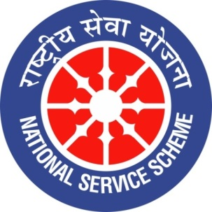 | 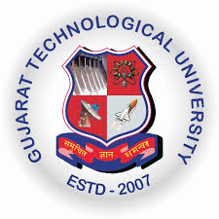 | 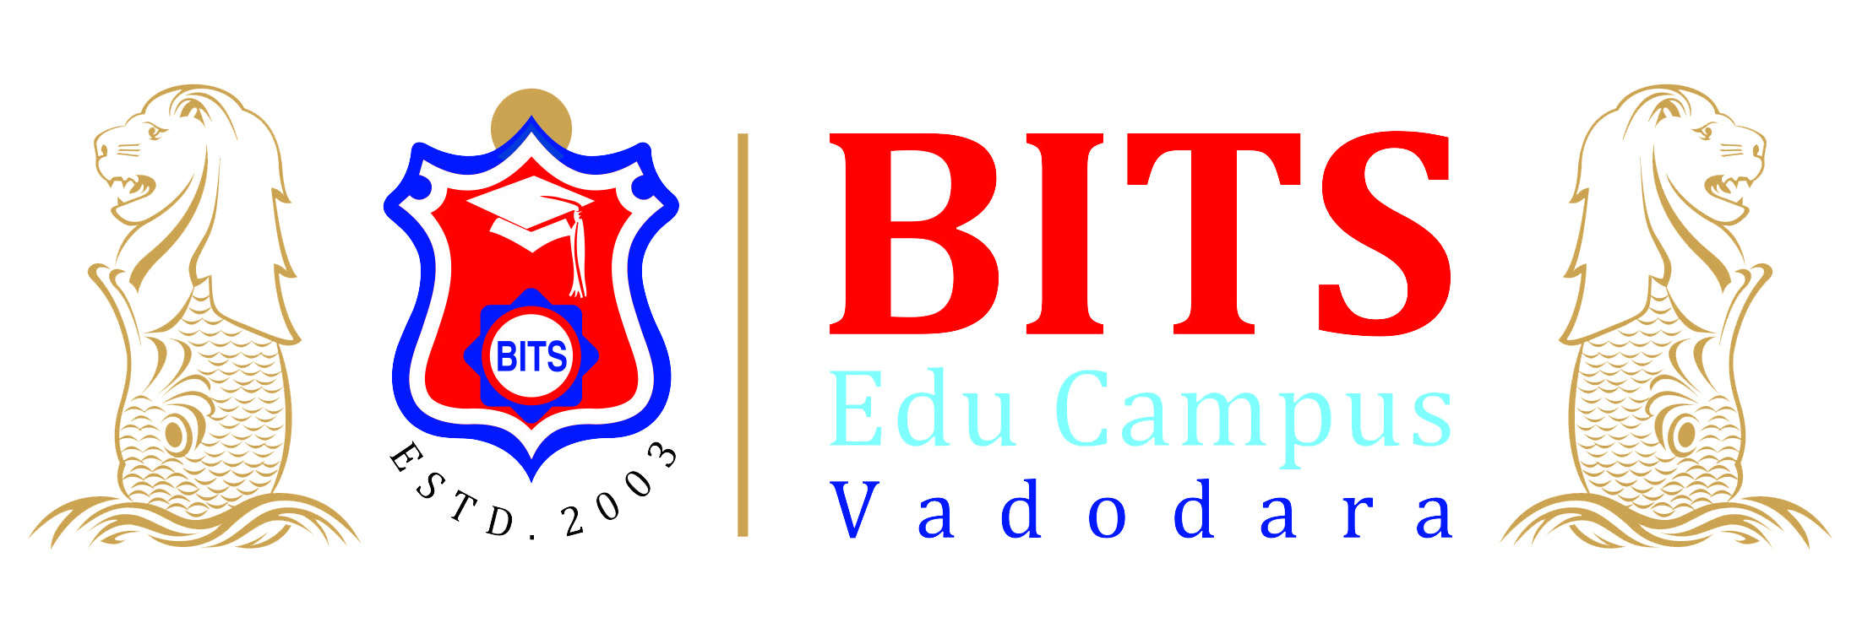
GUJARAT TECHNOLOGY UNIVERSITY
NATIONAL SERVICE SCHEME
BABARIA INSTITUTE OF TECHNOLOGY
A Report on Armed Forces Flag Day Celebration
on 07th December 2018
of NSS Unit - Babaria Institute of Technology

NSS Unit Name/College Name: Babaria Institute of Technology
Event Name: Armed Forces Flag Day Celebration
Event Date, Time and Location: 07th December 2018, BITS Edu Campus.
Brief Description of the Event:
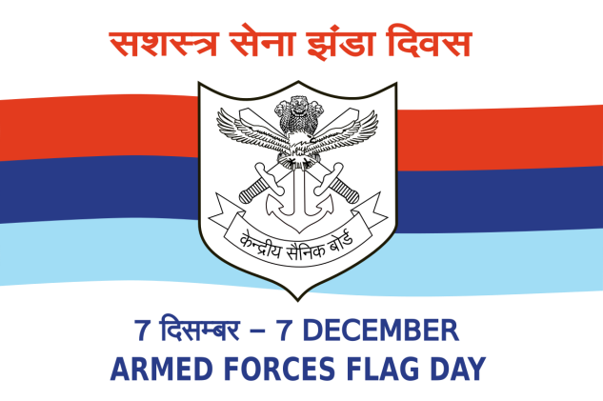
The Armed Forces Flag Day is celebrated all over India on 7th of December in order to collect funds from people of India for the welfare of the Indian armed forces personnel. The Flag Day Fund is mainly utilized for Rehabilitation of battle casualties, Welfare of the serving personnel and their families, Resettlement and welfare of ex-servicemen and their families.
NSS unit of Babaria Institute of Technology has celebrated The Armed Forces Flag Day commemoration and the collection of funds through distribution of flags. This event helps to create awareness in youth about armed forces and their contribution to the nation.
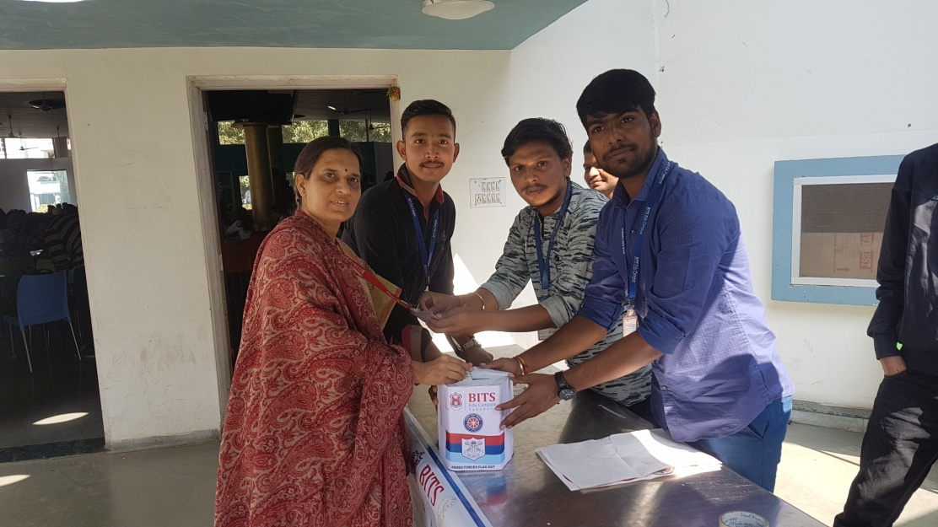 | 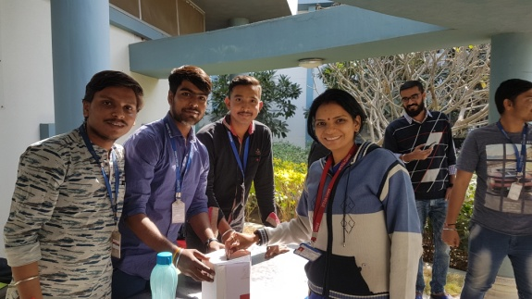
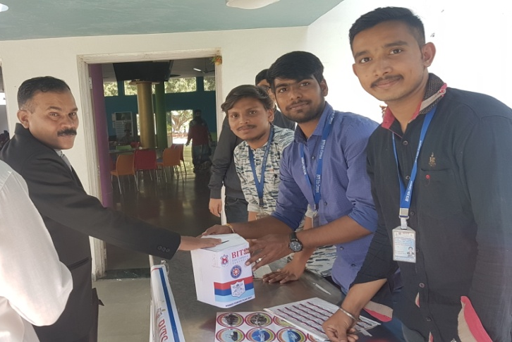 | 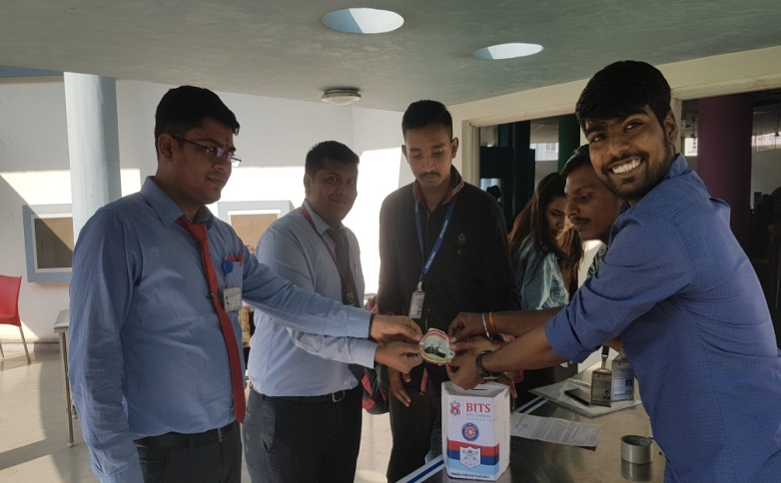
Armed Force Flag Day Commemoration and Collection at Babaria Institute of Technology

