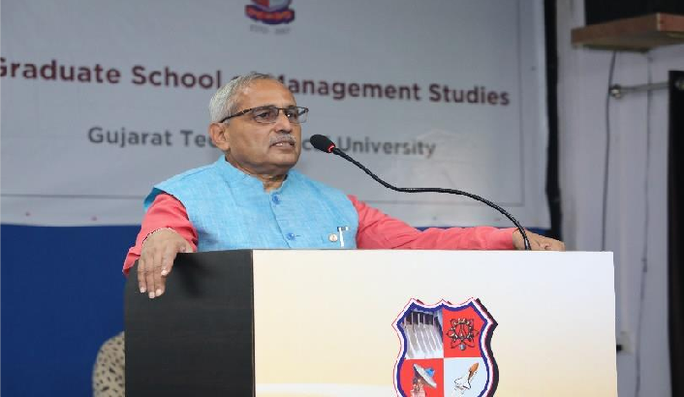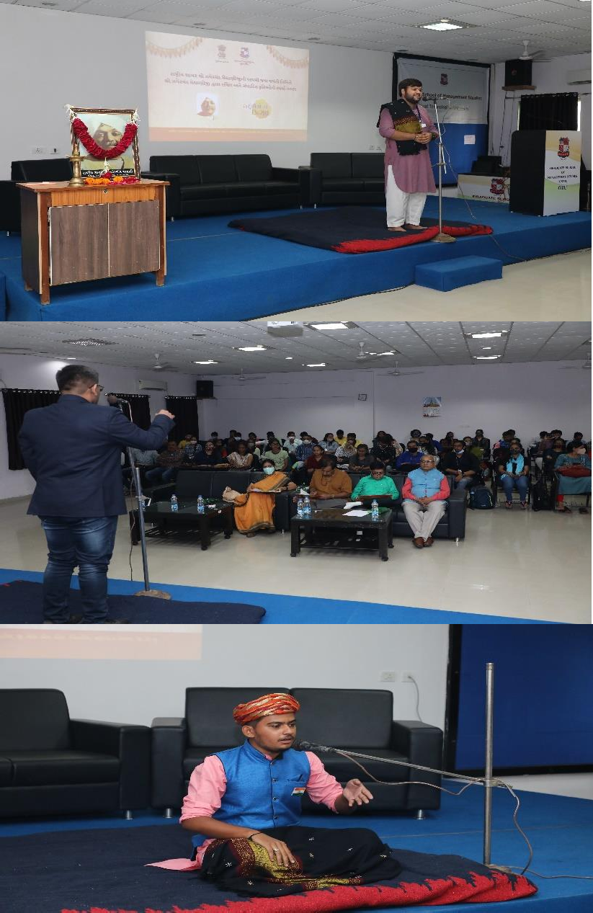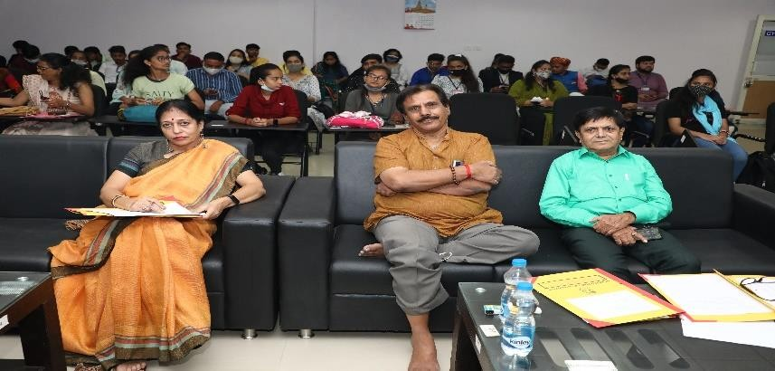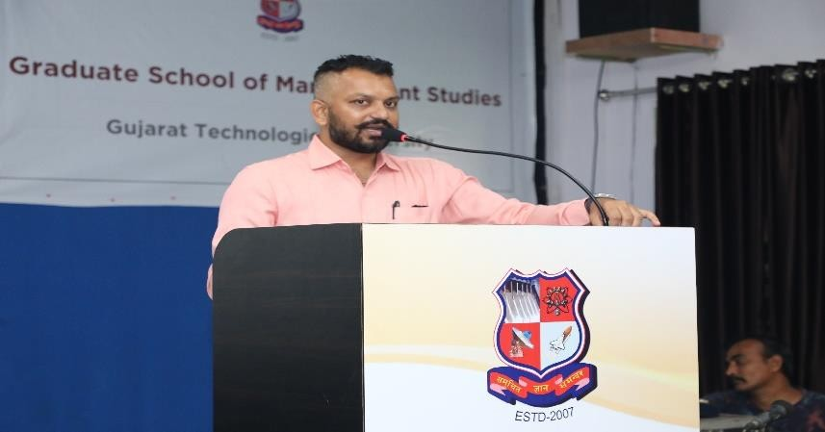National Shayar Shri Zaver Chand Meghaniji 125th Birth anniversary celebration University Level song / poetry / folk song competition

National Shayar Zaver Chand Meghaniji 125th Birth anniversary celebration

University Level song / poetry / folk song competition
conducted on 17/09/2021

GTU had Organized National Shayar Shri Zaver Chand Meghaniji 125th Birth anniversary celebration University Level song / poetry / folk song competition. GTU Affiliated 48 Colleges and 147 winners from all over Gujarat were participated In University Level song / poetry / folk song competition. Total no.of 148 GTU PG student participated in this event.This Event had organized by Deptt.Of Sports, Youth Affairs & Cultural Activities.

