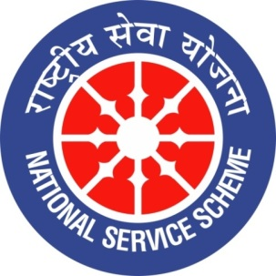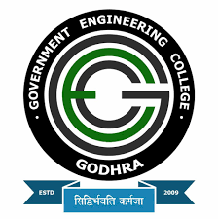
GUJARAT TECHNOLOGY UNIVERSITY
NATIONAL SERVICE SCHEME
GOVERNMENT ENGINEERING COLLEGE GODHRA
A Report on ANTI-DRUG AWARENESS DAY on 11th APRIL, 2022 of NSS CELL GEC GODHRA

NSS Unit Name/College Name: NSS CELL GEC,GODHRA
Event Name: ANTI-DRUG AWARENESS DAY 2022
Event Date, Time and Location: 11th April from 12:30 pm - 1:30 pm at GEC GODHRA
Brief Description of the Event:
As part of spreading the awareness against the ill effects of drugs among citizens, in coordination with the Narcotic Control Bureau (N.C.B.), the Government of India has uploaded an e-pledge titled "Say Yes to Life, No to drugs". Along with a pledge to raise awareness, our N.S.S. unit decided to celebrate Anti-Drug Awareness Day to create awareness about the severe impact of drug abuse and seek support to fight it out.
Our unit organized a program on the 11th of April to celebrate Anti-Drug awareness day in the seminar hall of the general department. The program started with an introduction speech explaining the ill effect of the drug on our health. Moreover, how to get over our addiction. As the theme suggested, SAY YES TO LIFE, NO TO DRUGS, our volunteers explained the importance of one's life, how drugs ruin everything, and that we must choose life over drugs.
Also, as many people in our country suffer from drug addiction, one of our volunteers explained where the drugs are coming from and which neighbouring country has illegal drug production problem through the map of India. This day was celebrated as black day. We ended the program with a small quiz and a pledge to protect ourselves from drug addiction, choose life above drugs, and click some pictures for our social media campaign.

Major Outcomes of Event:
- The Indian government aims to discourage people from engaging in illegal recreational drug use by making the people pledge to choose life over drugs.
- We learned about our country's situation in the fight against drug addiction.
- We learned about the illegal production and distribution of drugs and how India can fight it.
- We learned about the ill effects of drugs.

PHOTOGRAPHS

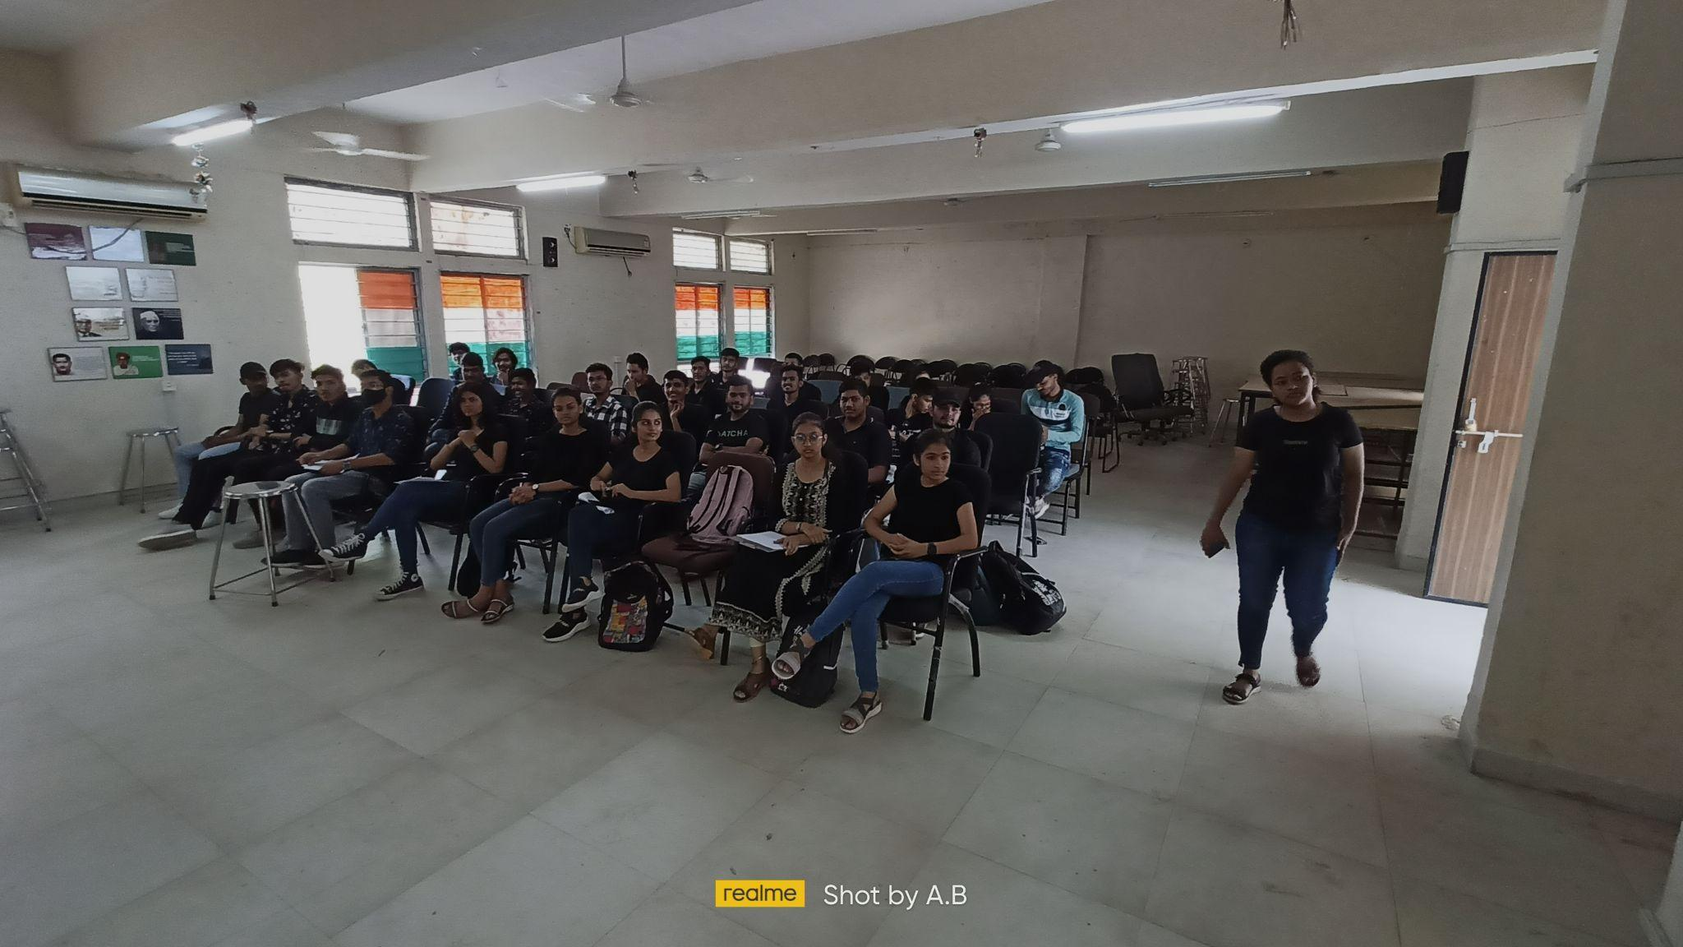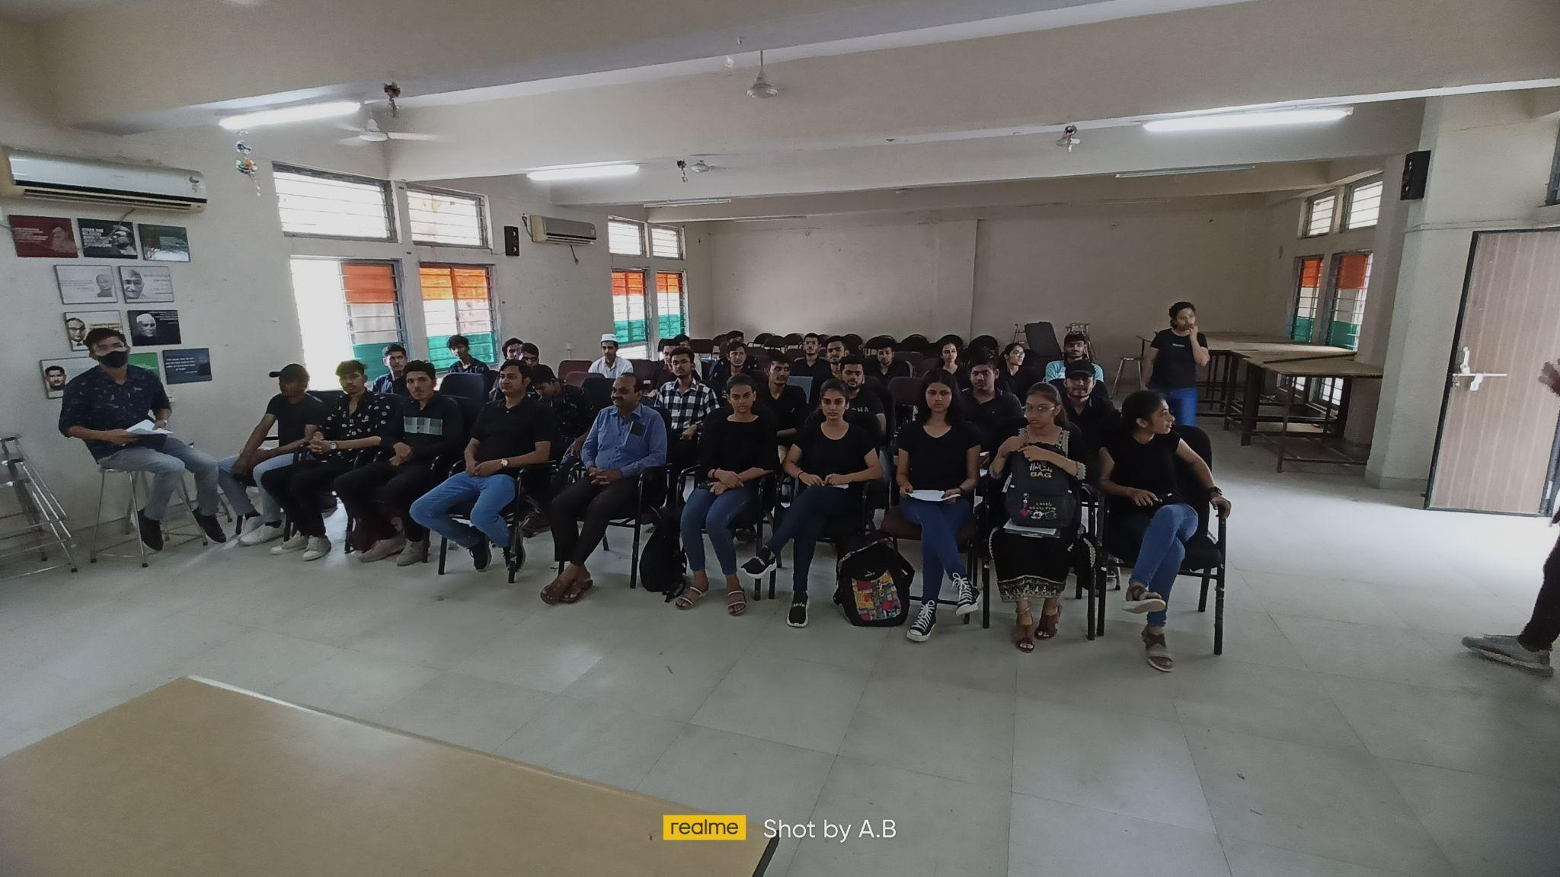
[Students gathered for the start of the event]

[Professors giving a welcome speech ]

[Volunteers explaining the number of drug users in India]
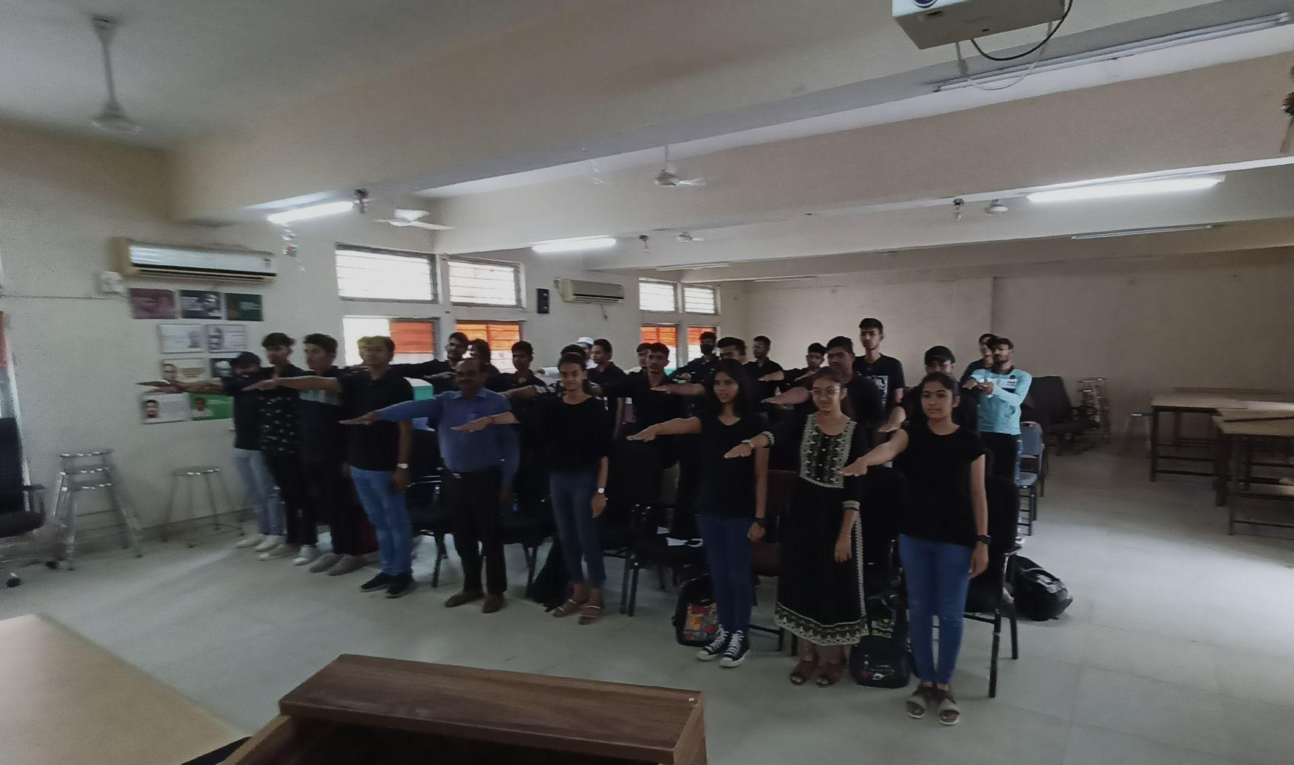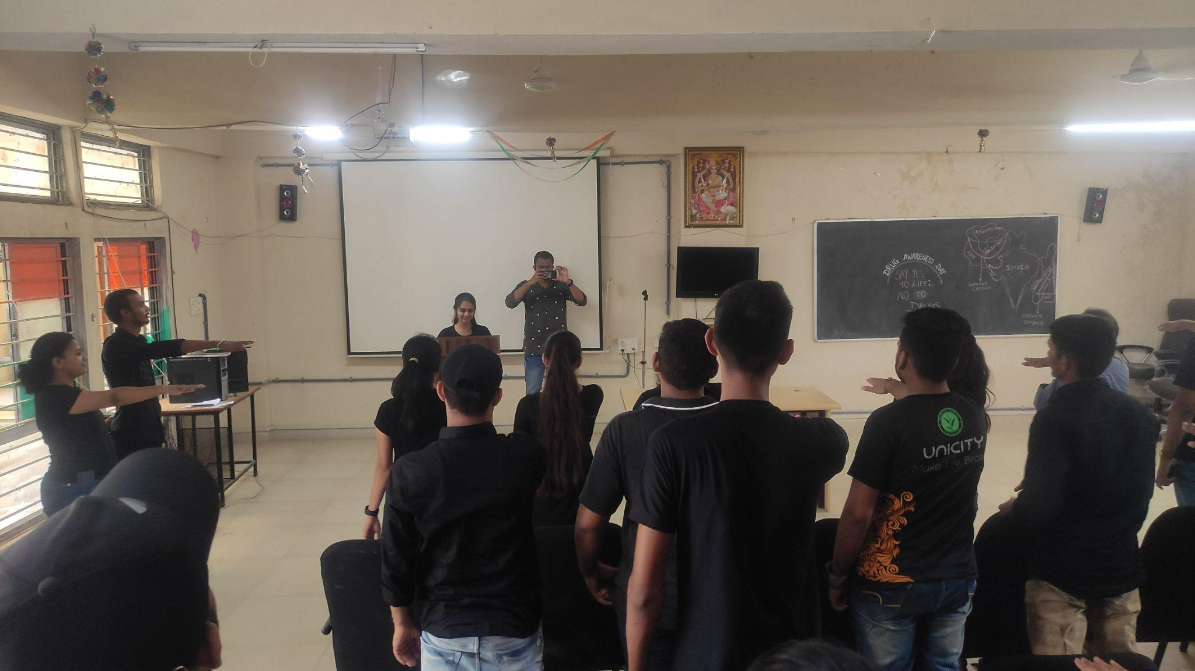

[Students taking oath for No Drug ]

