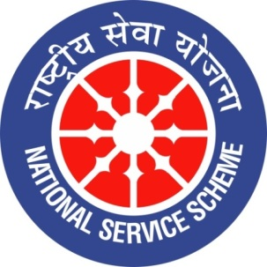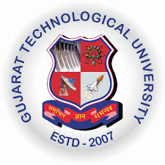
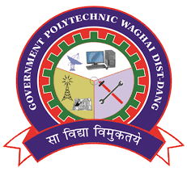
GUJARAT TECHNOLOGY UNIVERSITY
NATIONAL SERVICE SCHEME
GOVERNMENT POLYTECHNIC WAGHAI
A Report on constitution day /Friday celebrationon 25/10/2022 of Government Polytechnic waghai
NSS Unit Name/College Name: Government Polytechnic waghai
Event NAME: Constitution day Celebration
Event Date, Time and Location: Government polytechnic waghai
Brief Description of the Event:. Constitution day celebrated at Government polytechnic waghai on Friday date 25/10/2022. All branch students and staff members take oath on constitution day.
Major Ou/tcomes of Event: Students know important of Indian constitution
Photographs of the Event:

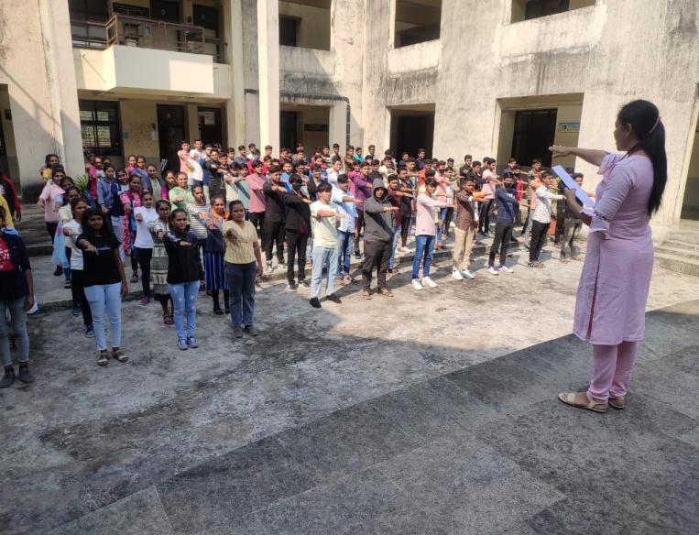 | 