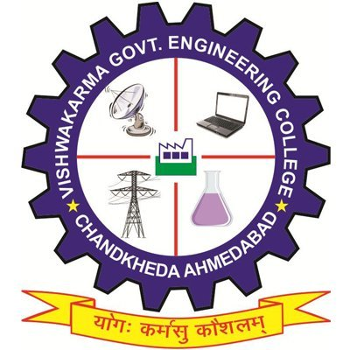
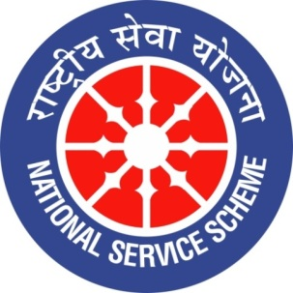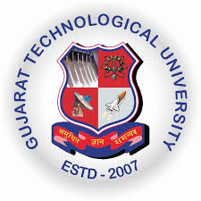
GUJARAT TECHNOLOGICAL UNIVERSITY
NATIONAL SERVICE SCHEME
VISHWAKARMA GOVERNMENT ENGINEERING COLLEGE, CHANDKHEDA
NSS VGEC
A Report on “EK BHARAT SHRESHTA BHARAT” activity.
NSS Unit Name/College Name: NSS VGEC (VISHWAKARMA GOV. ENG. COLLEGE)
Event NAME:-lecture programme and screening films of Chhattisgarh.
Event Date, Time and Location :- 22 November 2019, VGEC Campus, 01:00 to 04:00 PM
Brief Description of the Event:-
India is a land that symbolises unity in diversity. In India there are people of many relegions speaking different languages and following different culture.so to strengthen the unity of India “Ek Bharat Shrestha Bharat” programme was started and under this programme each state was paired with another state so that they can exchange their culture and traditions. As Gujarat state is paired with Chhattisgarh and Chhattisgarh was carved out of Madhya Pradesh on 1 November so an event regarding this was arranged by NSS VGEC to enhance knowledge of students about rich culture, tradition, and practices of Chhattisgarh. In this event a lecture programme was arranged in which professors and students of VGEC have given information about Chhattisgarh so that mutual understanding and bonding of students along with tradition and culture of Chhattisgarh can be enhanced.
Along with the lecture programme students were made to see short films on Chhattisgarh representing folk dance, staple foods, folk songs, places of tourist attraction overthere. This short films have made students more familiar with Chhattisgarh and they enjoyed watching it .

Principal of VGEC Dr. N.N Bhuptani praised this activity and said, “Only Youth has power to lead India towards development by connecting each state with another state”.
Prof. Alpesh Dafda said,“The knowledge of language, culture, traditions and practises will lead to an enhanced understanding and bonding between one another, and thereby will strengthen the unity and integrity of India”.

Major Outcome of The Event:
- Students came to knew more about paired state Chhattisgarh and there knowledge regarding Chhattisgarh had been enhanced to another level.
Images of Event:-

