GUJARAT TECHNOLOGY UNIVERSITY
NATIONAL SERVICE SCHEME
ANAND PHARMACY COLLEGE
A Report on YOGA MEDITATION-2022
NSS Unit Name/College Name: Anand Pharmacy College
EVENT NAME: YOGA MEDITATION 2022
Event Date: 22/06/2022
Theme: YOGA for KUNDALINI(DHYAN)
Time:11:45-12:45
Platform: UG-2 Class Room, Anand Pharmacy College
Participant: NSS Volunteers, Teaching & Non-teaching staff.
Total Participant :65
Brief Description of the Event:
NSS unit of Anand Pharmacy College, Anand had celebrated YOGA MEDITATION 2022 on 22nd June 2022. It was great experience for all those who participated . There were total 49 participants out of which 45 were the students and the other 4 were faculty members of the college itself. The programme commenced with information about kundalini dhyan which was further followed by performing kundalini dhyan.

Major Outcomes of Event:
Practicing meditation aids in achieving mindfulness along with balance, strength and flexibility. This event left a very educative and inspiring impact on the participants. Performing meditation on regular basis helps us attain discipline and consistency in our day to day life.
Photograps of event:
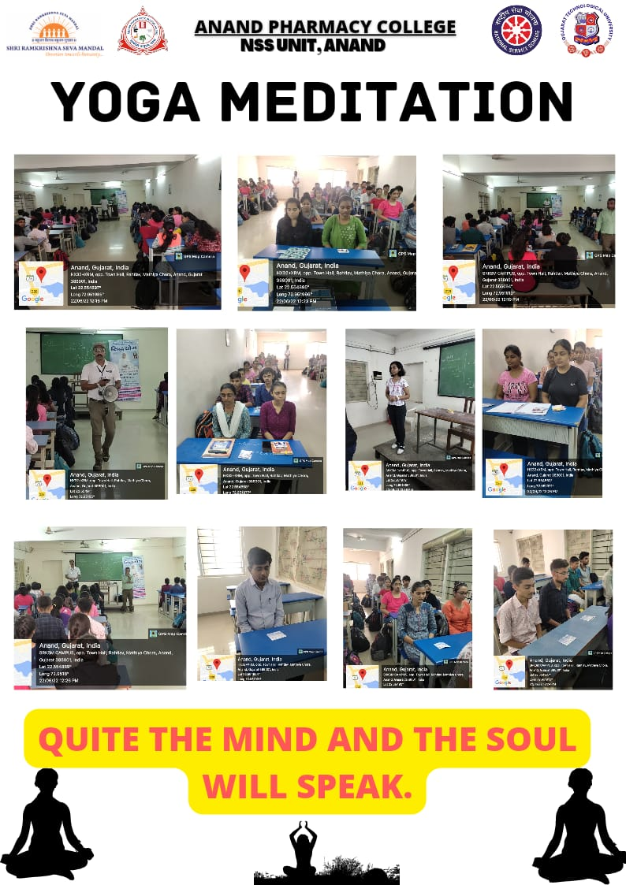

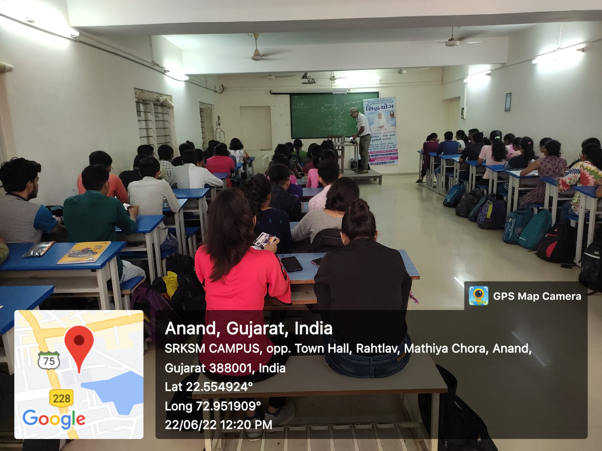
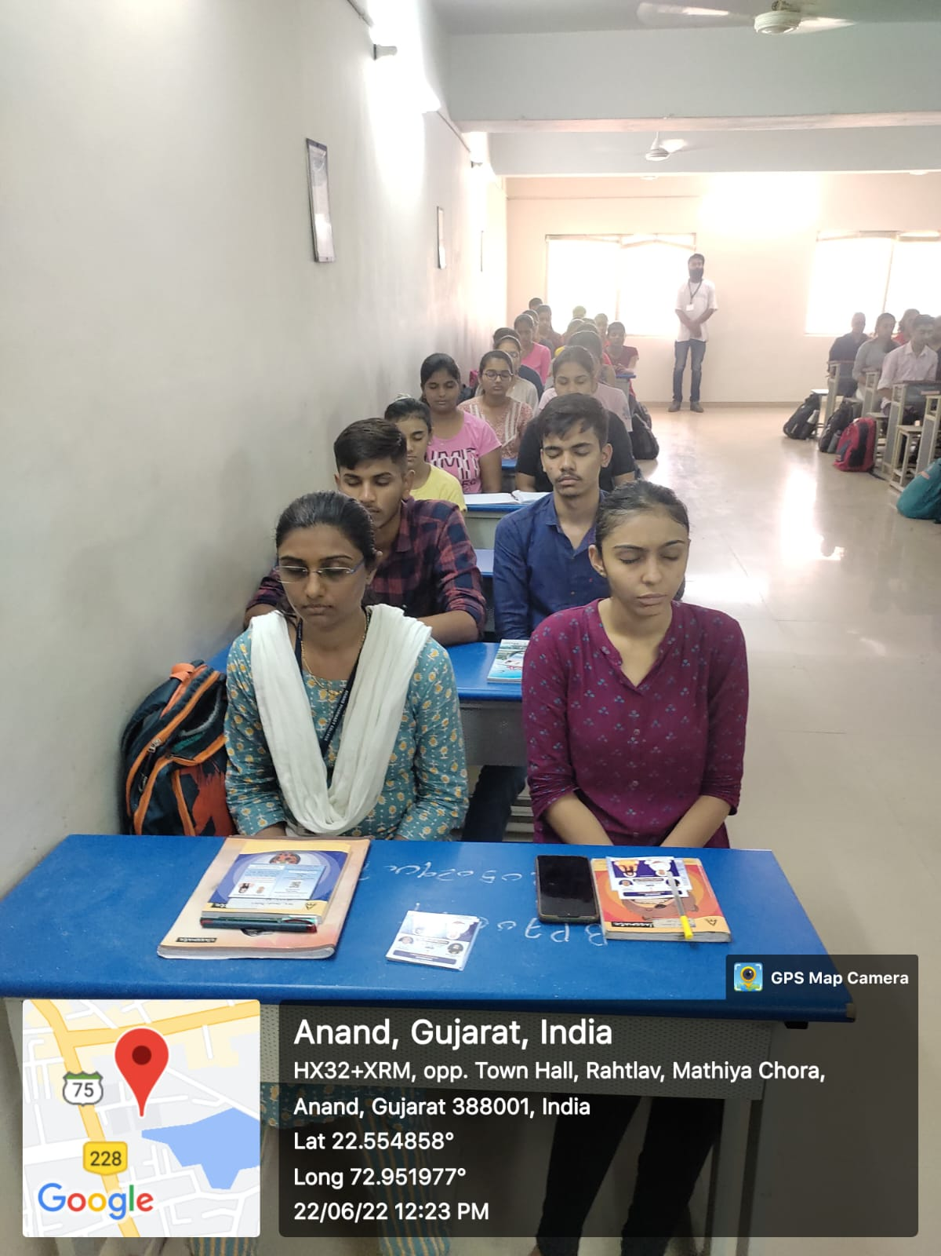

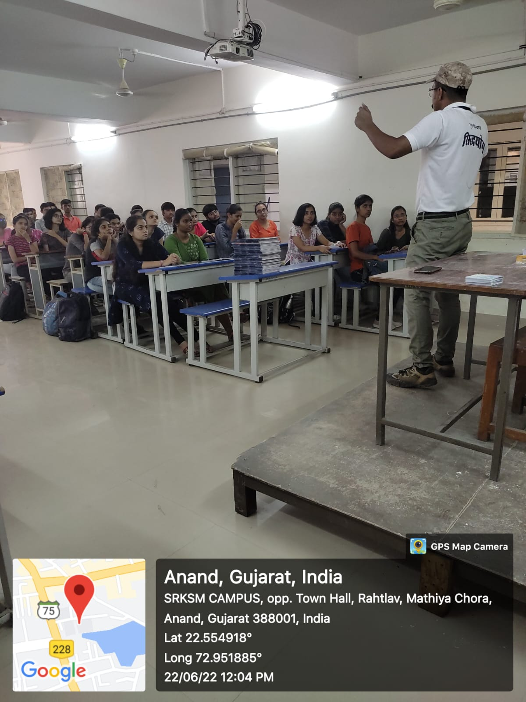
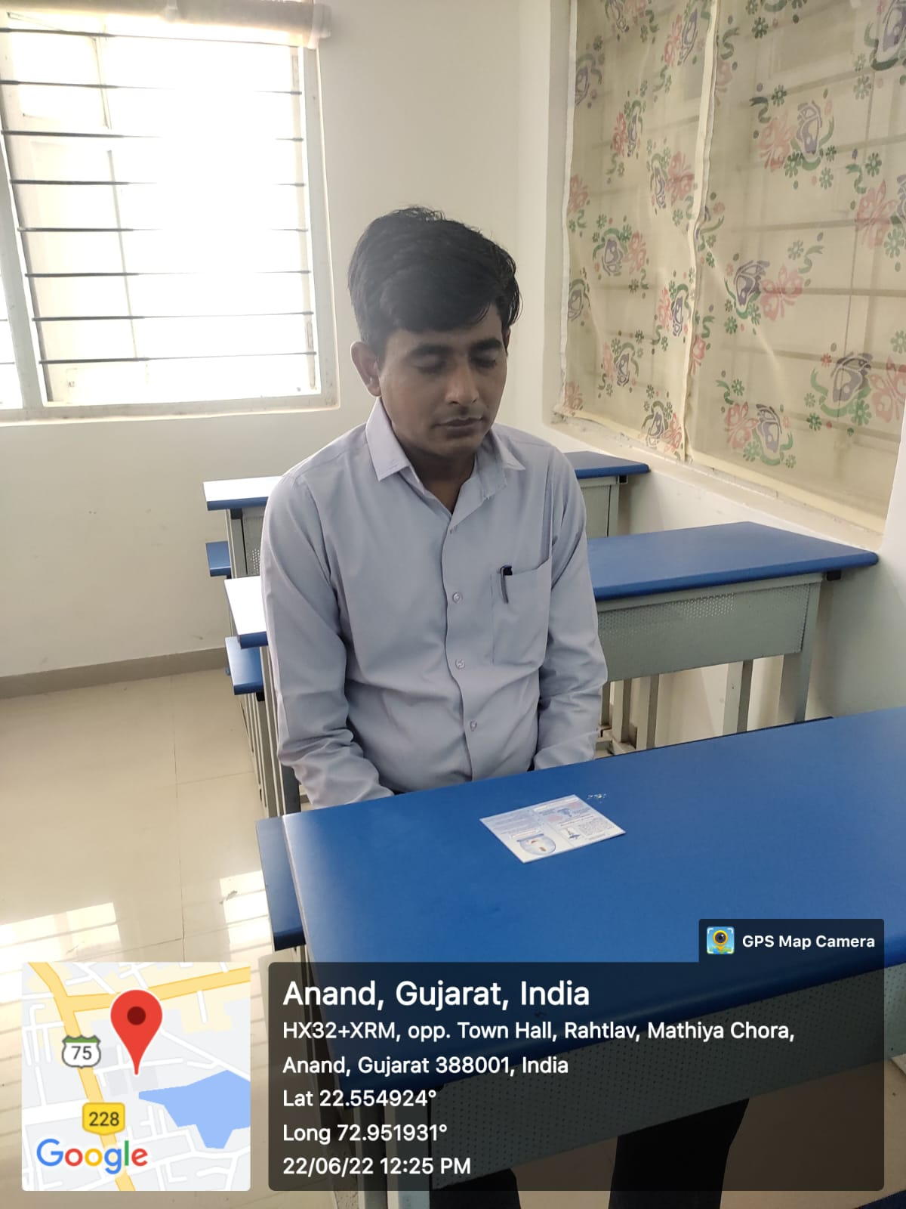
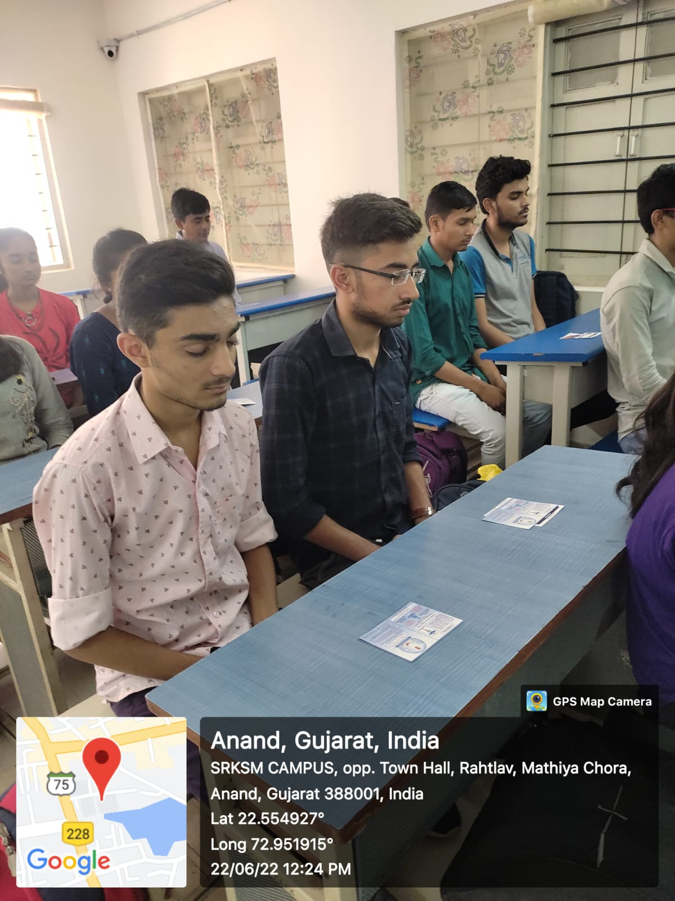

List of Participant:

Sr No. | Name | Enrollment No. | Class
1 | Ganjawala Meet | 212050290101 | B.Pharm 2nd Sem
2 | Varma Meher | 212050290029 | B.Pharm 2nd Sem
3 | Rami Disha | 212050290084 | B.Pharm 2nd Sem
4 | Patel Kosha | 212050290102 | B.Pharm 2nd Sem
5 | Patel Sakshi | 212050290099 | B.Pharm 2nd Sem
6 | Desai Jil | 212050290057 | B.Pharm 2nd Sem
7 | Patel Shreya | 212050290058 | B.Pharm 2nd Sem
8 | Pujari Niyati | 212050290050 | B.Pharm 2nd Sem
9 | Bhavsar Khushi | 212050290039 | B.Pharm 2nd Sem
10 | Desai Hetvi | 212050290086 | B.Pharm 2nd Sem
11 | Makwana Dhruv | 212050290080 | B.Pharm 2nd Sem
12 | Dadhaniya Hit | 212050290072 | B.Pharm 2nd Sem
13 | Ambasana Harsh | 212050290082 | B.Pharm 2nd Sem
14 | Tripathi Vaishanvi | 212050290085 | B.Pharm 2nd Sem
15 | Gandhi Khushi | 212050290047 | B.Pharm 2nd Sem
16 | Panada Sachin | 212050290095 | B.Pharm 2nd Sem
17 | Chandani Rishika | 212050290094 | B.Pharm 2nd Sem
18 | Maji Dipika | 212050290096 | B.Pharm 2nd Sem
19 | Rakholiya Khushi | 212050290045 | B.Pharm 2nd Sem
20 | Ahir Anjani | 212050290070 | B.Pharm 2nd Sem

Sr No. | Name | Enrollment No. | Class
21 | Varma Janshi | 212050290032 | B.Pharm 2nd Sem
22 | Patel Isha | 212050290098 | B.Pharm 2nd Sem
23 | Sheladiya Krupesh | 212050290058 | B.Pharm 2nd Sem
24 | Akbari Soham | 212050290055 | B.Pharm 2nd Sem
25 | Ladani Nandan | 212050290088 | B.Pharm 2nd Sem
26 | Trabadiya Kunj | 212050290028 | B.Pharm 2nd Sem
27 | Gohil Kuldeepsinh | 212050290061 | B.Pharm 2nd Sem
28 | Patel Maitri | 212050290040 | B.Pharm 2nd Sem
29 | Patel Tanvi | 212050290002 | B.Pharm 2nd Sem
30 | Patel Riya | 212050290093 | B.Pharm 2nd Sem
31 | Rana Sakshi | 212050290106 | B.Pharm 2nd Sem
32 | Sindha Dhruva | 212050290107 | B.Pharm 2nd Sem
33 | Rathod Pearlin | 212050290062 | B.Pharm 2nd Sem
34 | Patel Tanisha | 212050290003 | B.Pharm 2nd Sem
35 | Panchal Hetvi | 212050290083 | B.Pharm 2nd Sem
36 | Chaudhari Dhruvi | 212050290044 | B.Pharm 2nd Sem
37 | Rohit Kaushik | 212050290078 | B.Pharm 2nd Sem
38 | Bhatt Khushi | 212050290063 | B.Pharm 2nd Sem
39 | Yadav Khushi | 212050290059 | B.Pharm 2nd Sem
40 | Patel Vandan | 212050290027 | B.Pharm 2nd Sem

Sr No. | Name | Enrollment No. | Class
41 | Shah Divy | 212050290100 | B.Pharm 2nd Sem
42 | Prajapati Prakruti | 212050290065 | B.Pharm 2nd Sem
43 | Honey Raval | 212050290077 | B.Pharm 2nd Sem
44 | Kushwaha Tanu | 212050290030 | B.Pharm 2nd Sem
45 | Jetpariya Shreya | 212050290043 | B.Pharm 2nd Sem
46 | Mr. Subhashchandra Patel | - | -
47 | Mr. Rajesh Patel | - | -
48 | Mrs. Gopi Patel | - | -
49 | Mrs. Himali Desai | - | -

Name and Sign of NSS PO: Mr. Subhashchandra K. Patel 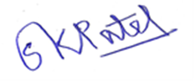

Name and Sign of Student Head: Ms. Janki M. Patel

Name and Sign of Principal/ Vice Principal: Dr Tejal R. Gandhi / Dr. Kalpana G. Patel

