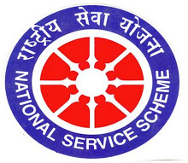
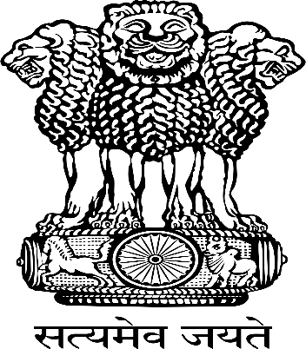
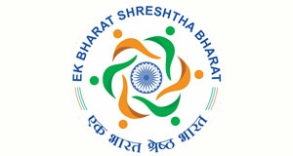
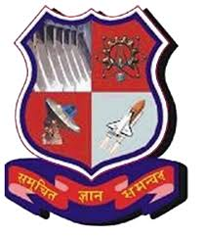

NATIONAL INTEGRATION CAMP 2020
  - एक भारत श्रेष्ठ भारत
Heartily Thankful to;
Government of Gujarat, Education department NSS cell,
Higher education, Gandhinagar,
Regional Director, NSS, Ministry of Youth Affairs and Sports
&
National Service Scheme (NSS)
The Maharaja Sayajirao University of Baroda
DATE: 20th to 26th of January
VENUE: Faculty of Social Work, The Maharaja Sayajirao University of Baroda

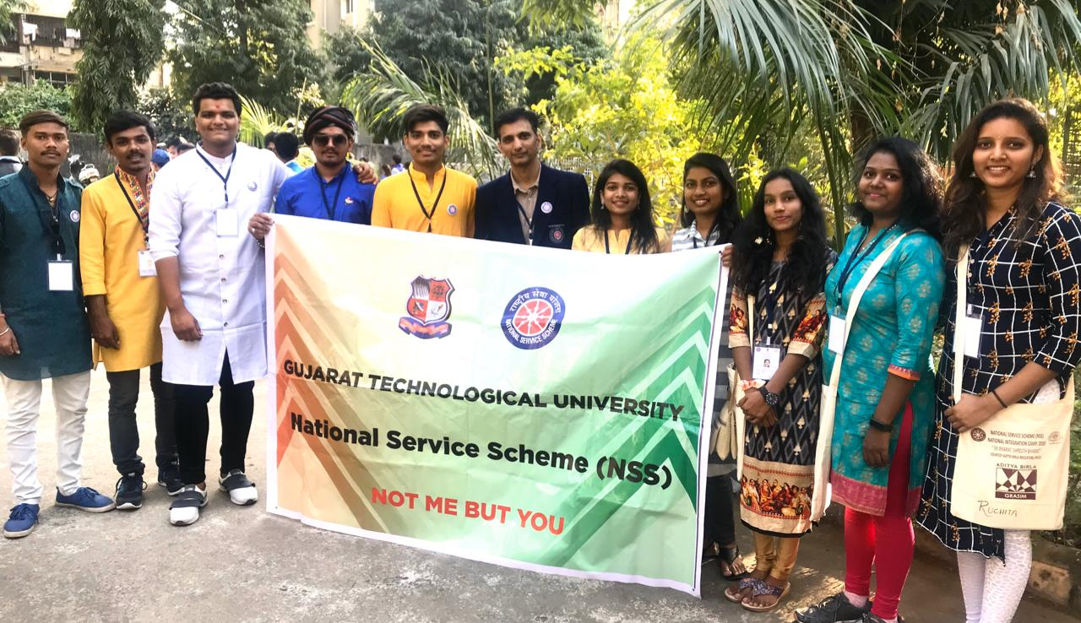

TEAM GTU :

Dr. Niket Shashtri Program officer , SCET Surat

Tirth Rao GEC,Godhara

Mohit M Padaliya GEC,Patan

Sahil Shingala SCET , Surat

Dholu Monikkumar VGEC , Gandhinagar

Patel Prince SPCE,Bakrol

Viral Taral LDEC , Ahmedabad

Chavda Bhumi SCET , Surat

Parmar Sakshi B.&B. Institute of technology ,V V Nagar

Kadam Ruchita Babaria Institute of technology

Christian Rutvi Babaria Institute of technology

DIRECTIVES:
- The camp was of 7 days i.e. of 20th to 26th of Jan.
- All the volunteers meant to represent our state’s Food, Dressing, Festivals, Culture and Tradition.
Every session was started with the MSU song and NSS song.

The brief of each day is mentioned below:

DAY 1
On the first day, volunteers had registered themselves at venue. At 11:00 am we all had attended the live session on “परीक्षा पे चर्चा” by Hon. Prime Minister Narendra Modiji.
The inauguration ceremony was held at 4:30 pm. Mr. M. Nagarajan (IAS) commissioner of Higher Education, Gandhinagar was the chief guest. Mr. Narayan Madhu, Additional Commissioner, Higher Education, Gandhinagar, and Mr. Giridhar Upadhyay, Regional Director NSS, Ahmedabad were the Guest of Honor. Dr. Parimal H. Vyas, Hon. Vice Chancellor, M.S. Uni. of Baroda had delivered the inaugural address.
The Inter-state cultural event was held by the volunteers of the Chhattisgarh state and the MSU Gujarat. Both team volunteers had represented the folk songs and dances of their states.

  - DAY 2
The 2nd Day was started with the Yoga session. The expert lecture was held on “Nation building”. The extempore elocution competition was held after the lunch. The topics were given to the participants on the spot. There was one participant from each state. Each participant spoke for 2 minutes. Topics were like Women Empowerment, Effects of Westernization on India. Each team had time for the preparation for cultural event from 4:00 pm to 7:00pm. The inter-state cultural event was held between Chandigarh and Gujarat in evening .In that Chandigarh team had represented their state very beautifully.
  - DAY 3
On the 3rd day as per schedule yoga session was held followed by the breakfast. The batches of volunteers were taken to visit/know the MSU (MSU heritage walk). In post lunch session there was an elocution competition. The topics were “Channelizing youth for the development of nation” and “Unity in Diversity”. Then as per the schedule 5 pm to 7 pm was given for the preparation for the cultural event. The cultural event was started at 7:30 pm in which the volunteers of Odisha and Gujarat state had participated enthusiastically.

  - DAY 4
On the 4th day as per routine yoga and breakfast had been completed between 7 am to 10 am. After that an amusing lecture was delivered by Dr. JIGAR INAMDAR on ‘UNITY IN DIVERSITY’.
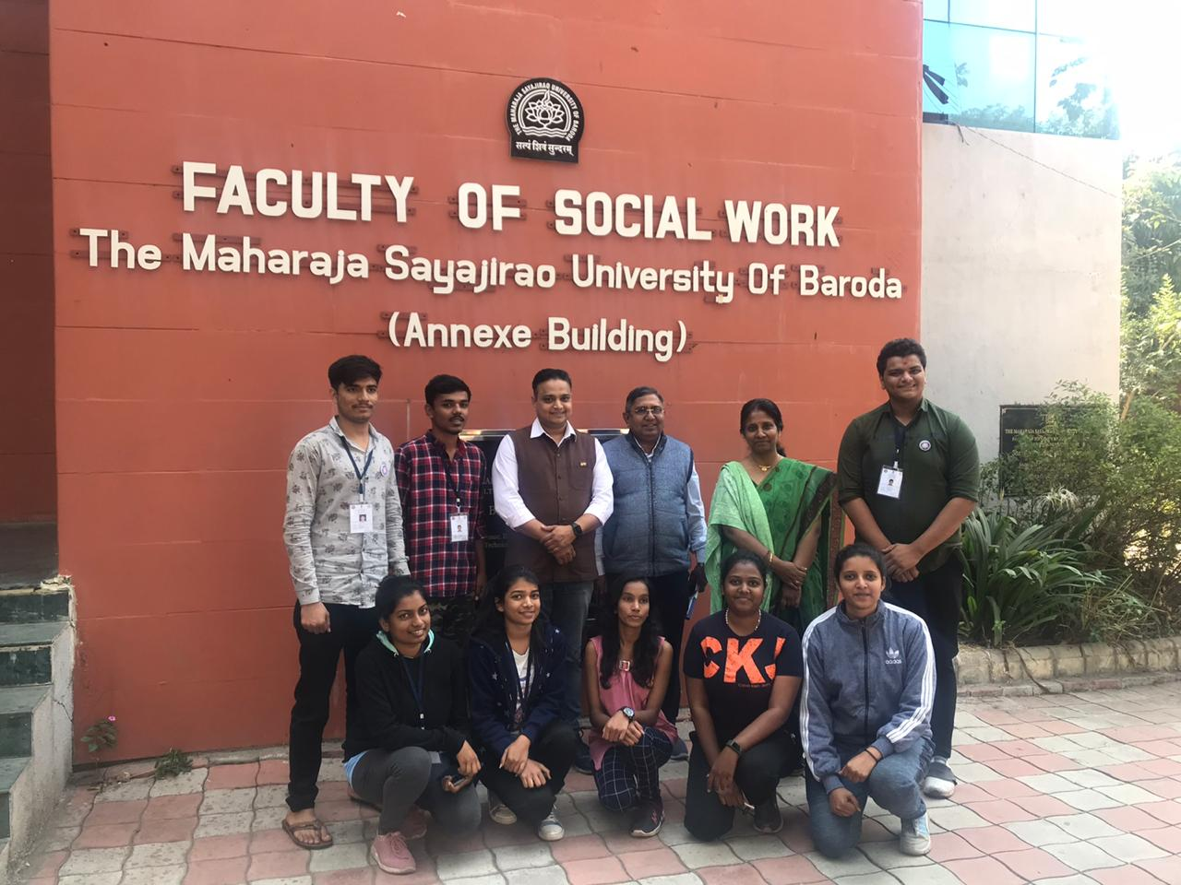

There was a Skit/ Nukkad natak competition in post lunch session. The topics were chosen by the volunteer on social issues. The team GTU had represented pure folk of Gujarat. We performed various forms of Garba and Raas. We also performed the Lok Geet of Gujarat.
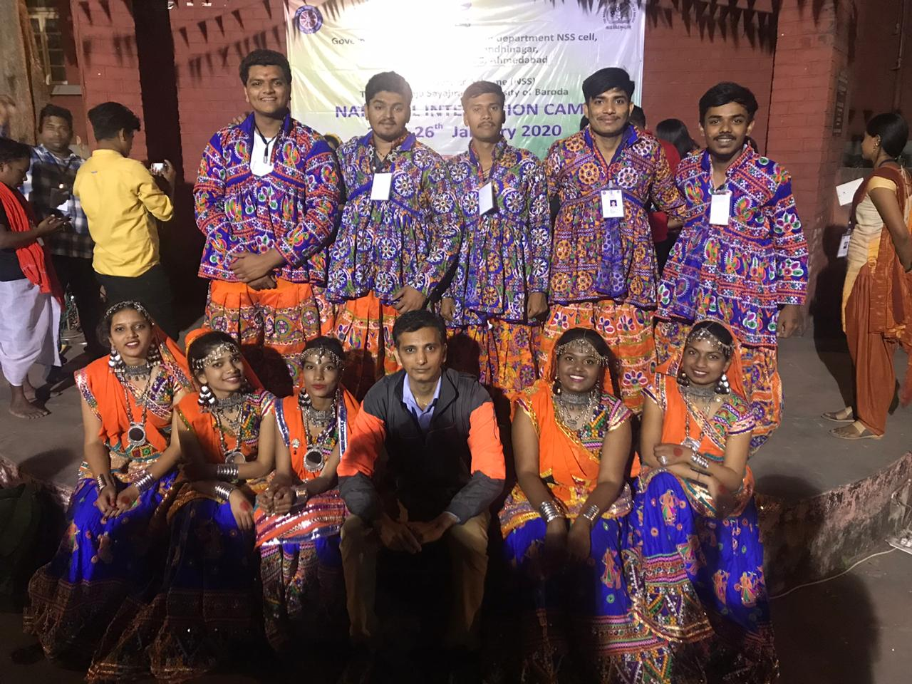
The Garba team of GTU
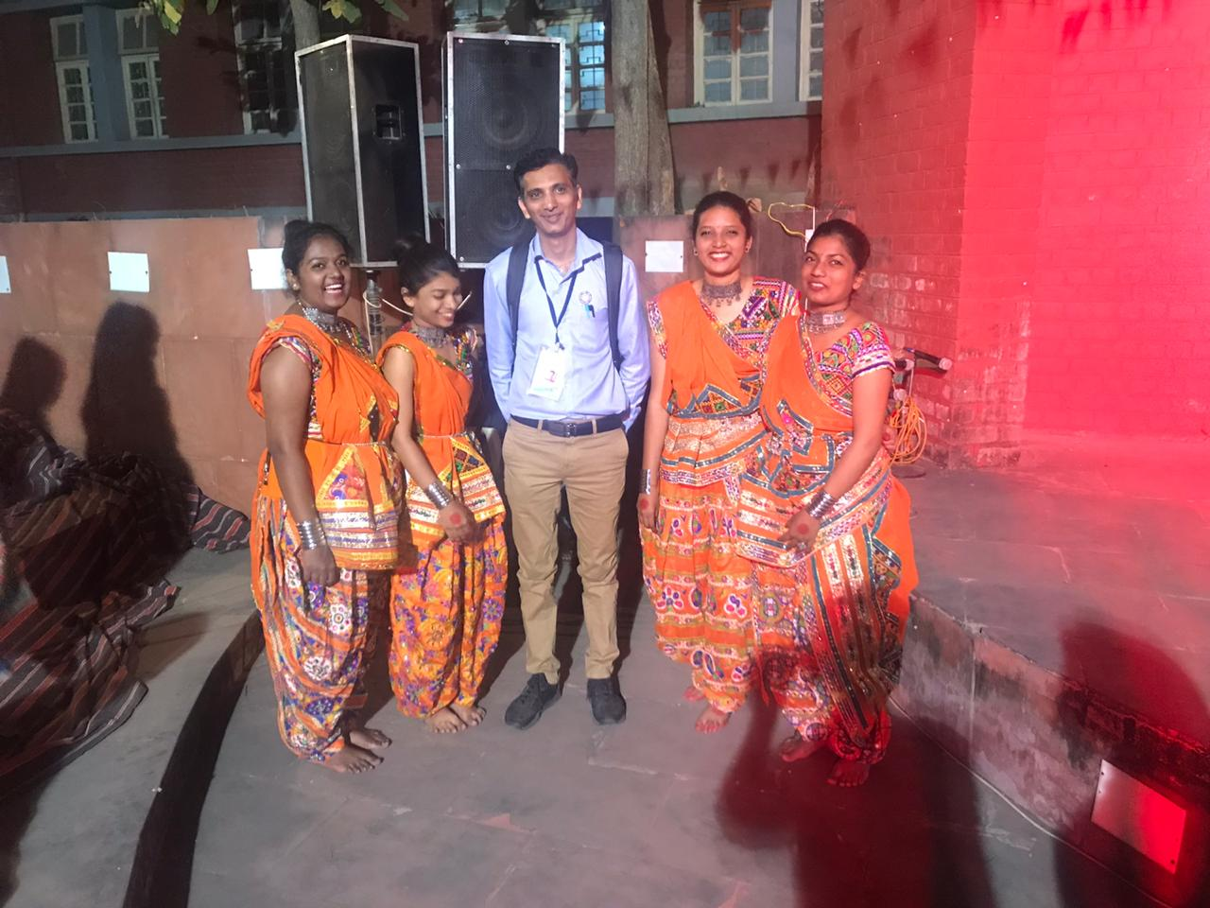
  - Ganesh Vandna Team of GTU

  - DAY 5
On the 5th day same as the other days a session was held by ‘Youth And Spiritual Health’ by Shree Shashibhai Shah. A visit to ‘Statue of Unity’, ‘Sardar Sarovar Dam’ and ‘Lakshmi Vilas Palace’ was arranged.
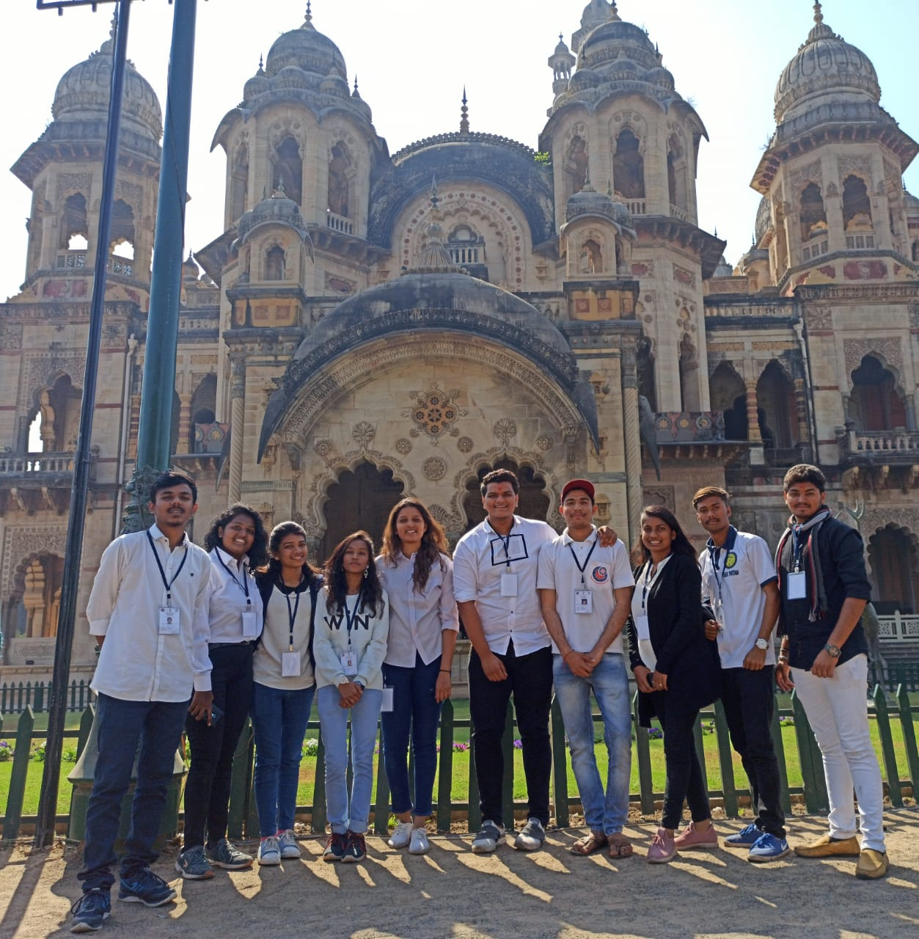
GTU Team at Laxmi Vilas Palace
  - 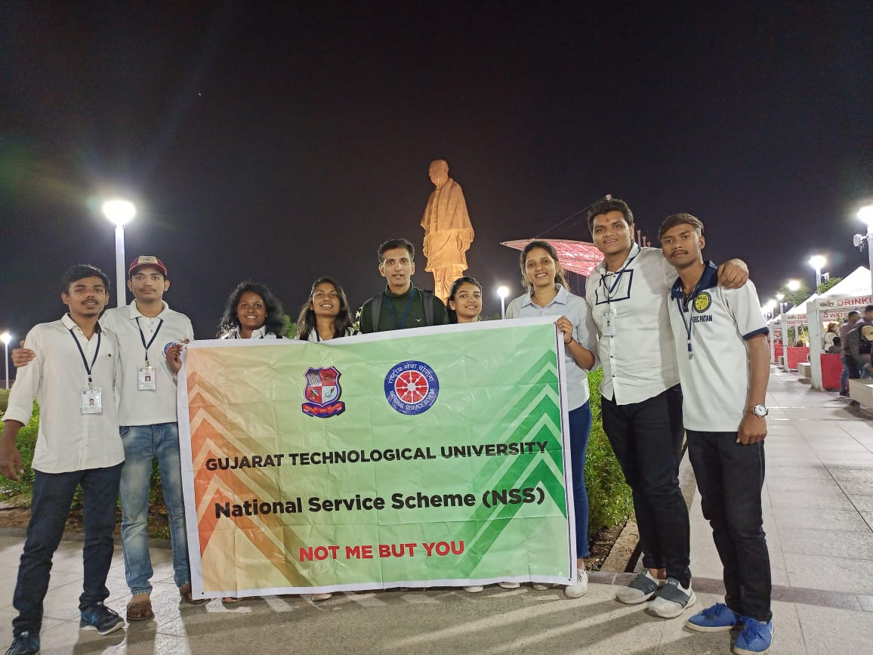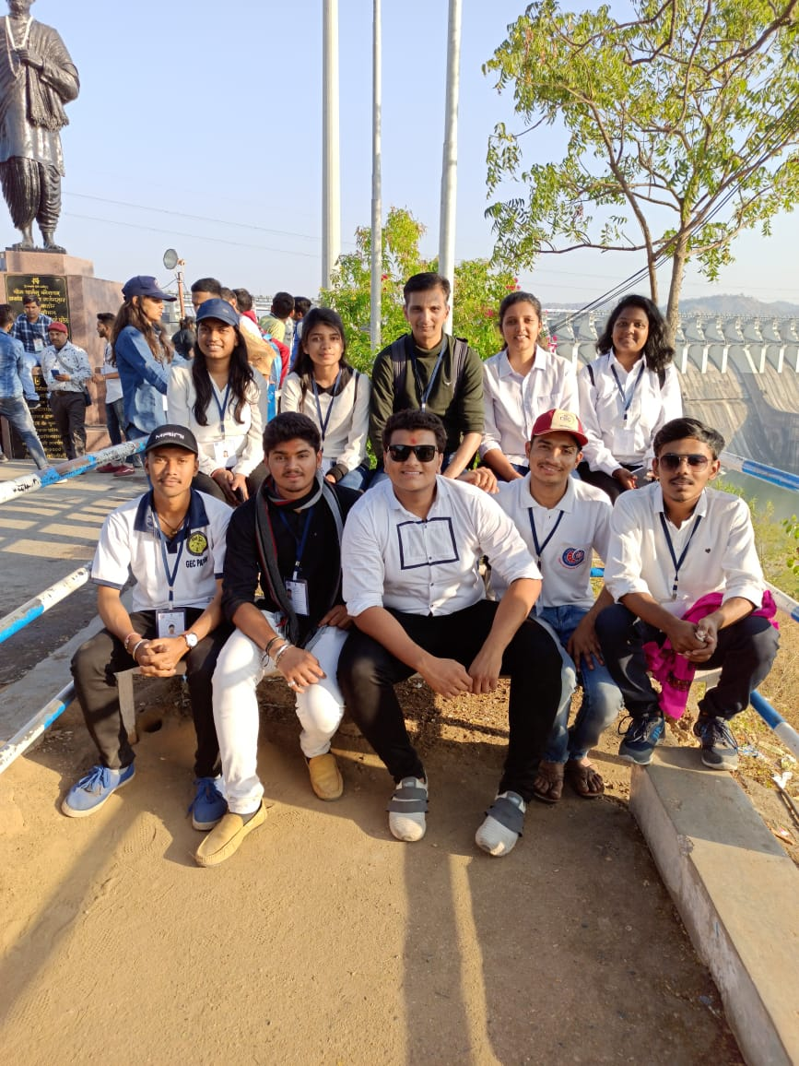
  - GTU Team at Statue of Unity
  - DAY 6
On the 6th day in post yoga and breakfast session there was a expert talk on ‘Youth and Ek Bharat Shreshth Bharat’ by Shri Nandak Pandya.
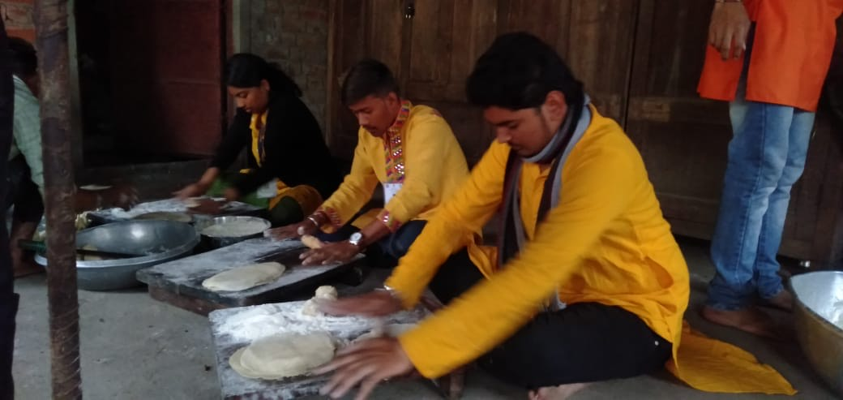
On this day the duty of serving break fast and lunch was allotted to us (GTU) along with another two universities. Our volunteers had helped in preparing the breakfast also.
GTU Team preparing Lunch

GTU Team preparing breakfast
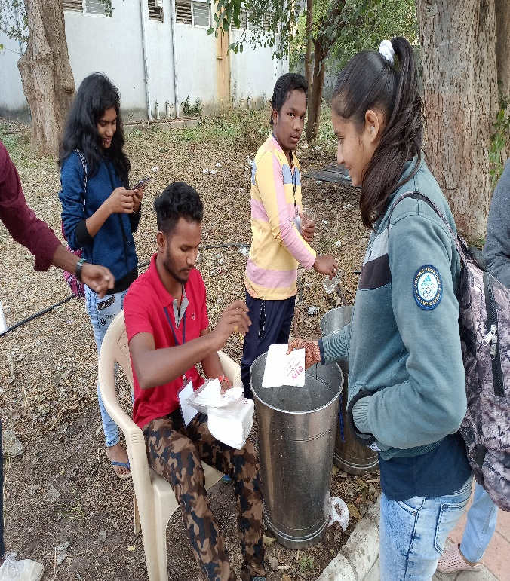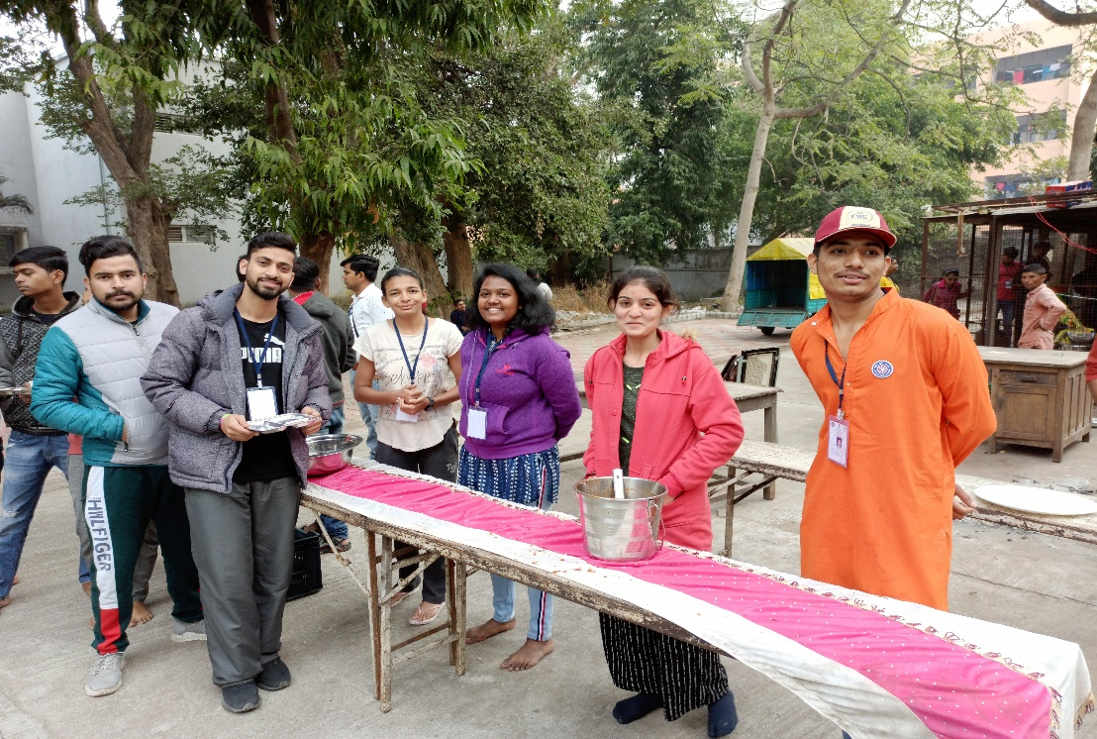
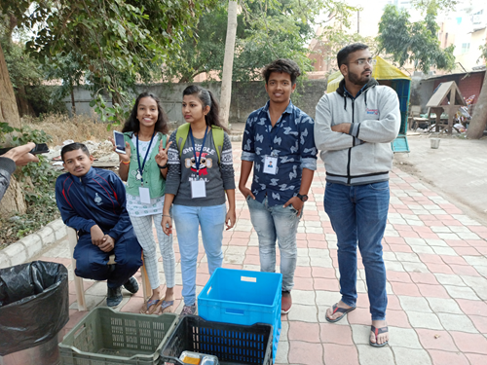
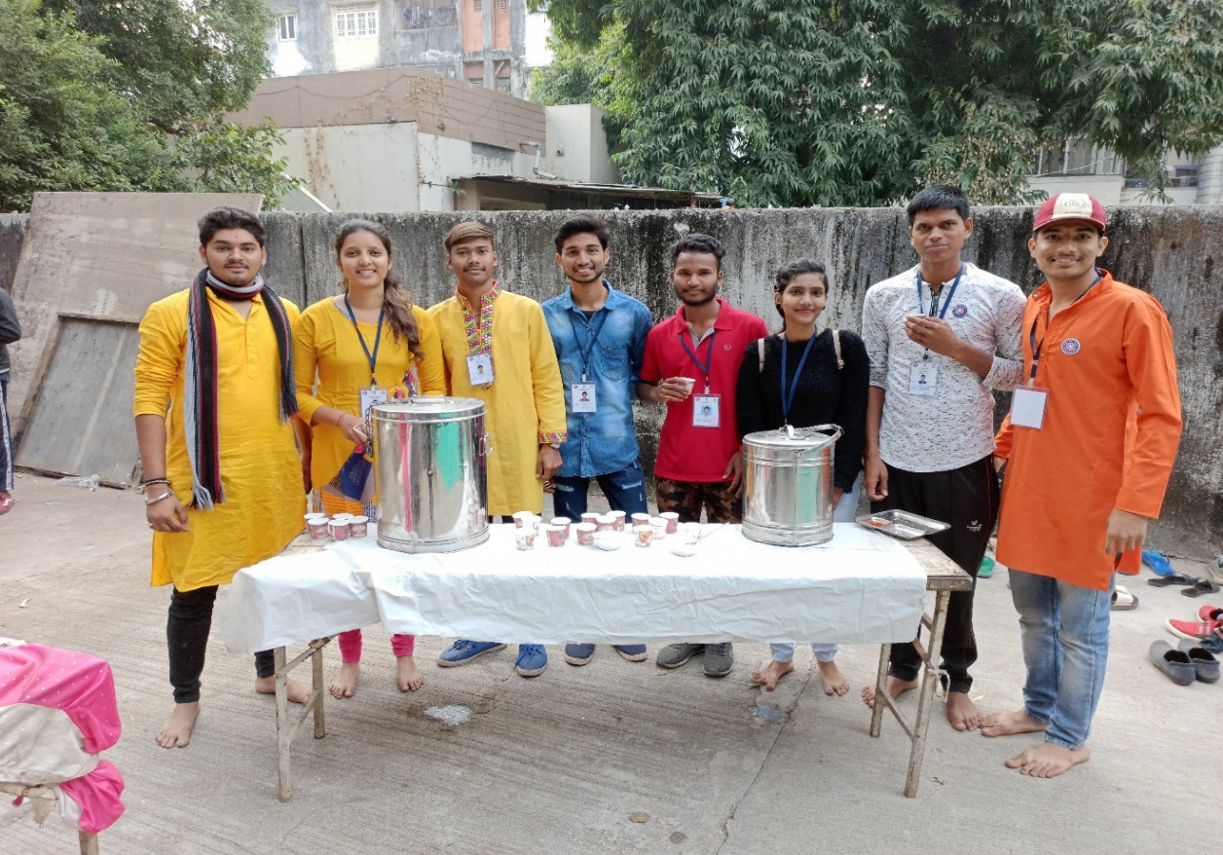

GTU Team serving tea and breakfast
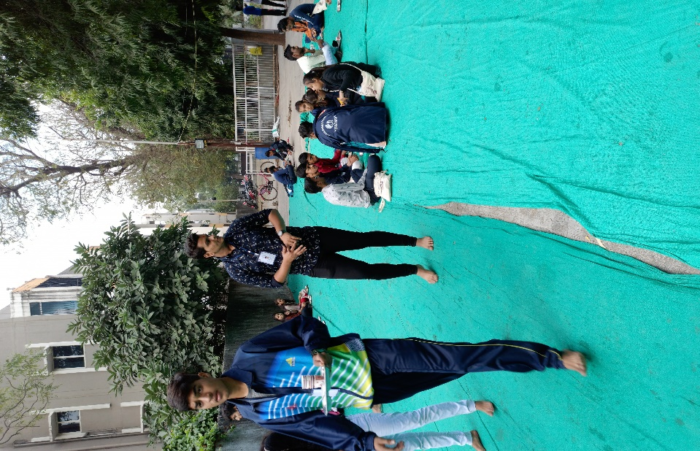

THE REPUBLIC DAY ( 7th Day )
The 7th days was the memorable day of the camp. We were fortunate enough to celebrate the Republic Day along with different states. All states team had demonstrated their culture in procession from the faculty of Social Work to The University pavilion. Shri Satish Sharma the police commissioner of Vadodara and other dignitaries were with us for Republic day celebration. NCC, SCOUT & GUIDE, NSS other battalions were also there for the celebration of the REPUBLIC DAY. Different culture of the different cities were represented by the volunteers of NSS from the different cities. The Guajarati culture was represented by the ‘Ranglo and Rangli’ by the student of performing arts.
Then we all came back to The faculty of Social Work, had lunch and then get separated with the bundle of memories, new friends, their culture, new bringing, some knowledge, improvement in the personal development and health and tears in eyes.
The camp gave the irreplaceable moments and memories to each and every one of us!

The GTU With Vice Chancellor of M S university
  - SOME PICTURE OF INTEGRATION AT A GLANCE: