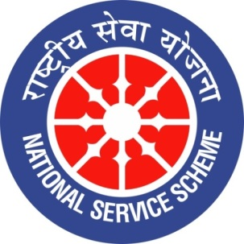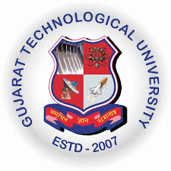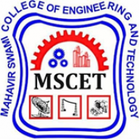

GUJARAT TECHNOLOGY UNIVERSITY
NATIONAL SERVICE SCHEME
A Report on “NATIONAL YOUTH DAY 2020” on 13/01/2020 at MSCET (111)

NSS Unit Name: MAHAVIR SWAMI COLLEGE OF ENGG. & TECH. (111), SURAT
Event NAME: NATIONAL YOUTH DAY 2020
Event Date, Time and Location: 13th JAN 2020, 10.00 A.M ONWARDS, SEMINAR HALL
Brief Description of the Event:
Swami Vivekananda was born on 12th January 1863. He was a key figure in the introduction of the Indian philosophies of Vedanta and Yoga to the western world and was credited with raising interfaith awareness. He was a chief disciple of 19th century saint Ramakrishna and founder of Ramakrishna Math and Ramakrishna mission. The 153rd Birth Anniversary of Swami Vivekananda is celebrated as “National Youth Day” all over the country giving a message to the youth the way of life and ideals that will make India a bettercountry.
NSS Unit of Mahavir Swami College of Engineering & Technology, Surat observed the “National Youth Day” on 13th January 2020 in association with Bharat Vikas Parishad with the primary aim of sensitizing the students about the philosophies, principles and ideas of Swami Vivekananda. The students were motivated to be good citizens of India, thus contributing to the development of the country. A lecture was delivered by Ratan Sharda, a well-known Author, Editor & T.V Panelist. The inspiring stories of Swami Vivekananda’s life briefed to the students by the Speaker made the session more interesting and captivating.
Kavi Shri Surendra Bholaji, Young Youtuber Badal Ram, Young Enterpreneur Mrs. Nisha Anand were some of the Guest who shared the experience of their success to the students of BMU. The event was ended by giving Memento to all the Guest with the hands of Respected Trustees of BMU.
The event was attended by Respected Trustees, Campus Director, Directors of all colleges, Faculties, Staff and around 400 students.
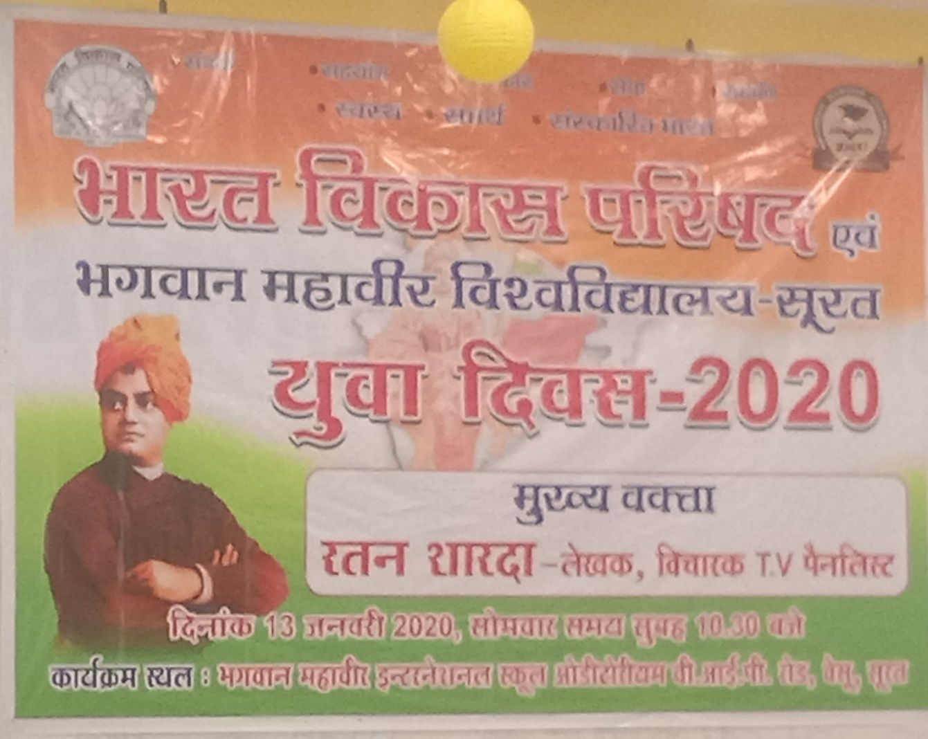
NATIONAL YOUTH DAY CELEBRATION 2020 AT BMU
Some Glimpse of the Event:
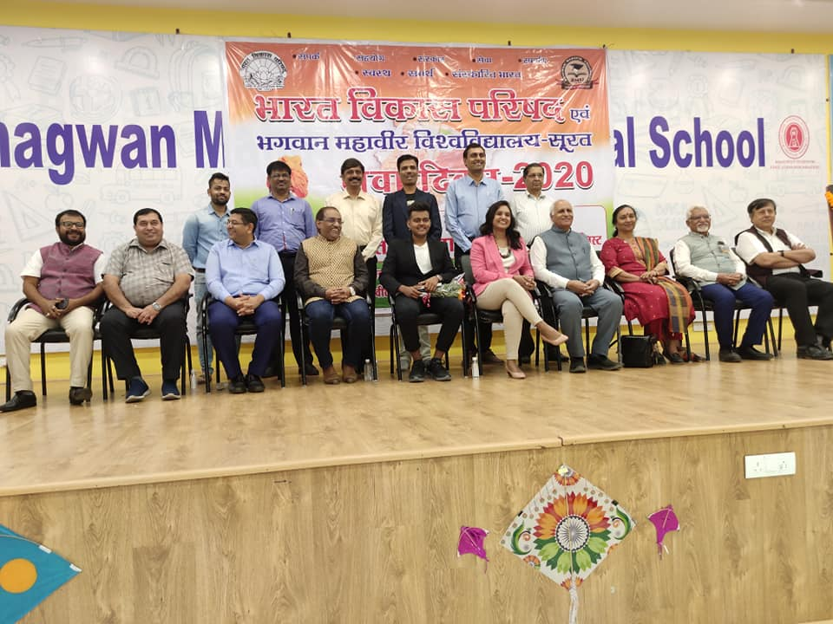
TRUSTEES, ALL DIGNITORIES & OTHER MEMBERS OF BVP AT THE EVENT
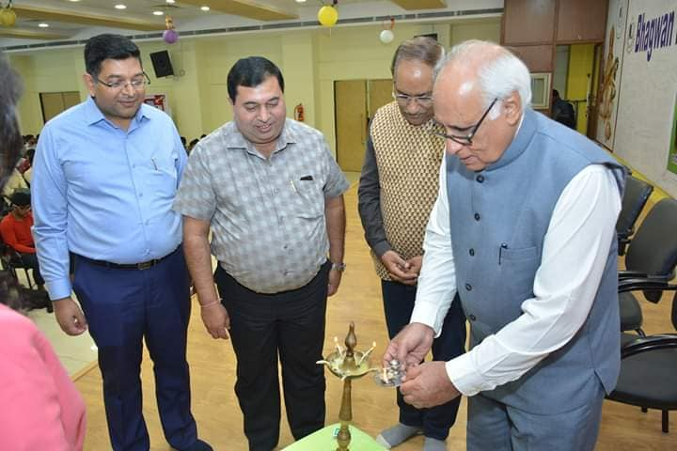
LAMP LIGHTING BY RATAN SHARDAJI ON NATIONAL YOUTH DAY 2020

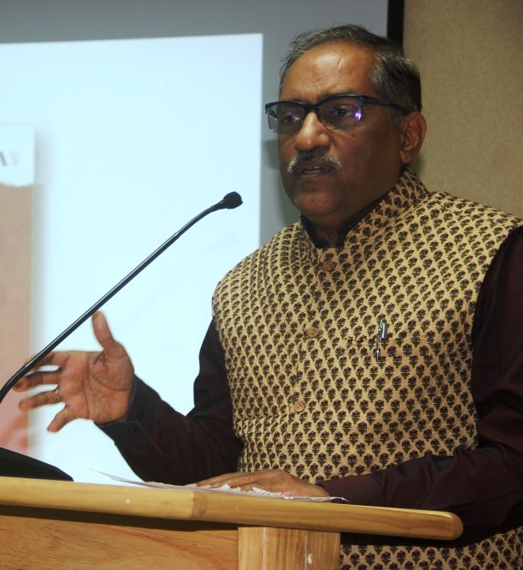
SHRI RATAN SHARDAJI (AUTHOR, EDITOR & T.V PANELIST)
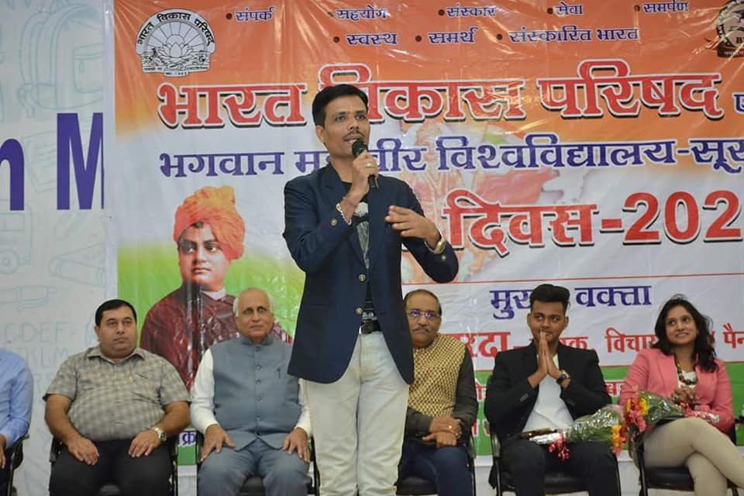
KAVI SHRI SURENDRA BHOLAJI

CULTURAL PROGRAMME PRESENTED BY STUDENTS OF BMU
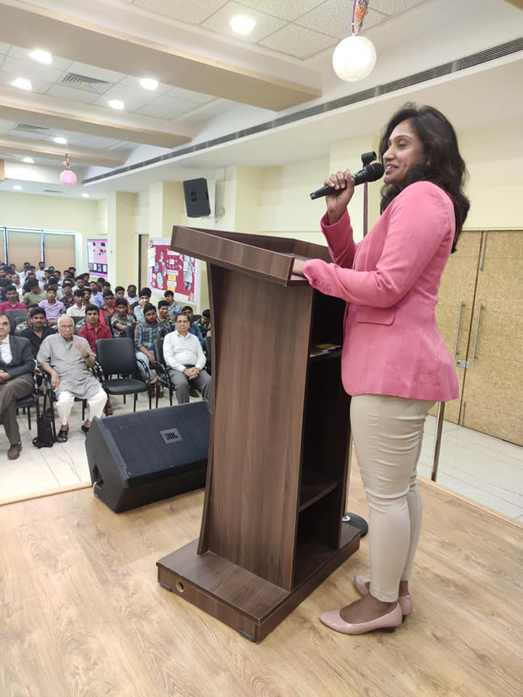
MRS. NISHA ANAND (YOUNG ENTREPRENEUR)

MR. BADAL RAM (YOUTUBER)

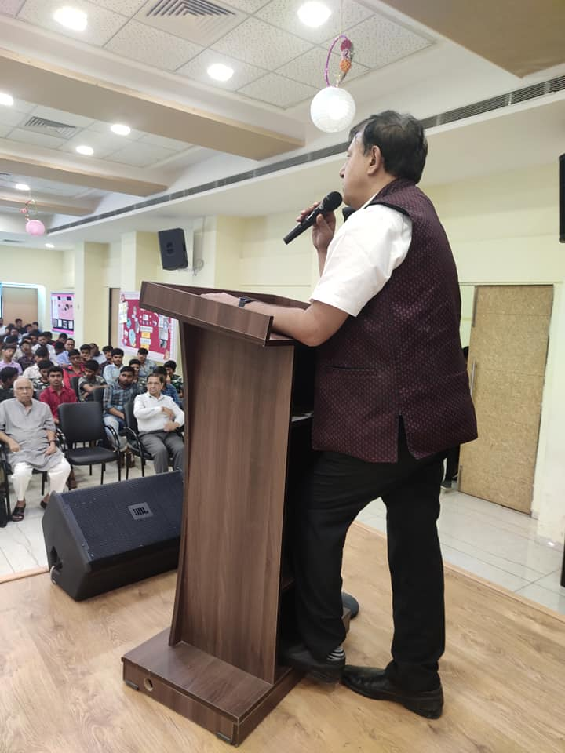
SHRI SANJAY PUNJABI (YOUTH SPEAKER, MEMBER BVP)
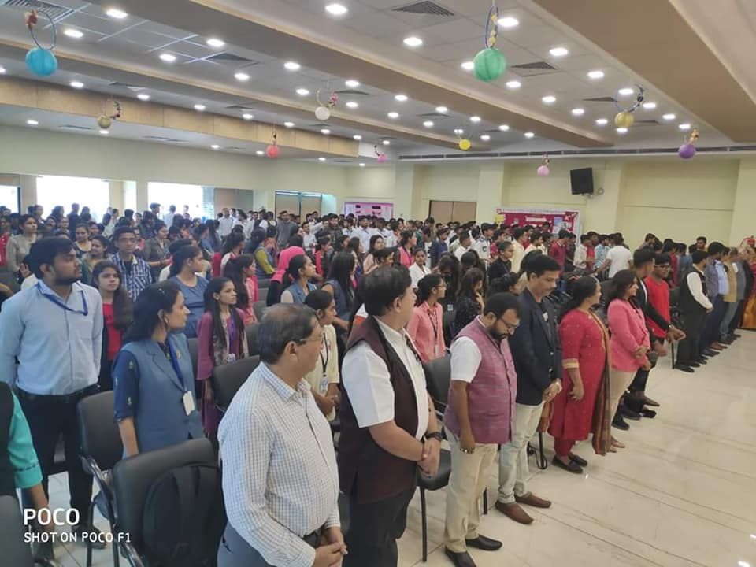
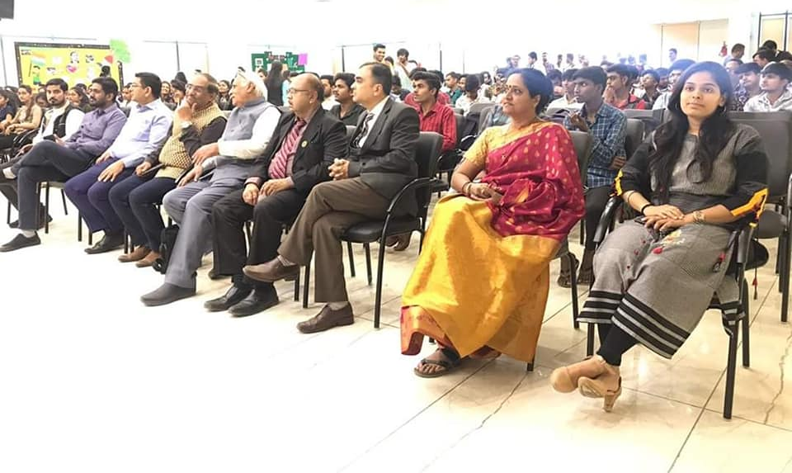
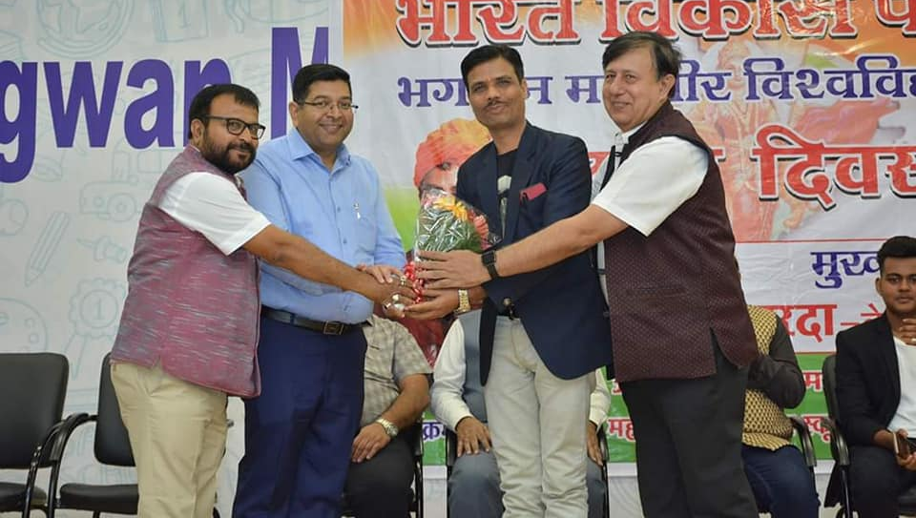
KAVI SHRI SURENDRA BHOLAJI WELCOMED WITH FLOWERS
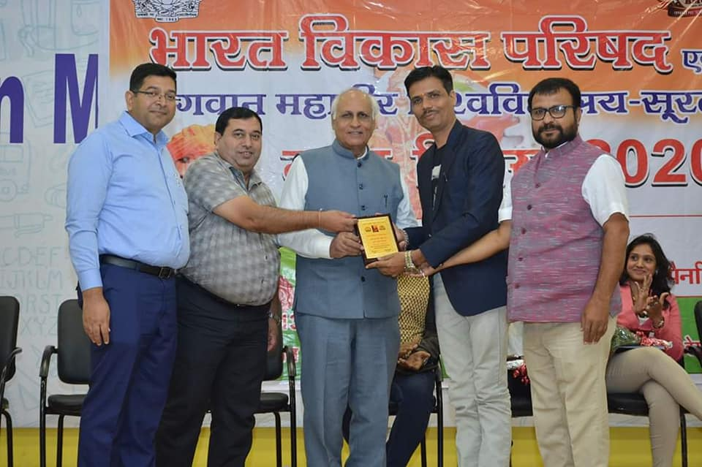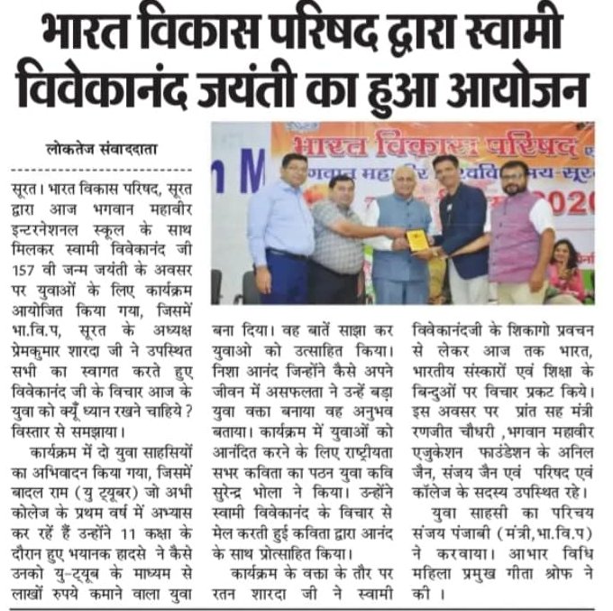
Submitted By:
Prof. Vijay Kothari
(N.S.S Program Officer)

