GOVERNMENT POLYTECHNIC VALSAD
Sr.No. | Extracurricular Activity | Date | No. of Participants | Coordinator
1 | Campus Cleanliness Drive | 04/10/2019 | 1200 | Mr. D P Rao (Civil)
2 | Rangoli Day- Tribute to Mahatma Gandhiji | 01/10/2019 | 40 | Mr. D R Saniawala (Civil)
3 | Elocution Competition- Tribute to Mahatma Gandhiji | 21/09/2019 | 22 | Mr. C P Bhalsod (Chemical)
4 | Drawing Competition- Tribute to Mahatma Gandhiji | 21/09/2019 | 50 | Mr. V V Desai (Electrical)  Mr. K C Patel (Plastic)
5 | Women’s Health awareness programme | 26/09/2019 | 110 | Mrs. K S Damania (Mechanical)
6 | Awareness Program-Tribute to Swami Vivekanand | 11/09/2019 | 35 | Mr. S M Gheewala (Electrical) Mr. D H Gadhvi (Plastic)
7 | Fit India Run Event | 21/11/2019 | 900 | Mr. H B Pavagadhi (General) Mr. D B Prajapati (Applied Mechanics)
8 | Swacchata Pakhwada | 15/01/2020  to 31/01/2020 | 1200 | Mr. D P Rao (Civil)
9 | Swacchata Quiz  (Department Wise) | 15/01/2020  to 31/01/2020 | 250 | Mr. D R Saniawala (Civil)
NSS ACTIVITIES DURING 2019-2020
“Swacchata Pakhwada”

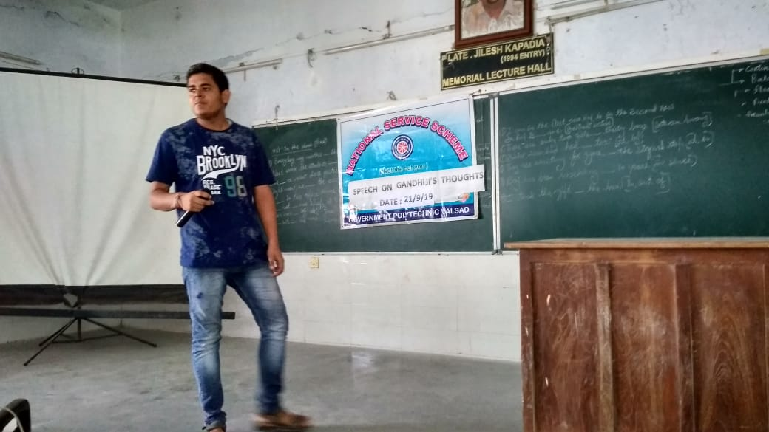
Elocution Competition- Tribute to Mahatma Gandhiji
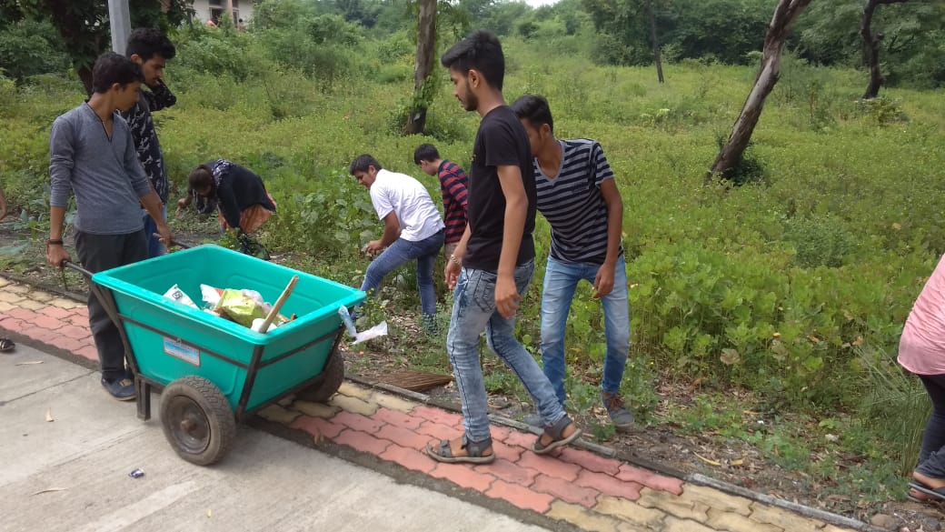
Swacchata Pakhwada

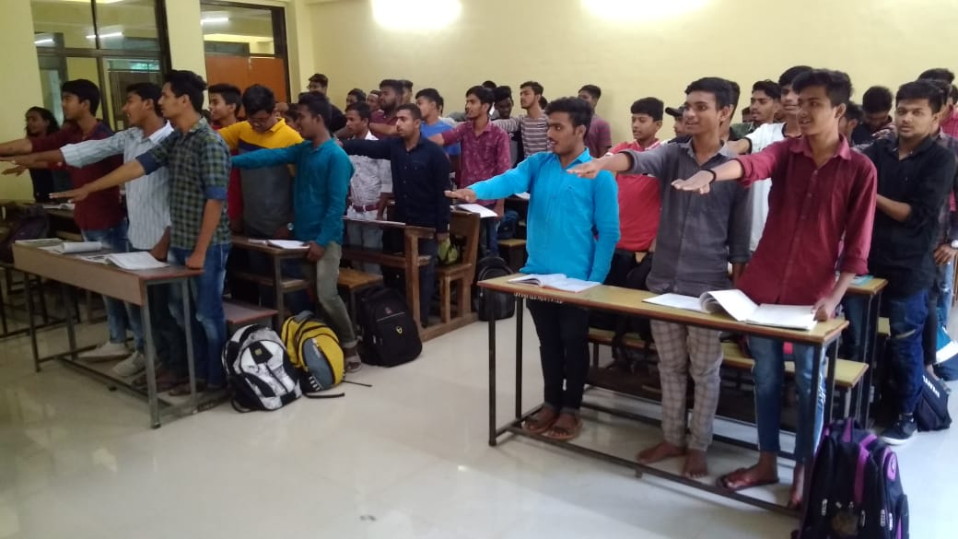
Oath taking ceremony
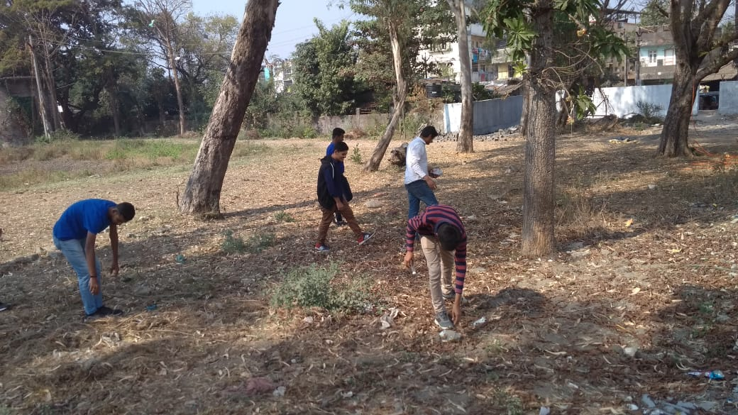
Swacchata Pakhwada

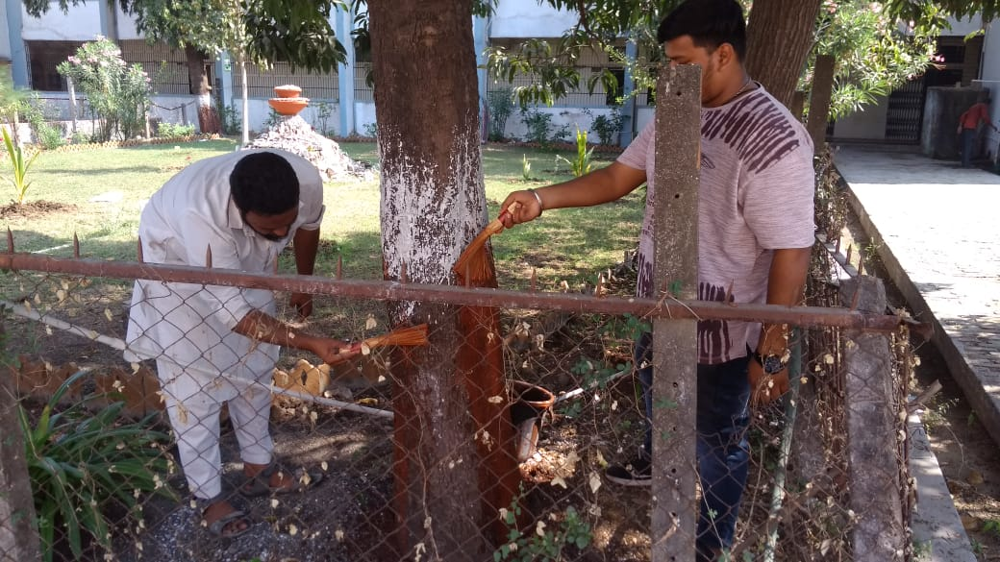
Swacchata Pakhwada

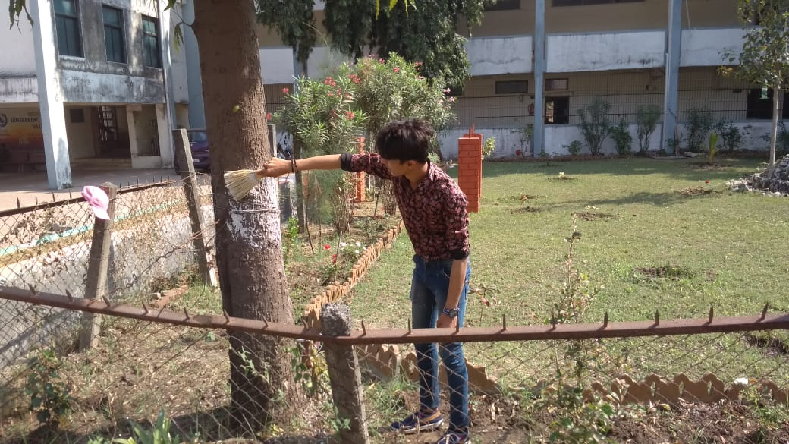
Swacchata Pakhwada
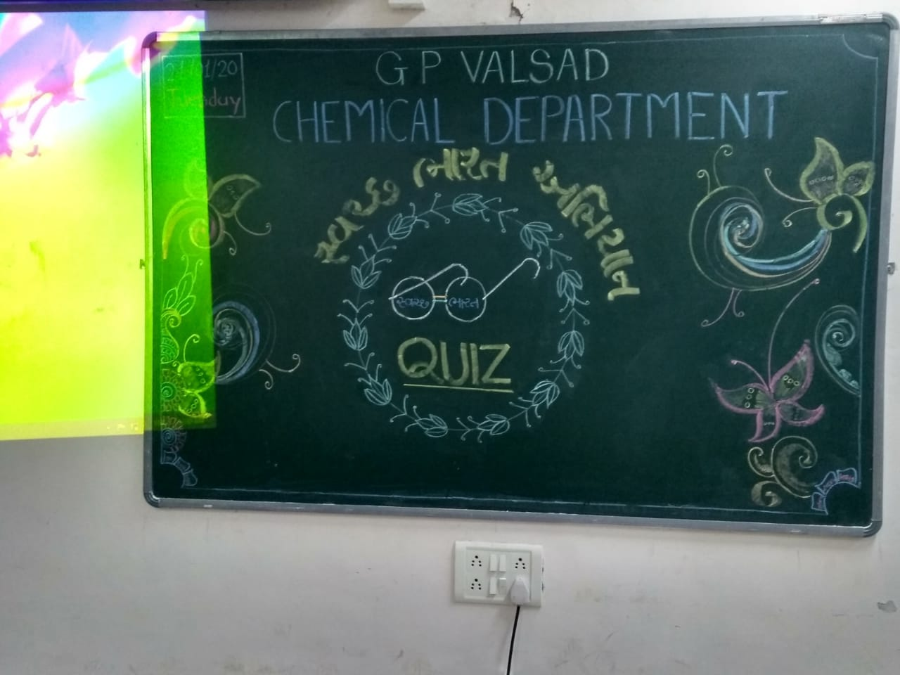
Swacchata Quiz
