**GUJARAT TECHNOLOGICAL UNIVERSITY**

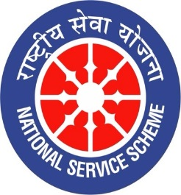

**राष्ट्रीय सेवा योजना**

**(NATIONAL SERVICE SCHEME)**

Report On

**NSS Day Celebration**

### (SPU Anand, September’19)

(Organized by)

**Sardar Patel University**

(22nd to 24th September, 2019)

### NSS Regional Directorate, Ahmedabad

### Selection and Training Camp

### At

**Gujarat Technological University**

(16th to 21st September, 2019)

University NSS Program Officer: Mr. Alpesh Dafda

Team Manager: Mr. Bharat Vadhiya

Academic year

(2019-2020)

**GTU**

**Gujarat State Highway 41, Near Visat Three Roads,**

**Nigam Nagar, Chandkheda, Ahmedabad, Gujarat 382424**

**Selection Process and Training**

**Introduction**

NSS Regional Director Ahmadabad declared to celebrate NSS day at Sardar Patel University, Vallabh Vidhyanagr , Gujrat , Anand . Hence, GTU decided selection process of NSS volunteers from the GTU affiliated colleges on. . The schedule of selection process was below.

Date: 13th September 2019.

Day: Friday

Time: 11:00 Am Onwards.

Venue: GTU, Sports Section.

**A glimpse of Selection process and Training**

As a part of GTU NSS, we emphasized to do selection process in a appropriate way so that our talented NSS volunteers perform very well in three days NSS Celebration at Sardar Patel University, Vallabh Vidhyanagar. In addition, we also keep in mind how minimum number of the students can participate in maximum events as per the criteria decided by NSS Regional Director. Moreover, More than 250 talented NSS Volunteers’ were enthusiastically participated for the first selection process and at the end we selected 24 NSS and made a perfect team.

**Practice and Training**

Selected NSS Volunteers’ participated in Training and Practice from 16th to 21st September 2019 at Gujarat Technological University. After final selection process , Final GTU NSS Day Celebration Team stayed in GTU Campus and did practice in a group as well individually as per event. NSS Team did practice of Individual as well as group event such as Essay Competition , Elocution Competition, Quiz Competition, Solo Song Competition , Group Song Competition, Solo Acting Competition, Group Dance, Slogan Writing Competition, Power Point presentation Competition, Rangoli Competition, Poster Painting Competition, Garba Competition, Traditional Coustume Competition, Poetry Competition, Photography Competition, Short Film Competition, Short Story Competition, Instrumental Music Competition, PPT Presentation by PO on ‘ My Unit & Adopted Village’

**Some glimpses of Selection process and training.**

**NSS Day Selection: 2019-2020**

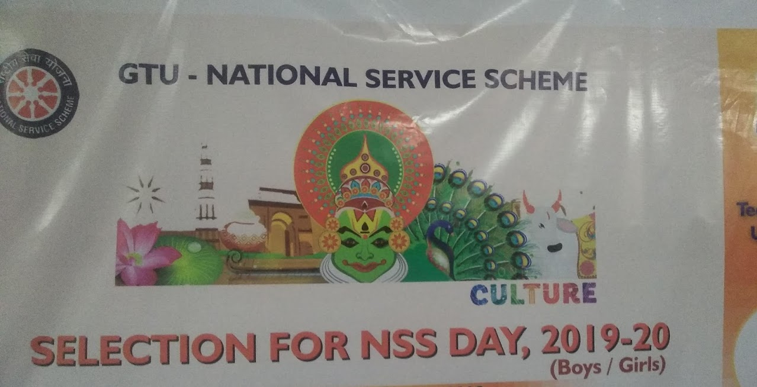

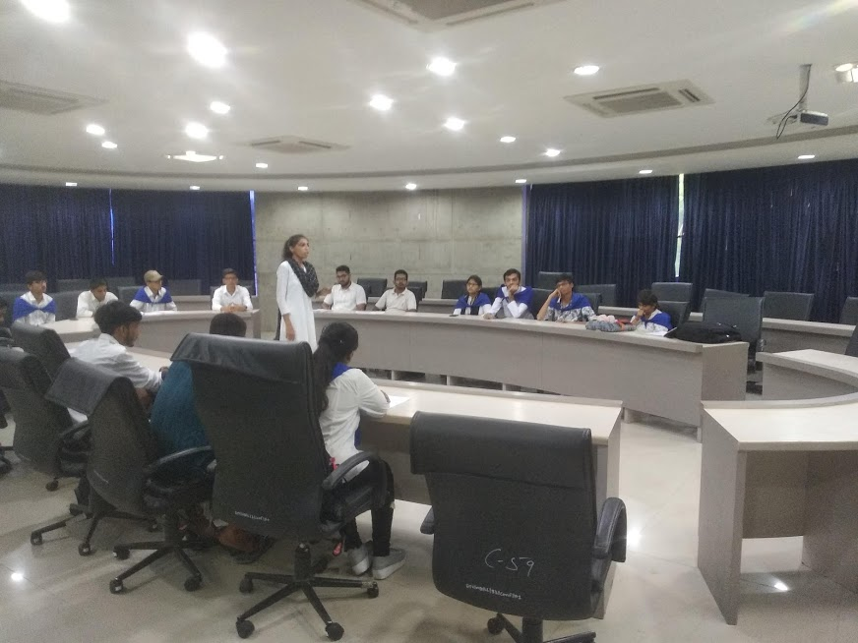

NSS Volunteer Participate in Elocution

**Students are participated in Skit**

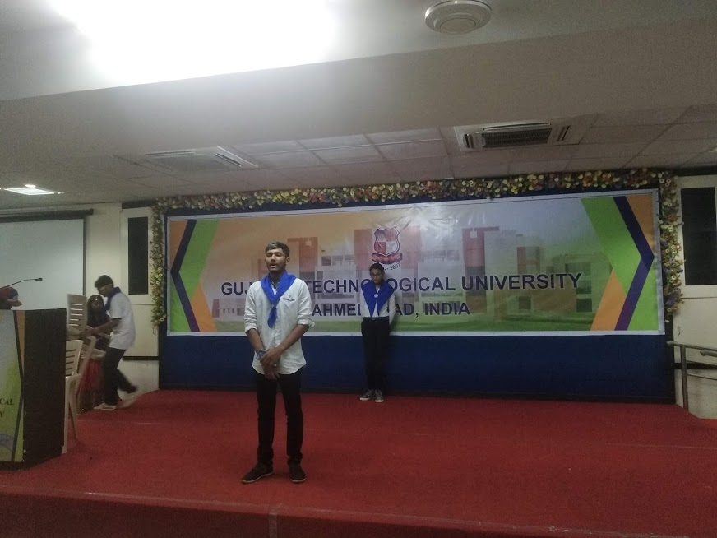

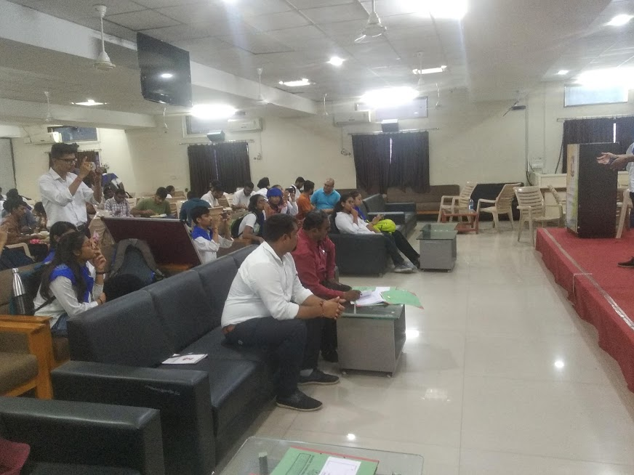

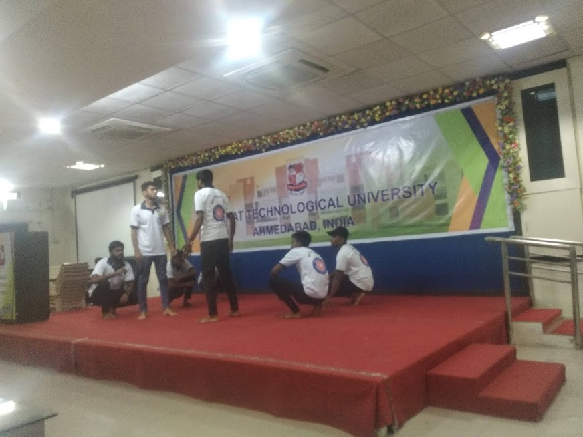

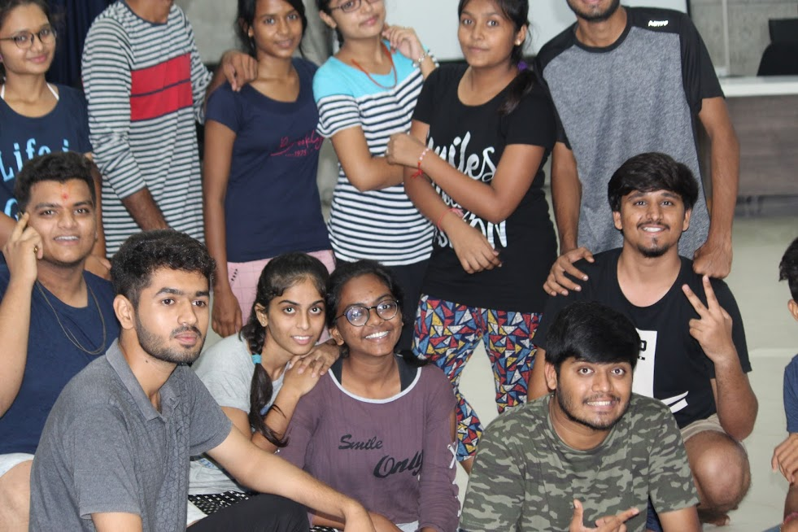

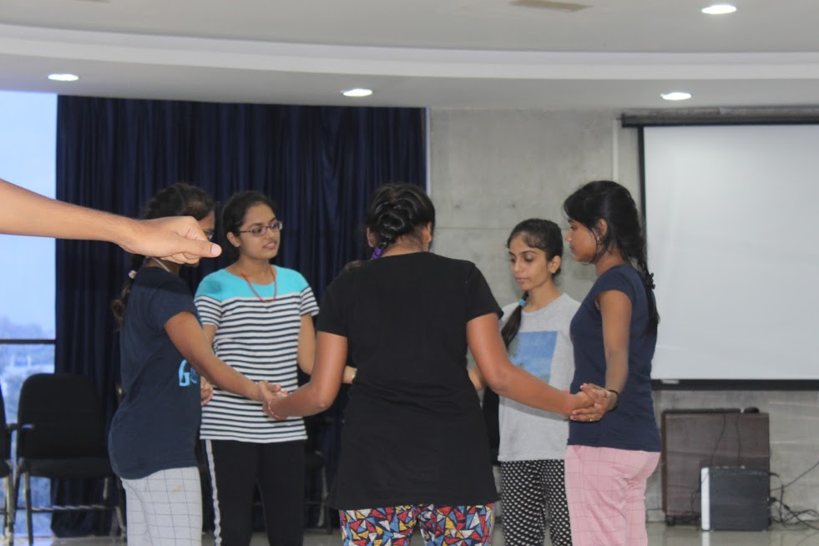

**NSS Day Celebration at Sardar Patel University from 22nd to 24th September, 2019.**

Day : 1 | Sunday | 22nd September 2019

As per our schedule, A NSS Team of GTU reached at Sardar University at 8:30 am on 22nd September 2019. First, NSS Volunteers’ completed their registration process and breakfast between 8:30 to 10:00 Am.

Session 1: Inauguration function

All the NSS Volunteers were gathered in Gyanoday Bhavan for inauguration Function of the State NSS Day Celebration. In this inauguration faction, the following guests were present to make this program successful:

**Shri Bhupendrasinh Chudasama:** Honorable Minister of Higher Education and Technical Education , Government of Gujarat.

**Professor Shirish Kulkarni :** Vice- Chancellor , Sardar Patel Univeristy , Vallabh Vidhyanagar.

**Shri Lalit Padalia:** Commissioner, Higher Education, Gujarat State.

**Shri Narayan Madhu:** Additional Commissioner, Higher Education, Gujarat State

**Shri Girdhar Upadhyay:** Regional Director of NSS, Government of India.

**Dr. (Mrs) Darshnaben Joshi**: State NSS Officer, State NSS Cell, CHE , Gandhinar .

**Shri Tusar Majmudar**: I/C . Registrar Sardar Patel University.

The main chief guest of this inauguration program was Mr. Bhupendrasinh Chudasma : Cabinet Minister Education, Law & Justice, Legislative & Parliamentary Affairs, Government of Gujarat.

He talked about NSS Activity and How NSS Volunteers’ can contribute for the upliftment of society and nation. In addition, he also emphasized to Avoid plastics to make this environment clean.

In addition, he mentioned various schemes given by Government and it’s a duty of NSS Volunteers’ to pass this message to villagers during various NSS activity and camp.

After Inauguration function of this program, various competitions were organized as per below schedule:

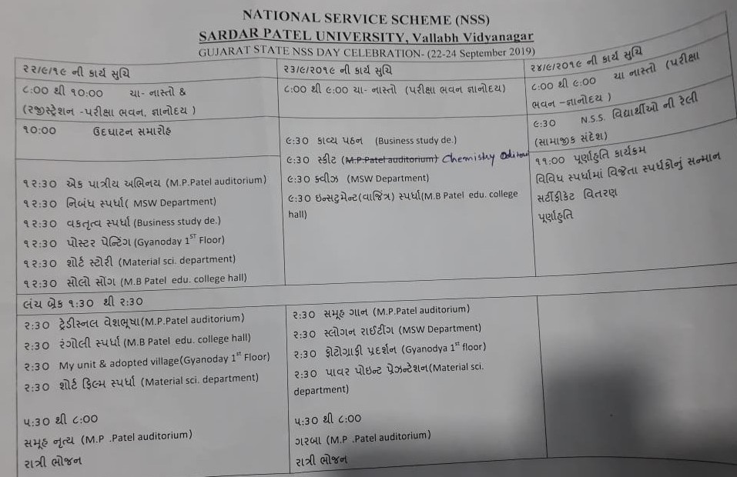

Session 2: After inauguration function, all the NSS Volunteers’ went for individual as well as group competition. All the events were organized in different building of Sardar Patel University. Various competition such as Solo Acting Competition, Essay Competition, Elocution Competition, Poster Painting Competition, Short Story Competition, Solo Song Competition were organized between 12:30 PM to 1:30 PM . All the volunteers were participated with zeal and zest.

Session 3 : After second session of various above competarion, all the NSS Volunteers’ were gathered under Gyanoday Bhavan for lunch . They completed their lunch process between 1:30 to 2:30 and went for other competition. . Various competition such as Traditional Coustume Competition, Rangoli Competition , My Unit & Adopted Village (For Program Officer ) and Short Film Competition . All the volunteers were participated with zeal and zest.

Session 4: After third session, all the NSS Volunteers’ were gathered in M.P.Patel Auditorium for Group Dance . This was such competition that all were waiting for a day. More than 10 team performed with energy, corporation, zeal and zest . we enjoyed a lot of this competition. And day one end with spicy dinner. After all the NSS Volunteers’ allotted their Rooms in Hostel as well as Swaminarayan Temple very far from Sardar Patel University. By the support of team, we finally completed of Day 1.

Some Glimpses of an Event.

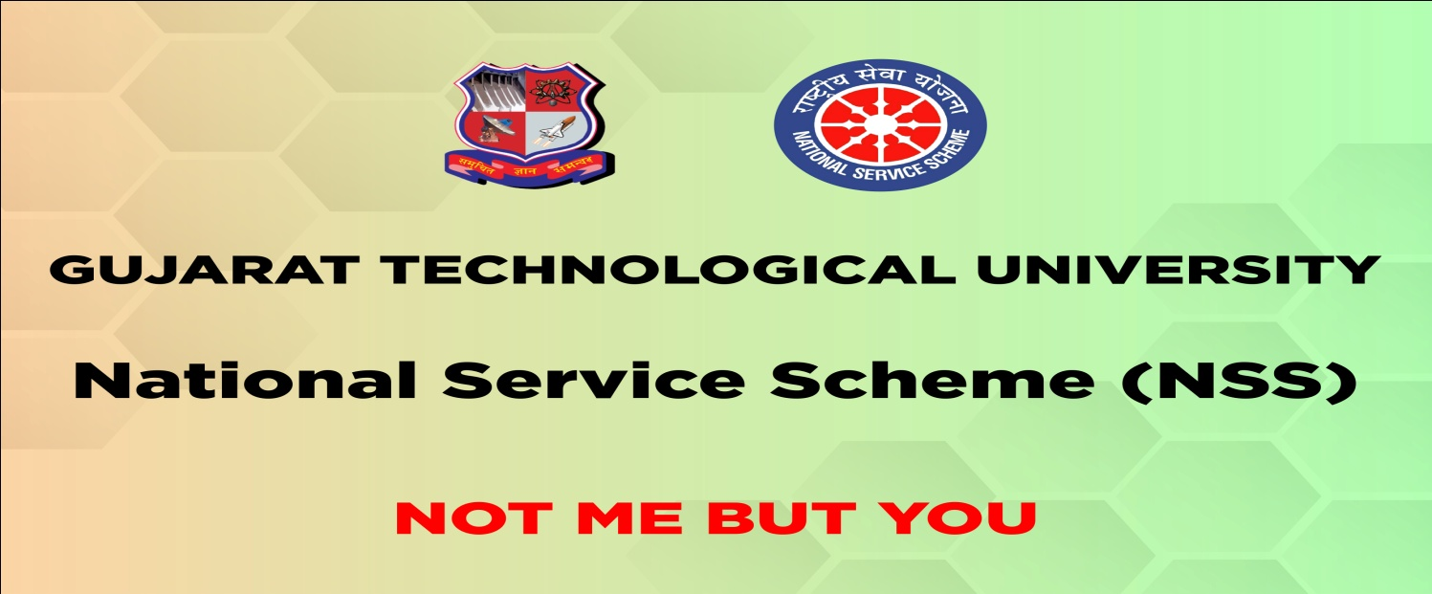

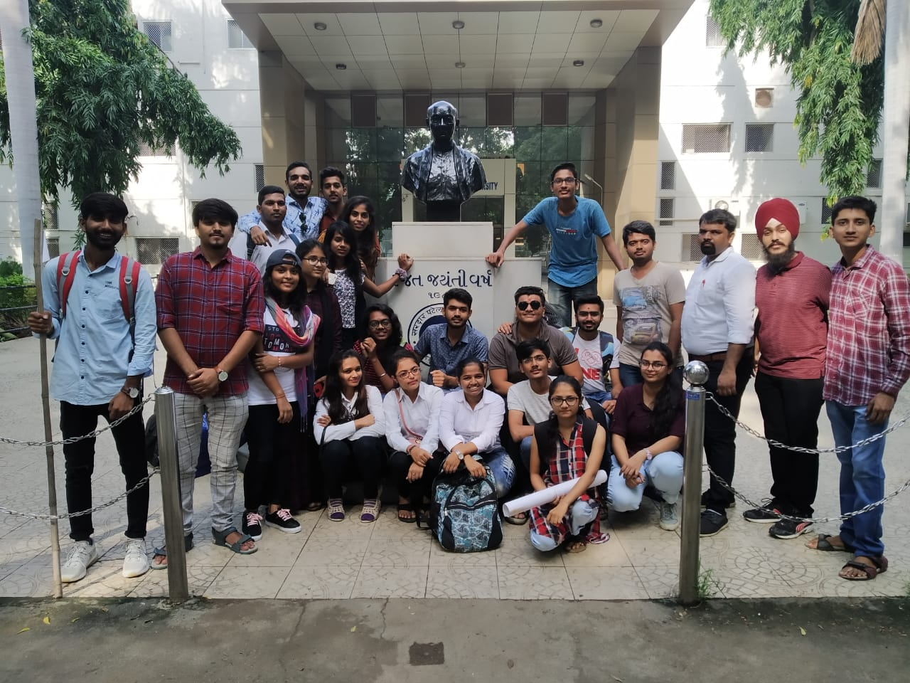

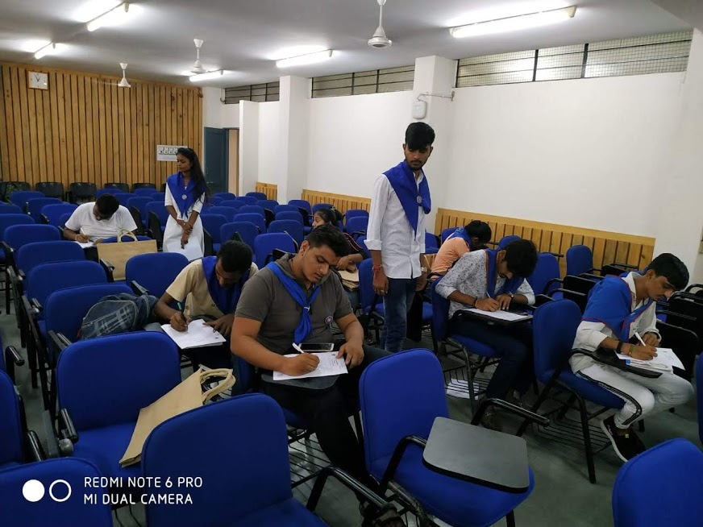

|  |  |
| --- | --- |
| C:\Users\admin\AppData\Local\Temp\WhatsApp Image 2019-10-01 at 11.28.31 PM.jpeg | C:\Users\spce\Desktop\nss day\VID_20190922_141120.jpg |

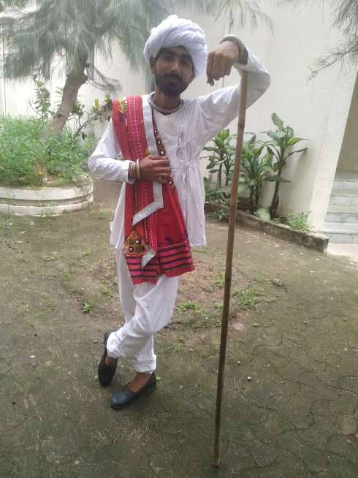

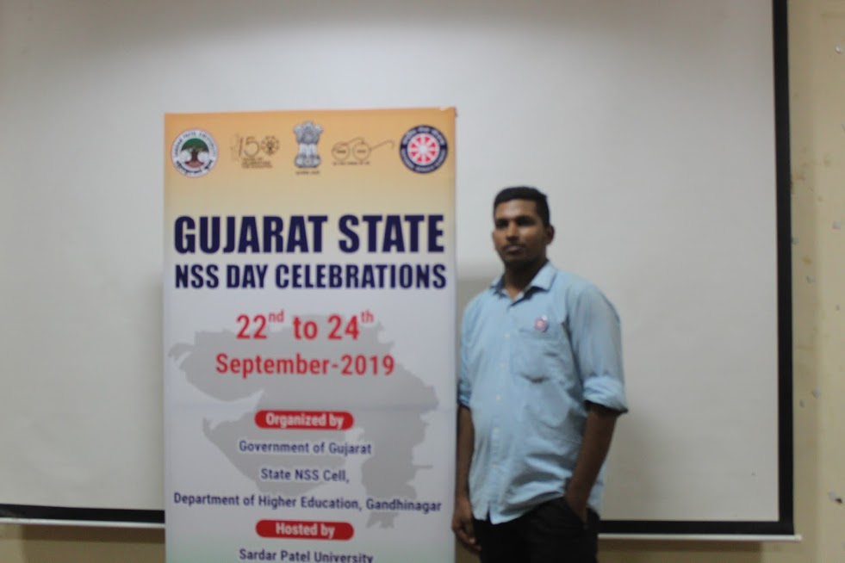

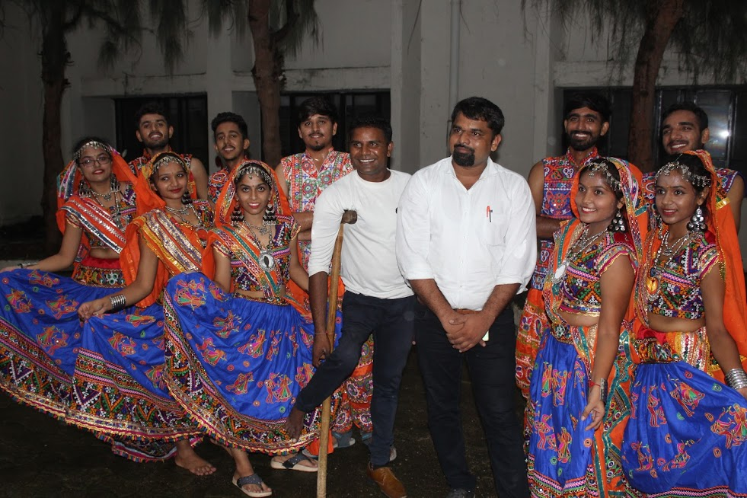

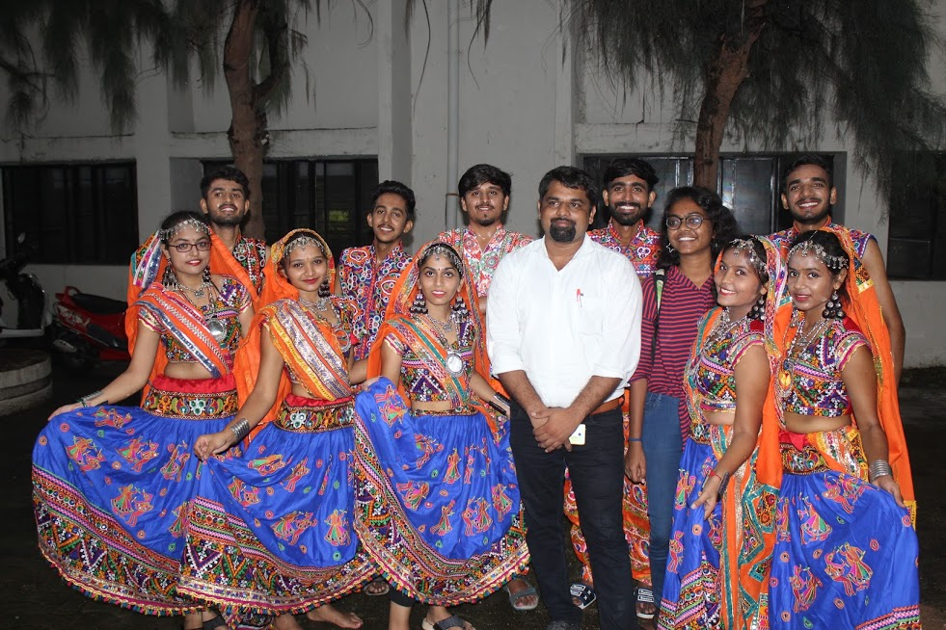

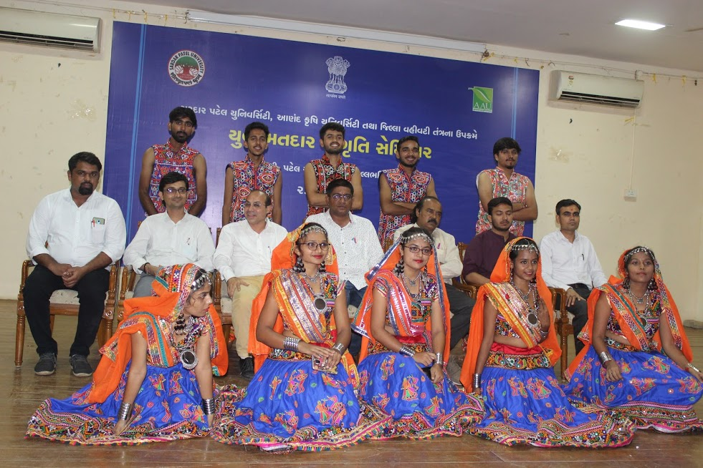

Day : 2 | Monday | 23rd  September 2019

All the NSS Volunteers were gathered in Gyanoday Bhavan for Tea and Breakfast at 8:00 Am and competed they work till 09:00 am.

Session 1: After 9:30 onwards, all the NSS volunteers’ were went for various individual competition such as Poem Recitation Competition, Quiz and Instrumental Music. Individual and group competition were covered in this session. The entire NSS Volunteers’ of different university and schools were present for lunch under Gyanoday Bhavan at 12:30 Pm. The second day was enjoyable for the NSS Volunteers’.

Session 2: A Group Song, Slogan Writing, Photography exhibition and Power point Presentation were covered in session number two between 2:30 to 5:00 Pm. Our Talented NSS Volunteers’ showed their talent and performed very well. All team gathered for heavy tea around 5:00 Pm.

Session 3: Last session arranged in a such way that students enjoyed a lot. More than 10 team performed with energy, corporation, zeal and zest in this Garba Competition. we enjoyed a lot of this competition. After that , we gathered for spicy dinner at Gyanoday Bhavan.

Some Glimpses of an Event.

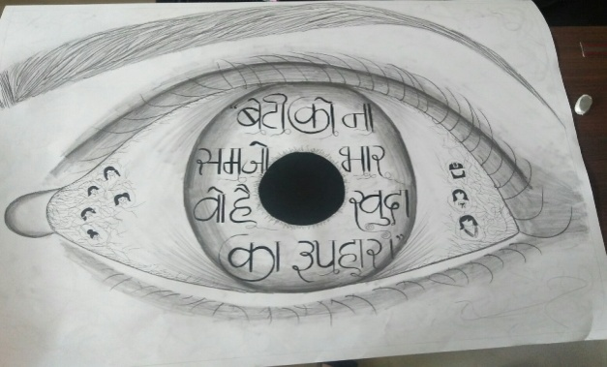

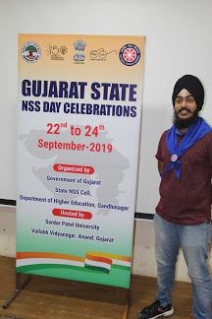

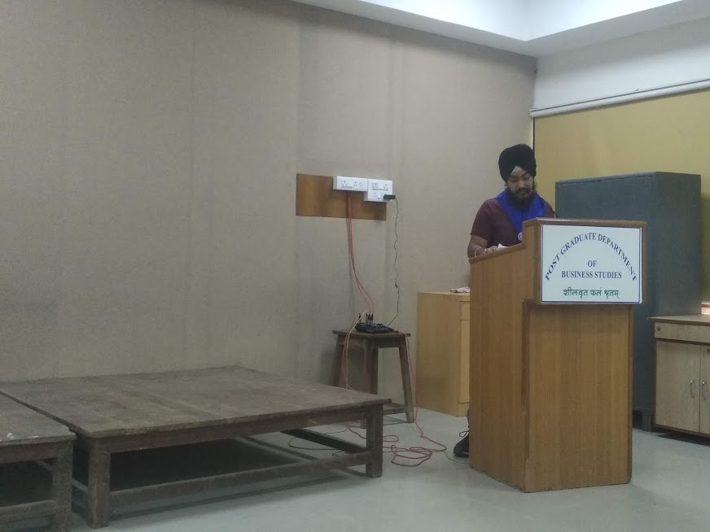

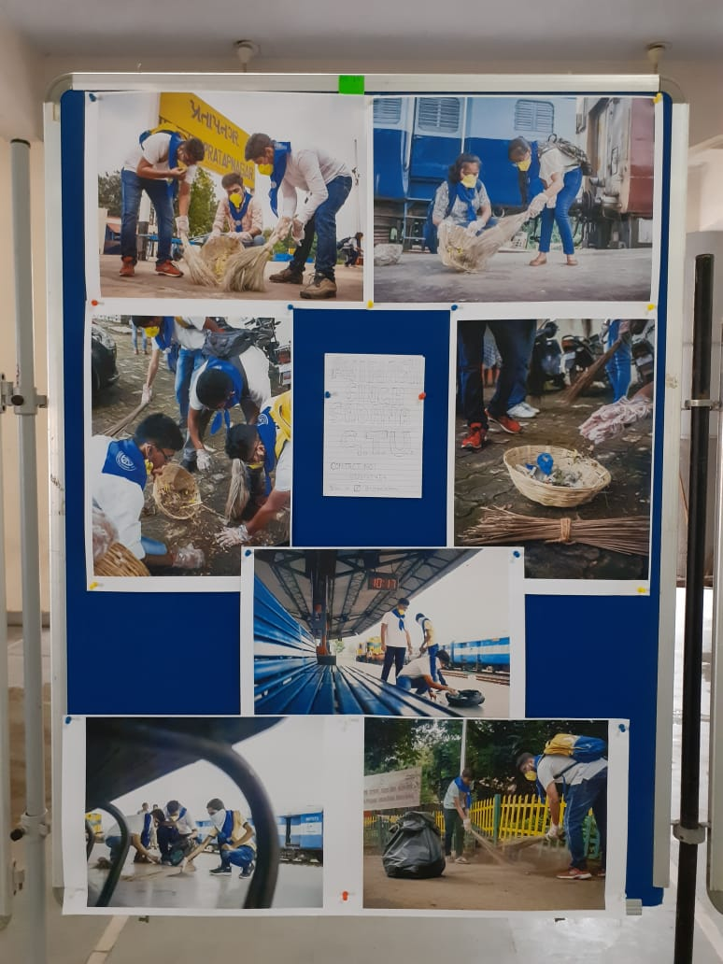

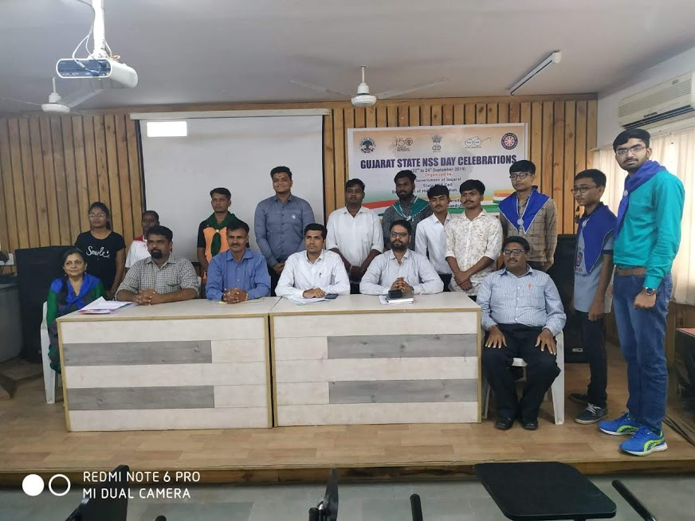

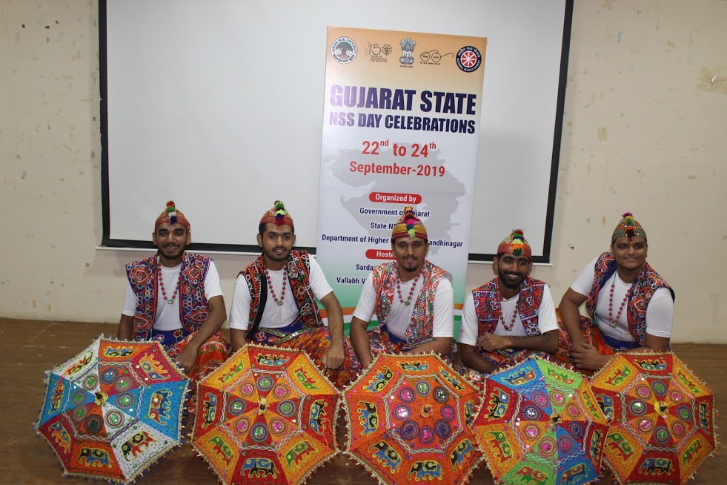

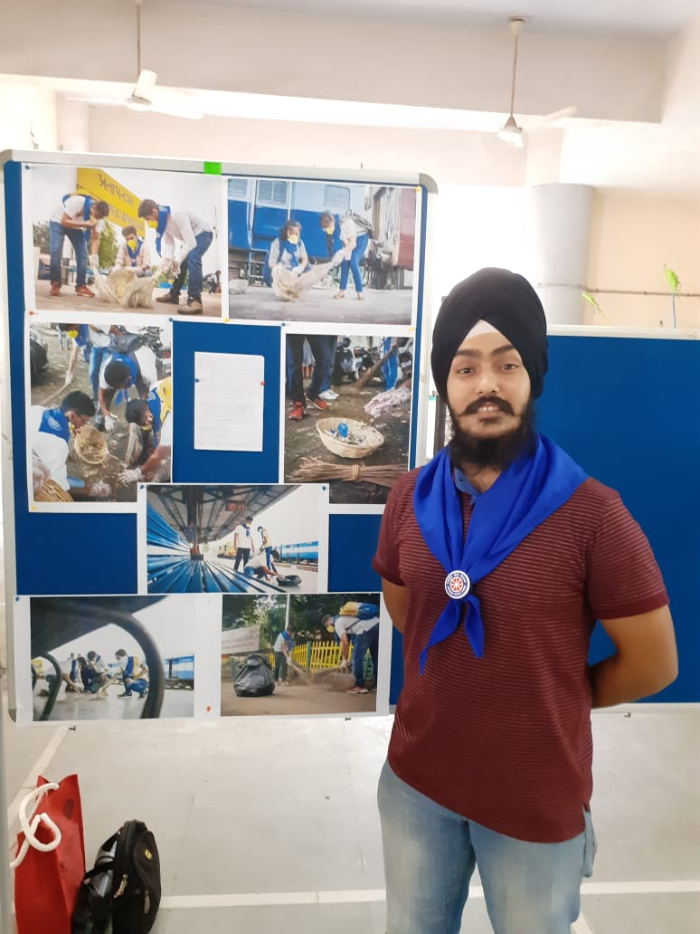

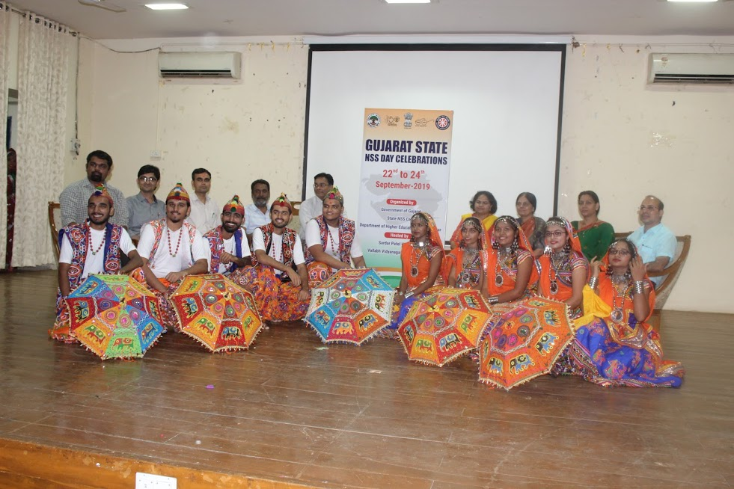

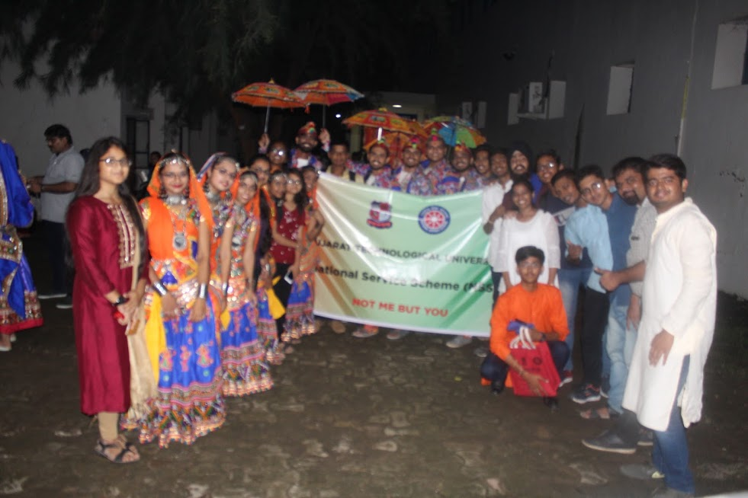

Day : 3| Tuesday | 24rth  September 2019

All the NSS Volunteers were gathered in Gyanoday Bhavan for Tea and Breakfast at 8:00 Am and competed they work till 09:00 am. They were ready for Rally.

Session 1| Rally : The main purpose of this rally was to make aware all the citizen about various issues faced at the present time, more than 5oo NSS volunteers’ and 25 Po’s from the Gujarat joint in this rally. The rally started from Sardar Patel Univertiy to Bhaikaka Statue , Iskon Temple and end to SPU.NSS Volunteers’ followed unity and discipline in this rally.

Session 2: Valedictory function: Valedictory functions are an important part of any program. The **Chief guest** of this function was Shri Devusinh Chauhan , Honarable Minister of Parliament . In addition, **guest of honour** was Shri Narayan Madhu , Additional Commissioner , Higher Education and Shri Girdhar Upadhyay , Regional Director of NSS , Government of India, including Dr. (Mrs) Darshnaben Joshi , State NSS Officer , NSS Cell , CHE , Gandhinagar.

The **Chief guest** of this function was Shri Devusinh Chauhan , he talked about various problems we have been facing at a present time. In addition, we also motivated NSS Volunteers’ to work for the building of the nation.

Prize and Certificate distribution:

Total 20 Events were organized for NSS Volunteers’ and 01 event for NSS PO’s. More than 500 NSS Volunteers’ and 25 POs from 17 University and 5 schools were participated in this State NSS Day Celebration at Sardar Patel University. Prize and certificate given by Chief guest and guest of honour to the winner. We (GTU ) secured 1st position in this State Day NSS Celebration and got Trophies and certificate.

**Gujarat Technological University**

**Event and Position**

|  |  |  |
| --- | --- | --- |
| **Sr.No** | **Name of an Event** | **Position** |
| 1 | **Essay Competition** | 2nd |
| 2 | **Elocution Competition** | 1st |
| 3 | **Group Dance** | 3rd |
| 4 | **Slogan Writing Competition** | 1st |
| 5 | **Power Point presentation Competition** | 2nd |
| 6 | **Poster Painting Competition** | 1st |
| 7 | **Traditional Costume Competition** | 2nd |
| 8 | **Photography Competition** | 3rd |
| 9 | **Short Film Competition** | 3rd |
| 10 | **Short Story Competition** | 2nd |
|  |  |  |
|  |  | First : 3  Second : 4  Third : 3  **Total : 10** |

Some Glimpses of an Rally

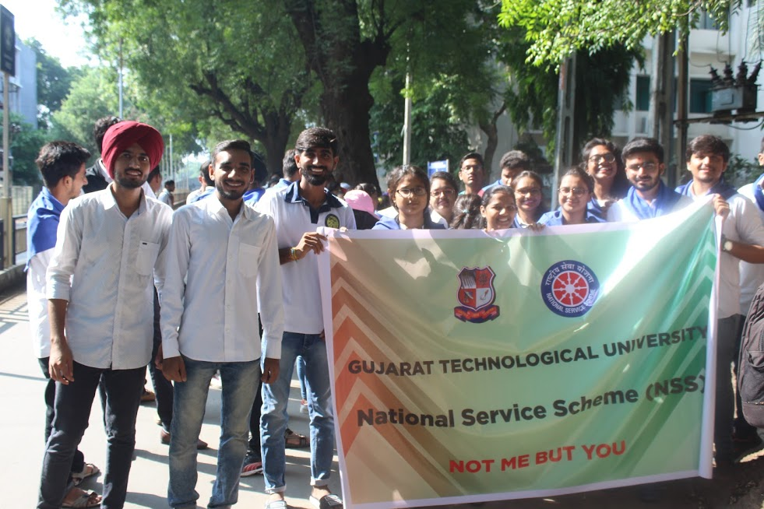

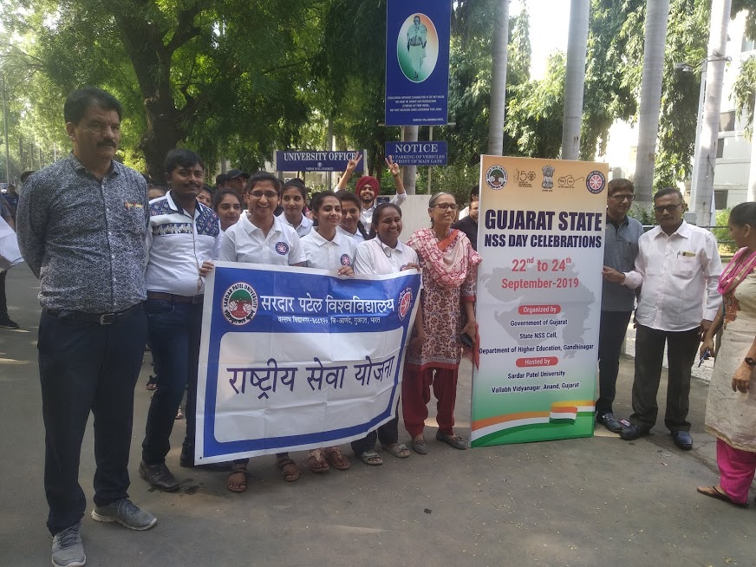

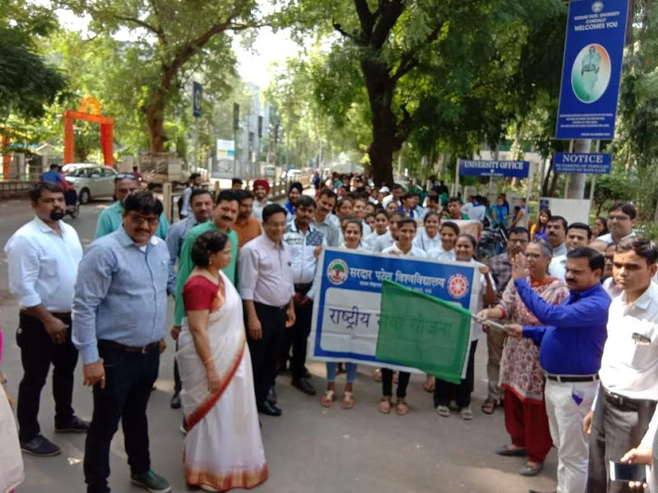

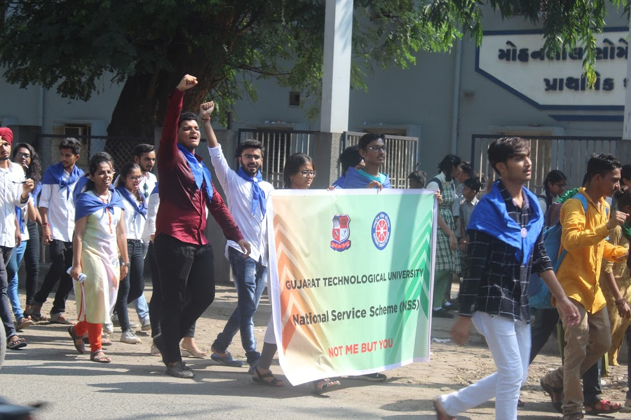

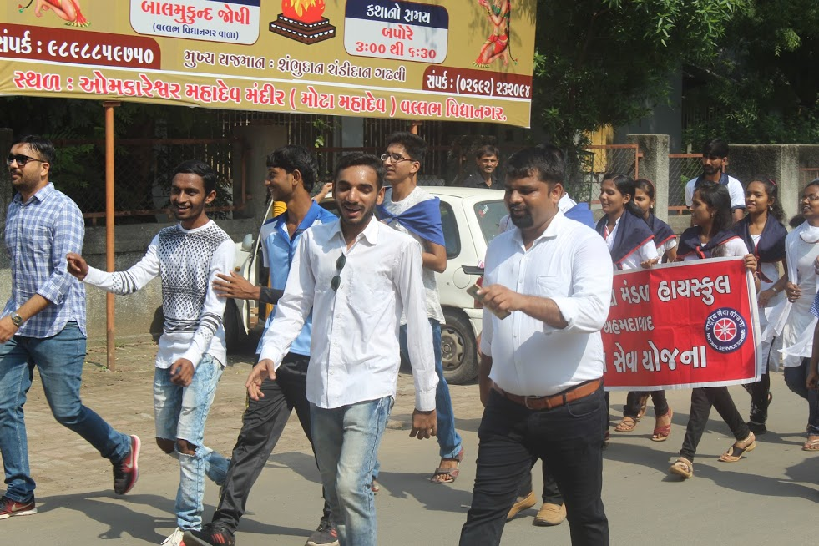

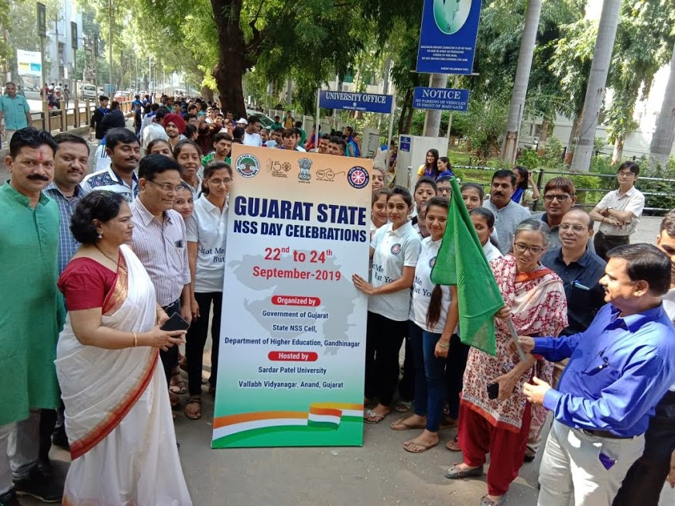

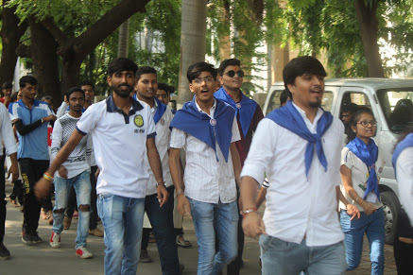

Chief Guest and Guest of Honor in Valedictory function

|  |  |  |
| --- | --- | --- |
| C:\Users\spce\Desktop\nss day\IMG-20190924-WA0032.jpg | C:\Users\spce\Desktop\nss day\IMG-20190924-WA0034.jpg | C:\Users\spce\Desktop\nss day\IMG-20190924-WA0050.jpg |

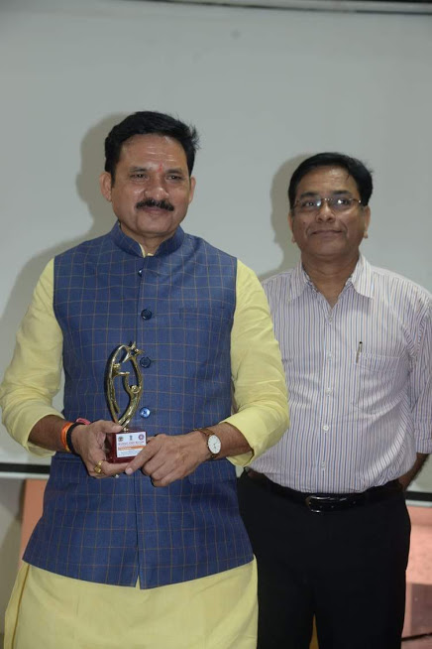

Some Glimpses of Prize Distribution

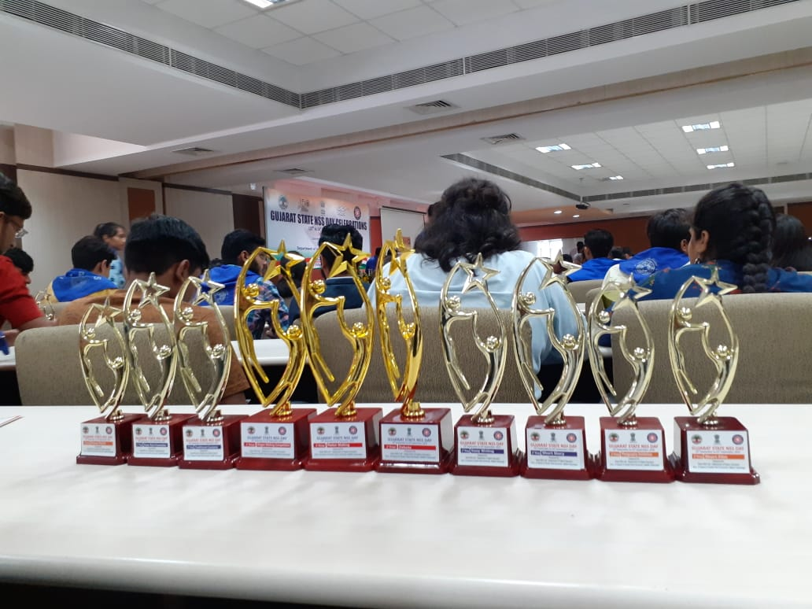

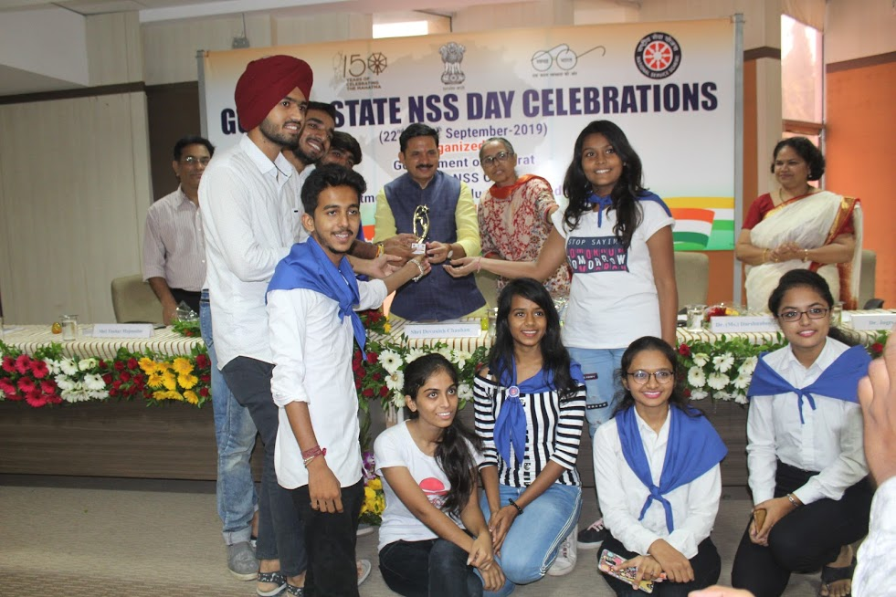

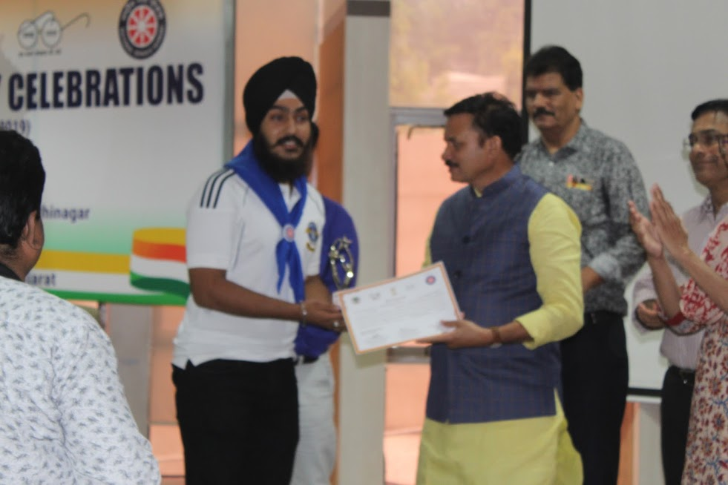

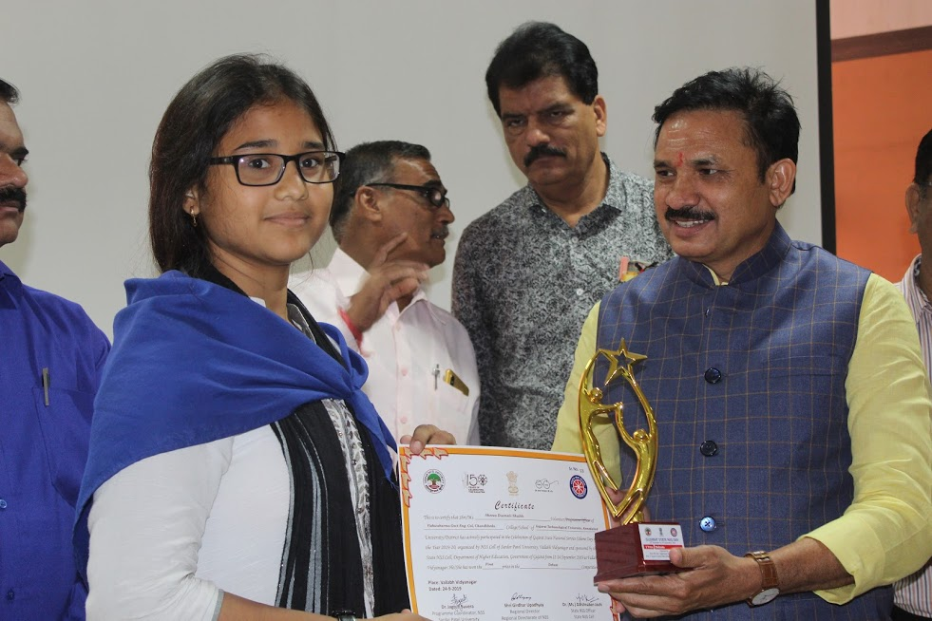

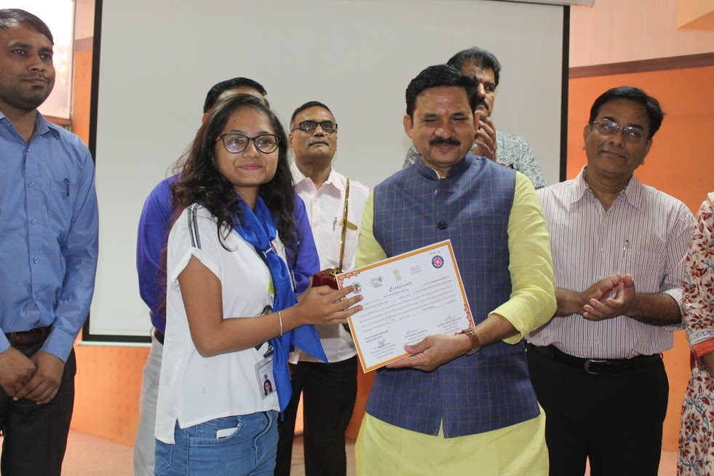

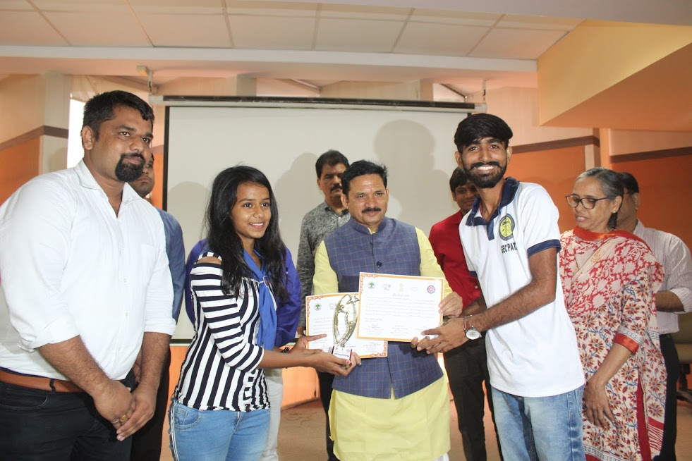

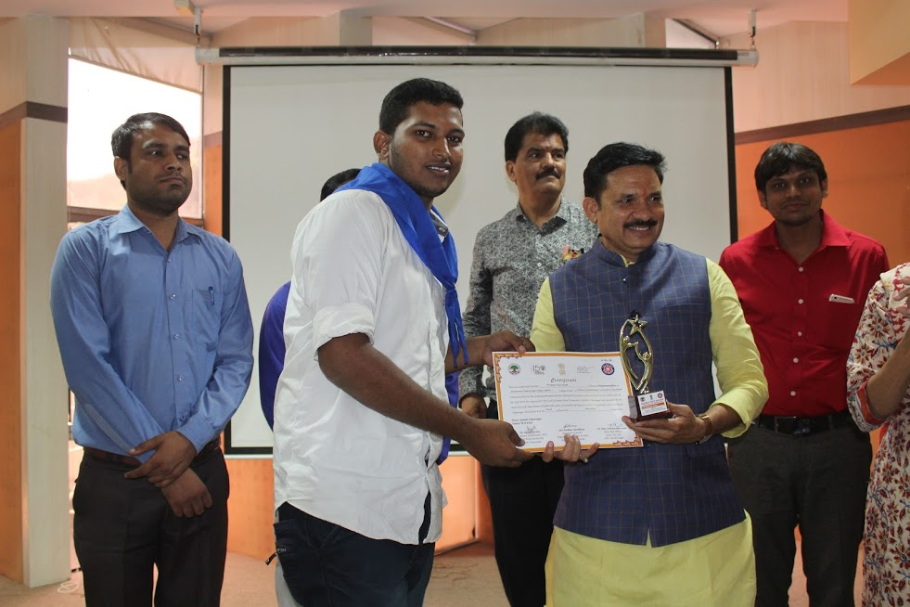

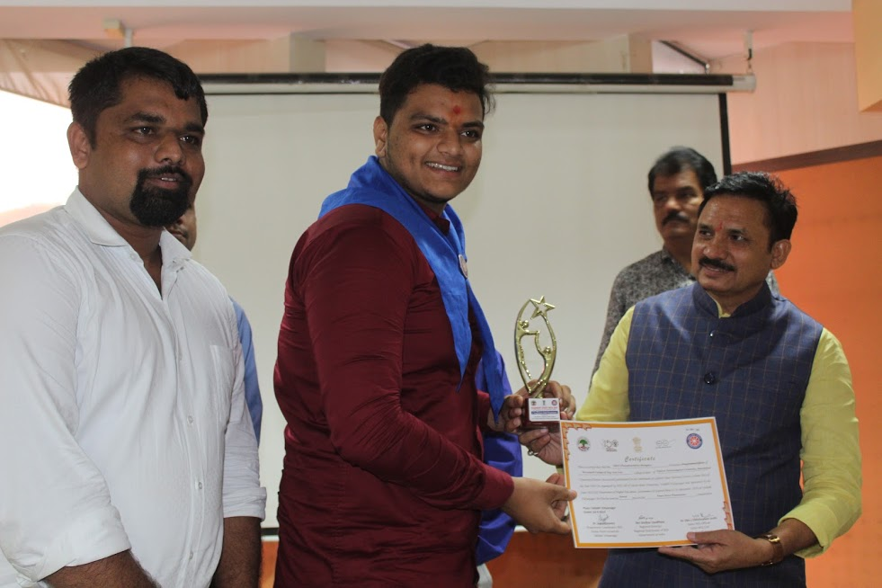

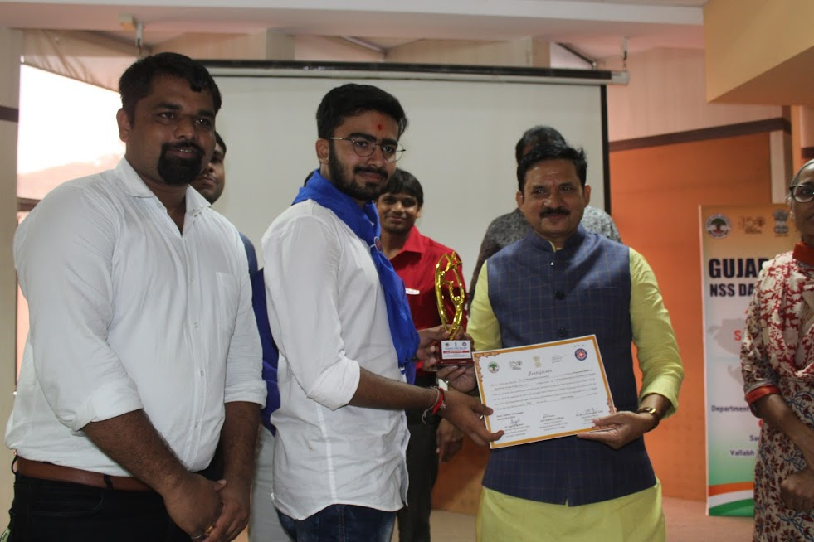

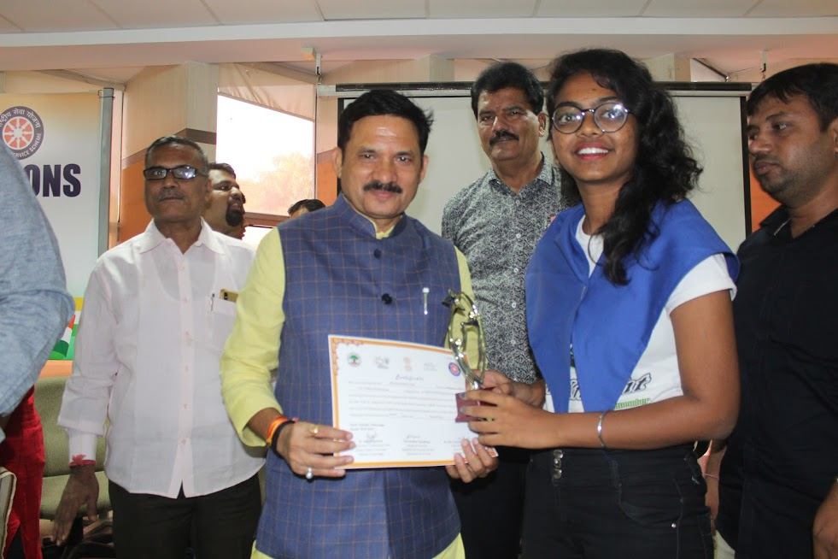

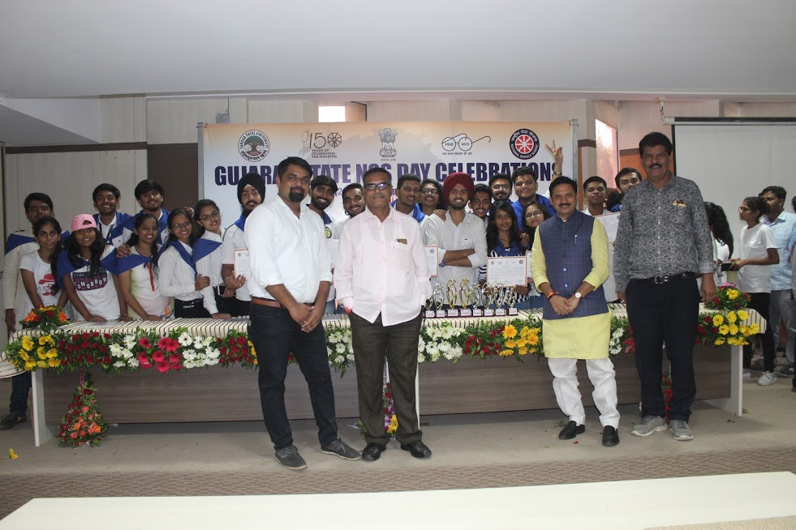

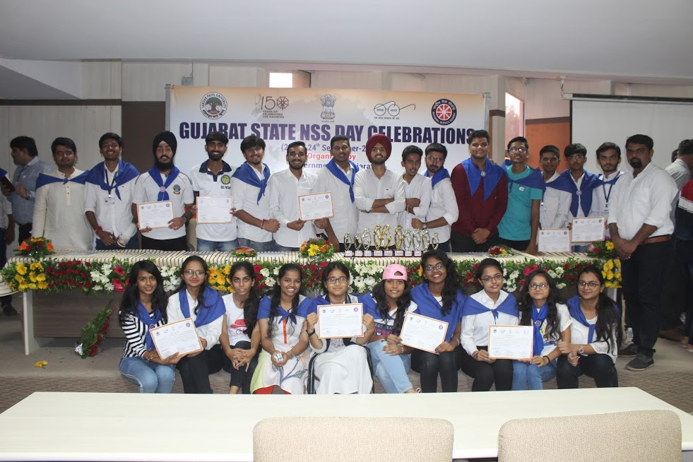

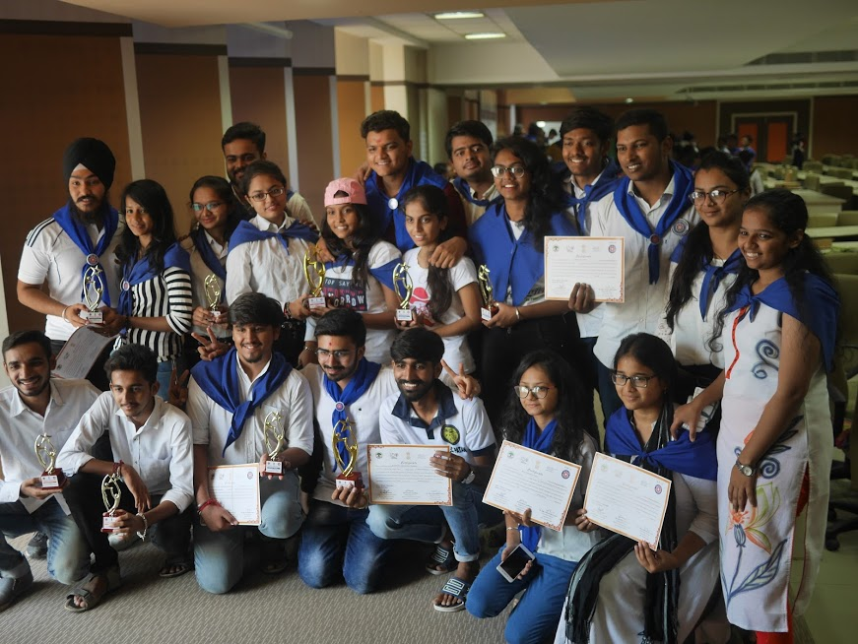

Welcome Function at GTU

A team of State NSS Day Celebration reached at GTU at 6:00 Pm on 24th September 2019 and arranged welcome Function for the motivation and appreciation of NSS Volunteers’ achievements. Dr. K.N. Khersir, Prof. Alpesh Dafdasir and other GTU Staff of NSS and Sport were present and appreciated student’s achievements. Dr. K. N. Kher , Registrar of GTU was a chief guest of this program. He welcomed NSS GTU team and motivated students by appreciating their hard work , support and sincerity. At the end, high tea and snakes was arranged for NSS Volunteers’.

**Some Glimpses of an Event.**

**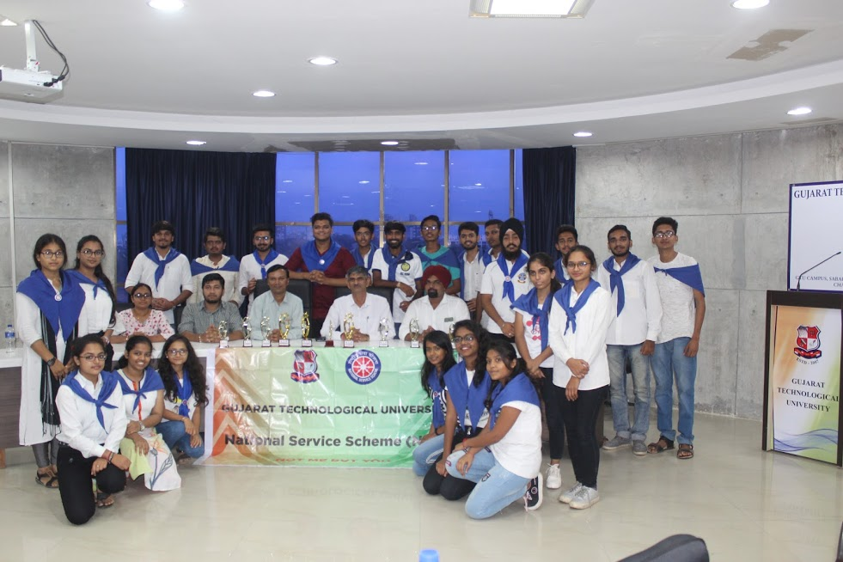**

**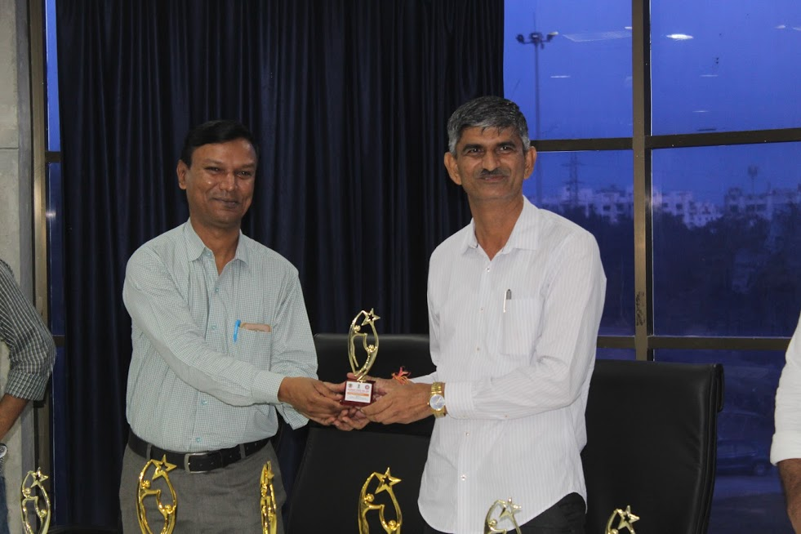**

**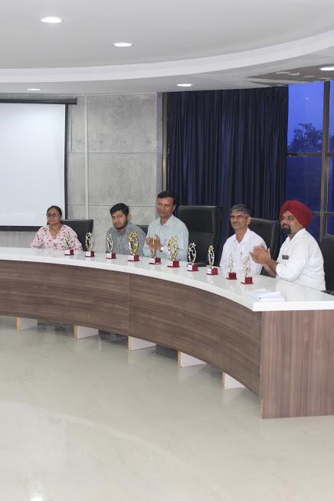**

**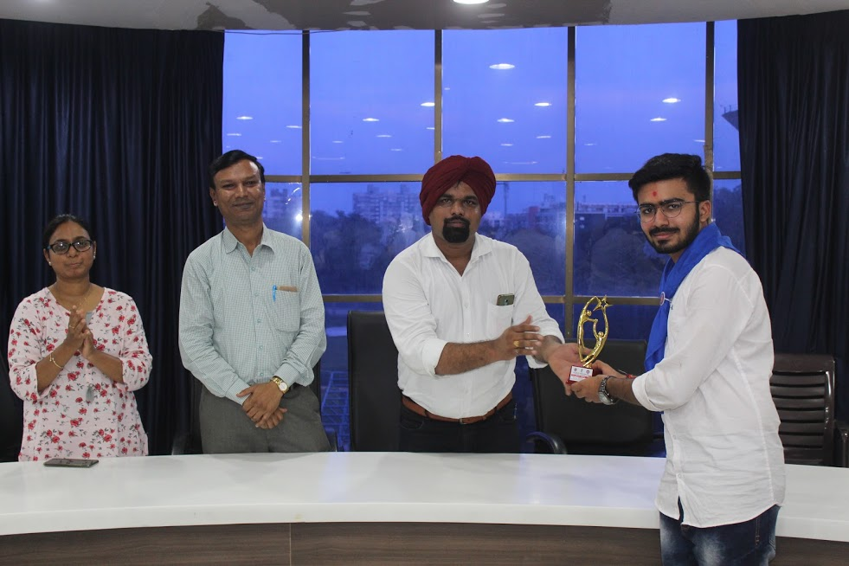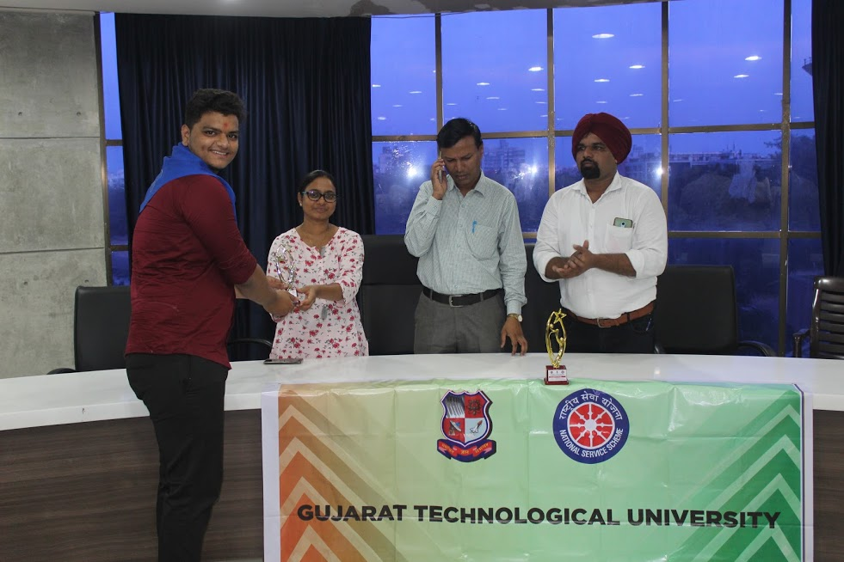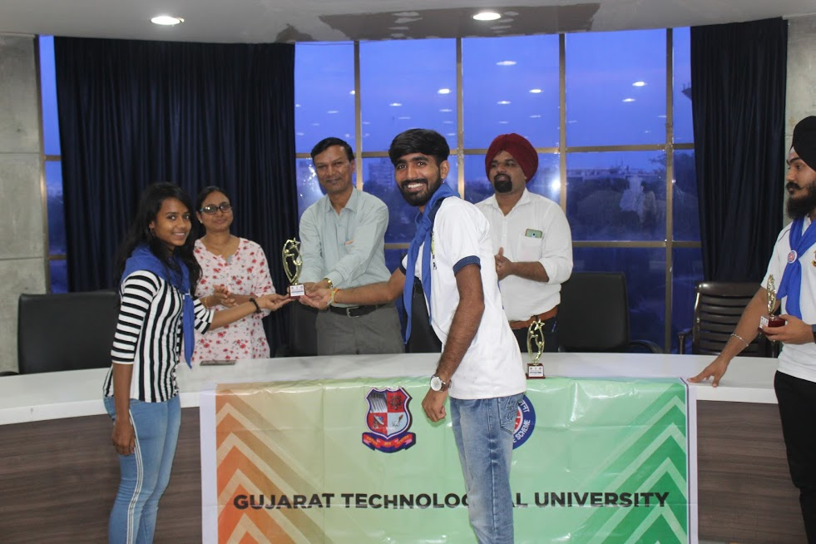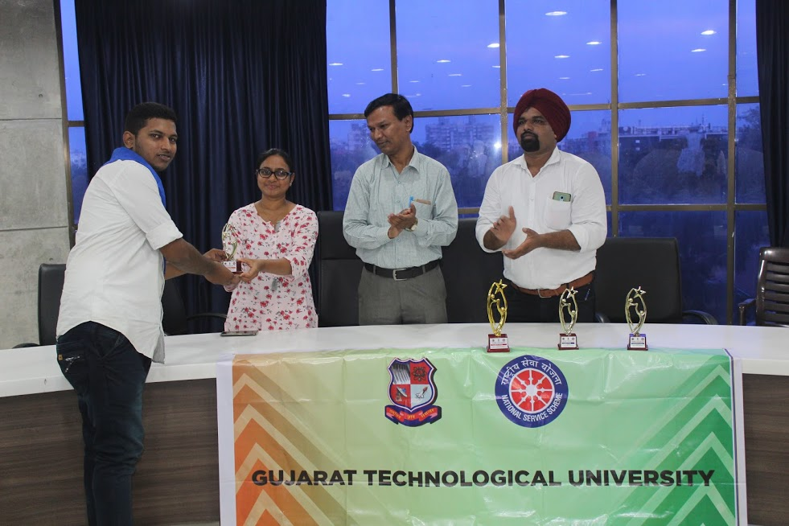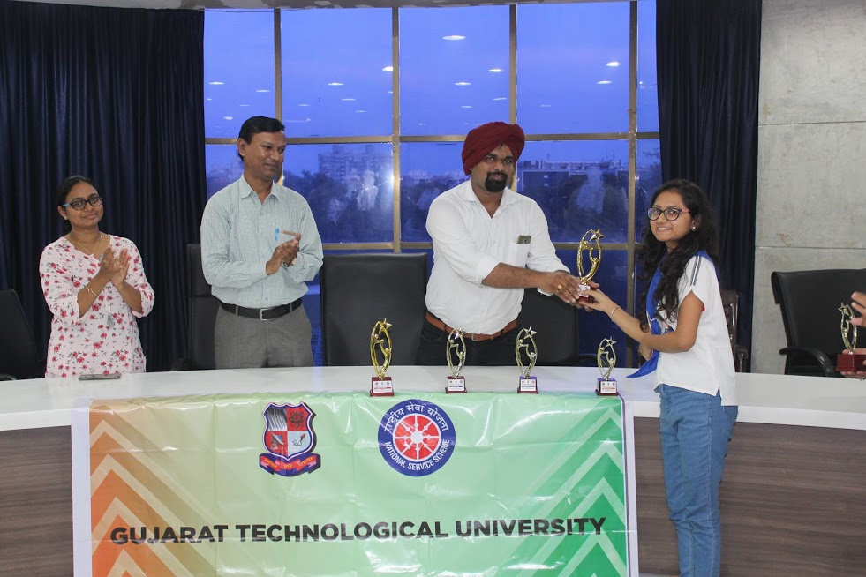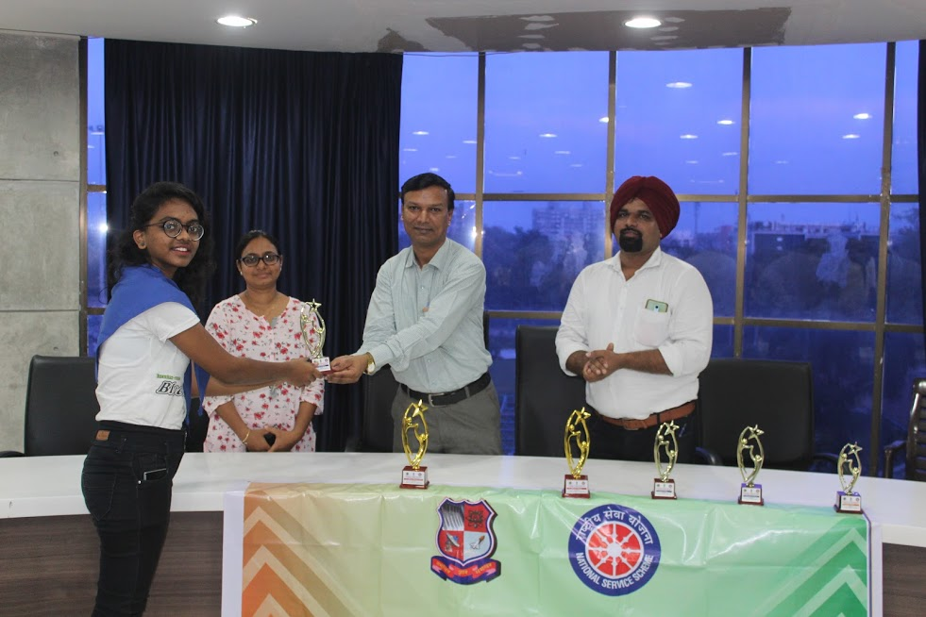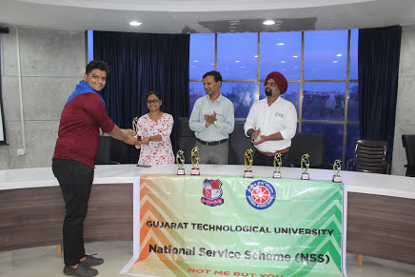** **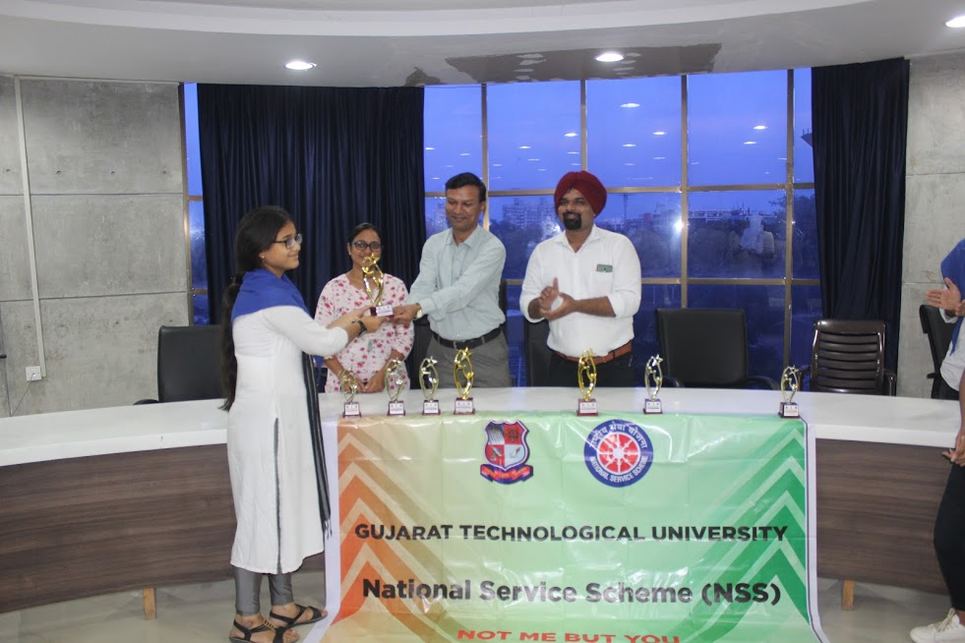 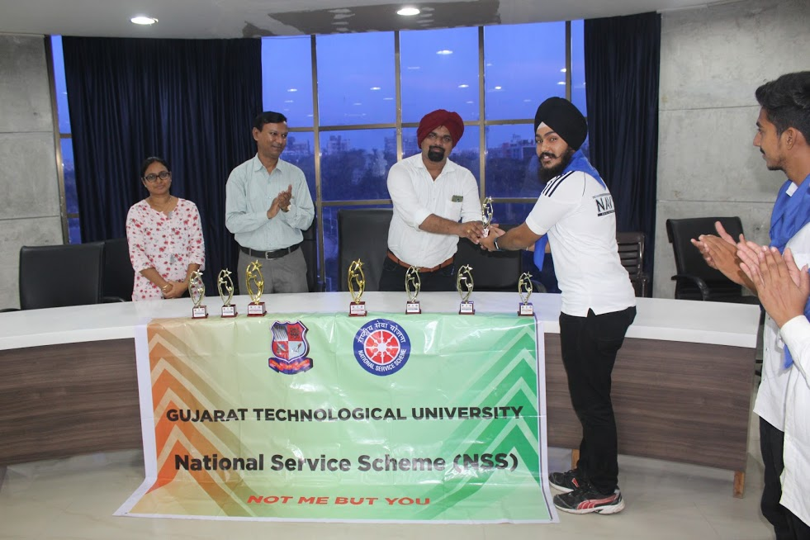**

**Acknowledgement**

We extend our sincere thanks to our honorable Vice-Chancellor Prof. (Dr.) Navin Shethsir , Registrar Dr. K.N. Khersir for their support and co-operation. We also owe our deep sense of gratitude and thankfulness to all the faculties Sport Section, NSS Section, NSS POs, and NSS Volunteers’ for their kind support and cooperation . At the nutshell, we thank one and all for their direct or indirect support.

|  |  |
| --- | --- |
| **Prof. Alpesh Dafda** | **Mr.Bharat Vadhiya** |
| University NSS Coordinator | NSS Program Officer |
| GTU , Ahmadabad | SPCE, Bakrol |
|  |  |