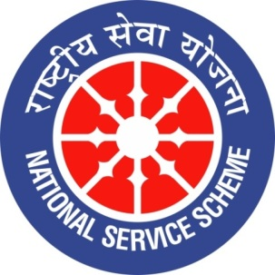 

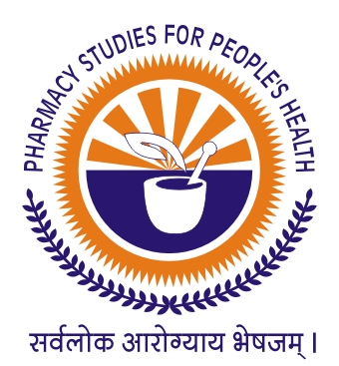

**GUJARAT TECHNOLOGICAL UNIVERSITY**

**NATIONAL SERVICE SCHEME**

**SARDAR PATEL COLLEGE OF PHARMACY, BAKROL (244)**

**A Report on “MAHATMA GANDHI NIRVAAN DIN- SHAHID DIN” of SARDAR PATEL COLLEGE OF PHARMACY, BAKROL (244)**

**NSS Unit Name/College Name:**Sardar Patel College of Pharmacy, Bakrol (244)

**Event NAME:** “**MAHATMA GANDHI NIRVAAN DIN – “SHAHID DIN”**

**Event Date, Time and Location:** 30-01-2020

**Brief Description of the Event:**

Every year 30th January is observed as Mahatma Gandhi's Martyrdom day. This year India is observing the 72nd death anniversary of Mahatma Gandhi. Mohandas Karamchand Gandhi is known for his thoughts and principles he followed during his lifetime. For spreading this thoughts and principles,NSS team of Sardar Patel College of Pharmacy, Bakrol also celebrated death anniversary of Gandhiji as “Shahid Din”. Elocution competition on life of Mahatma Gandhiji and other freedom fighters was arranged and 6 students enthusiastically Participated in it.

**30-01-2020**

|  |
| --- |
| **F:\NSS\MAHATMA GANDHI NIRVAN\PICS\2020-01-30 at 11.07.50 AM (1).jpeg** |
| **F:\NSS\MAHATMA GANDHI NIRVAN\PICS\2020-01-30 at 11.07.50 AM (3).jpeg** |
| **F:\NSS\MAHATMA GANDHI NIRVAN\PICS\2020-01-30 at 11.07.50 AM (4).jpeg** |
| **F:\NSS\MAHATMA GANDHI NIRVAN\PICS\2020-01-30 at 11.07.50 AM (7).jpeg** |
| **F:\NSS\MAHATMA GANDHI NIRVAN\PICS\2020-01-30 at 11.07.50 AM (8).jpeg** |
| **F:\NSS\MAHATMA GANDHI NIRVAN\PICS\2020-01-30 at 11.07.50 AM (13).jpeg** |

**Major Outcomes of Event:**

1. To spread great leader’s thoughts to youth through this program.
2. Our young generation get awareness about freedom fighters and their sacrifices

**Mr. Zalak D. Dave Dr. Samir K. Shah**

**NSS Program Officer Principal**