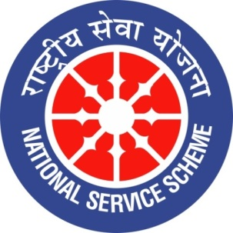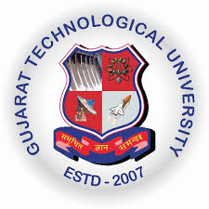
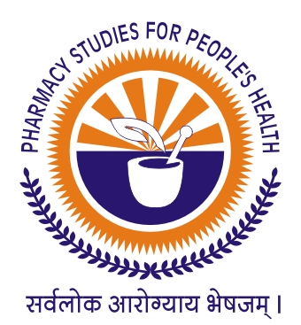
GUJARAT TECHNOLOGICAL UNIVERSITY
NATIONAL SERVICE SCHEME
SARDAR PATEL COLLEGE OF PHARMACY, BAKROL (244)
A Report on “INTERNATIONAL MOTHER LANGUAGE DAY” of SARDAR PATEL COLLEGE OF PHARMACY, BAKROL (244)

NSS Unit Name/College Name: Sardar Patel College of Pharmacy, Bakrol (244)
Event NAME: “INTERNATIONAL MOTHER LANGUAGE DAY”
Event Date, Time and Location: 21-02-2020
Brief Description of the Event:
Every year 21st February celebrated as “INTERNATIONAL MOTHER LANGUAGE DAY” in India. In which, 50 students and 20 faculty members were celebrated International mother language day at Sardar Patel College of Pharmacy together. NSS Co-ordinator gave short speech on importance of using mother language in life. As a part of the celebration, essay Writing Competition was arranged for students on “Importance of Mother language in Life”. 7 Students Participated in essay writing competition with zeal.

18-02-2020
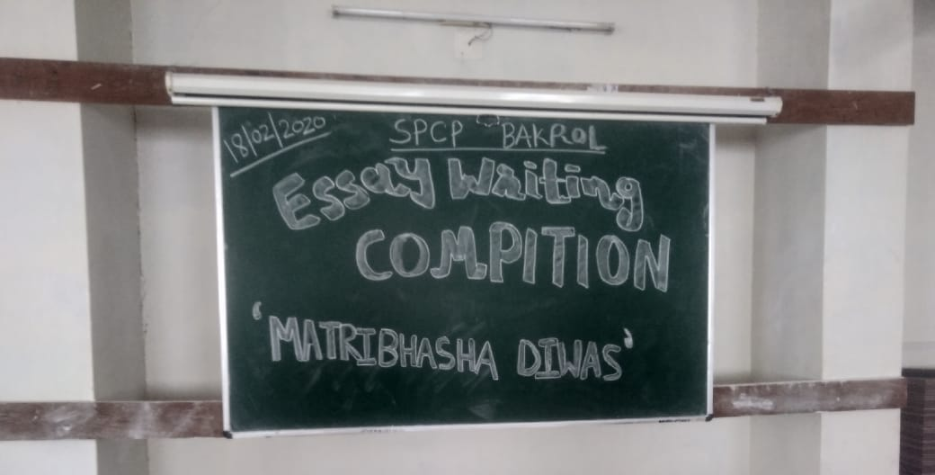
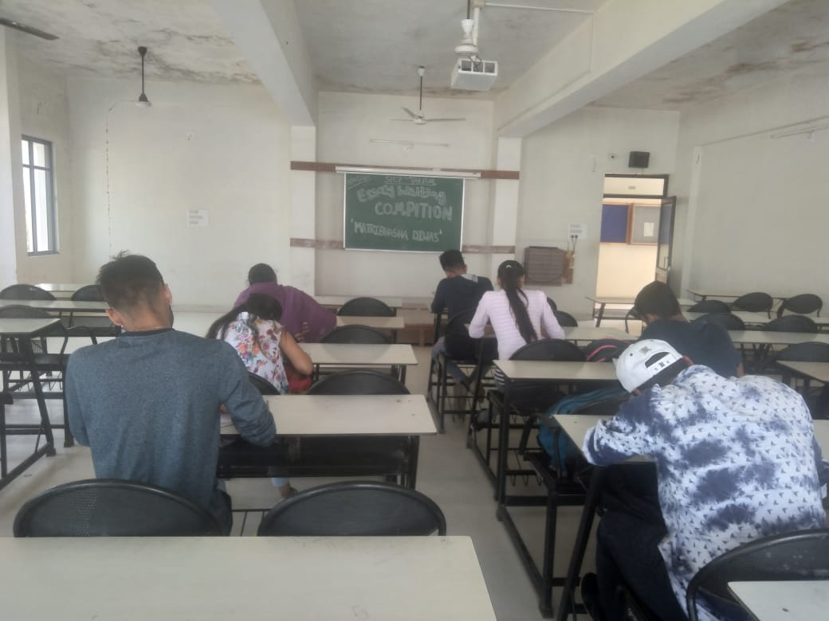
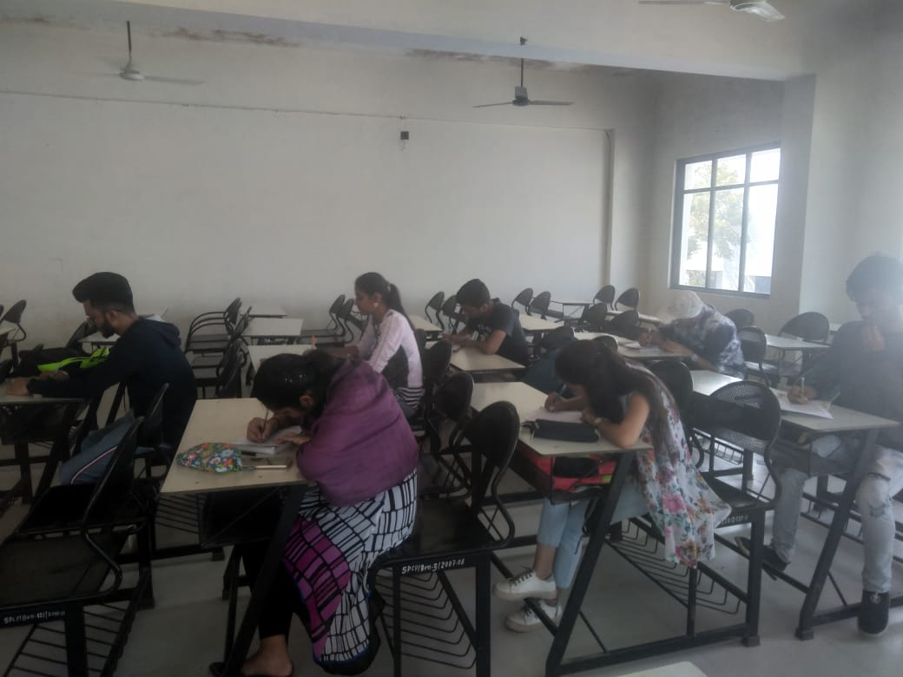
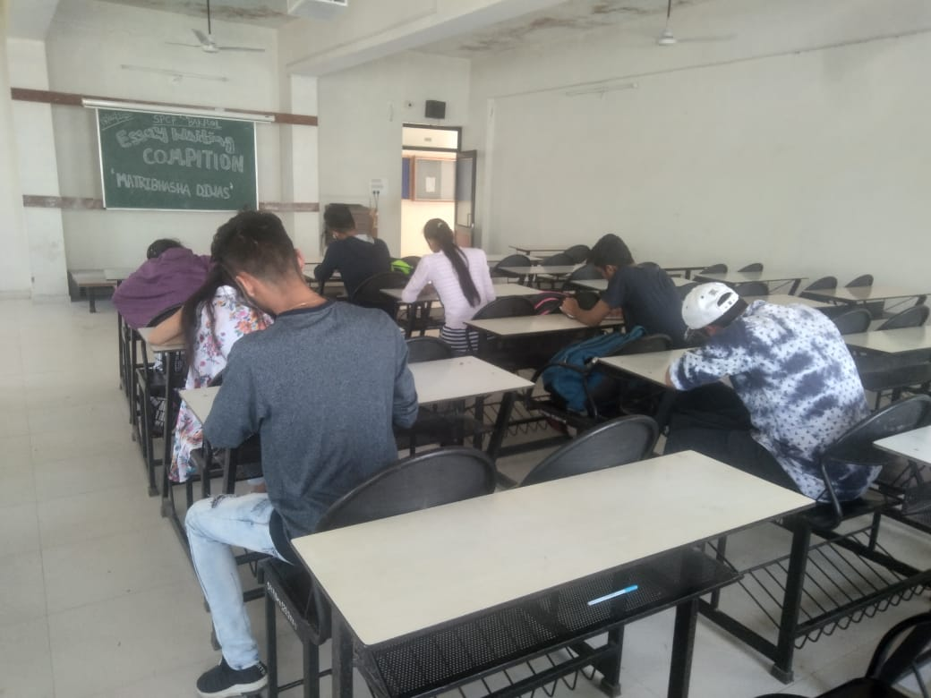

Major Outcomes of Event:
- To aware students about importance of mother language.
- To encourage youngsters about Knowledge rich literature available in their own mother language.

Mr. Zalak D. Dave Dr. Samir K. Shah
NSS Program Officer Principal

