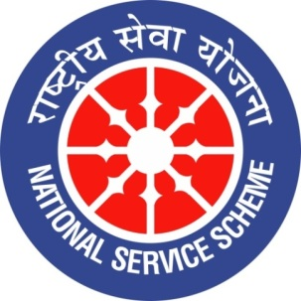
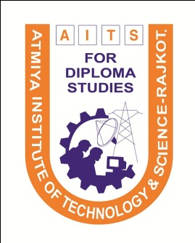ollege Logo
GUJARAT TECHNOLOGY UNIVERSITY
NATIONAL SERVICE SCHEME

A Report on Tree Plantation Campaign on 14th December 2019 at Atmiya Institute of Technology & Science For Diploma Studies, Rajkot

NSS Unit Name/College Name: Atmiya Institute of Technology & Science For Diploma
Studies, Rajkot
Event NAME: “Tree Plantation Campaign”
Event Date, Time and Location: 14/12/2019, 08:30 AM at Railway Loco Colony, Rajkot.
Brief Description of the Event:
Tree Plantation campaign was organized by Diploma Engineering department on date 14/12/2019 in which 32 students of NSS unit had taken participation along with two faculties
This campaign was organized at Railway Loco colony Rajkot with the help of Navrang nature club and total 45 number of trees were planted.

Major Outcomes of Event:
About 45 number of trees were planted during this event.

Photographs of the Event:
