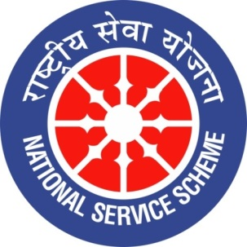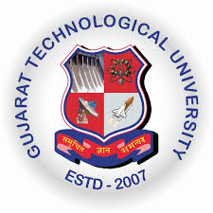
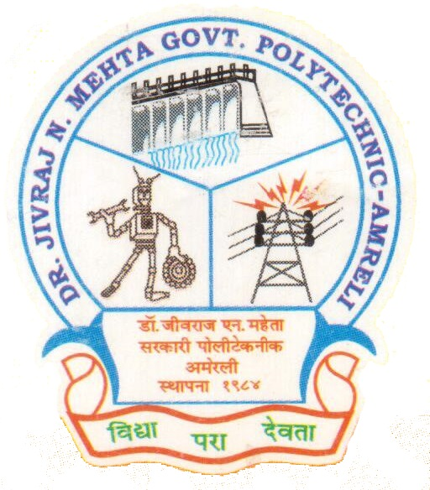
GUJARAT TECHNOLOGY UNIVERSITY
NATIONAL SERVICE SCHEME
DR.J.N.MEHTA GOVERNMENT POLYTECHNIC-AMRELI
A Report on 70th Anniversary of Indian Constitution

On 26/11/2019

NSS Unit Name/College Name: Dr. JNMGPA - NSS unit

Event NAME: Celebration of 70th Anniversary of Indian Constitution

Event Date, Time and Location: 26/11/2019, Main Building-Room No.-202.

Brief Description of the Event:

Dr. JNMGPA - NSS unit celebrated 70th Anniversary of Indian Constitution with the students of our institute. After completing the very first speech by K.D. Ramanuj about our “CONSTITUTION” one student namely Trushant Devmurari delivered the complete lecture on the same. At the end we have read the preamble of our Constitution and took an oath altogether…….Jay Hind
Honourable Principal B.P. Raval Sir, HOD-Elect. S.V. Jagani Sir, Lect. K.D. Ramanuj Sir, Lect. M.D. Mathukia Sir (NSS-Committee Member) were present during this precious occasion.
Photographs of the Event:

