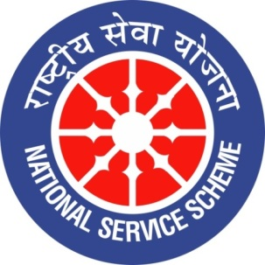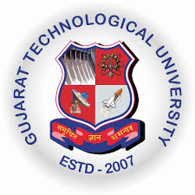
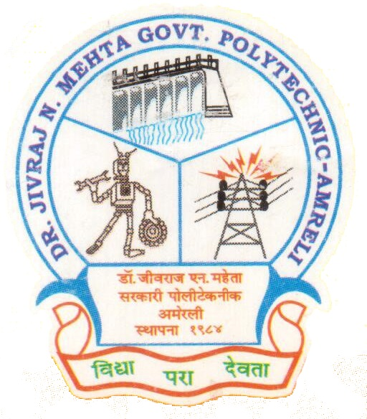
GUJARAT TECHNOLOGY UNIVERSITY
NATIONAL SERVICE SCHEME
DR.J.N.MEHTA GOVERNMENT POLYTECHNIC-AMRELI
A Report on Thalassemia Test

On 24/02/2020

NSS Unit Name/College Name: Dr. JNMGPA - NSS unit

Event NAME: Thalassemia Test

Event Date, Time and Location: 24/02/2020, 11:30 am, New Building

Brief Description of the Event:
Dr. JNMGPA - NSS unit in coordination with Thalassemia test (Institute committee) organized thalassemia test at our institute on 24th February 2020 for all the first year students. The camp was totally free of cost for all the students. The Indian Red-Cross Society—Bhavnagar was specially invited for collection of blood samples for the testing. All the first year students were made aware about thalassemia, its type and the effect of this blood disorder in our life.
The importance of thalassemia testing was also elaborated as it is the only measure of preventing spreading of this disorder. An informative documentary was also shown to the students on the day before the testing and during the camp. Counselling was provided by our Honourable Principal Shri B.P. Raval sir, Senior Members of the thalassemia test committee, Lect. A.D. Mehta (NSS-P.O) and Lect. M.D. Mathukia (NSS-Committee Member) regarding the awareness related to their health issues and particularly about the importance of thalassemia in the blood. A large number of students were present during the camp for getting their blood tested. Total number of 80 students of various branches of first year provided their blood samples for testing. The whole event was well organized and controlled by the faculty of the institute. At the end we must say that we really enjoyed doing such kind of noble and social activity for stronger and healthy society.
Photographs of the Event:

