GUJARAT TECHNOLOGY UNIVERSITY
NATIONAL SERVICE SCHEME
COLLEGE NAME
A Report on SWACHHATA PLEDGE Day celebration on 30-10-2023 of GOVERNMENT POLYTECHNIC VADNAGAR

NSS Unit Name/College Name:Government Polytechnic Vadnagar
Event NAME: Swachhata Pledge
Event Date, Time and Location: 30-10-2023 at Government Polytechnic Vadnagar from 11:00 A.M Onwards
Brief Description of the Event: In view of Rashtriya ekta divas and in the memory of Shri Sardar Vallabhbhai patel, NSS Cell of Government Polytechnic Vadnagar has organized Swachhata Pledge at our campus from 11:00A.M onwards. Our volunteers , faculties and principal took part in Swachhata Pledge.
Major Outcomes of Event: swachhata awareness, unity in working, co-operation among team members
Photographs of the Event:
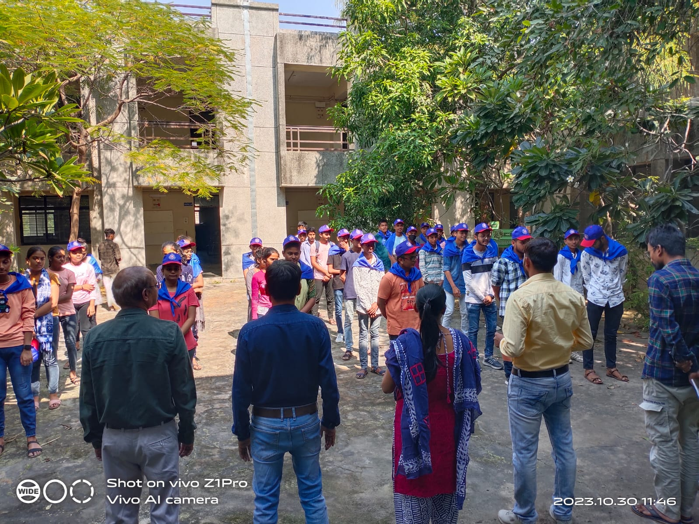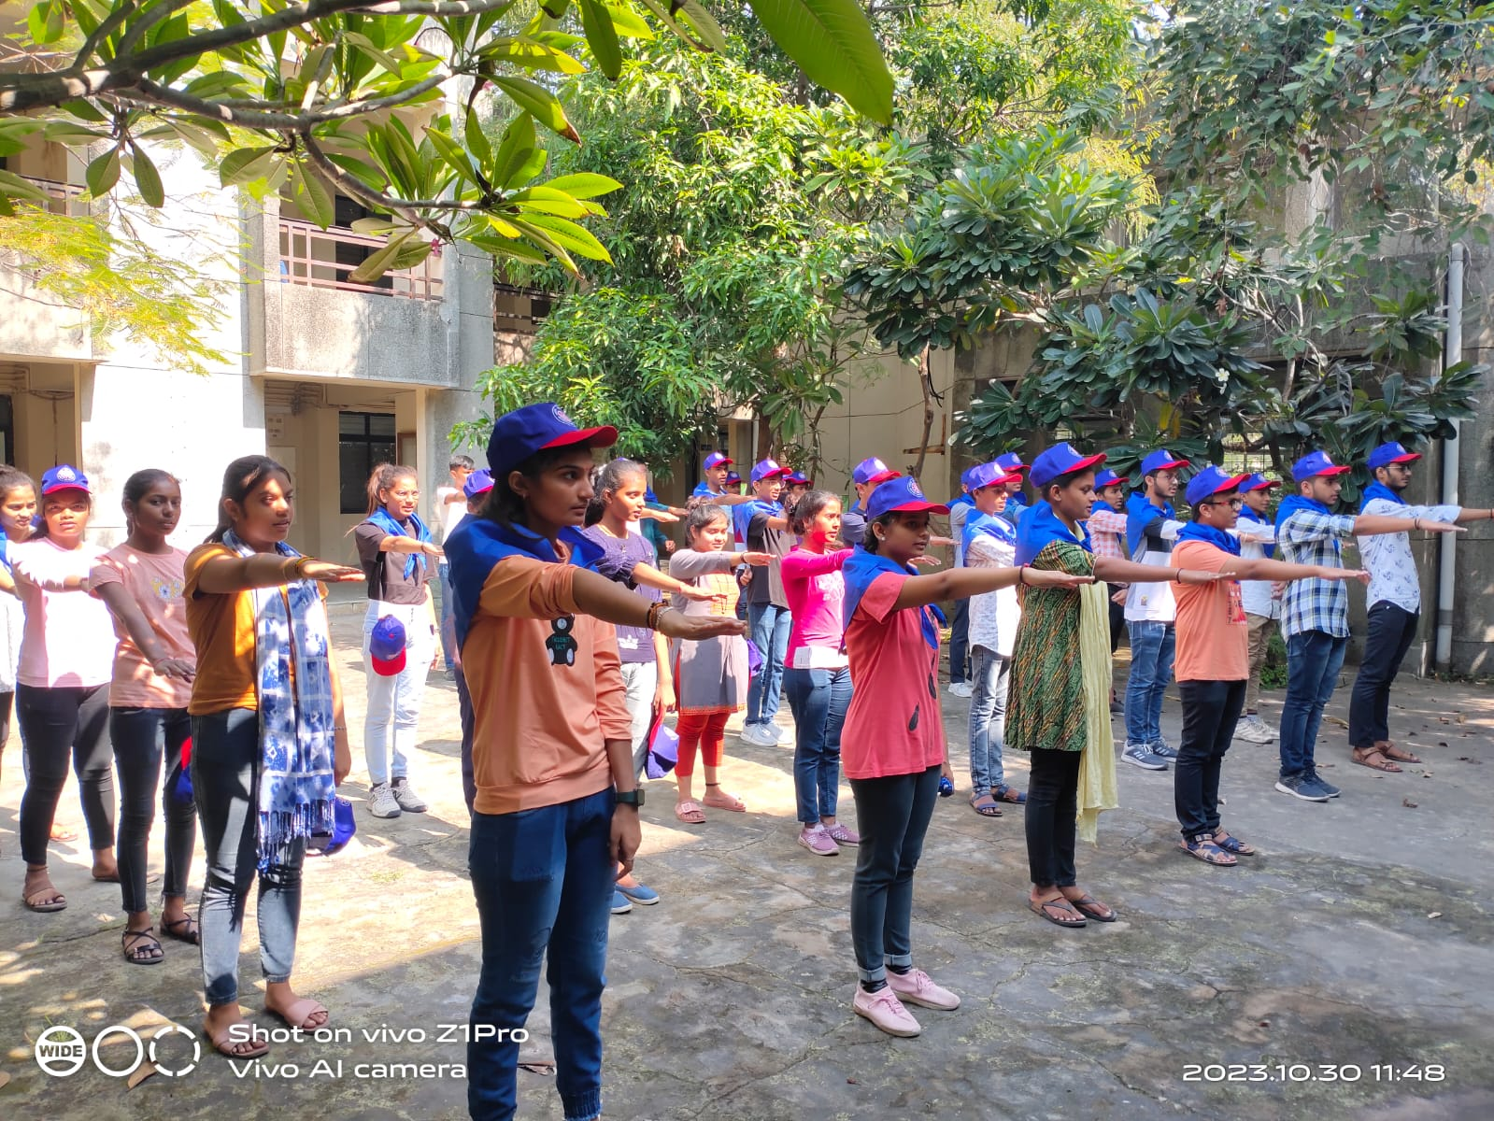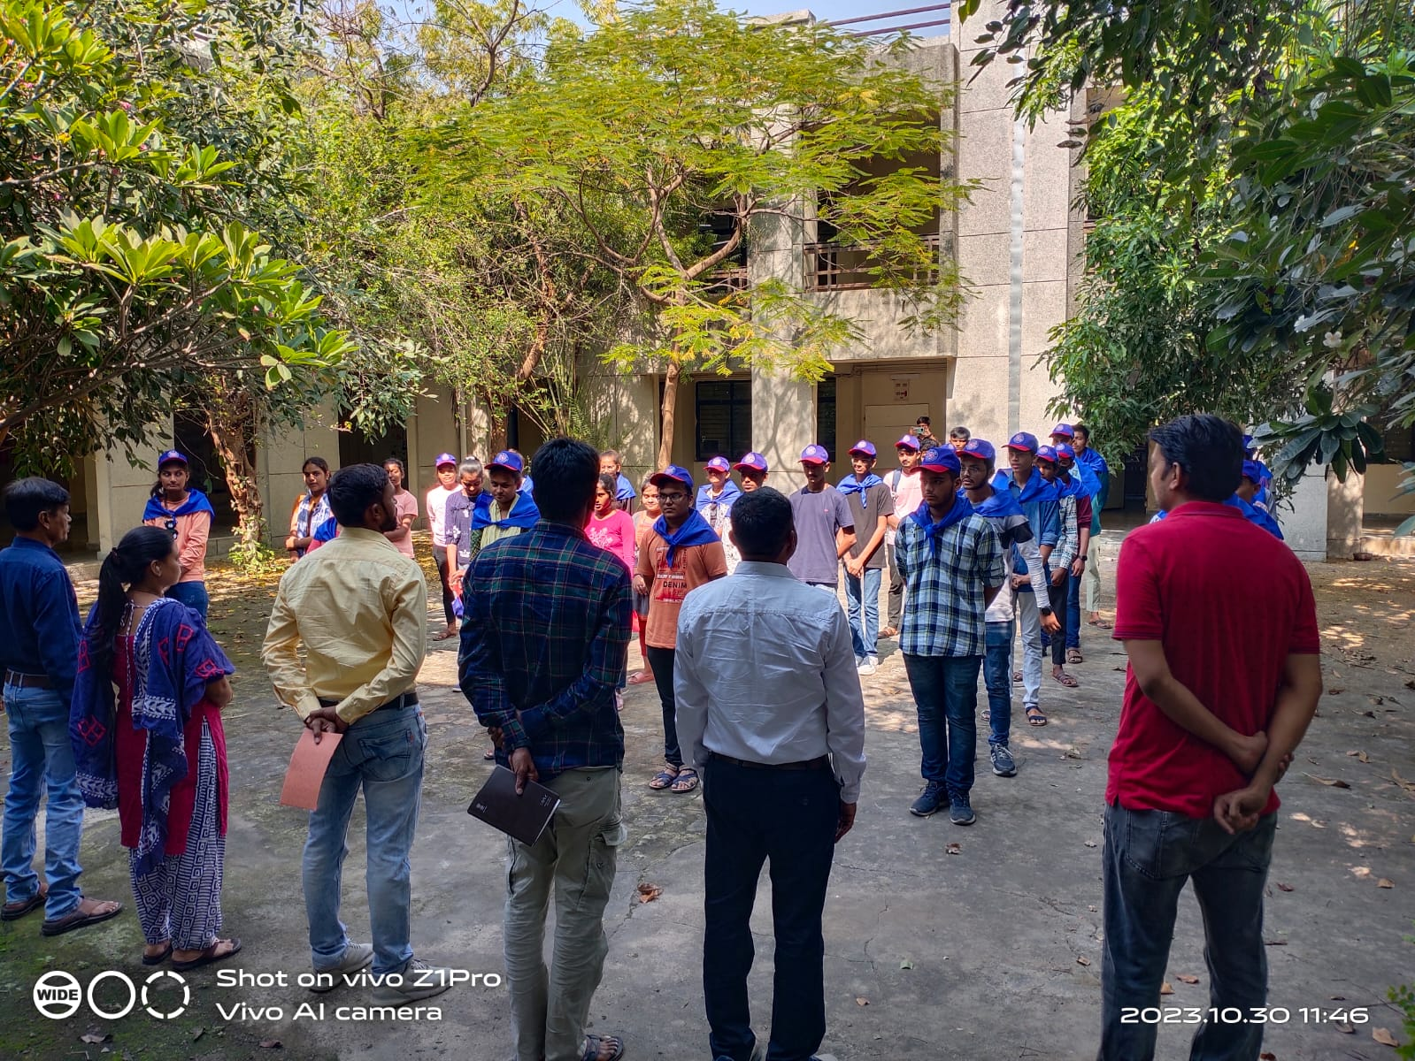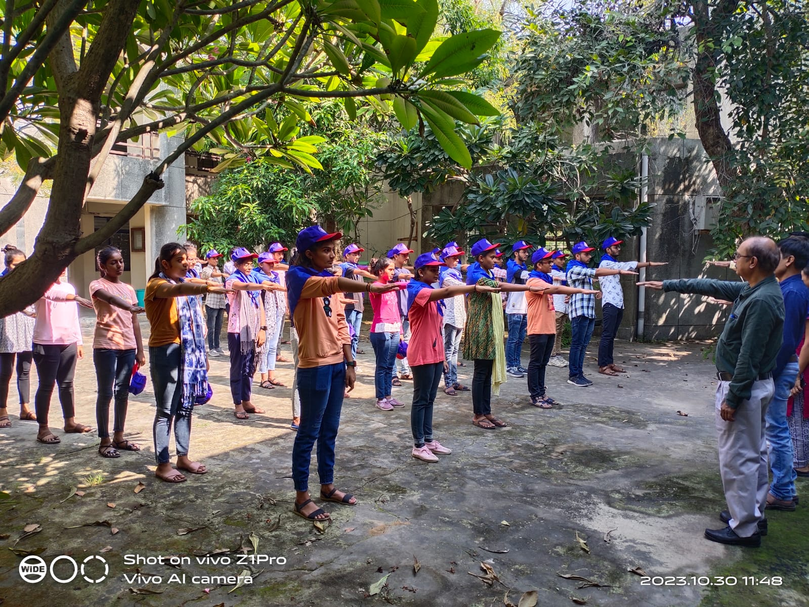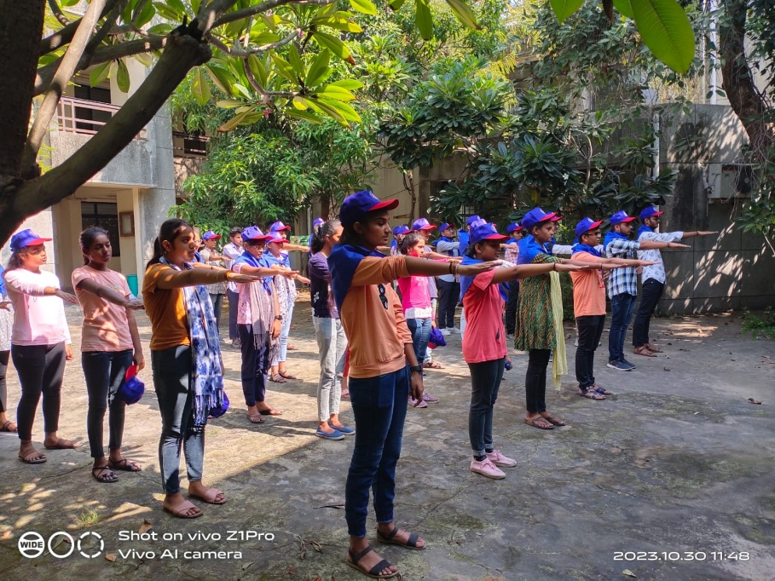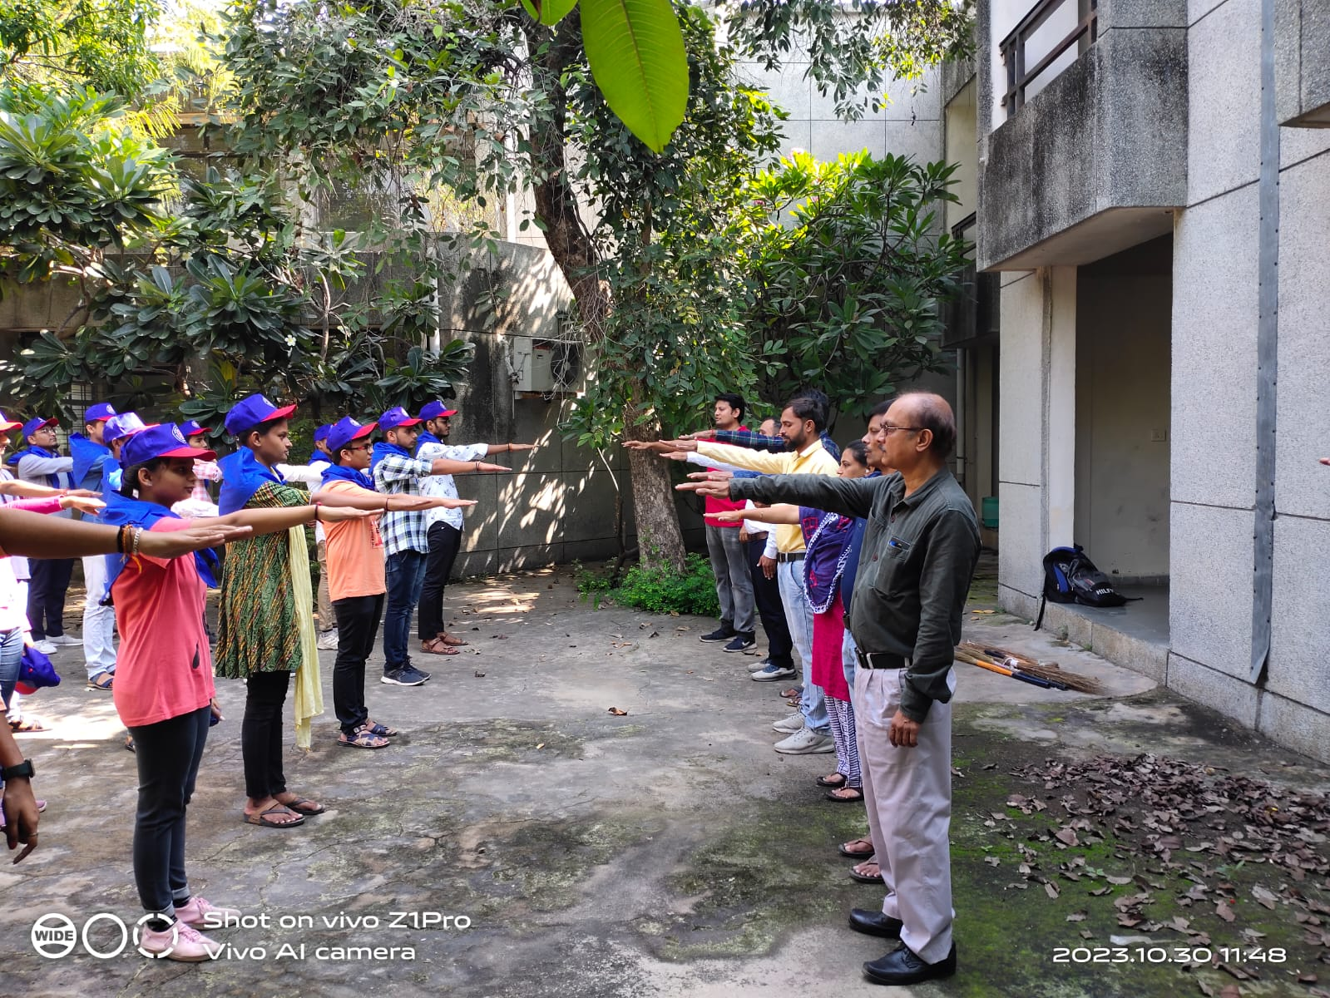

Upload Report in both WORD and PDF format

