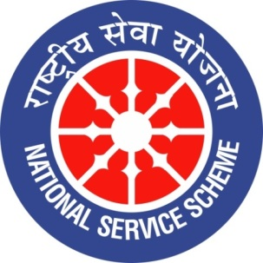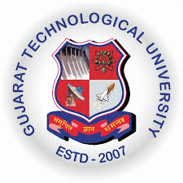
GUJARAT TECHNOLOGY UNIVERSITY
NATIONAL SERVICE SCHEME
HJD INSTITUTE OF TECHNICAL EDUCATION AND RESEARCH (085)
A Report on 70th Constitution awareness rally on 19th December’ 2019

NSS Unit Name/College Name: HJD INSTITUTE OF TECHNICAL EDUCATION AND RESEARCH (085)
Event Name: Constitution awareness rally
Event Date, Time and Location: Constitution awareness rally at Village Babiya and Tappar

Brief Description of the Event:

India’s Constitution was adopted on November 26, 1949, and came into force on January 26, 1950 marking the beginning of a new era in the history of India. The Government decided to observe 26th November as ‘Constitution Day’ or ‘Samvidhan Divas’. On the occasion of constitution day on November 26 ,2019 our college set to celebrate the occasion. The students on this occasion will be made aware about the preamble of the constitution as part of the celebration. The Constitution of India is the supreme law of India. The document lays down the framework demarcating fundamental political code, structure, procedures, powers, and duties of government institutions and sets out fundamental rights, directive principles, and the duties of citizens
Continue to this subsequence activities that a institute has to perfume about constitution. The institute have arrange constitution awareness rally at Village Babiya and village Tappar of Mundra taluka, (Dist. Kutch) where students of HJD Institute have give some knowledge about the constitution and their fundamental rights to the villagers. The whole programme is arranged under the guidance of Chairman sir Shri Jagdishbhai Halai and Institute coordinator Ms. Rasila Hirani. Also the programme is supported by Head of Engineering Mr. Vishal Bhimani and all other staff member. Total 33 volunteer have anticipated to this campaign. This programme is Coordinated by NSS officer Mr. Hiteshgiri Goswami and Team.

Mr. Hiteshgiri Goswami Dr. Kalpana Maheshwari
NSS Program Officer Principal

