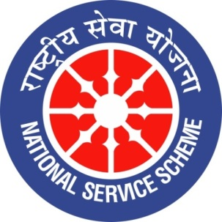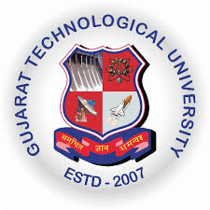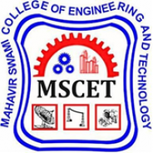

GUJARAT TECHNOLOGY UNIVERSITY
NATIONAL SERVICE SCHEME
A Report on “NUKKAD NATAK 2020” on 30/01/2020 at MSCET (111)

NSS Unit Name: MAHAVIR SWAMI COLLEGE OF ENGG. & TECH. (111), SURAT
Event NAME: NUKKAD NATAK 2020
Event Date, Time and Location: 30th JAN 2020, 09.30 A.M ONWARDS, MSCET CAMPUS
Brief Description of the Event:
In the first of its kind, a “Nukkad Natak Competition” was staged at the Mahavir Swami College of Engineering & Technology, Surat that depicted the message of non-violence, Beti Bachao Beti Padhao, Peace and Harmony to the general masses on 30th January 2020 organized by NSS Volunteers. In this competition 07 Groups from different colleges of BMU participated & everyone came up with an interesting topic like child labour, gender inequality, ill effects of mobile, etc.
These competition was a part of BMU Youth Festival 2020. Winners of the Competition were MSCET Students & Runner up were BMPOLY Students. Winners of the Nukkad Natak were awarded with Trophies with the hand of Respected Director Dr. Vijay Matawala sir (MSCET).
The event was attended by Director of MSCET, Faculties, Staff and around 200 students.
Major outcome of the event:
- To help students generate awareness regarding Gender Inequalities.
- To help students to generate positive attitude towards women safety.
- It gives everyone lesson & belief to fight against evils in society.
- To provide student with a platform in order to show case their talent.
- Students get motivated to perform such nataks in future.

“NUKKAD NATAK COMPETITION 2020” AT MSCET

Some Glimpse of the Event:
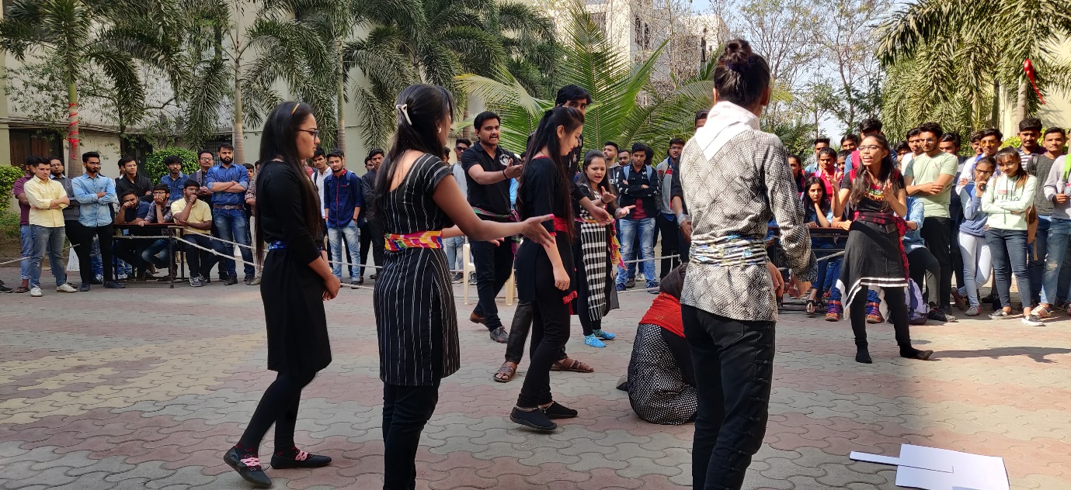
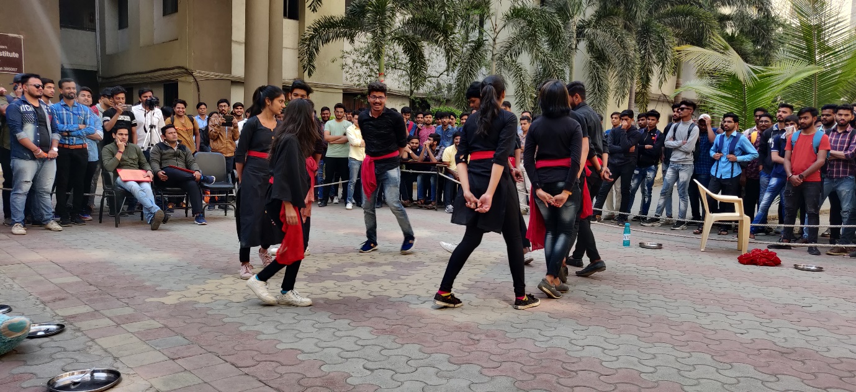
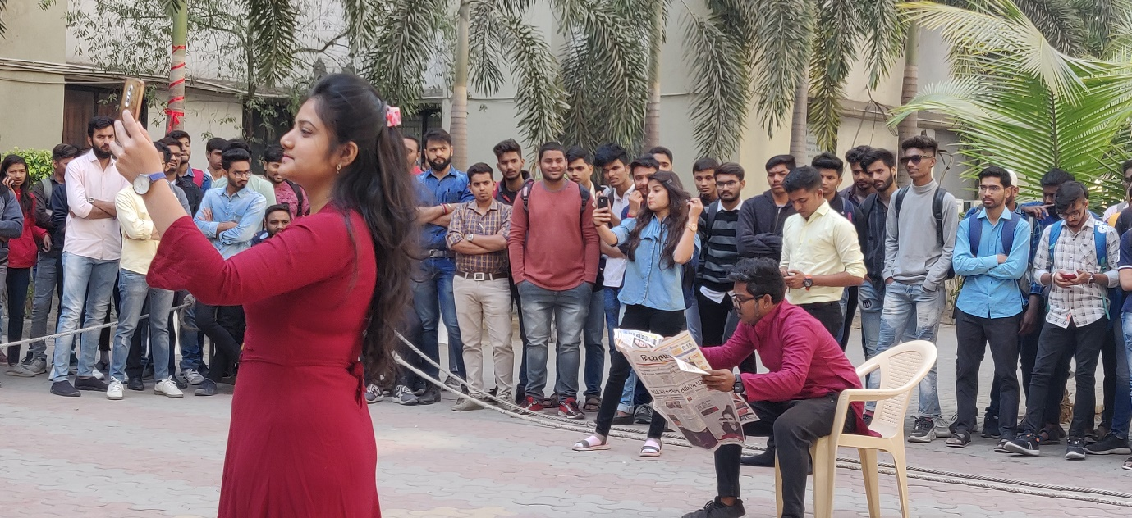
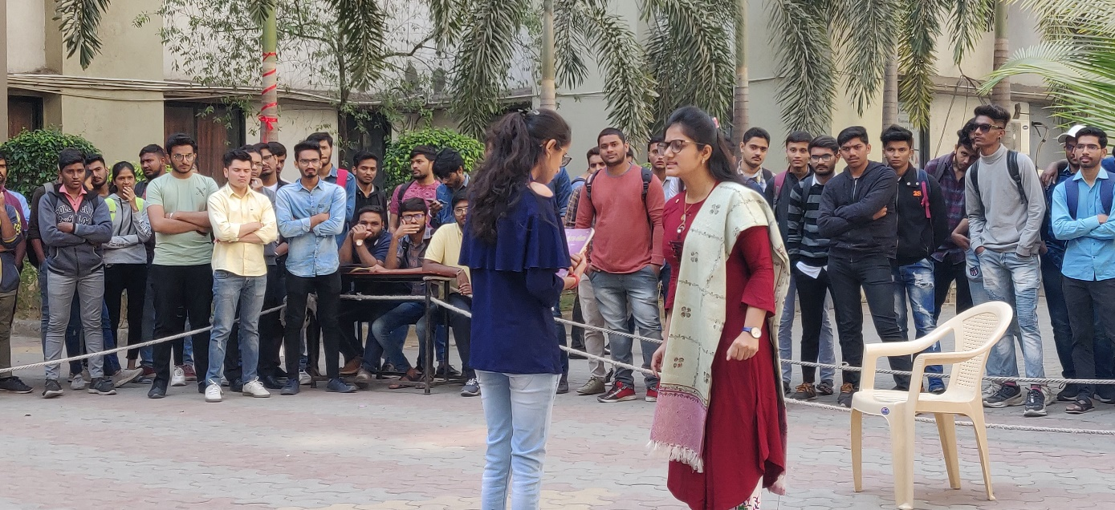
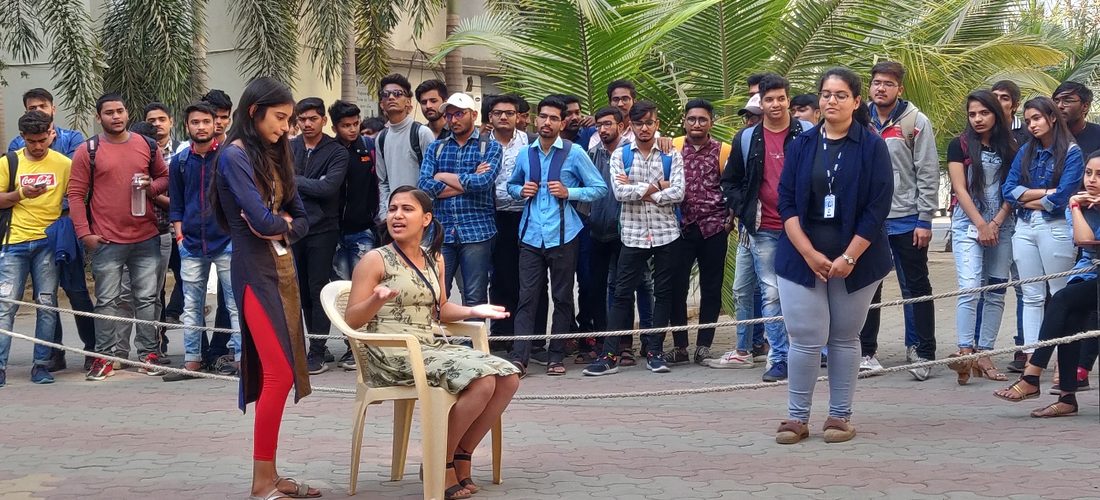
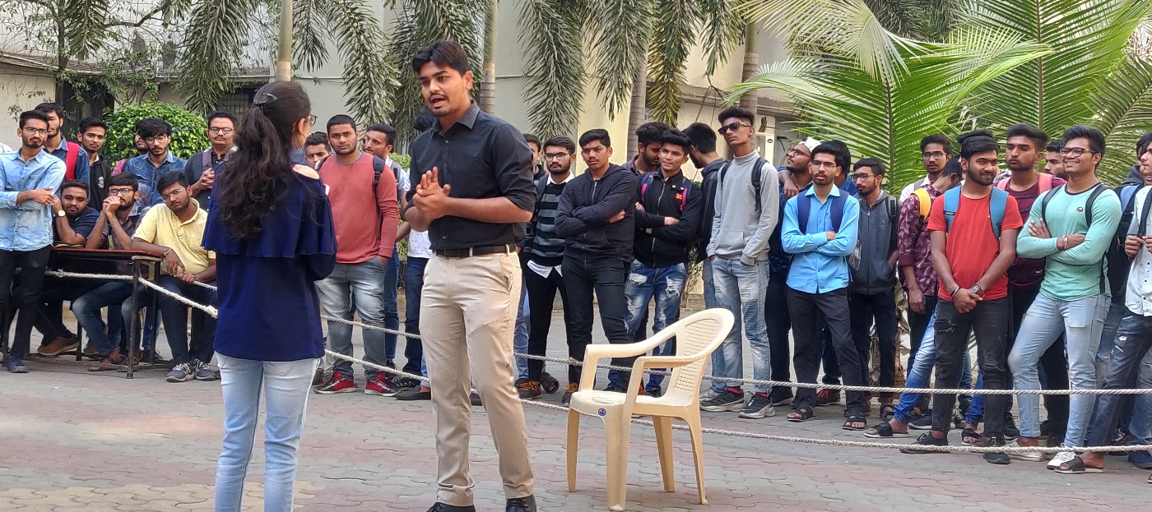
STUDENTS OF BMU PERFORMING AT THE EVENT
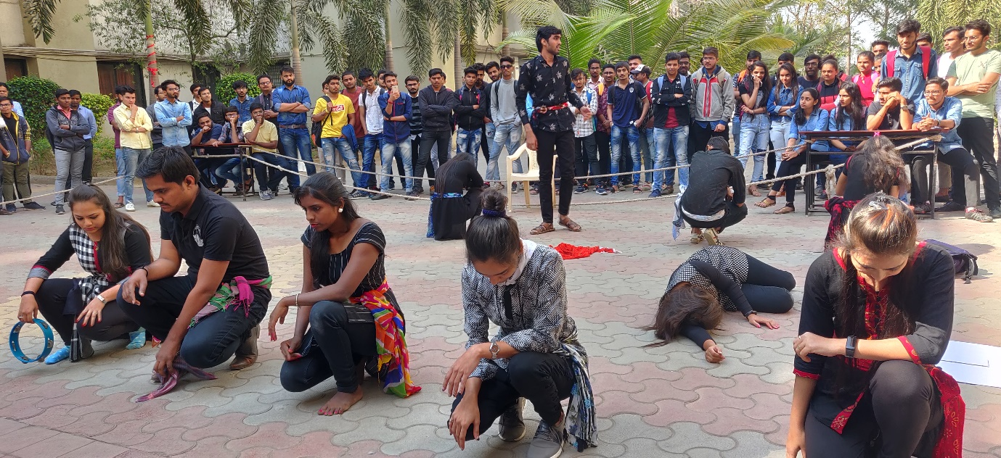
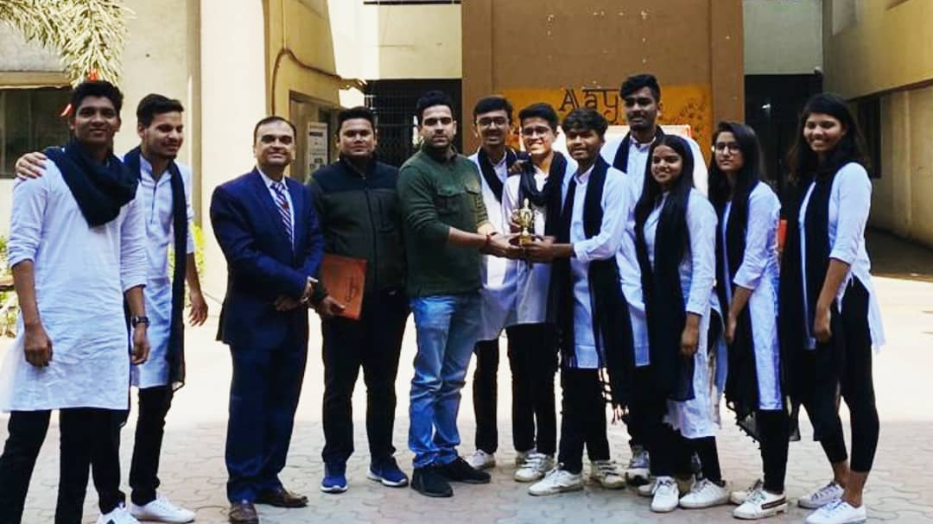
WINNERS OF NUKKAD NATAK – STUDENTS OF MSCET COLLEGE

Submitted By:
Prof. Vijay Kothari
(N.S.S Program Officer)

