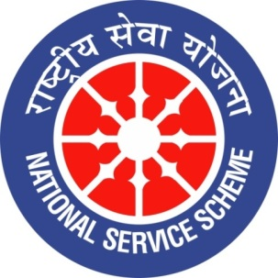
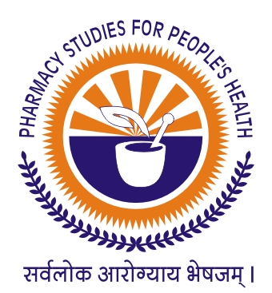
GUJARAT TECHNOLOGICAL UNIVERSITY
NATIONAL SERVICE SCHEME
SARDAR PATEL COLLEGE OF PHARMACY, BAKROL (244)
A Report on “NETAJI SUBHASHCHANDRA BOSE BIRTHDAY CELEBRATION” of SARDAR PATEL COLLEGE OF PHARMACY, BAKROL (244)
NSS Unit Name/College Name:Sardar Patel College of Pharmacy, Bakrol (244)
Event NAME: “NETAJI SUBHASHCHANDRA BOSE BIRTHDAY CELEBRATION”
Event Date, Time and Location: 23-01-2020
Brief Description of the Event:
Every year 23rd January is observed as Netaji Subhash Chandra bose’s Birthday in India. During Freedom movement Subhashchandra bose had gave significant contribution and his defiant patriotism made him national hero. Netaji was known for his fighting attitude and stratagies agaist british raj. To culminate his thoughts and attitude in students, NSS team of Sardar Patel College of Pharmacy, Bakrol also celebrated birthday of Netaji Subhash Chandra bose. In which, NSS officer, gave a short speech about the life of netaji followed by Tiranga rally was arranged in campus premises and 50 Students Participated in it with zeal.

23-01-2020
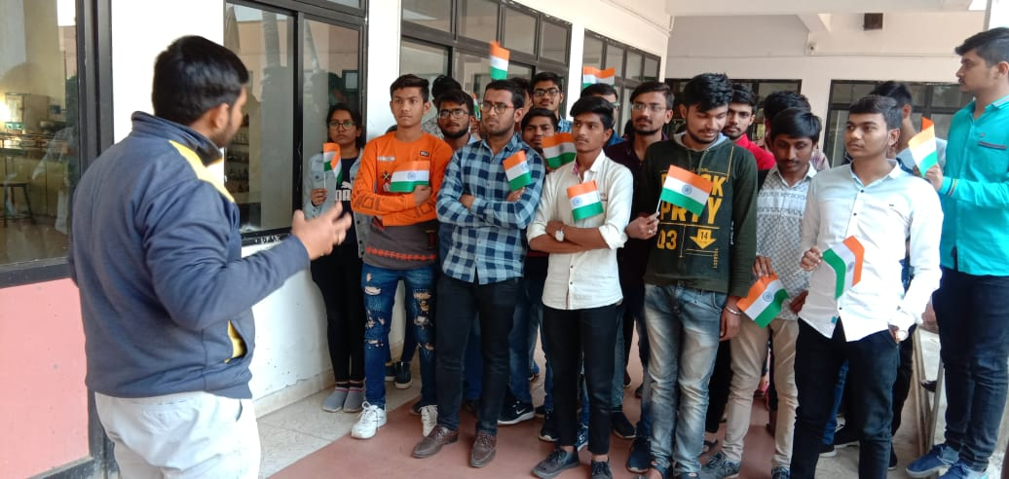
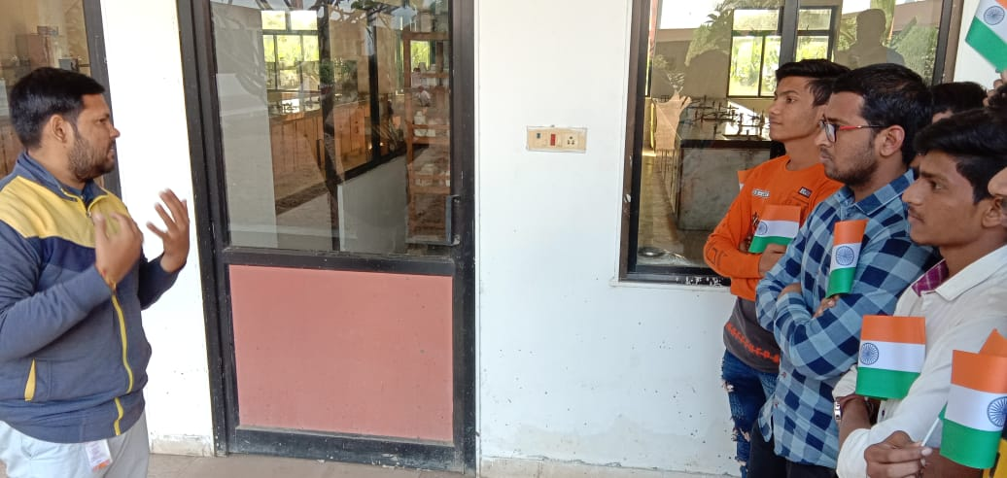
Major Outcomes of Event:
- To aware our young generation about life of Netaji Subhashchandra Bose and his contribution towards India’s freedom movement.
- To culminate his thoughts and attitude in students.

Mr. Zalak D. Dave Dr. Samir K. Shah
NSS Program Officer Principal

