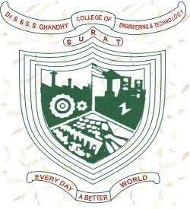
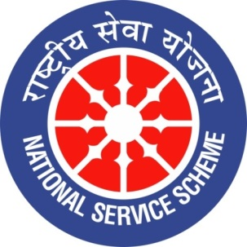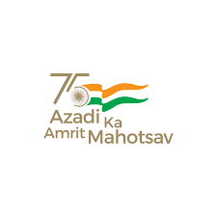
Dr. S & S. S GHANDHY COLLEGE OF ENGG. & TECH. SURAT

A Report on International Yoga Day Celebration on 21/6/2022
Event Date, Time and Location: 21-06-2022, 7:30 AM to 9:00 AM Seminar Hall (female staff and students) institute Dome (male staff and students) Ghandhy College, Surat
Brief Description of the Event:
Under Aazadi ka Amrut Mahotsav celebrations, The International Yoga Day celebration was arranged by Dr. S & S. S. Ghandhy college of Engg. & Tech., Surat on 21st June, 2022. Total 91 staff and 74 students enthusiastically participated in the same.
Photographs of the Event:

