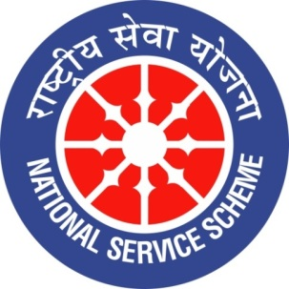
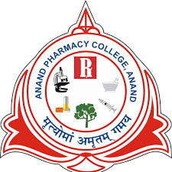
GUJARAT TECHNOLOGY UNIVERSITY
NATIONAL SERVICE SCHEME
ANAND PHARMACY COLLEGE
A Report on Seed Ball Plantation 2022
NSS Unit Name/College Name: Anand Pharmacy College
EVENT NAME: Seed Ball Plantation
Event Date: 25/06/2022
Theme: Seed Ball Plantation
Time: 12:00 to 12:40 PM
Place: Anand Pharmacy College, Anand
Participant: NSS Volunteers, Teaching staff.
Total Participant :34
Brief Description of the Event:
NSS unit of Anand Pharmacy College, Anand had organised a Seed Plantation Programme on 25th July 2022. It was great experience for all those who participated . There was total 34 participants out of which 32 were the students and the other 2 were faculty members of the college itself. The programme commenced with Preparation of seed balls (seeds including Jamun, Neem, Mango, Ashoka and Papaya) which was further followed by throwing a ball in fertile soil.

Major Outcomes of Event:
This activity will be an initiative to limit global warming by effectively reducing atmospheric Carbon dioxide (CO₂).
Photograps of event:

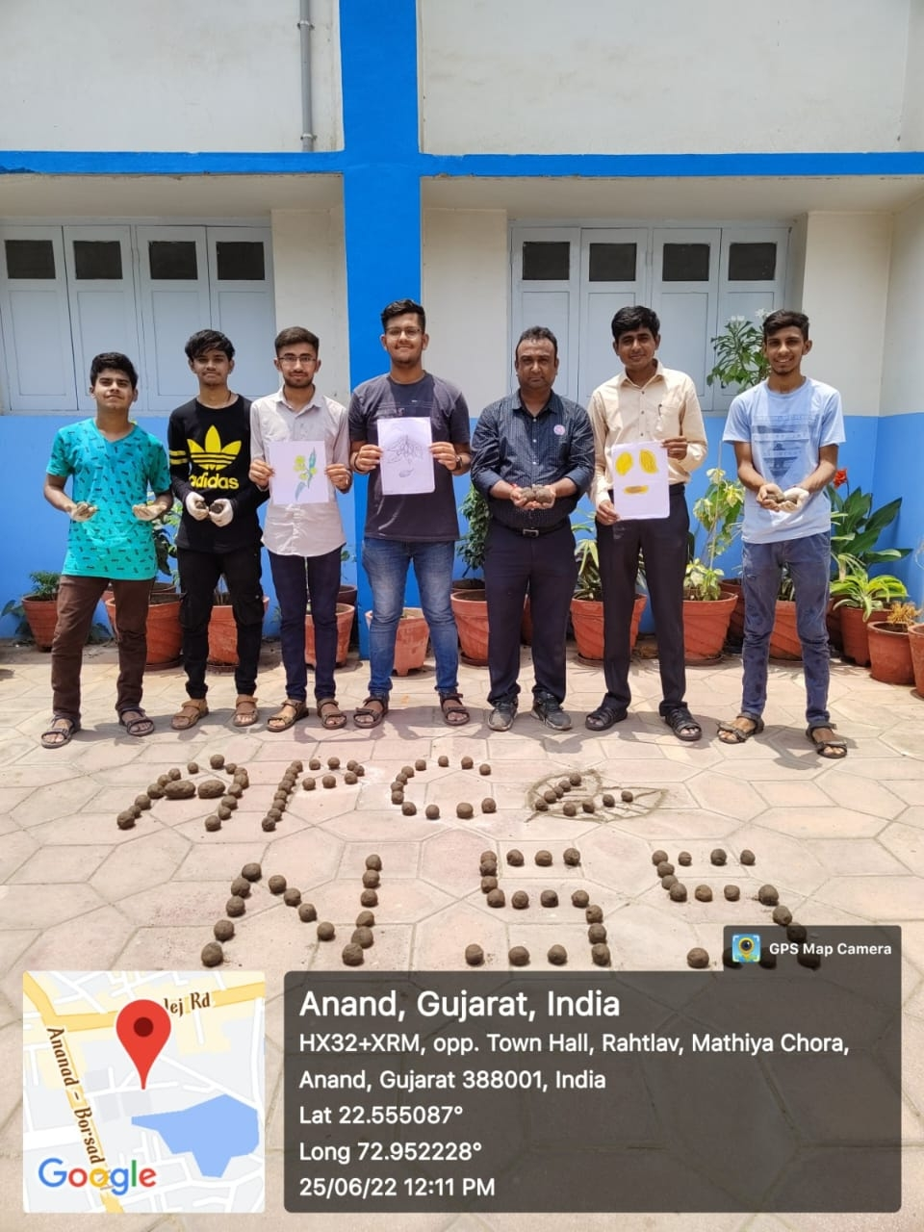
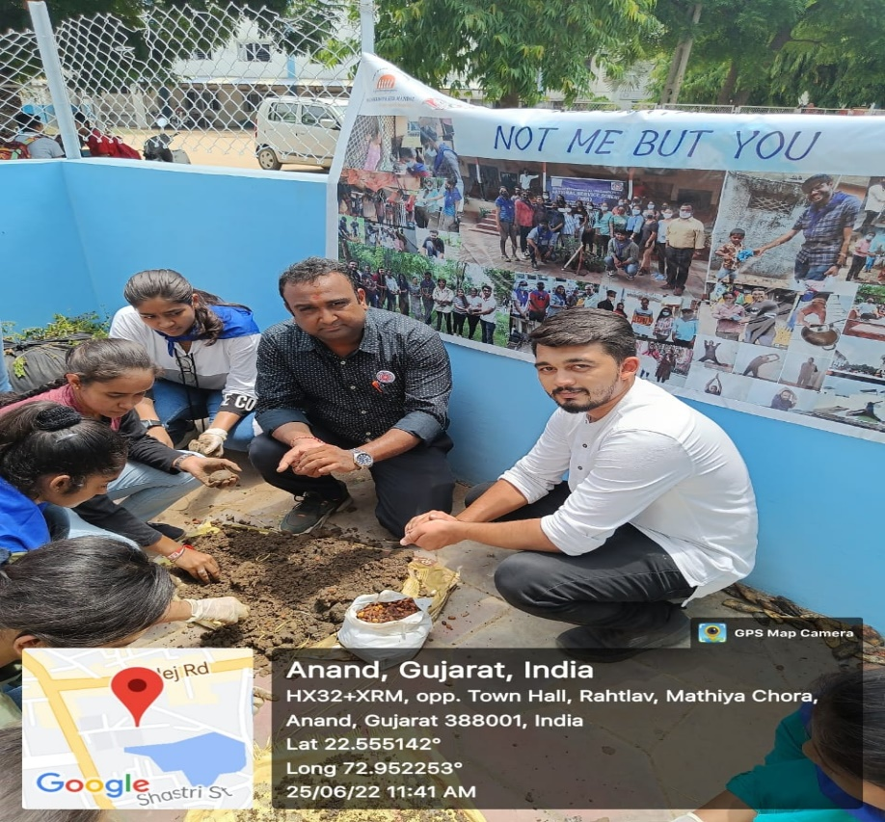

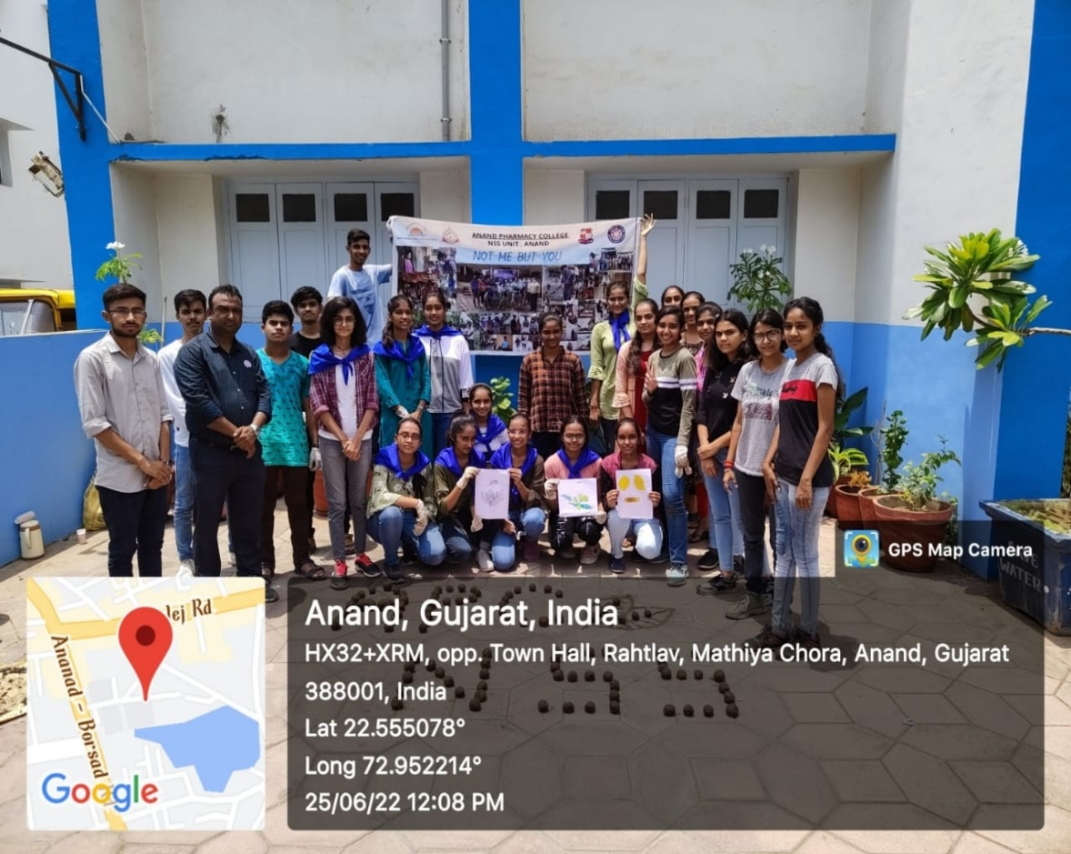
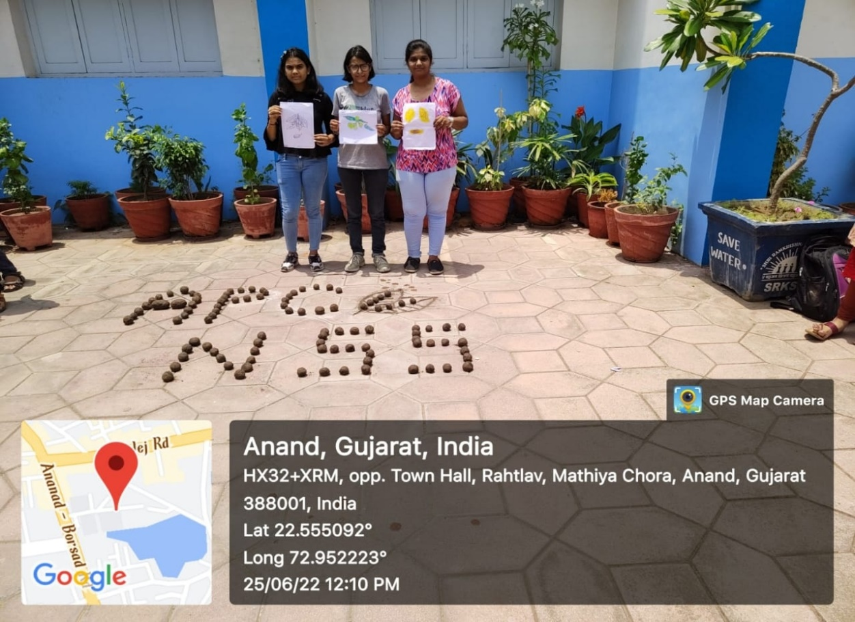
List of Participant:
Name Roll no Sign
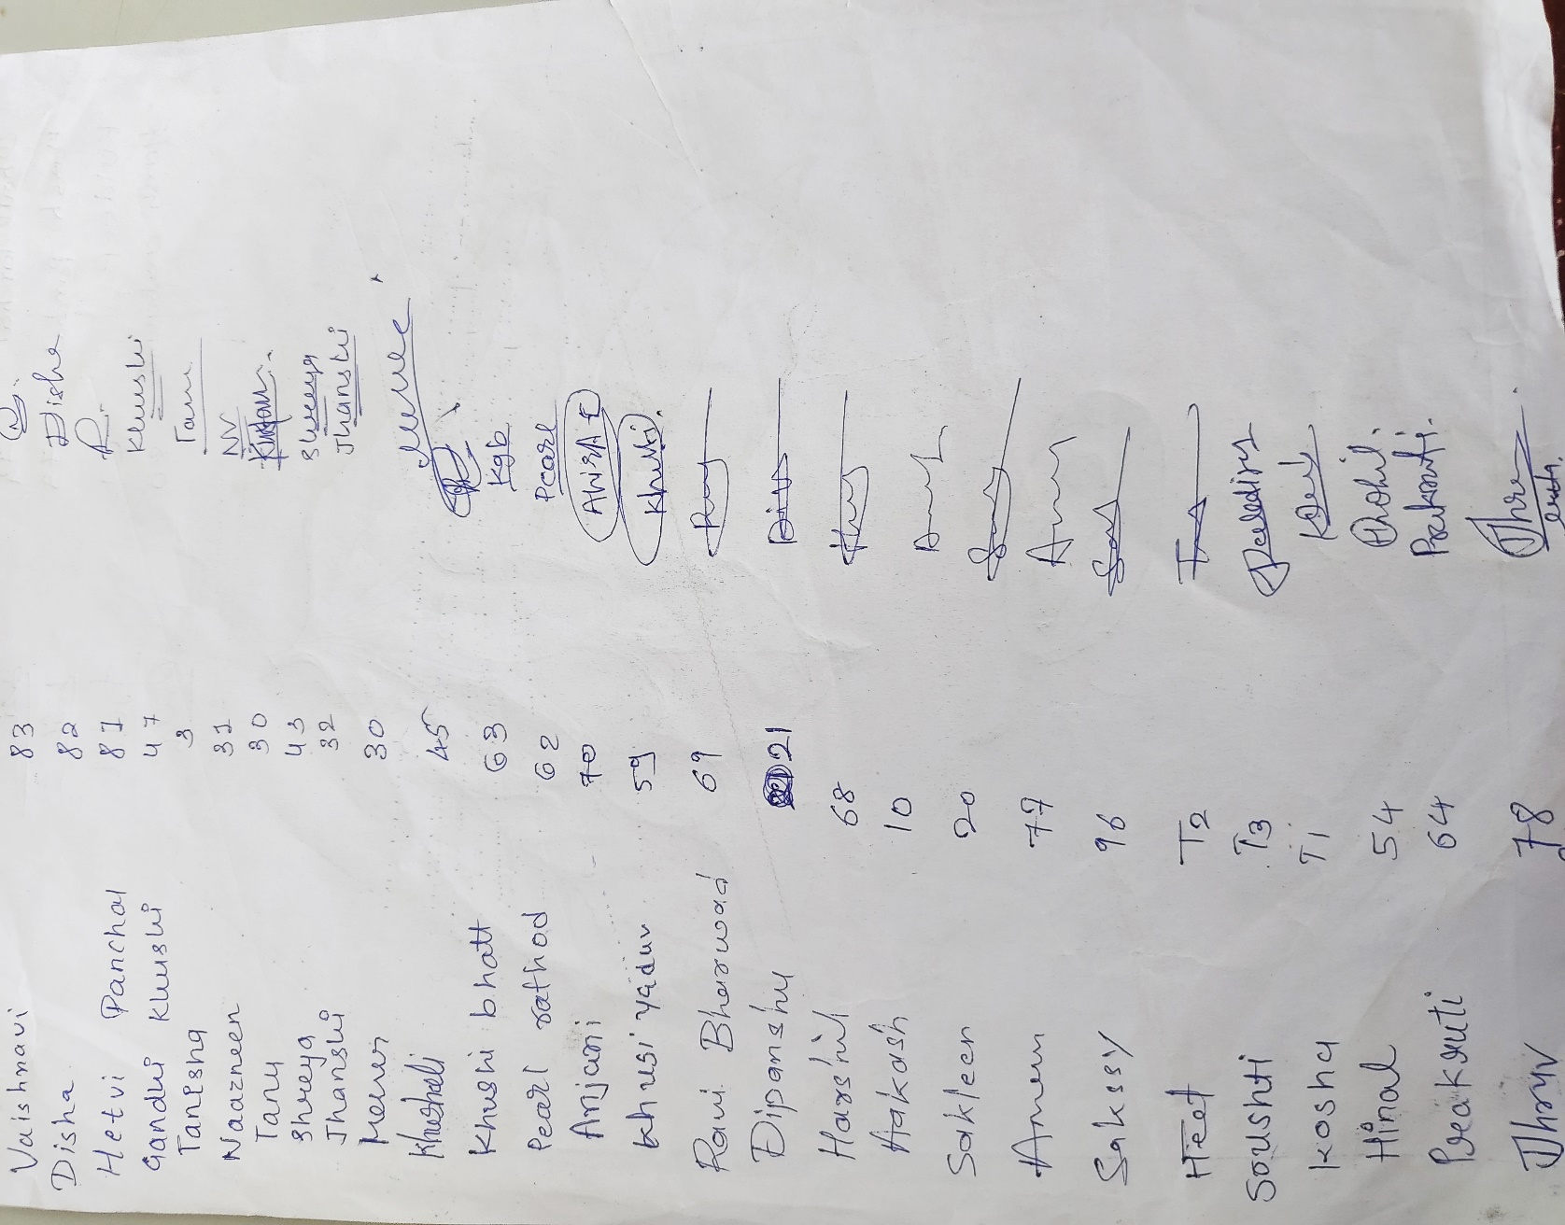

Faculty Members
- Mr.Subhashchandra K. Patel
- Dr. Rajesh Parmar

Name and Sign of NSS PO: Mr. Subhashchandra K. Patel 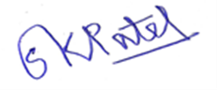

Name and Sign of Student Head: Ms. Janki M. Patel

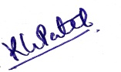
Name and Sign of Principal/ Vice Principal: Dr Tejal R. Gandhi / Dr. Kalpana G. Patel

