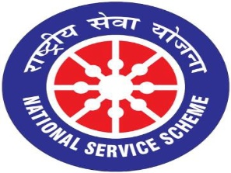
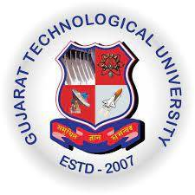
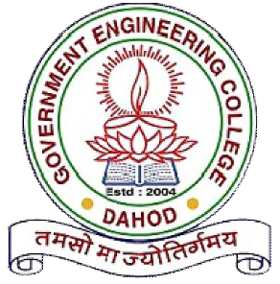
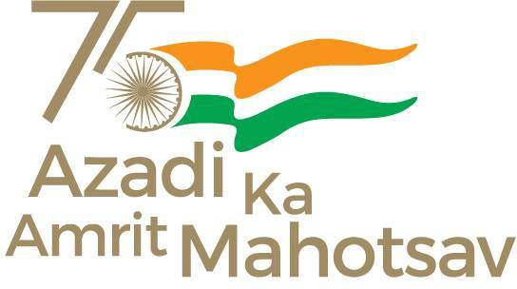

Gujarat Technological University NATIONAL SERVICE SCHEME

Government Engineering College-Dahod (018)
A Report: Seedball Prepration and Plantation Activity on 29-06-2022, Dahod
Brief of the Event:
Government Engineering College, Dahod organized Activity under National Service Scheme (NSS). A committee work under the “આજાદી કે અમૃત મહોત્સવ પર એક ભારત શ્રેષ્ટ ભારત કે પાંચ પ્રકલ્પ” as per the directives of Directorate of Technical Education, Gujarat state and Ministry of Youth Affairs & Sports, Government of India.

As a part of Panch- Prakalp activities, on 29th June 2022, Seedball Prepration and Plantation Activity is organized by NSS unit of GEC Dahod At GEC Dahod Campus, Dahod. Dr. Manoj K. Singh (Assistant professor, Maths Dept.) is the programme coordinator and Divyanshu, Gaurav, Farida, Rukaiya, Greshi and Greni are the student coordinators who successfully organized this event.
Major Outcome:
Students are aware with the importance of plants for our environment.

Attached photograph Here.
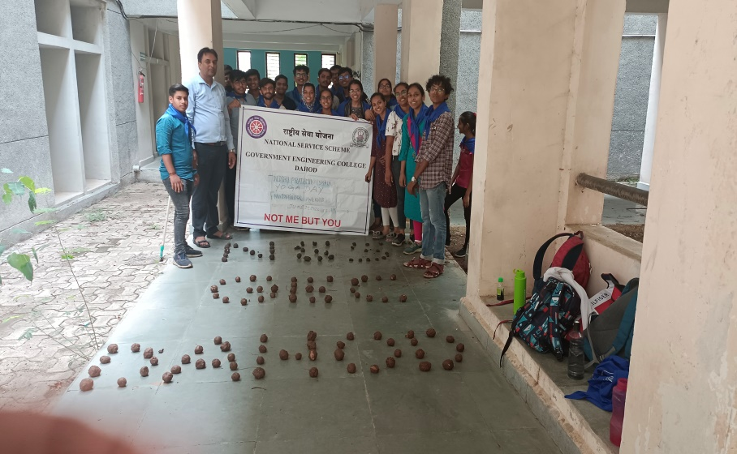 | 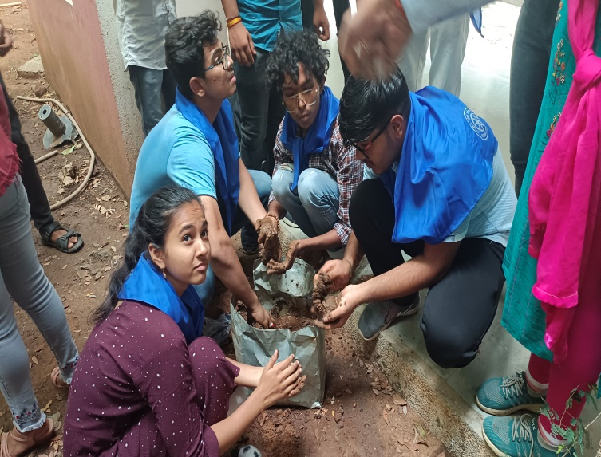
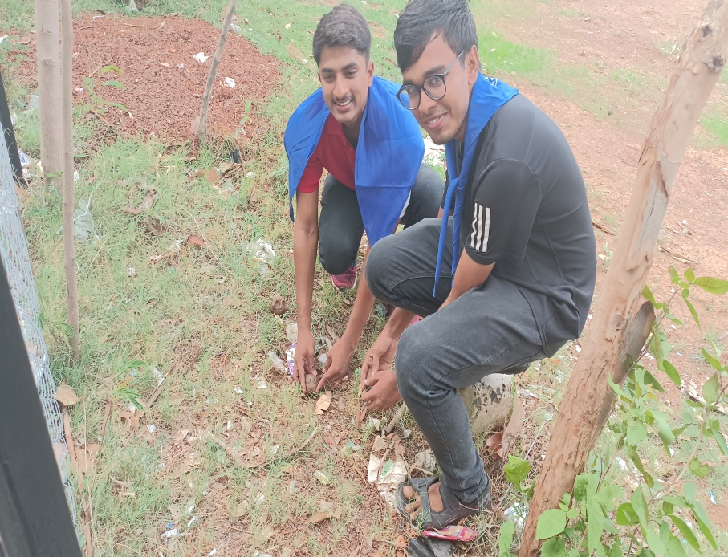 | 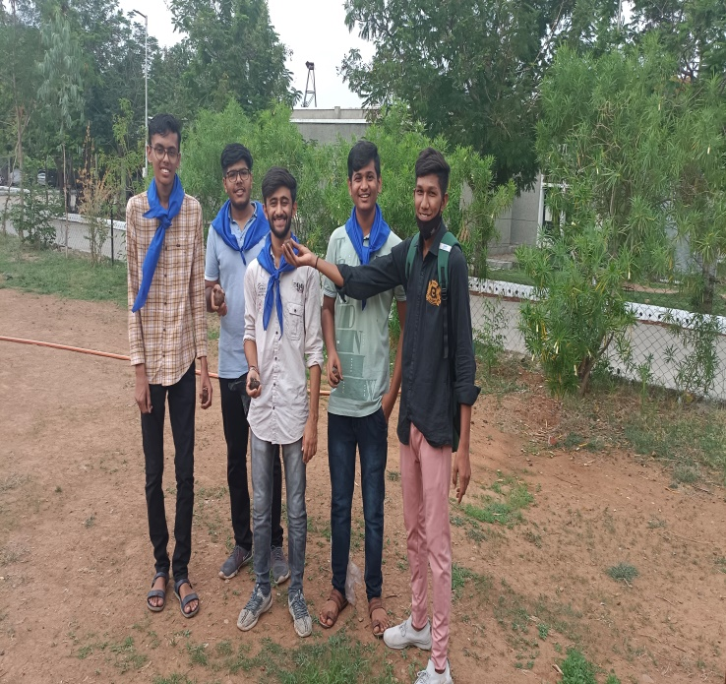
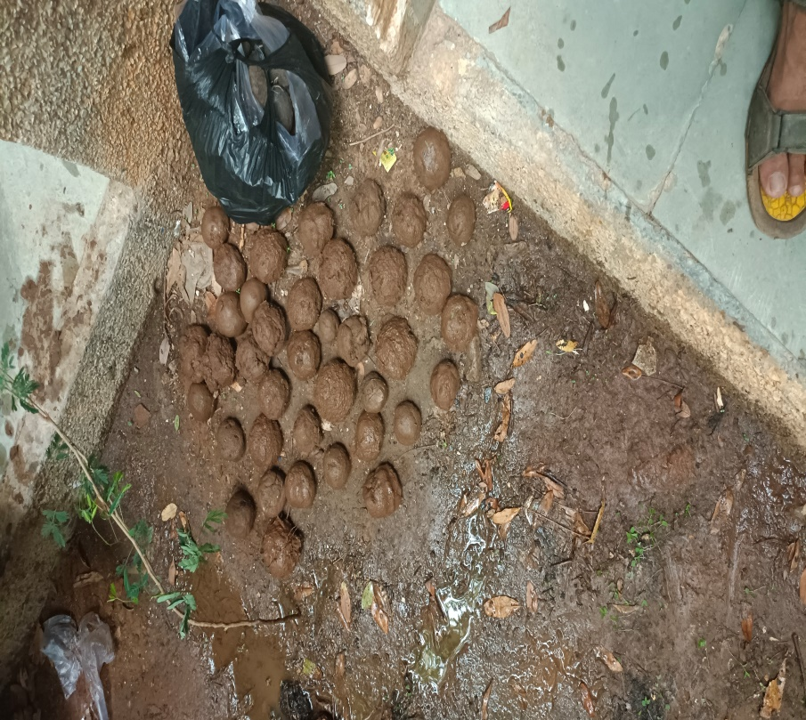 | 