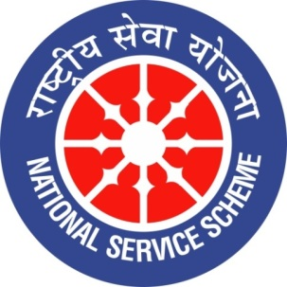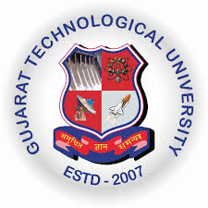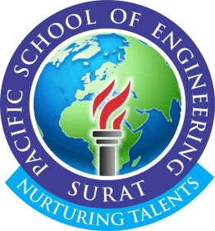
GUJARAT TECHNOLOGY UNIVERSITY
NATIONAL SERVICE SCHEME
PACIFIC SCHOOL OF ENGINEERING
A Report on BLOOD DONATION CAMP on 21/01/2020 of PACIFIC SCHOOL OF ENGINEERING -SURAT

NSS Unit Name/College Name: Pacific School of Engineering- Kadodara, Surat
Event NAME: Thalassemia and Sickle cell check up camp
Event Date, Time and Location: 21/01/2020 , 10:00 am onwards and B - 104 (Physics Lab)
Brief Description of the Event: We had organized a Thalassemia and Sickle cell check up camp association with Indian Red Cross Society , Ahmedabad at our campus. There were a team of 02 doctors. Oune doctor also gave motivational speech and video to students regarding Thalassemia .
Major Outcomes of Event:
Total 80 students were tested by doctors.
Photographs of the Event:

