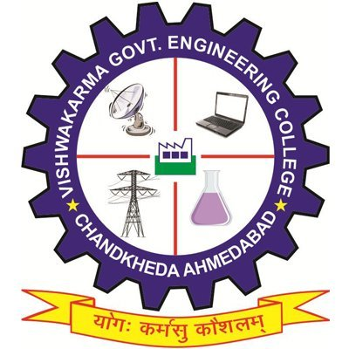
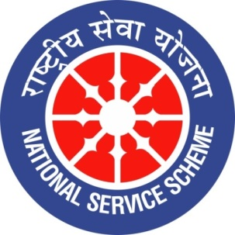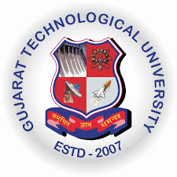
GUJARAT TECHNOLOGICAL UNIVERSITY
NATIONAL SERVICE SCHEME
VISHWAKARMA GOVERNMENT ENGINEERING COLLEGE, CHANDKHEDA
NSS VGEC
A Report on universal children’s day celebration.
NSS Unit Name/College Name: NSS VGEC (VISHWAKARMA GOV. ENG. COLLEGE)
Event NAME:-universal children’s day celebration with under privileged children.
Event Date, Time and Location:-21 November 2019, slum areas near tapovan circle, 01:00 PM to 03:00 PM.
Brief Description of the Event:-
It is rightly said that god is closest to children because they have purest hearts and minds. The rights of some of these purest souls are snatched away from them at a very young age, in fact they are not aware of their rights. Children are gift of god and they must be brought up with proper care and attention but unfortunately some children are not getting proper nourishment and education. So to encourage such blooming buds and made them aware about their rights NSS VGEC has planned to celebrate universal children’s day with under privileged children. Volunteers of NSS VGEC visited slum areas and spent couple of hours with children residing there and did several activities with them.
They encouraged the children to study and also their parents to get them admitted in school. The celebration was carried forward by playing several games with those children and telling them motivational and historical stories. Children enjoyed spending time with volunteers and learned some good things. At last they were provided snacks and celebration completed with a huge satisfying smiles on their faces and a great bliss in hearts.

Principal of VGEC Dr. N.N Bhuptani praised this activity and said that he believes that every child must know his rights and should be given proper care and education because he is the one who will change the future of nation.
Prof. Alpesh Dafda said,“ Children are world’s most precious resources if guided in a proper manner they can change the world ”.

Major Outcome of The Event:
- Children came to know about their rights and have fun performing different activities .
Images of Event:-

