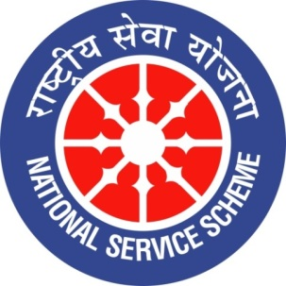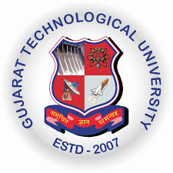
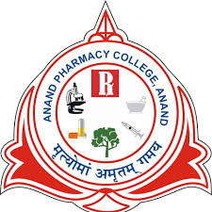
GUJARAT TECHNOLOGY UNIVERSITY
NATIONAL SERVICE SCHEME
ANAND PHARMACY COLLEGE
A Report on INTERNATIONAL YOGA DAY CELEBRATION 2022
NSS Unit Name/College Name: Anand Pharmacy College
EVENT NAME: INTERNATIONAL YOGA DAY CELEBRATION 2022
Event Date: 21/06/2022
Theme: YOGA for Humanity
Time:7:30 to 8:10 AM
Platform: Anand High school, Anand
Participant: NSS Volunteers, Teaching & Non-teaching staff.
Total Participant :45
Brief Description of the Event:
NSS unit of Anand Pharmacy College, Anand had celebrated International Day of Yoga 2022 on 21st June 2022. It was great experience for all those who participated . There were total 45 participants out of which 42 were the students and the other 3 were faculty members of the college itself. The programme commenced with recitation of prayer which was further followed by performing different Yoga Asana.

Major Outcomes of Event:
Practicing yoga aids in achieving mindfulness along with balance, strength and flexibility. This event left a very educative and inspiring impact on the participants. Performing yoga on regular basis helps us attain discipline and consistency in our day to day life.
Photograps of event:
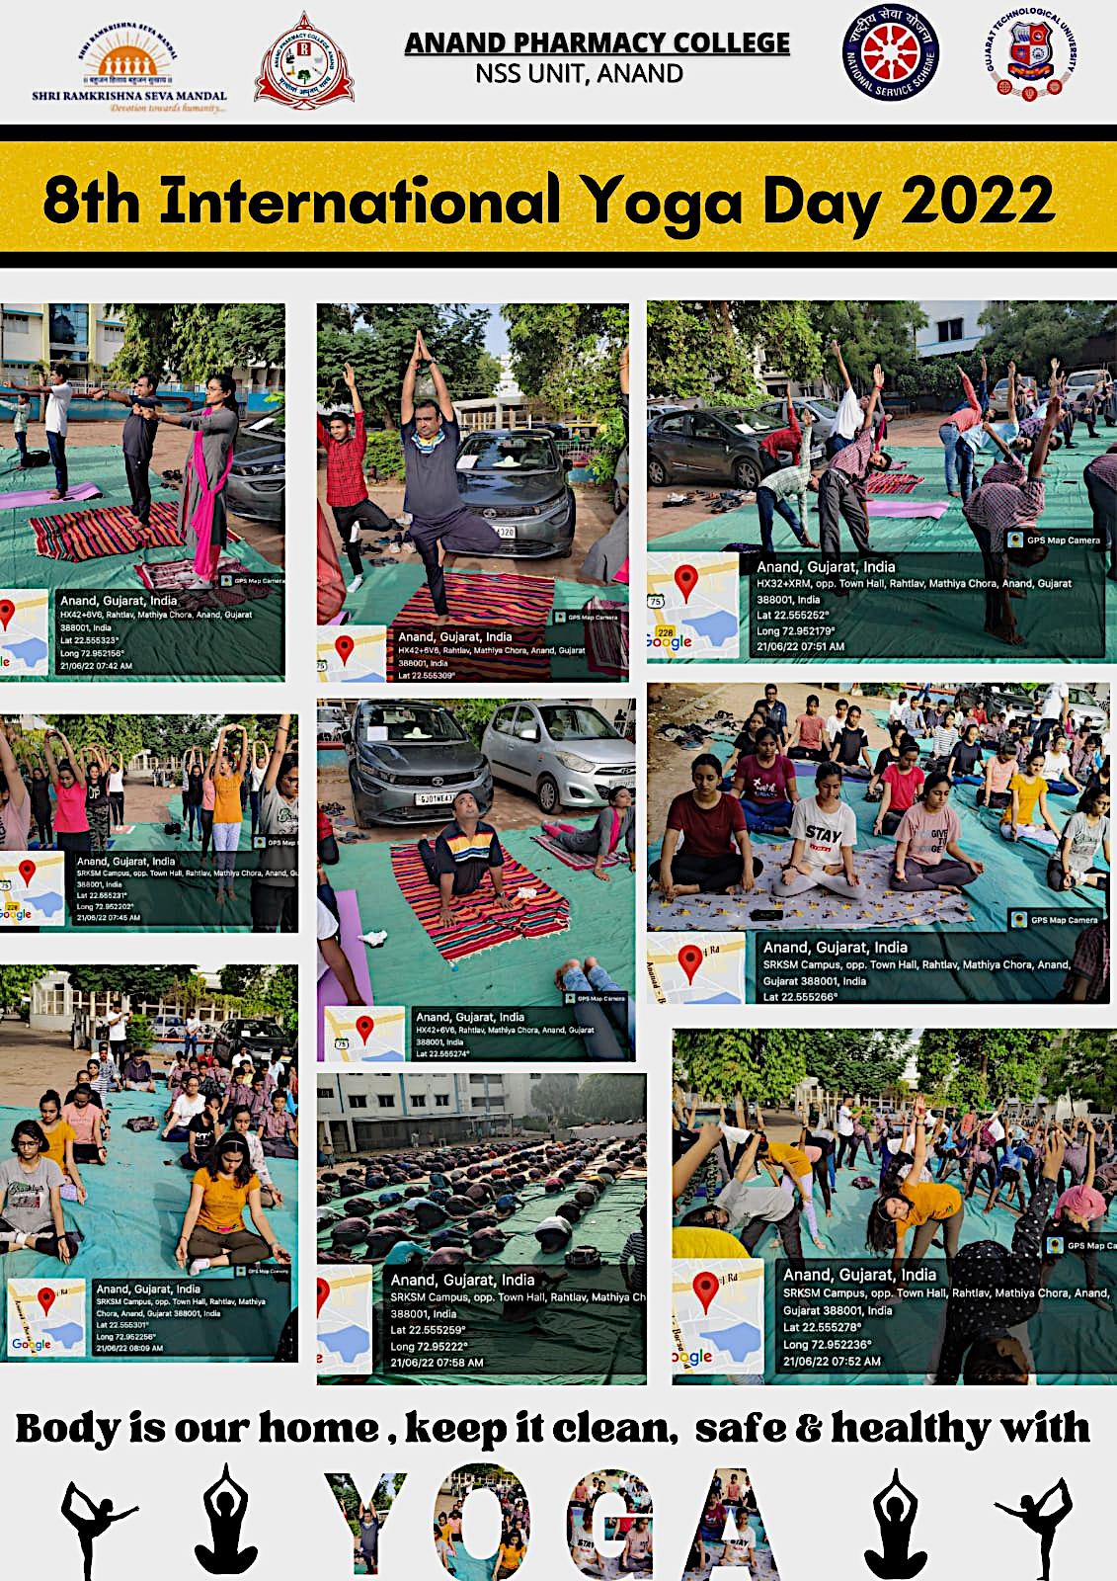

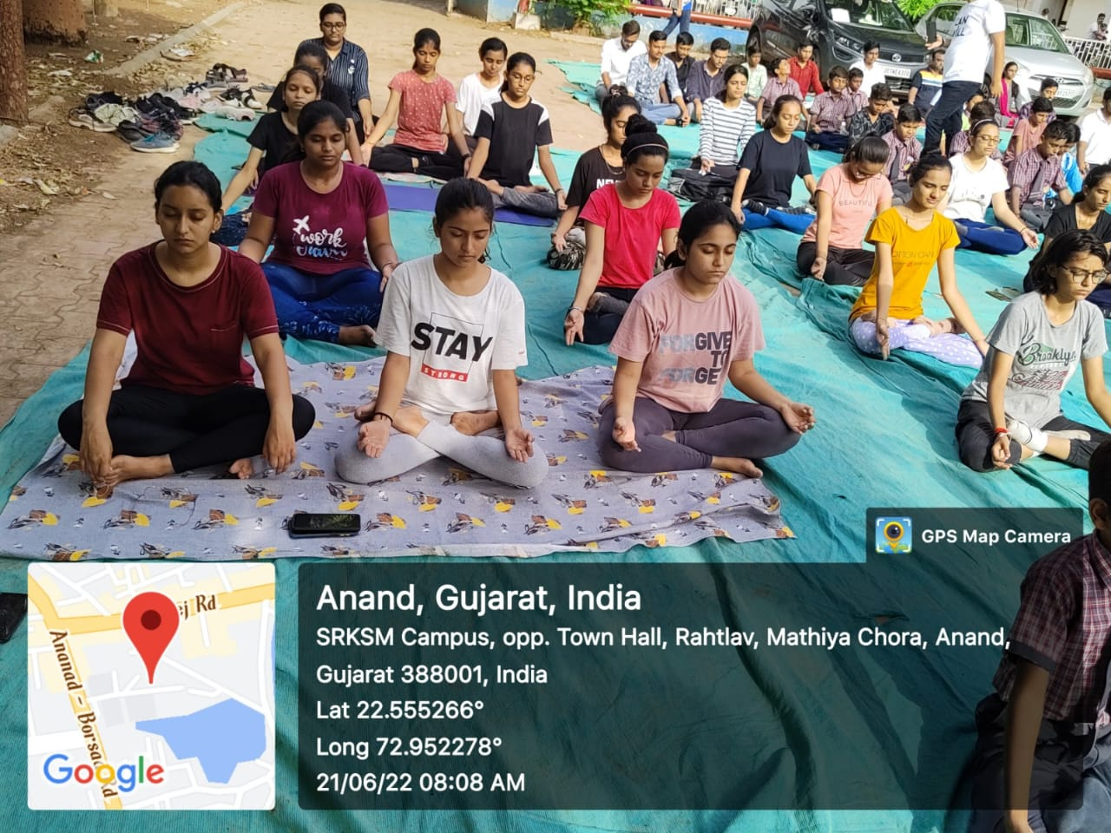
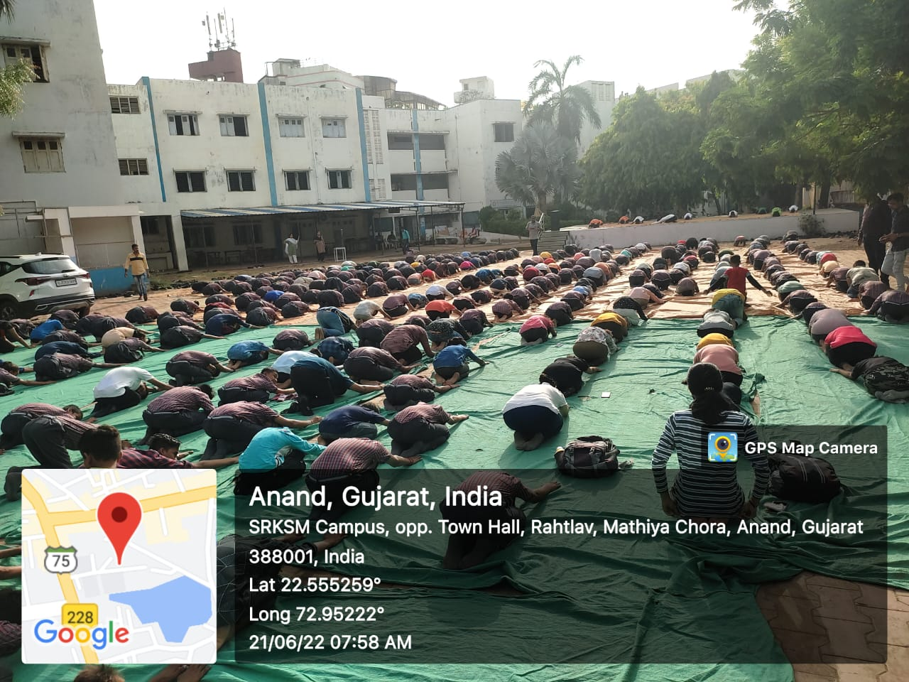
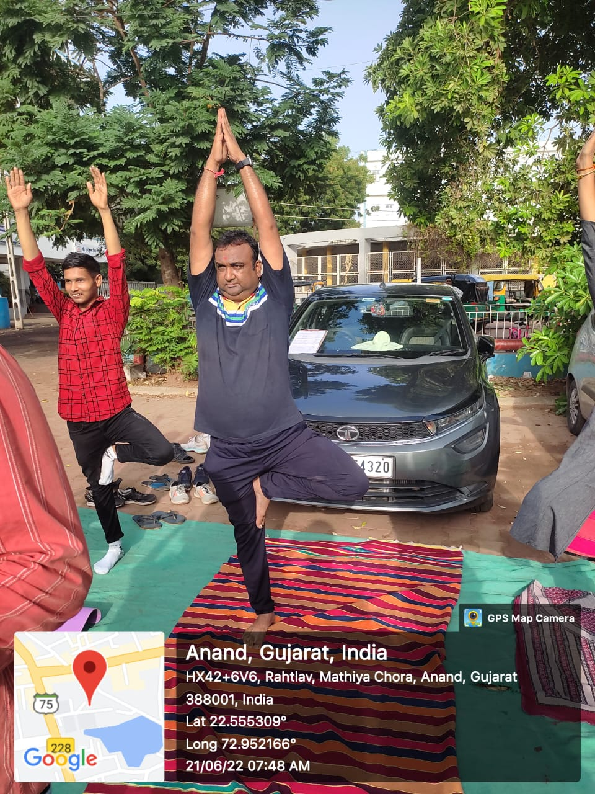

List of Participant:
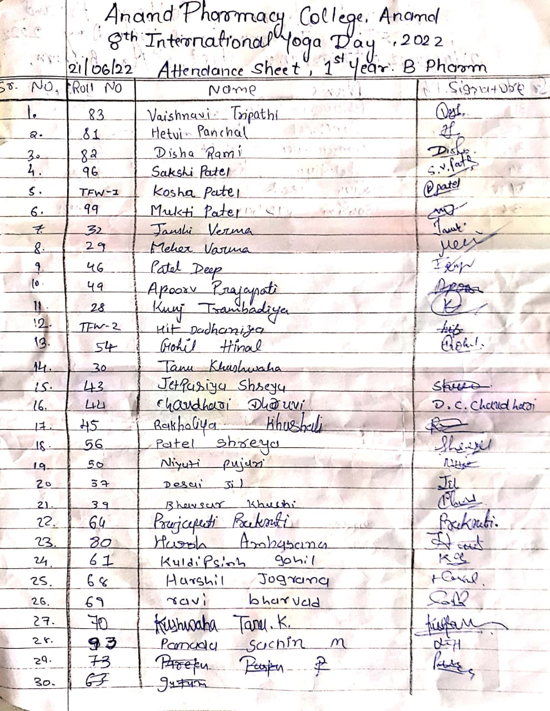
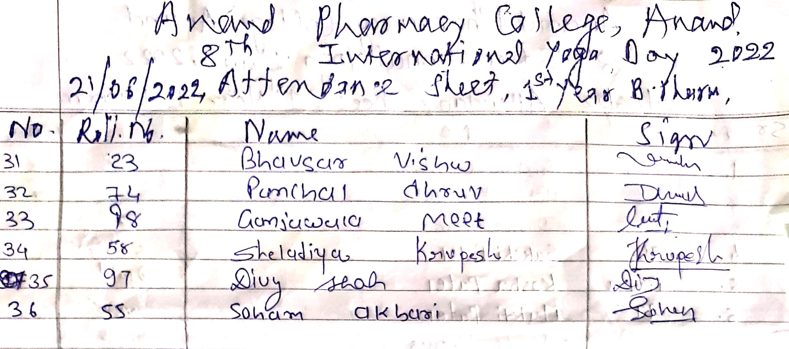
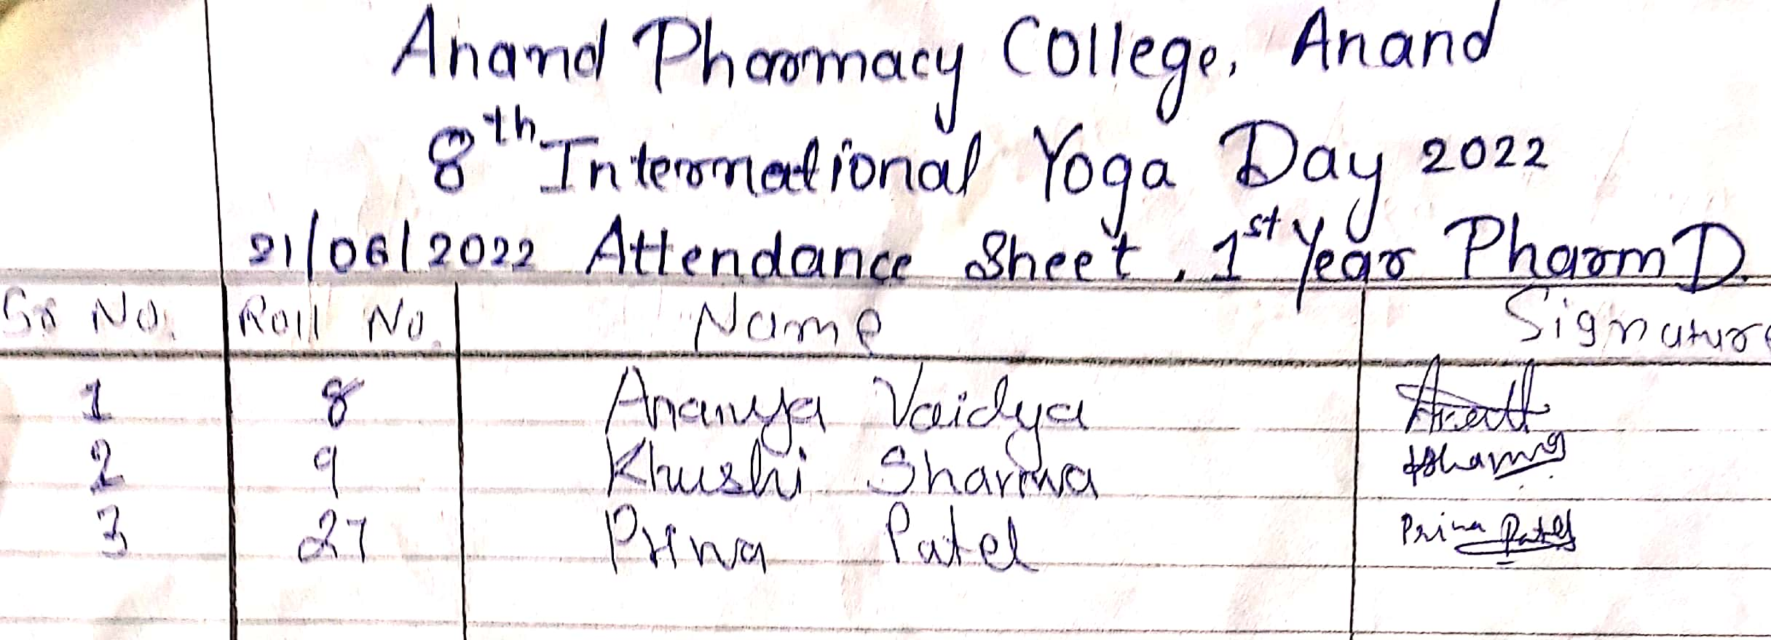
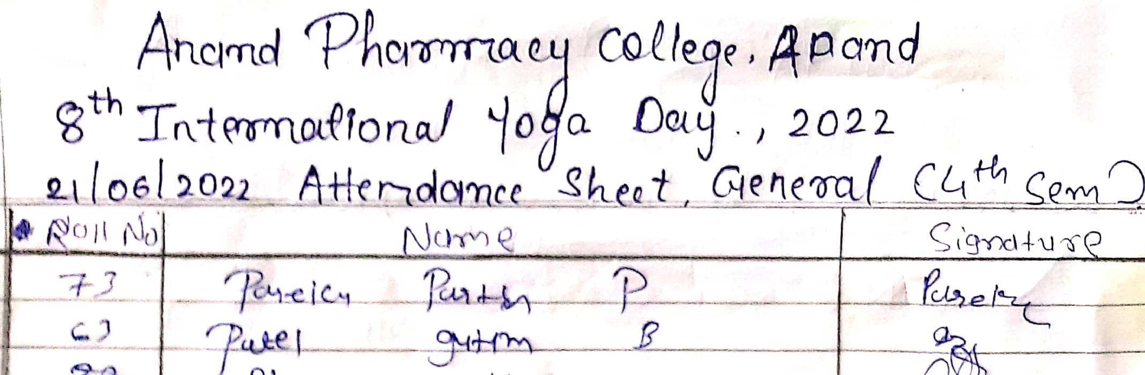
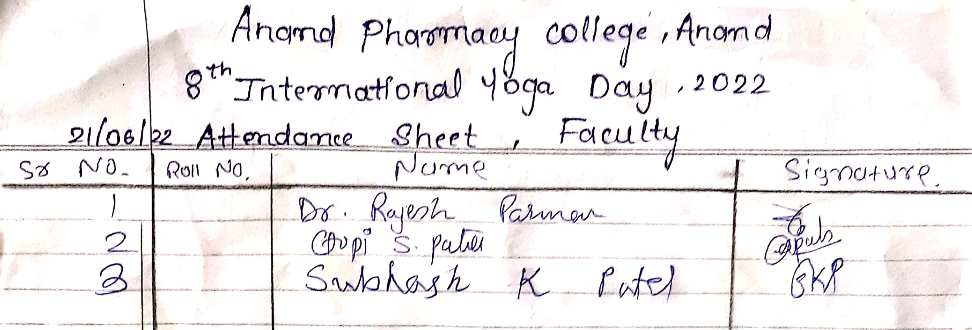

Name and Sign of NSS PO: Mr. Subhashchandra K. Patel 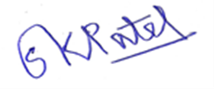

Name and Sign of Student Head: Ms. Janki M. Patel

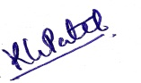
Name and Sign of Principal/ Vice Principal: Dr Tejal R. Gandhi / Dr. Kalpana G. Patel

