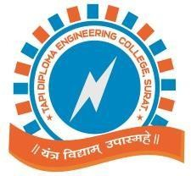
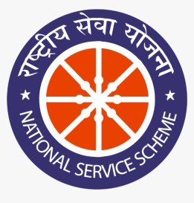

“YOGA SESSION”
On the Occasion of “International Yoga Day”

ORGANIZED BY
NSS COMMITTEE

FROM

13-06-2022

TO

21-06-2022

AT
Seminar Hall,
TAPI DIPLOMA ENGINEERING COLLEGE

REPORT PREPARED BY:

Mr. D. S. JARIWALA

NSS COORDINATOR &LECTURER IN MECHANICAL DEPARTMENT

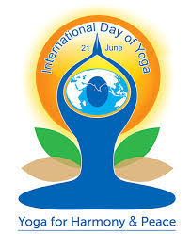

Yoga is known for its amazing health benefits. International Yoga Day, celebrated on the 21st of June each year ever since its inception in 2015, is a great effort to emphasize the importance of inculcating this ancient Indian art in our lives. The proposal to celebrate International Yoga Day was put forward by the Indian Prime Minister, Shree. Narendra Modi in September 2014.
We arranged total 7 sessions from 13th June to 20th June for students of various branches where around 200 students were participated.
Mr. Kush patel, who is 3 time champion in international yoga competition, was a guide for yoga session. Under his guidance around 75 staff members was performed different yoga’s
Today 21st June 2022, in our campus we have celebrated yoga day with all students, staff, and trustee members. Programme was started at 8.00 am proceed by Three OMKAR’S followed by sweet melody of trust song and further YOGA session was commenced by Mr. Khush Patel for an hour.
During the session atmosphere was enthusiastic and found helpful for all the participants. At last the programme was concluded by National Anthem at 10.15 am.

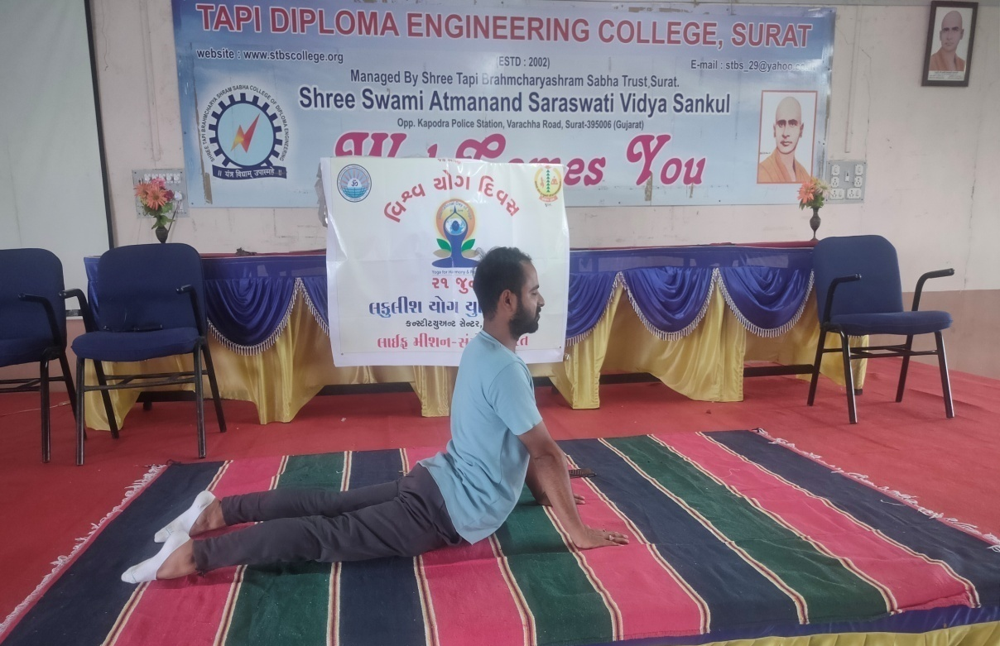
Mr. Kush Patel –Yoga Trainer
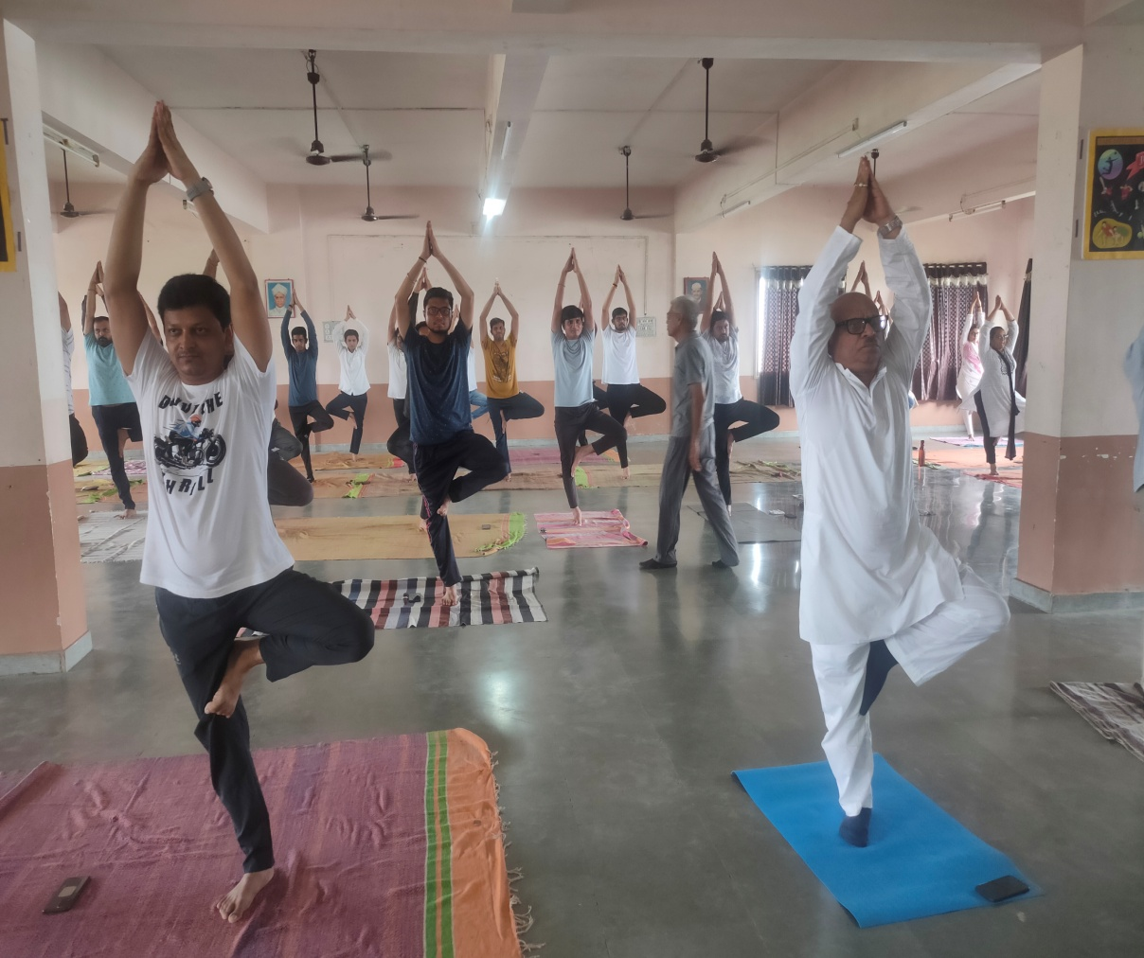
Dr. Y.S.Choupare (Principal), Dr. K.D.Vaghani(Treasurer-STBS Trust) with staff members.
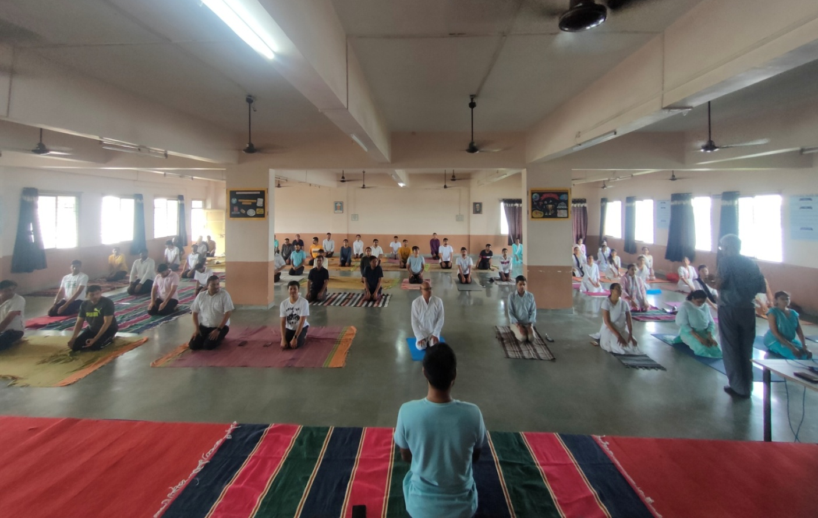
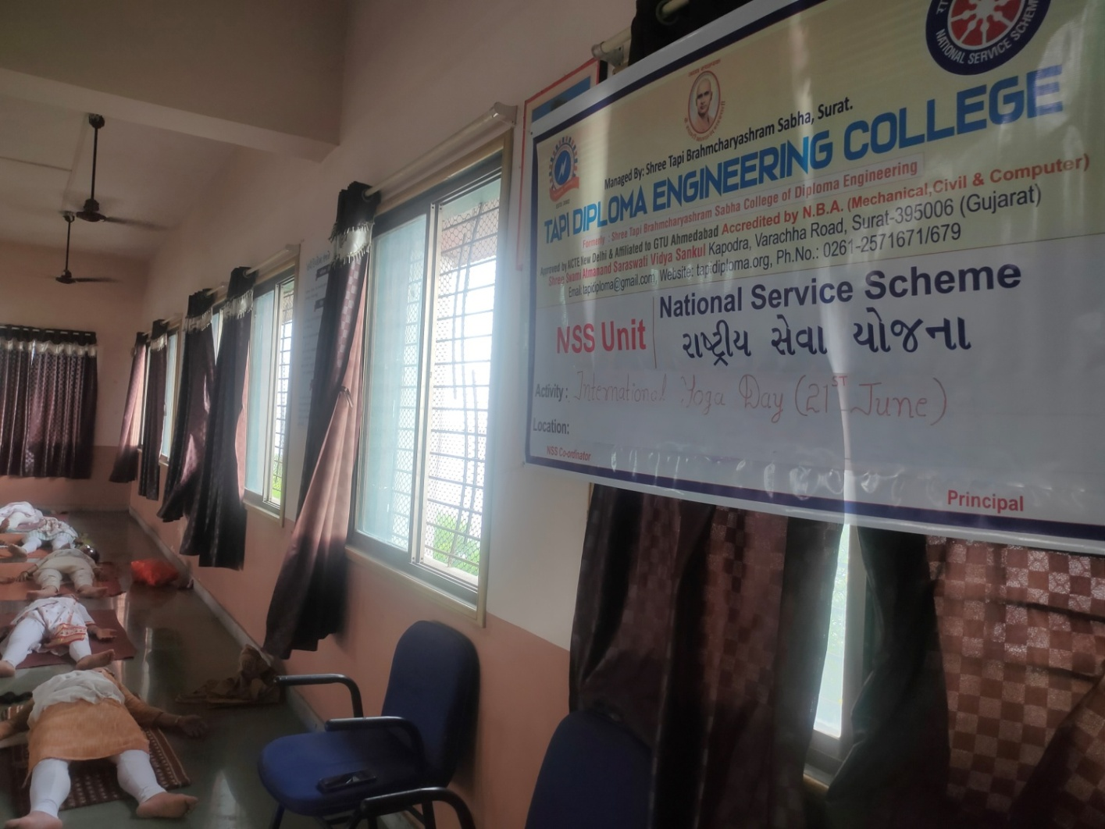

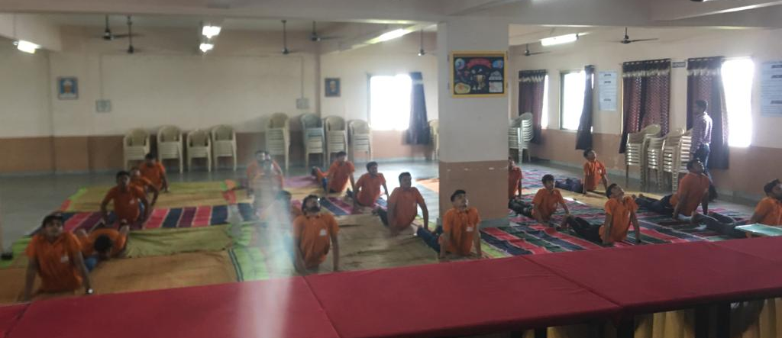
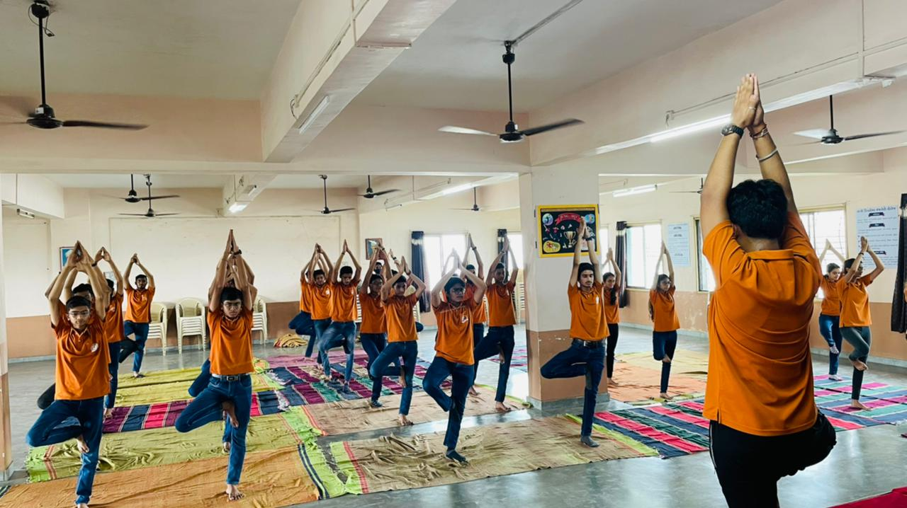

Principal
Dr. Y. S. Choupare

