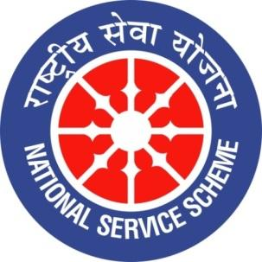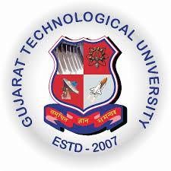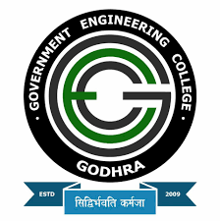
GUJARAT TECHNOLOGY UNIVERSITY
NATIONAL SERVICE SCHEME
GOVERNMENT ENGINEERING COLLEGE GODHRA
A Report on INTERNATIONAL YOGA DAY CELEBRATION from15th to 21st JUNE, 2022 of NSS CELL, GEC GODHRA

NSS Unit Name/College Name: NSS CELL, GEC GODHRA
Event Name: INTERNATIONAL YOGA DAY CELEBRATION 2022
Event Date, Time and Location: 15th JUNE to 21st JUNE, from 07:00 am to 07:30 am at the GEC GODHRA
Brief Description of the Event:
Yoga day is celebrated on 21st June every year since 2015, and we celebrate this day with the world. Each year NSS CELL, GEC GODHRA, commemorate this event by organizing a yoga camp where students and faculty members of our college gather to do yoga and learn about the ancient Indian art of healthy living. This year this event was organized from the 15th to the 21st of JUNE, and Prof. D.P. Pathak, along with Ranjan Patel (M.A. Sanskrit), a Qualified Yoga Trainer, conducted the Yoga camp.
In this seven-day event, the first day of yoga shibir started with the welcoming speech from Prof. D.P. Pathak and Prof. N.J. Parmar, after which Pathak sir introduced Ranjan Patel, a Qualified Yoga Trainer, and she started with a speech about yoga and its value in our life. She then taught yoga asana to all the faculty members and students. After completing yoga asanas, Prof. D.P. Trivedi taught meditation and breathing techniques. The yoga sessions continued for seven days, from 8:00 am to 9:00 am.
On 19 June, offline yoga sessions were not possible on Sunday, so Prof. D.P. Pathak conducted the yoga session of that day on the virtual platform. Students and faculty members joined the meeting on google meet, and they did yoga together by following the instructions and demonstration of Pathak sir. The day ended with the thoughts and reviews shared by Professors and students.
On the last day of yoga camp, Ranjan madam took the yoga sessions and taught some asanas to everyone. After completing it, she shared her views, and the program ended with a thank-you speech by Principal sir and Prof. Hardik Shukla sir and with the feedback and reviews shared by faculty members and students. The yoga camp was a success for all, and we learned many things from it.

Significant Outcomes of Event:
Some of the outcomes of these events are the following:
- Yoga intends to unite the body and mind to bring harmony; in the current situation, we need to be at peace and in connection with ourselves.
- Yoga originated in India, and we, the youth of India, need to learn about our roots, valves, and contribution to this world.
- Yoga is the ancient art of healthy living; we need this knowledge to thrive in this unhealthy environment.
PHOTOGRAPHS:
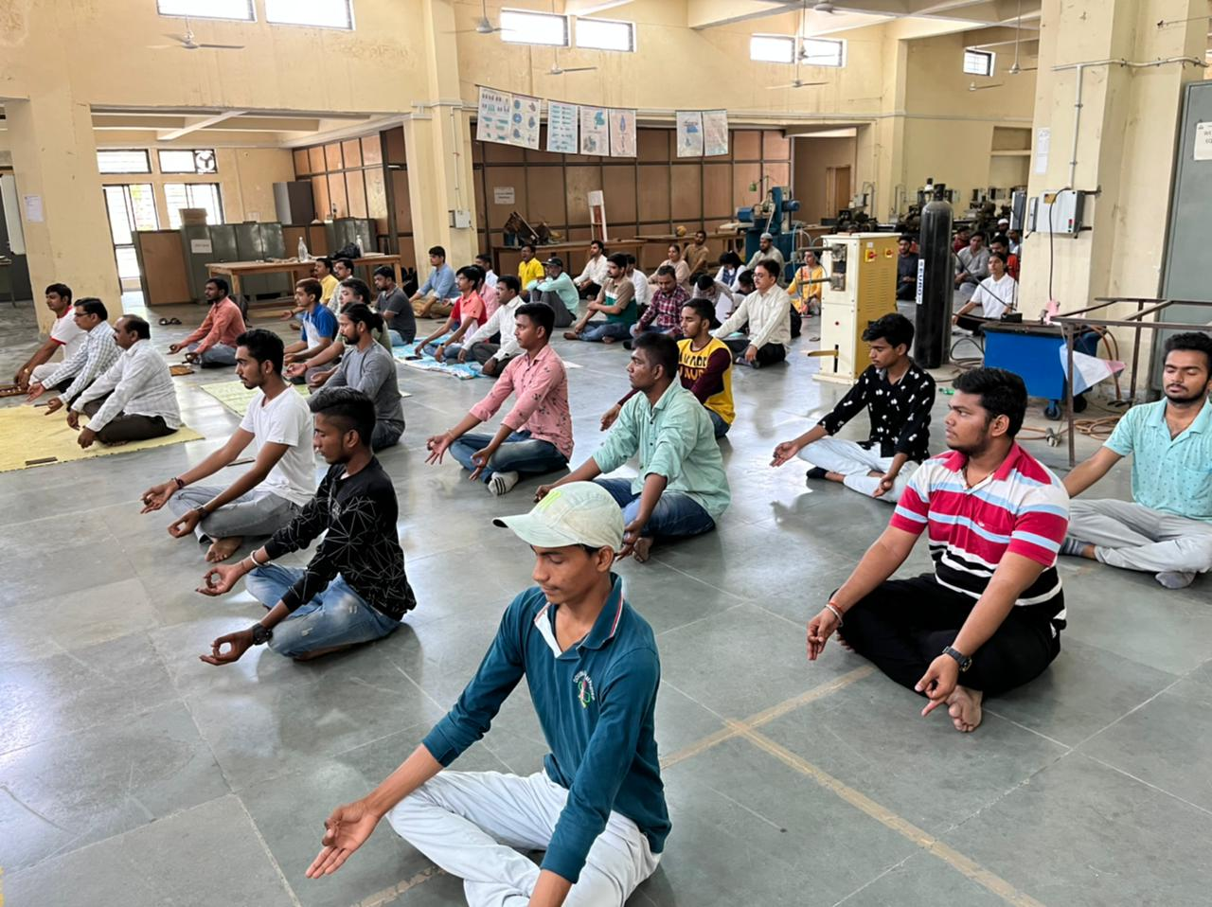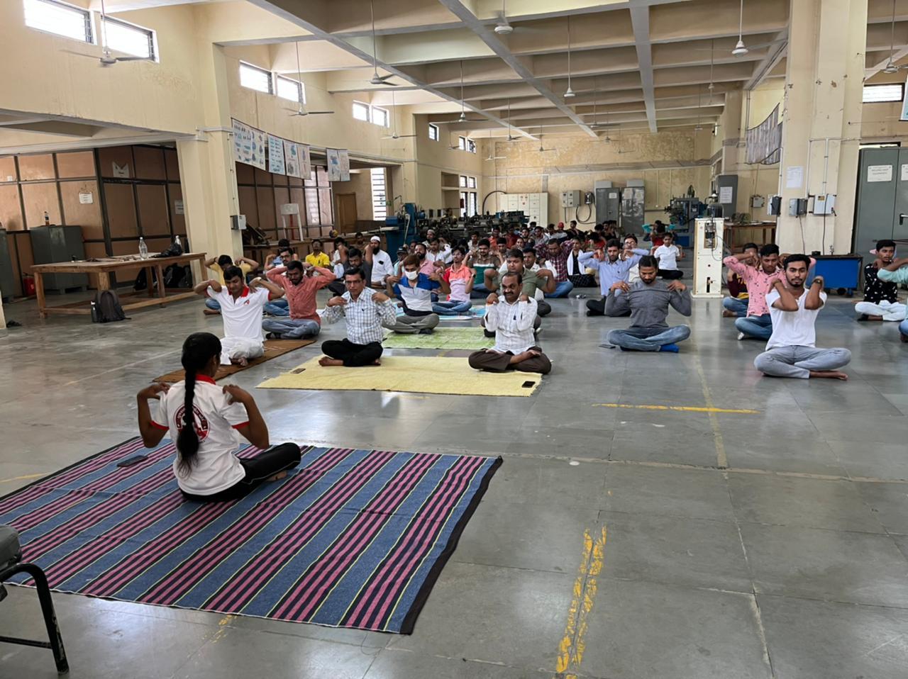

[STUDENTS AND PROFESSORS GATHER FOR YOGA IN WORKSHOP]

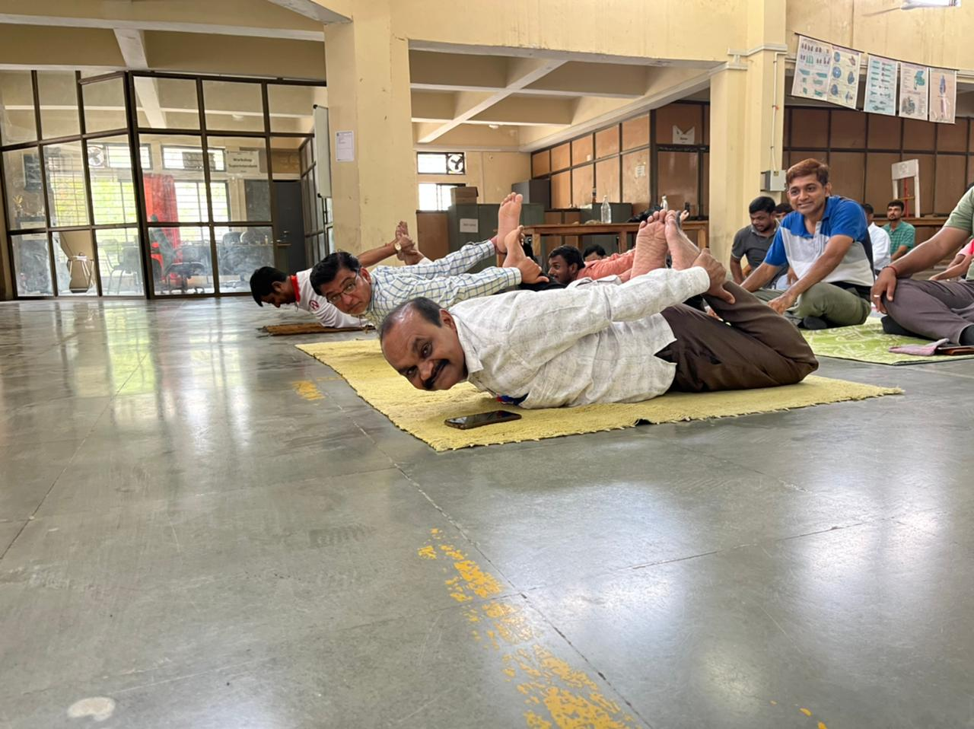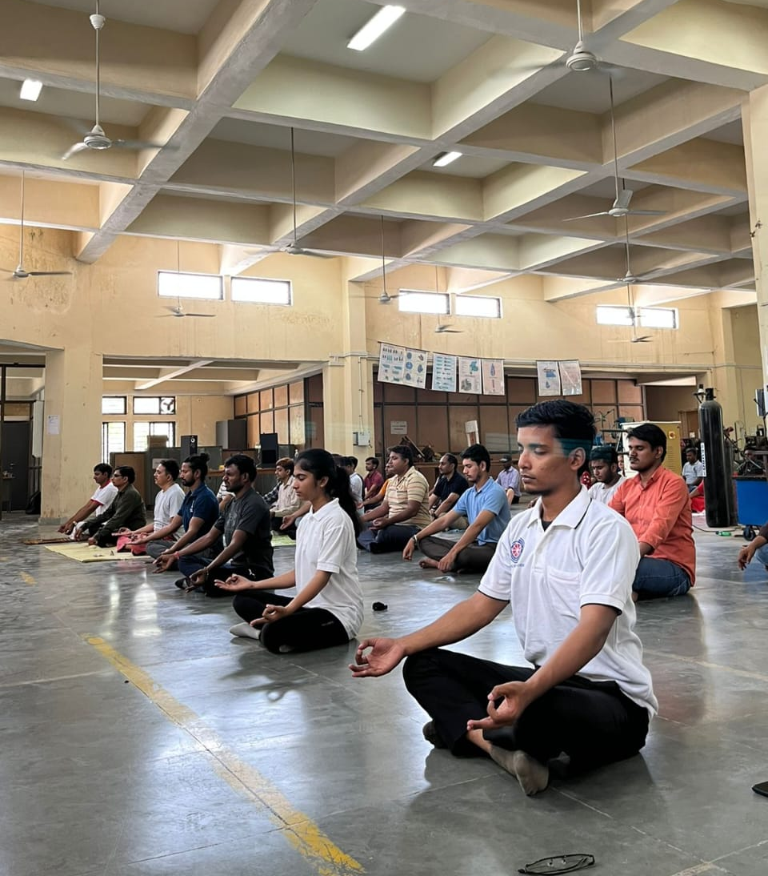
[STUDENTS AND PROFESSORS DOING YOGA ASAN]

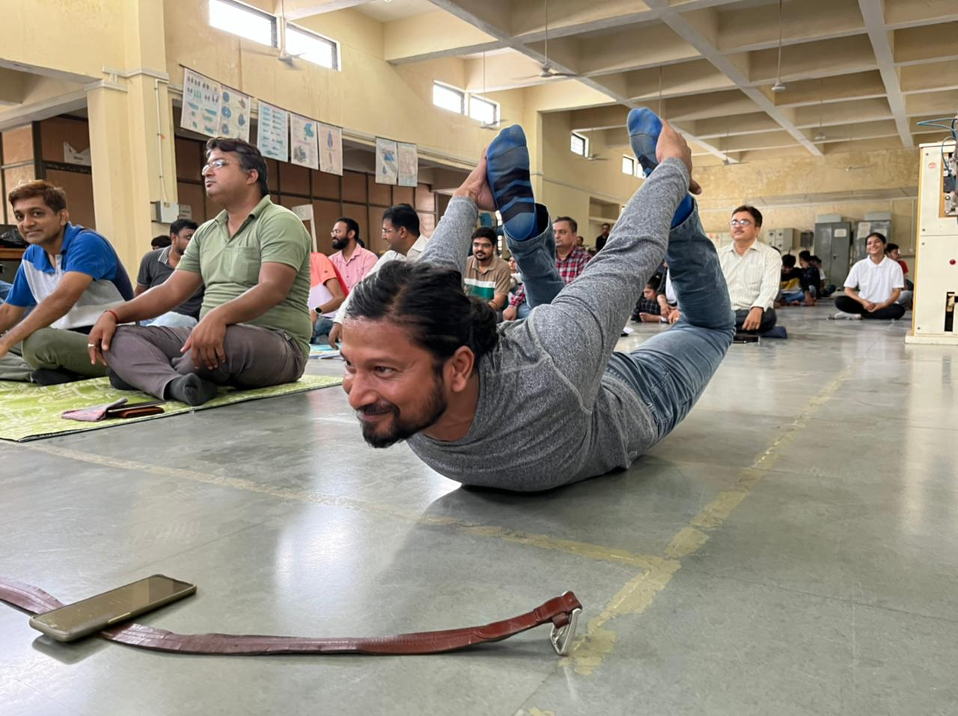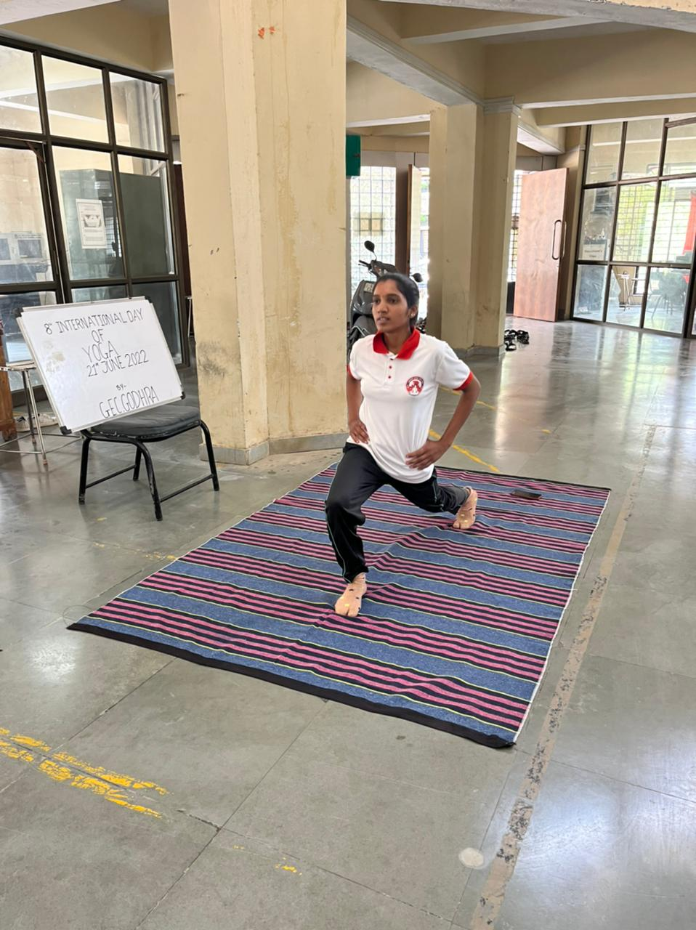
[YOGA TRAINER AND PROFESSOR INTRODUCING YOGA MOVES]

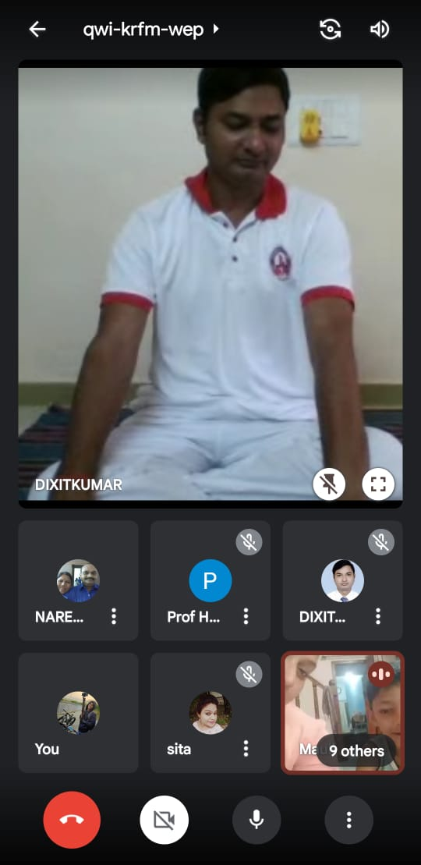
[YOGA SESSION CONDUCTED ONLINE]

