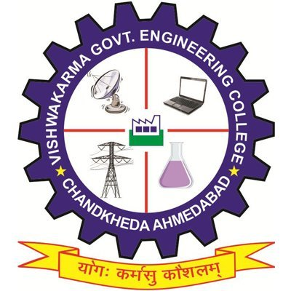
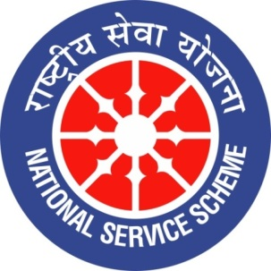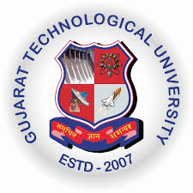
GUJARAT TECHNOLOGICAL UNIVERSITY
NATIONAL SERVICE SCHEME
VISHWAKARMA GOVERNMENT ENGINEERING COLLEGE, CHANDKHEDA
NSS VGEC
A Report constitution day celebration celebration.
NSS Unit Name/College Name: NSS VGEC (VISHWAKARMA GOV. ENG. COLLEGE)
Event NAME:-Constitution day celebration.
Event Date, Time and Location:-26 November 2019, 11:00 am to 12:30 pm, VGEC campus.
Brief Description of the Event:-
India adopted its constitution on 26th November 1949 and it came into effect on 26 January 1950, so this day has been declared as constitution day by our honourable prime minister Narendra Modi on 11 October 2015 as a part of year-long celebration of the 125th birth anniversary of Dr. B.R. Ambedkar to acknowledge the contribution of the framers of constitution and to aggravate the people regarding importance of constitution. Indian constitution is the longest constitution of any country on earth and it is influenced by constitutions of many other countries.
To spread awareness among the students of VGEC regarding their fundamental rights and duties and to enhance their knowledge about Indian constitution, reading of Preamble along with lecture programme and video screening was organised by NSS VGEC. In this celebration students were made to read the Preamble of Indian constitution and then short films on how Indian constitution was framed and challenges faced by the framers were screened. At last students were asked to share their knowledge and what new they learnt about Indian constitution during the lecture programme and video screening.

Principal of VGEC Dr. N.N Bhuptani addressing the students said that proper knowledge in youth about our constitution, fundamental rights and duties will lead to a development of better and peaceful India.
Prof. Alpesh Dafda said,“ Every student must know preamble of our constitution and they should understand that rights and duties both are correlative and they can’t be separated from each other”.

Major Outcome of The Event:-
Students came to know the history of Indian constitution and their rights and duties towards society.

Images of Event:-

