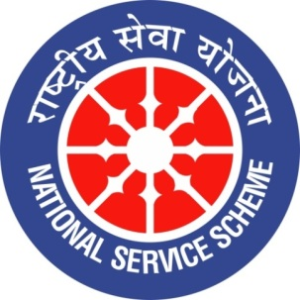
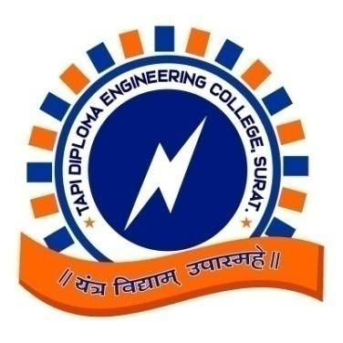
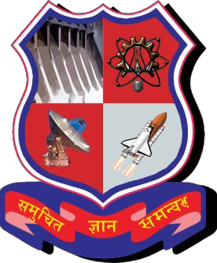

GUJARAT TECHNOLOGY UNIVERSITY
NATIONAL SERVICE SCHEME
REPORT

ON

“CELEBRATION OF 150th BIRTH ANNIVERSARY OF MAHATMA GANDHI”

ORGANIZED BY

EXTRA CO-CURRICULAR COMMITTEE

ON

19-12-2019

AT

TAPI DIPLOMA ENGINEERINGCOLLEGE, SURAT

REPORTPREPAREDBY:

Mr. V.R. VAGHANI & Mr. M.R.LAHERI
LECTURER IN MECHANICALENGINEERING DEPARTMENT

INTRODUCTION

On the occasion of 150th birthday of Mahatma Gandhi, Government of India declared various activities during 02-10-2018 to 02-10-2020. Like Inauguration of Gandhi vichar Kendra, Swachata abhiyan, Elocution competition, Essay writing, Film presentation, Poster presentation, drama competition etc.

EXTRA CO-CURRICULAR COMMITTEE

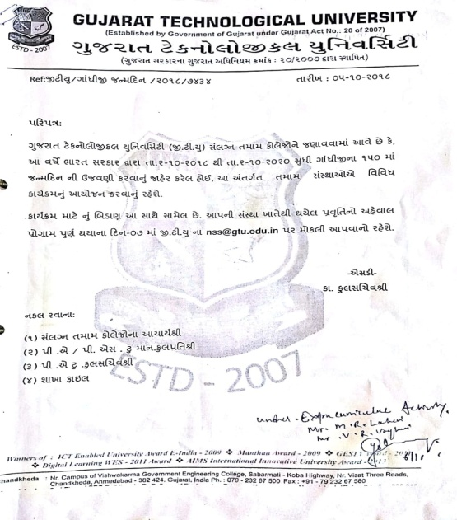

Keep this thing in mind; our honourable principal Prof. Y.S.Choupare has forme done extra co-curricular Committee in our college having 2 faculty members and students from various departments. Under this committee, we arrange different activities in our college campus and perform once in a month, and aware the students about Mahatma Gandhiji’s life and thoughts.

Image: Extra Co-Curricular Committee.

VYAKHYAN MALA

On 19th December 2019 3:30pm onwards, 150th birth anniversary of Mahatma Gandhi was celebrated by seminar, we have arranged seminar on the topic of “GANDHIJI’S JOURNALISM”, It is true that in the world inebriated on violence many have been drawn to Mahatma Gandhi’s experiments with non-violence and many such experiments are taking place today for which his lifelong endeavor remains the main source of inspiration. By this seminar we conveyed message on thoughts of mahatma Gandhi’s on Journalism. This was delivered by Mr. S.R.Jadav (Lecturer in Mechanical department)

Here are some of the glimpses

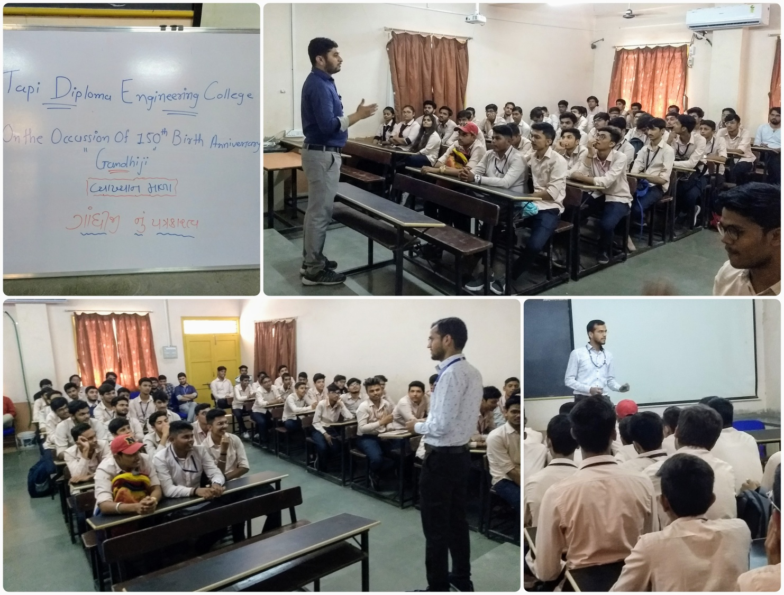

Principal
Prof. Y.S. Choupare

