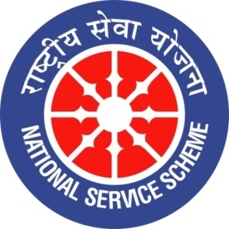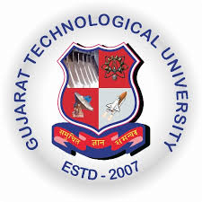
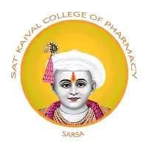

GUJARAT TECHNOLOGY UNIVERSITY
NATIONAL SERVICE SCHEME
SAT KAIVAL COLLEGE OF PHARMACY

A Report on Celebration of 79th independence day and cultural activities

NSS unit Name: Celebration of 79th independence day and cultural activities
Event NAME: Cultural activities programme
Event Date, Time and Location:15.08.2026 ,08 A.M SKCOP,SARSA
Brief Description of the Event:
Sat Kaival College of Pharmacy, Sarsa, celebrated the 79th Independence Day on 15th August with great patriotism, enthusiasm, and national pride. The programme commenced with the flag-hoisting ceremony, followed by the National Anthem, which filled the atmosphere with a sense of unity and respect for the nation. The dignitaries addressed the gathering and highlighted the importance of freedom, national unity, and the sacrifices made by our freedom fighters.
Following the formal ceremony, students participated in various cultural activities, including patriotic songs, dance performances, speeches, and other creative presentations reflecting the spirit of independence and India's rich cultural heritage. The programme encouraged students to develop patriotism, teamwork, discipline, and a sense of responsibility towards the nation. Faculty members and staff actively supported the successful organization of the event.
The celebration concluded with a message of unity, peace, and dedication towards building a stronger and better India. The event was a memorable occasion that inspired everyone to uphold the values of freedom, equality, and national integrity.
Outcomes of this event:
1.Patriotism and National Pride: Students developed a deeper sense of patriotism and respect for the nation by participating in the Independence Day celebration.
2. Awareness of Freedom Struggle: The programme helped students understand the sacrifices made by freedom fighters and the importance of India's independence.
3. Cultural Awareness: Students gained appreciation for India's rich cultural heritage, traditions, and diversity through various cultural performances.
4. Development of Confidence: Participation in speeches, patriotic songs, dances, and other activities enhanced students' confidence and public-speaking skills.
5. Teamwork and Cooperation: The event encouraged students and faculty members to work together in organizing and conducting the programme successfully.
6. Promotion of Unity: The celebration strengthened the spirit of unity, equality, and national integrity among students and staff members.
7. Social Responsibility: Students were motivated to become responsible citizens and contribute positively to society and the development of the nation.
8. Successful Celebration: The event created a memorable and inspiring experience, fostering discipline, enthusiasm, and respect for national values among all participants.

Photograph of event:
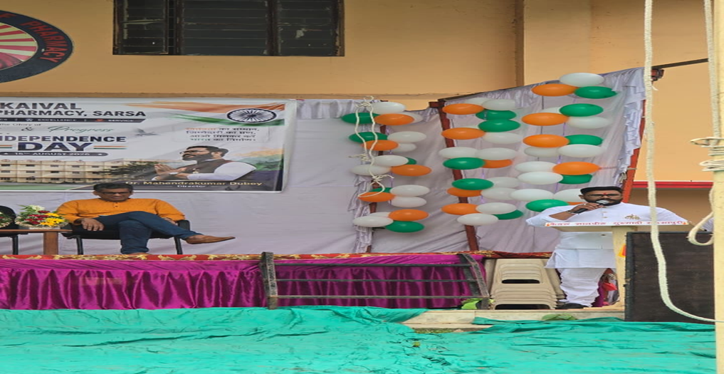
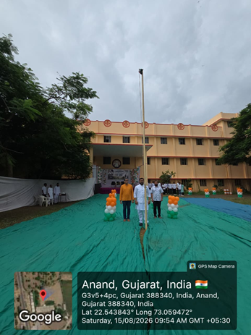
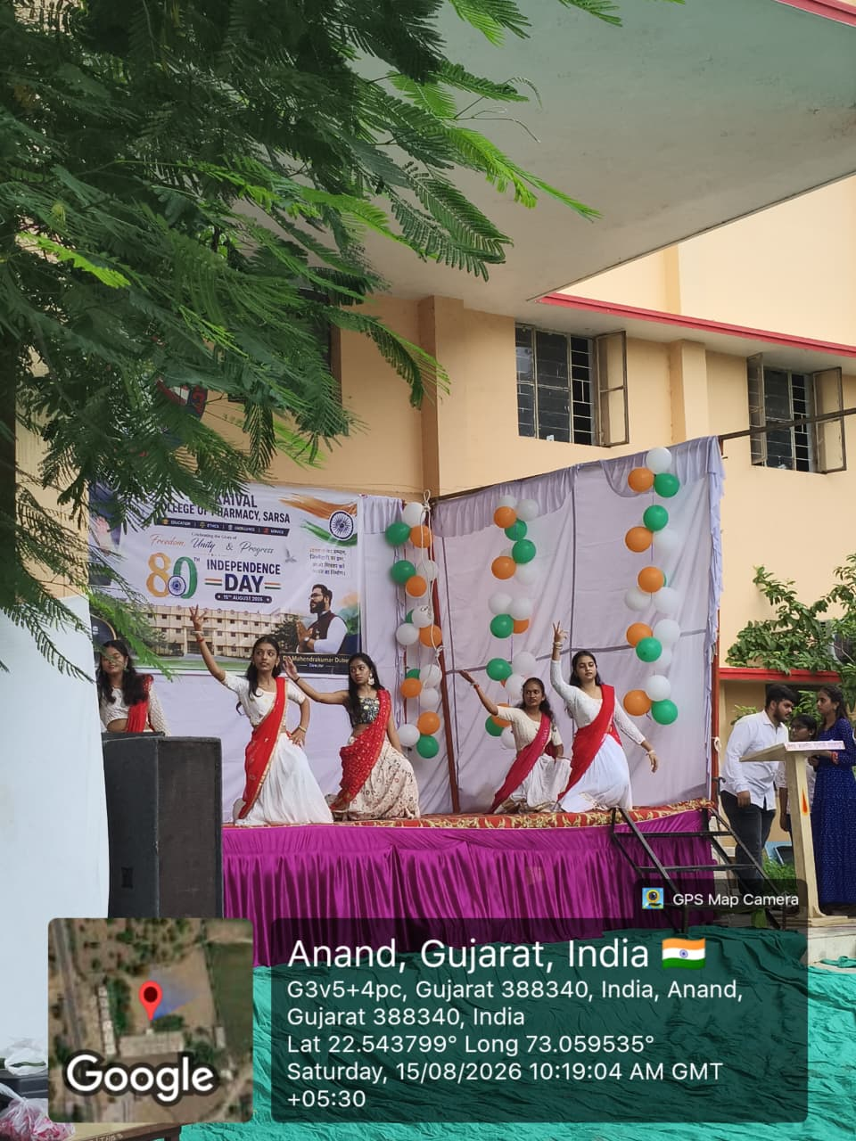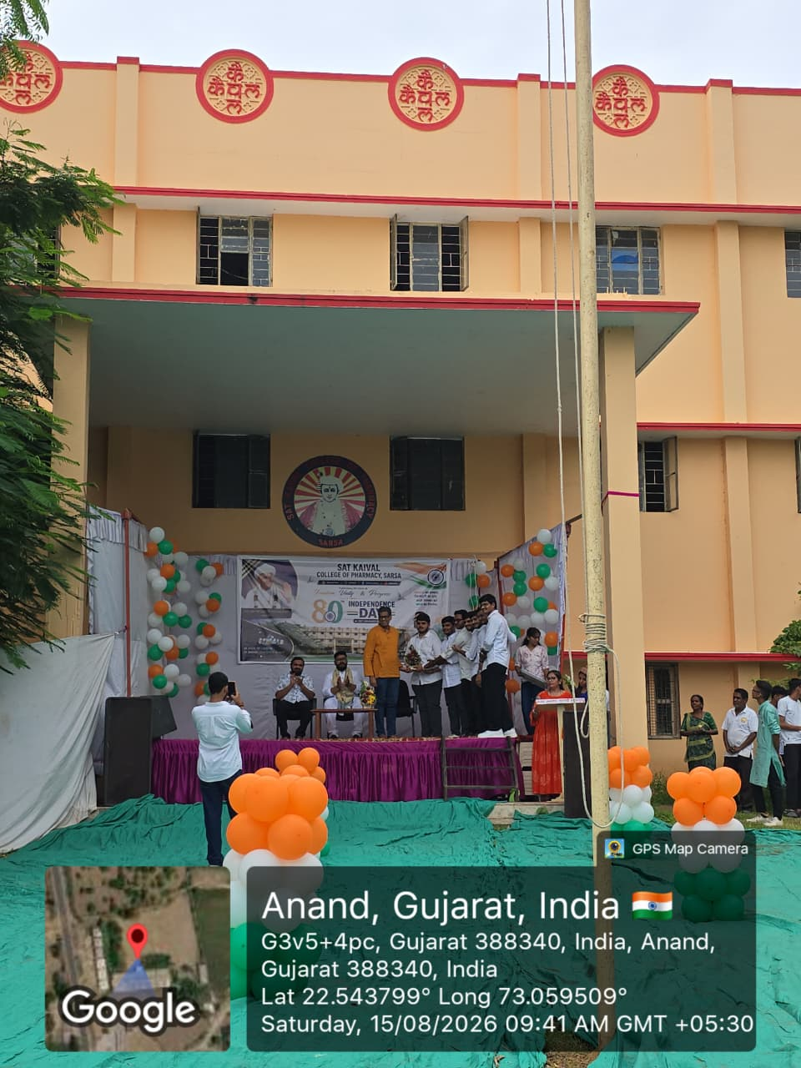
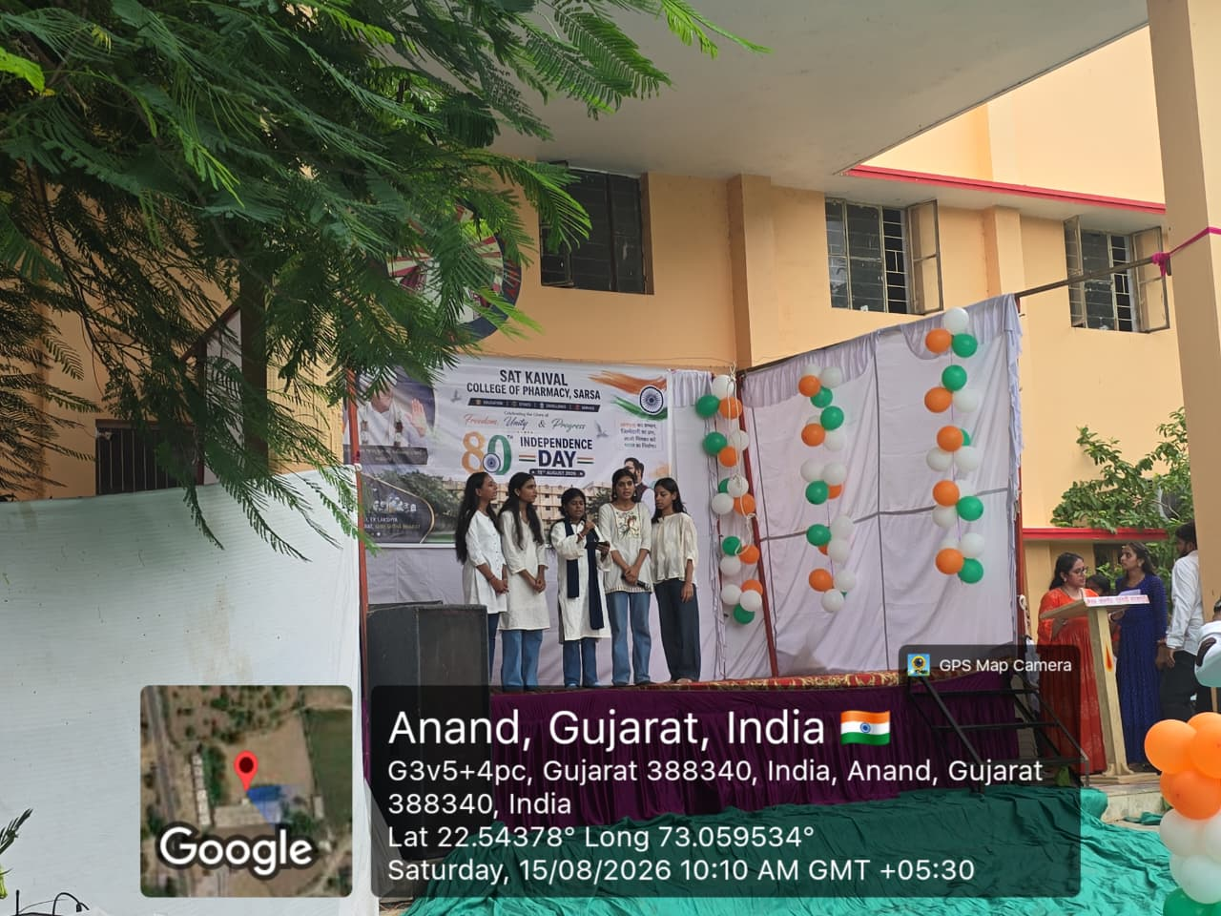
Submitted by
sejal bhoi( assistant professor}

