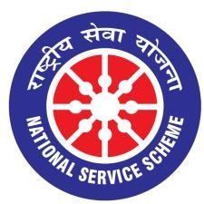

GUJARAT TECHNOLOGY UNIVERSITY
NATIONAL SERVICE SCHEME

Mental Health Awareness and Well-Being Program for Physical health

Date: 04 August, 2026

Organized by: NSS Unit of L C Institute of technology Bhandu
Date: 04 August 2026
Venue: LCIT Bhandu Work shop:- 012
Participants: NSS Volunteers/Students (100), Faculty Members (16), Other Staff (02)
1.Introduction
A Mental Health Awareness and Well-Being Program was organized to promote emotional well-being, reduce the stigma surrounding mental health, and encourage students to seek help whenever needed. The program aimed to educate engineering students about stress management, anxiety, depression, work-life balance, and healthy coping strategies.
Objectives
- To create awareness about the importance of mental health.
- To educate students on recognizing signs of stress, anxiety, and depression.
- To promote healthy lifestyle habits and emotional resilience.
- To encourage students to seek professional support when required.
- To foster a positive and supportive campus environment.
2.Program Details
The program commenced with a welcome address by the Principal, who emphasized the significance of maintaining good mental health alongside academic excellence. A renowned psychologist and mental health expert delivered an informative session on common mental health challenges faced by students.
The speaker discussed topics such as academic pressure, examination stress, emotional well-being, time management, mindfulness, and techniques for maintaining a healthy balance between personal and academic life. Students were introduced to practical stress-management methods, including deep breathing, meditation, physical exercise, and positive thinking.
An interactive question-and-answer session allowed students to openly discuss their concerns and receive professional guidance. The session encouraged participants to break the stigma associated with mental health and highlighted the importance of supporting friends and classmates who may be experiencing emotional difficulties.

3.Activities Conducted
- Expert lecture on mental health awareness.
- Stress management and mindfulness session.
- Interactive discussion and question-answer session.
- Relaxation and breathing exercises.
- Distribution of informational pamphlets on mental well-being.
A Mental Health Awareness session was conducted by Dr. Ankit Bhavsar, from psychiatry dept. Civil Hospital Mehsana to educate participants about the importance of mental well-being, stress management, recognizing common mental health concerns, and seeking timely professional support. The session encouraged open discussion, reduced stigma surrounding mental health, and provided practical strategies for maintaining emotional wellness.
4.Photograph
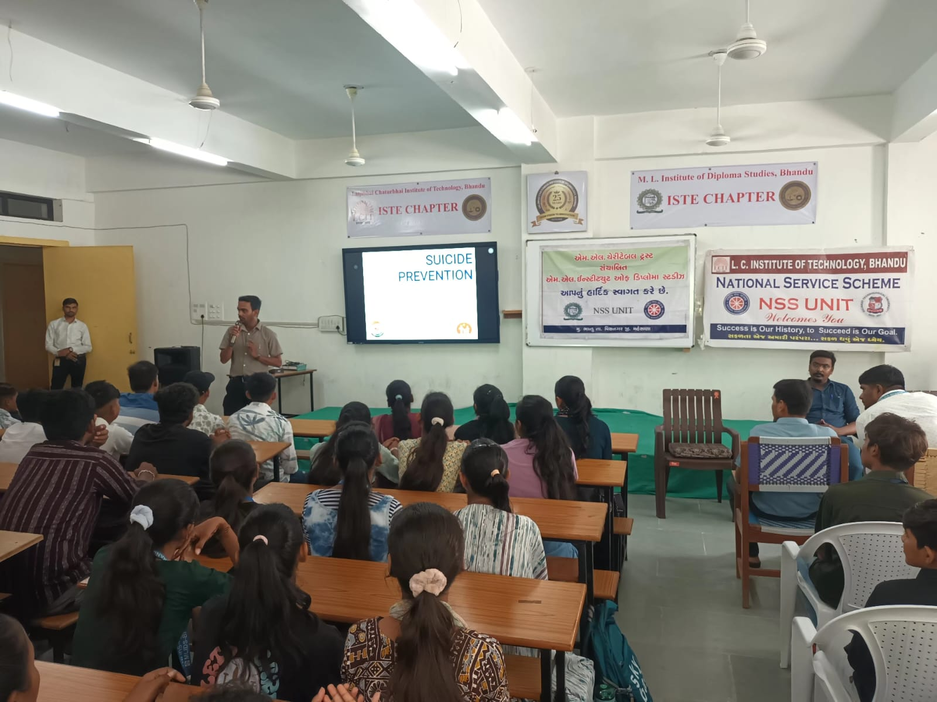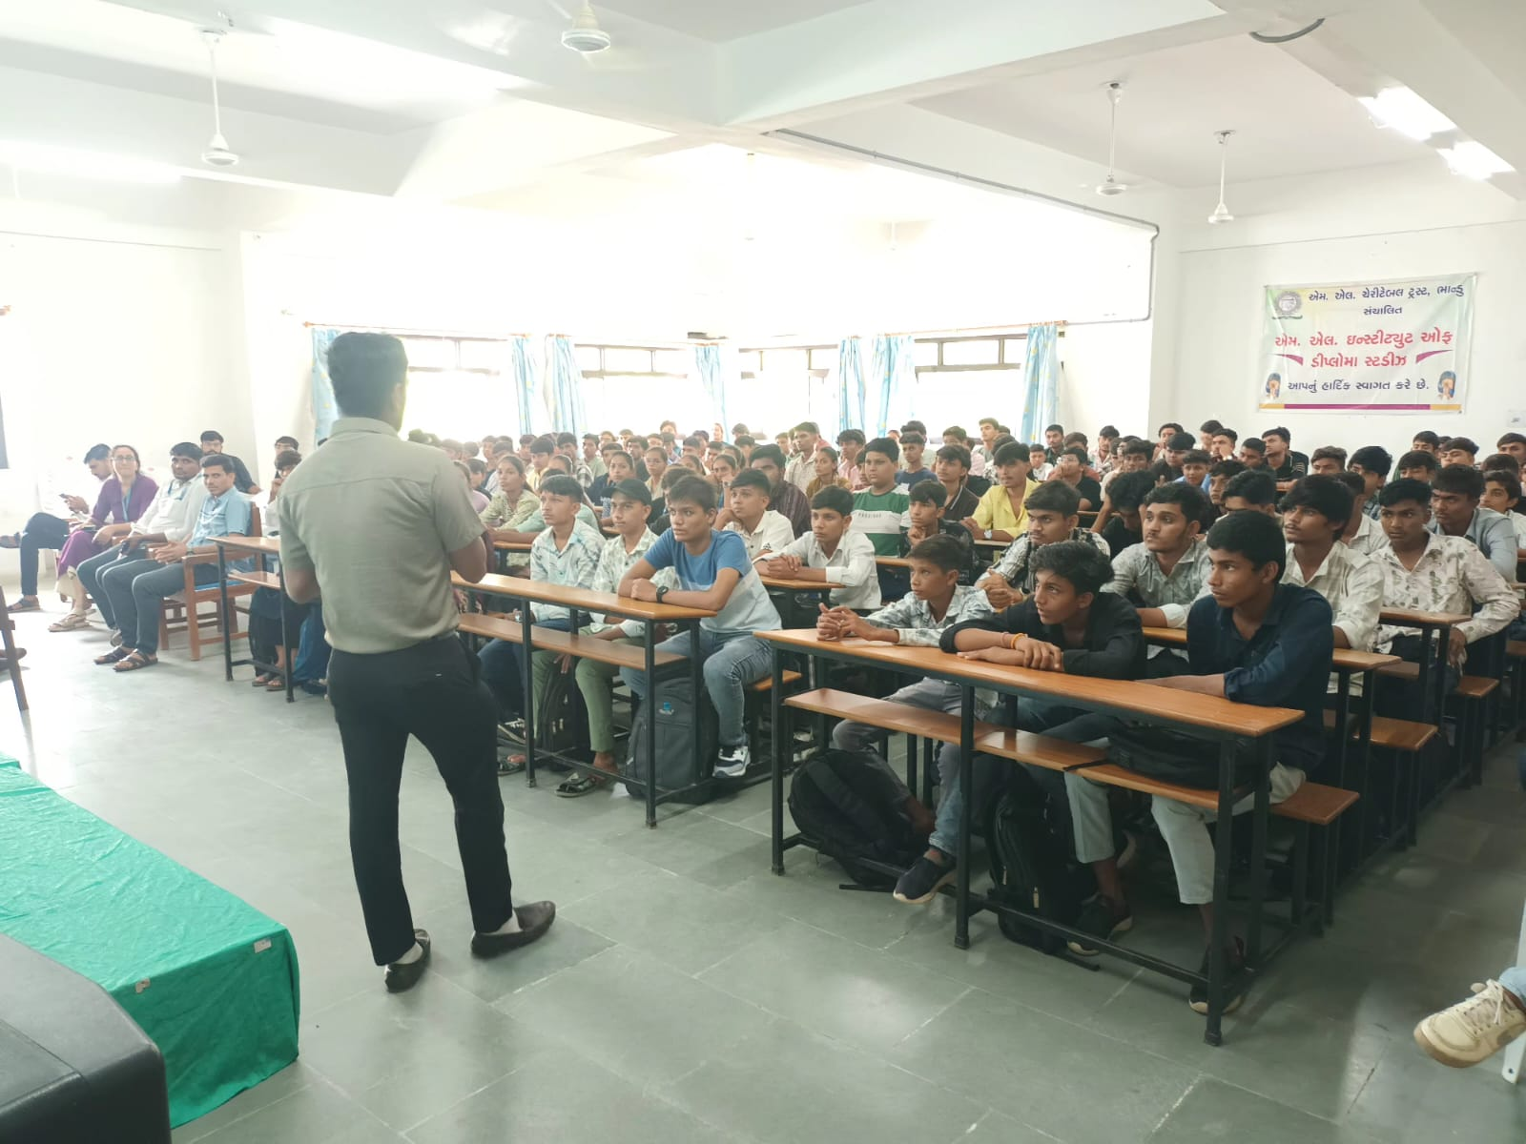
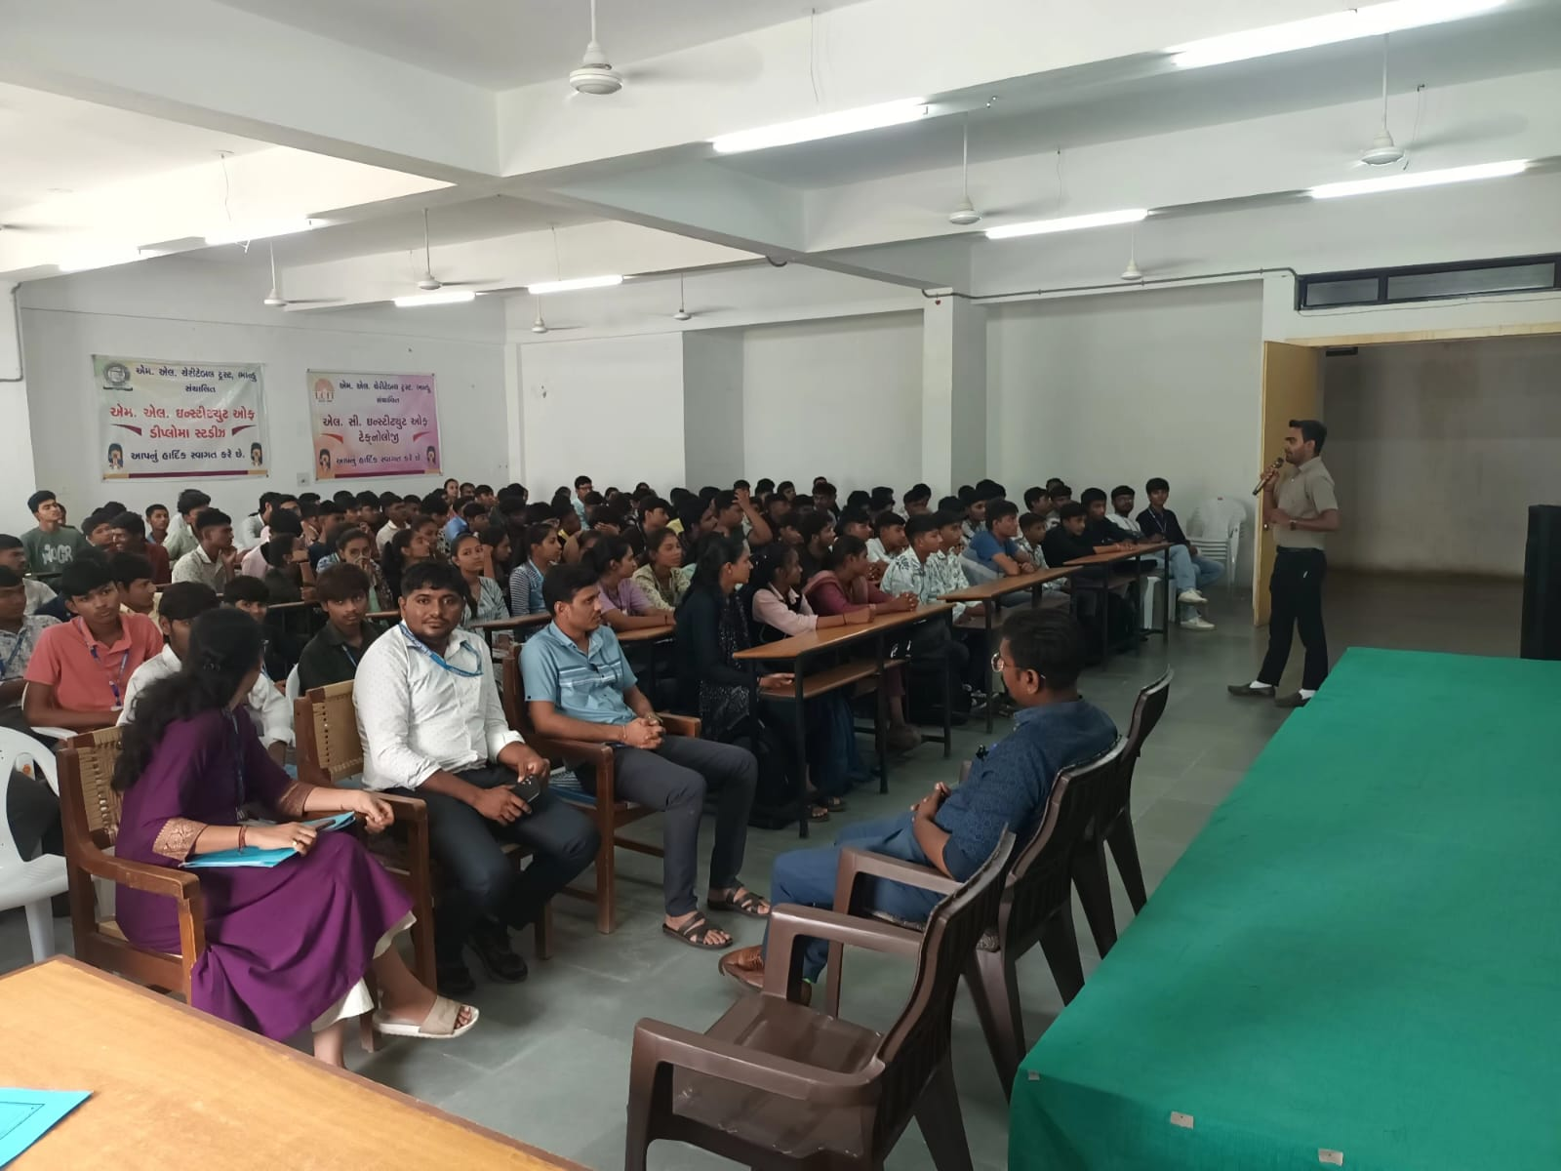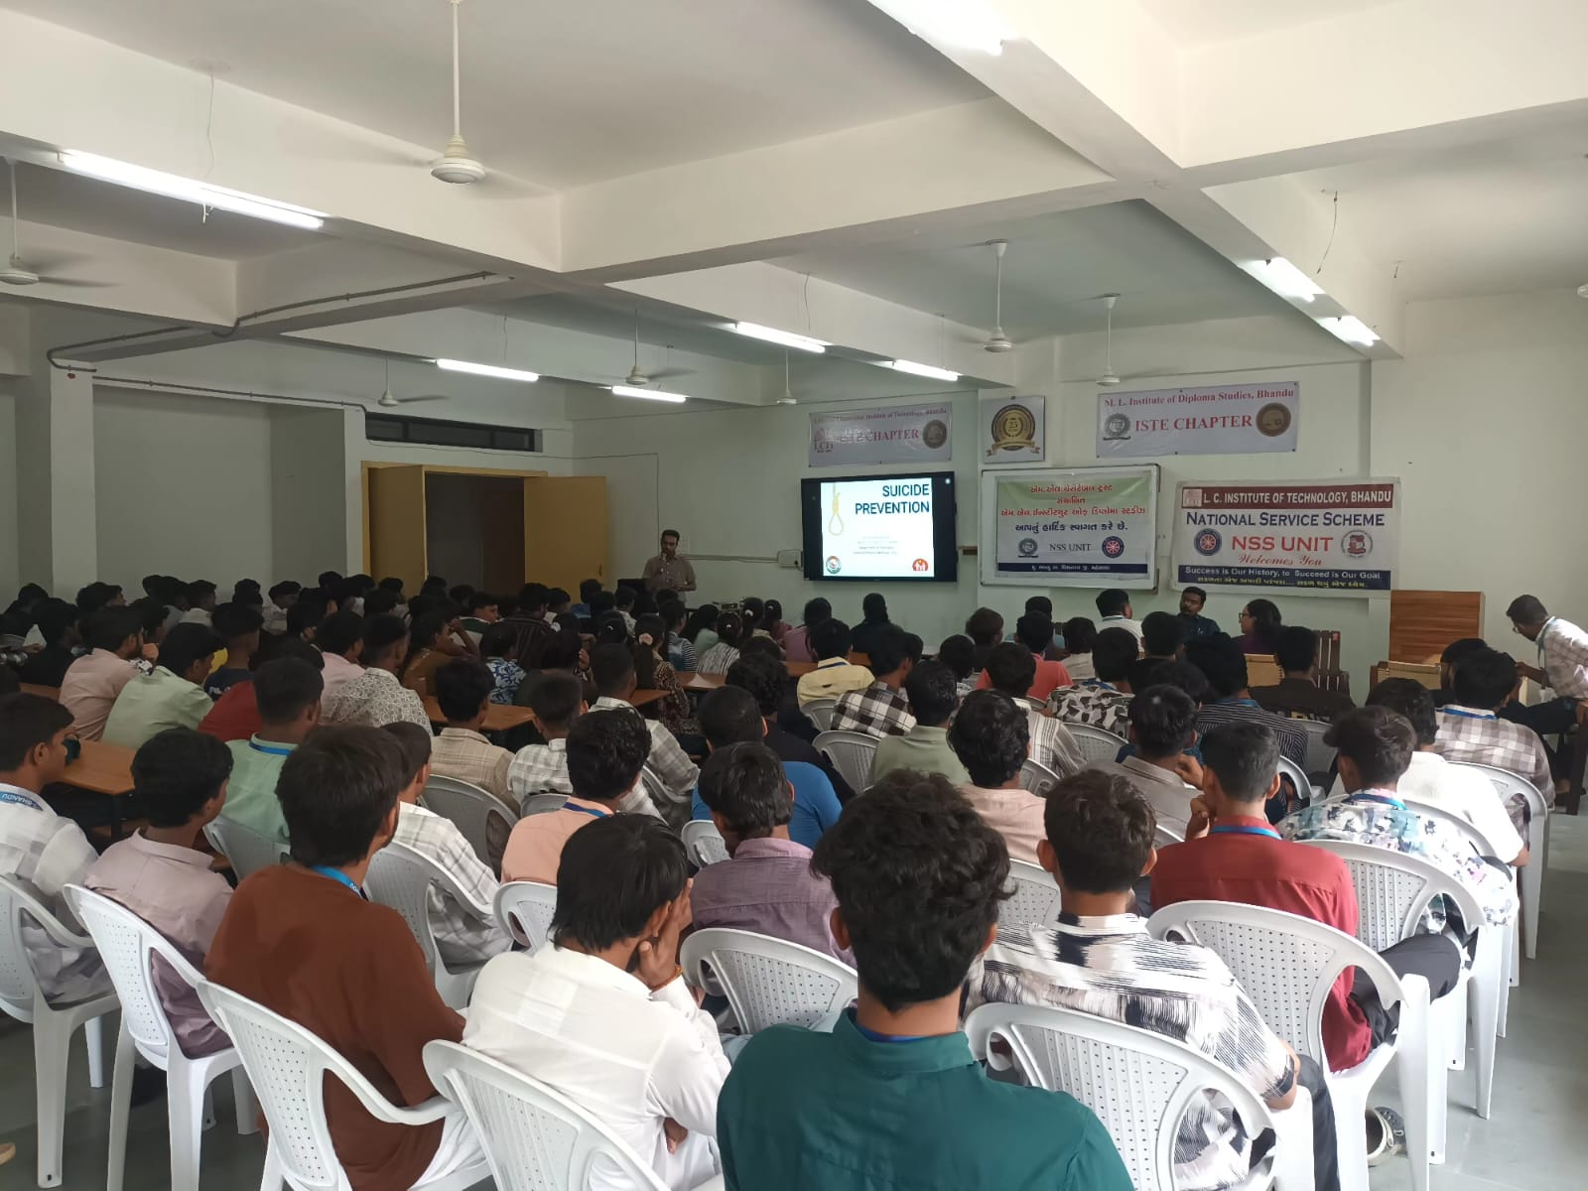

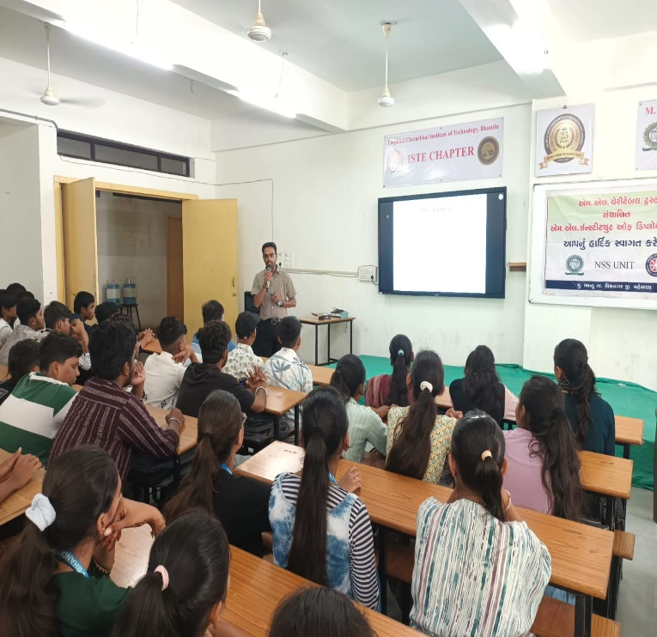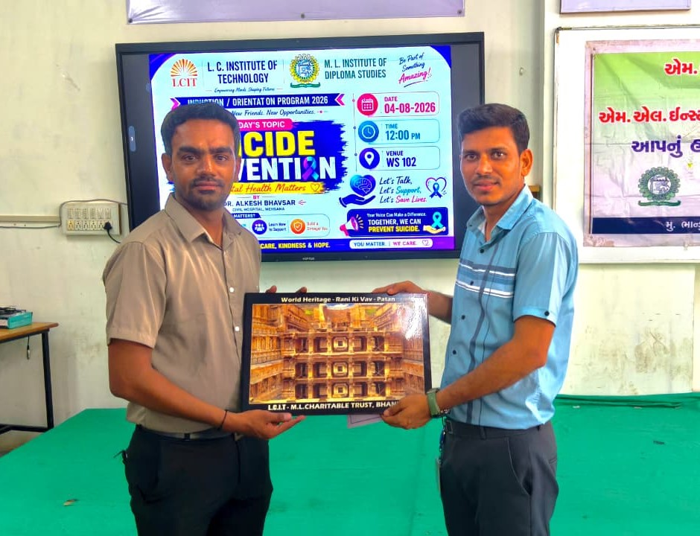
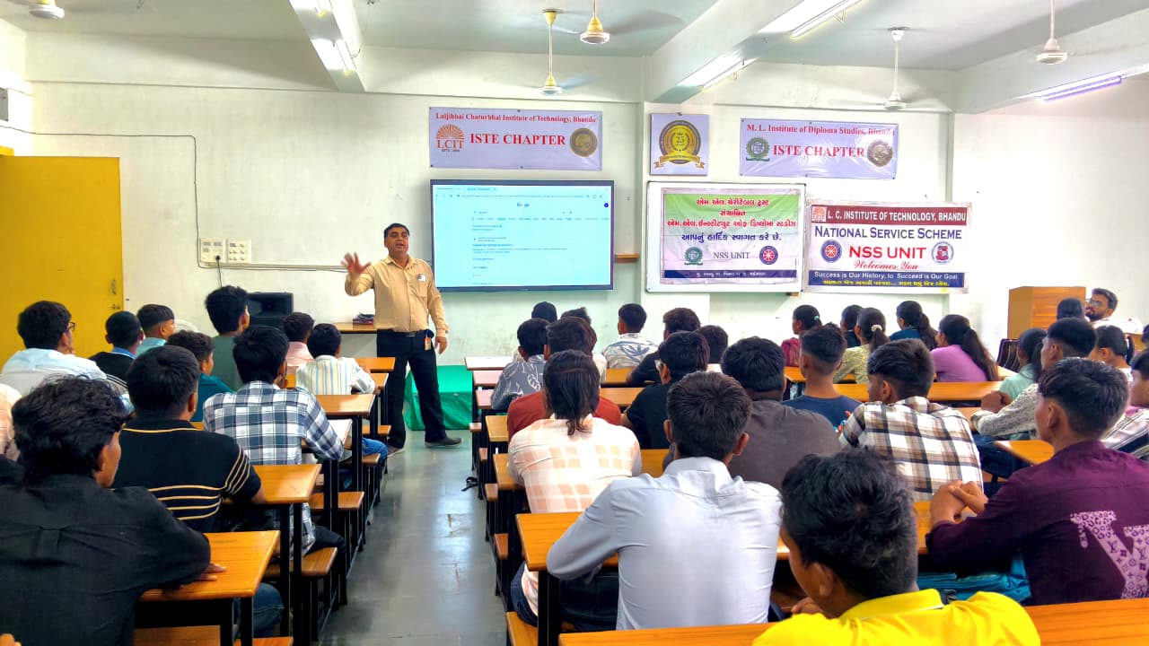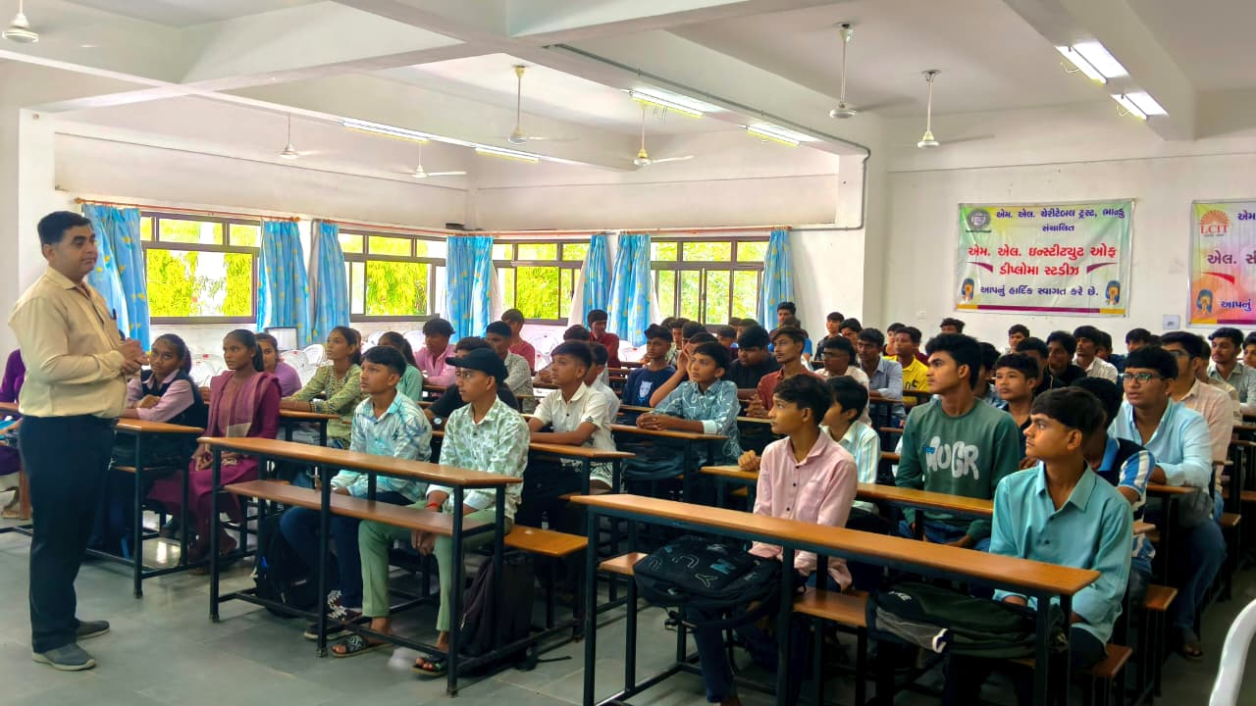
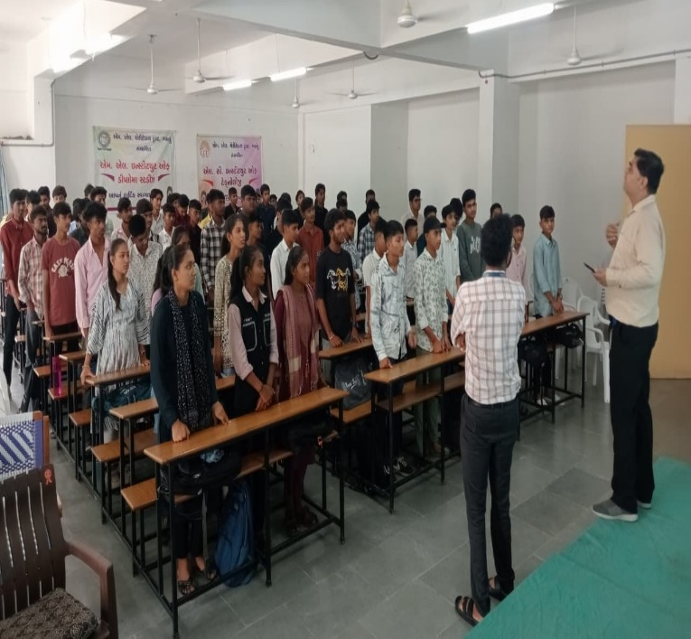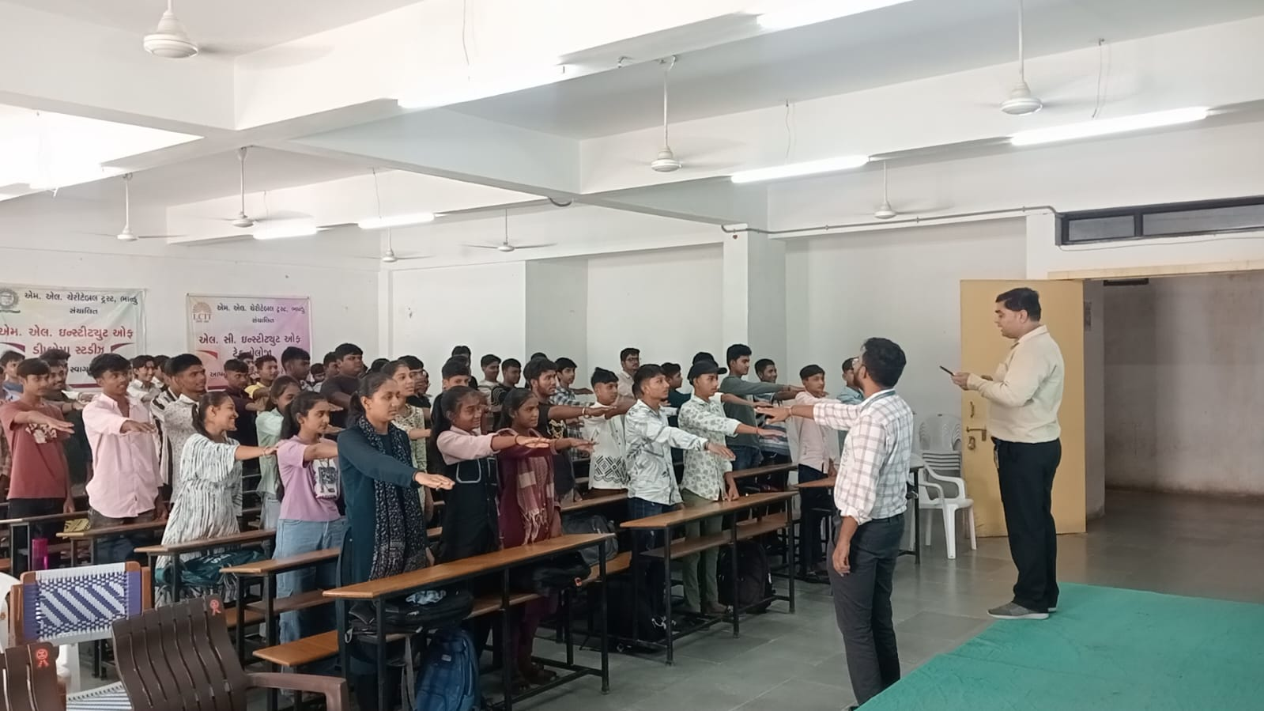
5.Outcomes
The program successfully increased awareness about mental health among students. Participants gained valuable knowledge about managing stress, improving emotional resilience, and maintaining a healthy lifestyle. Students expressed appreciation for the practical techniques shared during the session and recognized the importance of seeking help without hesitation when facing emotional or psychological challenges.
6.Conclusion
The Mental Health Awareness and Well-Being Program proved to be highly informative and beneficial for engineering students. It encouraged open discussions about mental health, promoted self-care practices, and reinforced the message that mental well-being is essential for academic success and personal growth. Such programs should be organized regularly to build a healthier, more supportive, and emotionally resilient campus community.
******

