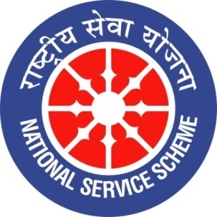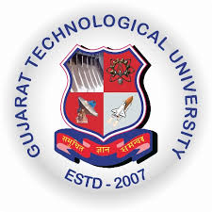
College Logo
GUJARAT TECHNOLOGY UNIVERSITY
NATIONAL SERVICE SCHEME
R N G PATEL INSTITUTE OF TECHNOLOGY
A Report on Art and Science of Manifestations on 06/07/2026 of 084/ R N G Patel Institute of Technology

NSS Unit Name/College Name: R N G Patel Institute of Technology
Event NAME: Magic Memory
Event Date, Time and Location: RNGPIT, Tajpore College, Bardoli, 06 July 2026 at 10:00 AM
Brief Description of the Event
A session on “Cyber Hygiene” was organised on 6 July 2026 at the RNGPIT Auditorium, with Saumil as the speaker. The programme aimed to create awareness among students about safe and responsible use of digital technologies. The speaker discussed common cyber threats, online scams, phishing attacks, password security, privacy protection, and safe browsing practices. Participants were guided on the importance of using strong passwords, enabling security features, avoiding suspicious links, and protecting personal information while using digital platforms. The session was interactive and informative, providing students with practical knowledge to stay safer in the digital environment.
The event helped participants develop greater awareness of cybersecurity and responsible digital behaviour. Students learned practical measures to protect their personal accounts, devices, and sensitive information from potential cyber threats. The session improved their understanding of phishing, fraudulent messages, unsafe websites, and the risks associated with sharing personal information online. Participants were also encouraged to maintain strong passwords, verify online communications, and remain alert while using social media and digital services. Overall, the programme strengthened students’ digital safety awareness and motivated them to adopt good cyber hygiene practices in their academic, professional, and personal lives.

