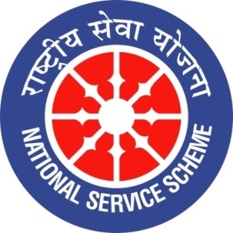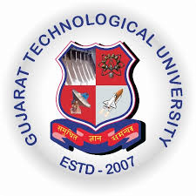
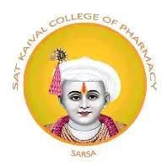

GUJARAT TECHNOLOGY UNIVERSITY
NATIONAL SERVICE SCHEME
SAT KAIVAL COLLEGE OF PHARMACY

A Report on GTU inter zonal sports competition celebration at sat kaival college of pharmacy

NSS Unit Name/College : Sat kaival college of pharmacy
Event NAME: “ GTU inter zonal sports competition (2026-27)”
Event Date, Time and Location:17/08/2026(kabbadi skcop campus)
Volley ball 07.09.2026(skcop campus)
Taekwondo 12.09.2026(Anand campus)
Brief Description of the Event: Sat Kaival College of Pharmacy (SKCOP) proudly organized the GTU Interzonal Sports Competition with the aim of promoting sportsmanship, teamwork, discipline, and physical fitness among students. The event provided an excellent platform for students from different colleges to showcase their sporting talents, competitive spirit, and teamwork. The competition was conducted in the presence of Dr. Mahendra Kumar Dubey, Director of Sat Kaival College of Pharmacy, along with faculty members and the sports expert team. Their presence and encouragement motivated the participants to perform with enthusiasm and dedication. The event fostered a spirit of healthy competition, mutual respect, and unity among students while highlighting the importance of sports in overall personality development.
Outcomes of this event:
- Students demonstrated their sporting abilities, skills, and competitive spirit through active participation in the GTU Interzonal Sports Competition.
- The event enhanced teamwork, leadership, discipline, coordination, and decision-making skills among participants.
- Students developed a sense of sportsmanship, mutual respect, and healthy competition.
- The competition encouraged students to prioritize physical fitness, mental well-being, and an active lifestyle.
- The event provided an opportunity for students from different colleges to interact, collaborate, and build friendships.
- Participants gained confidence and motivation to improve their performance in future sports competitions.
- The presence of Director Dr. Mahendra Kumar Dubey, faculty members, and the sports expert team encouraged participants and contributed to the successful organization of the event.
- The competition highlighted the importance of extracurricular activities in the overall personality development of students.

Photograph of event:
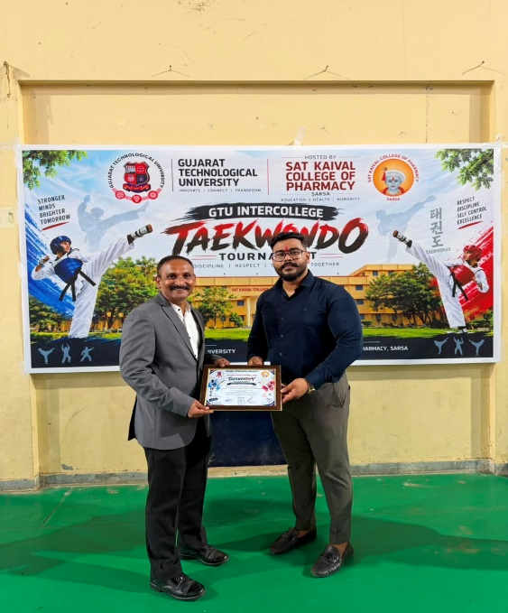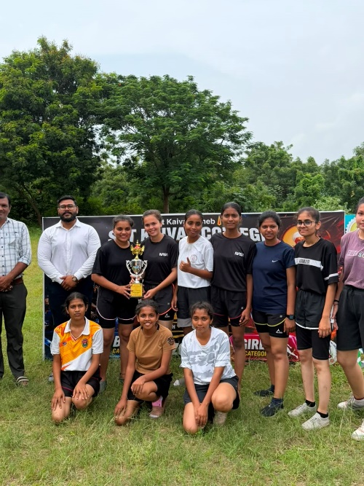
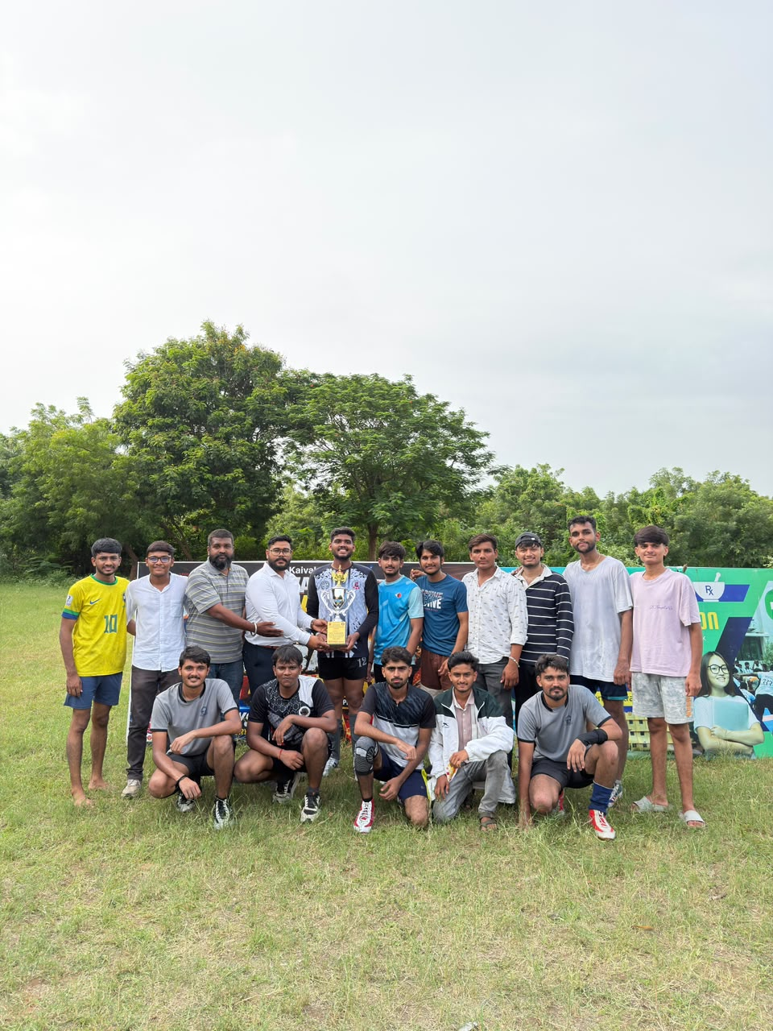
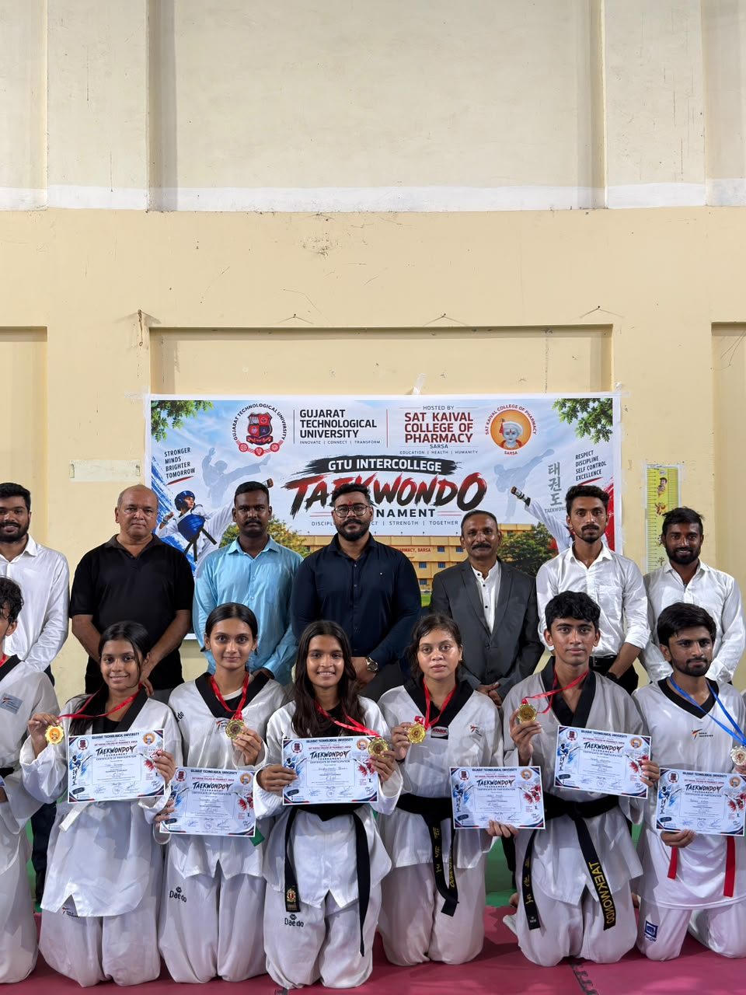

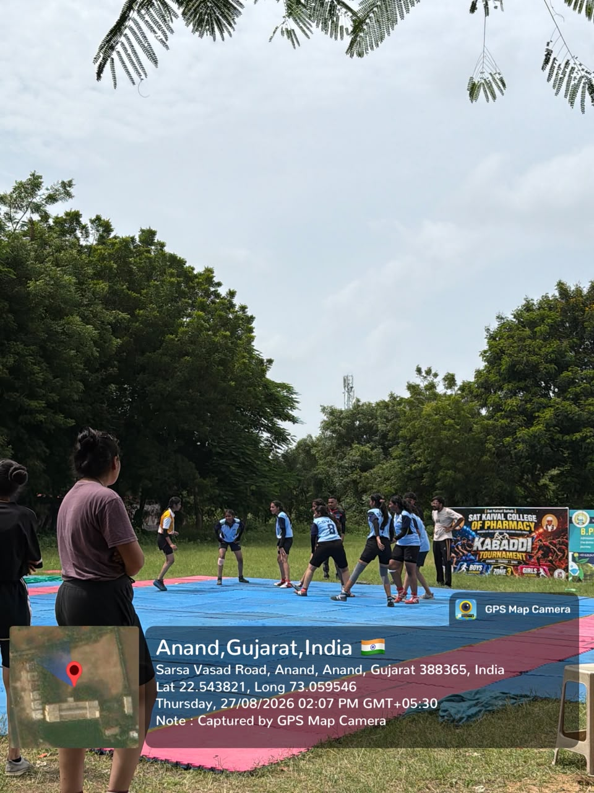
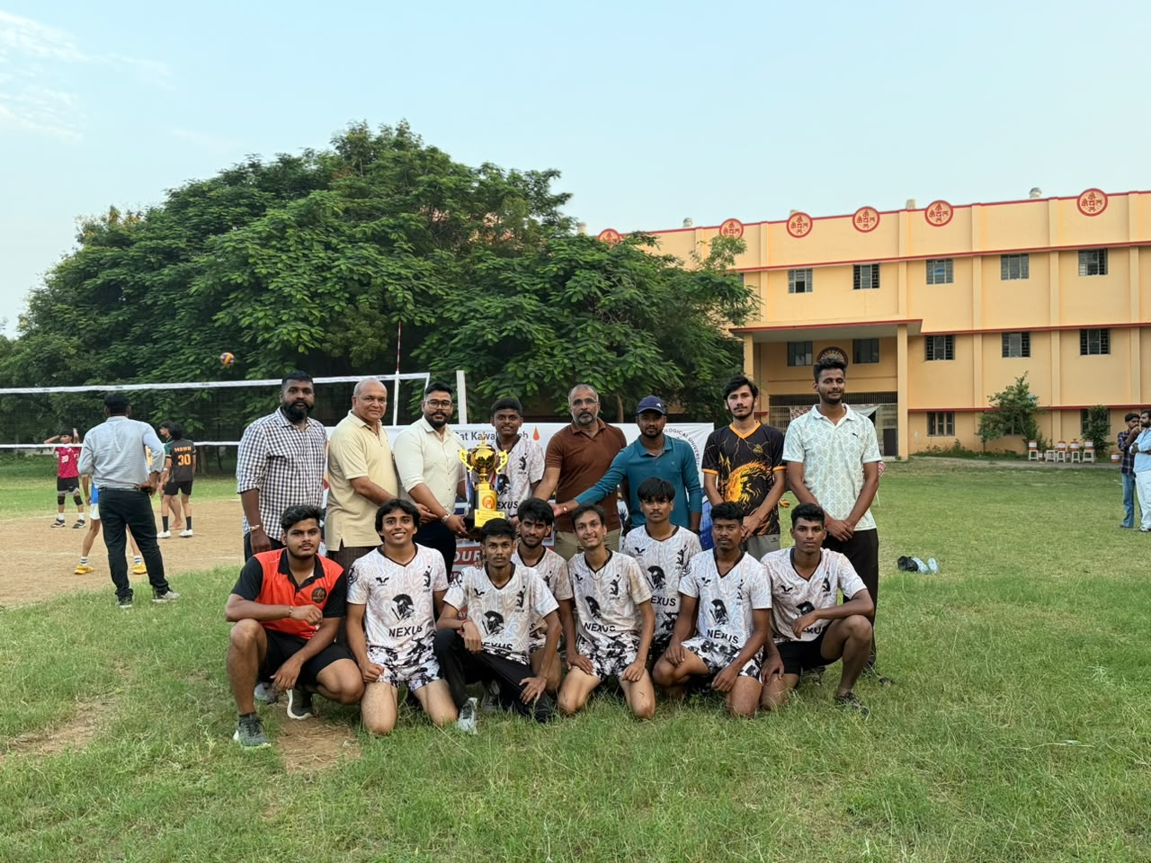
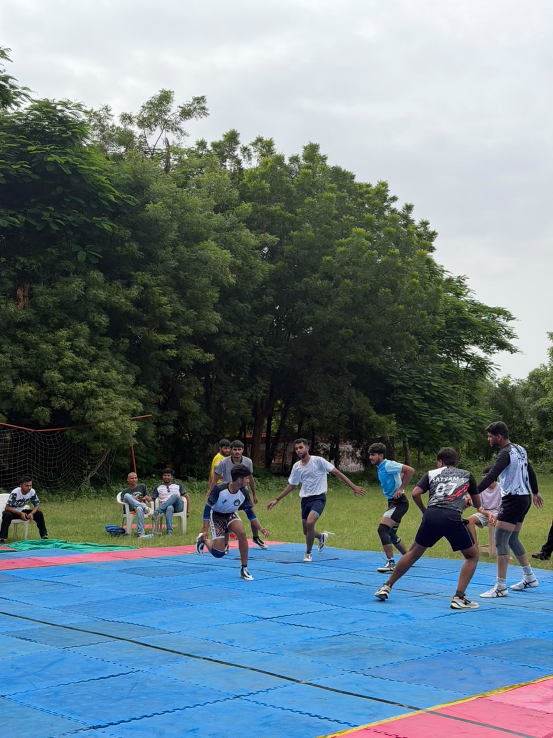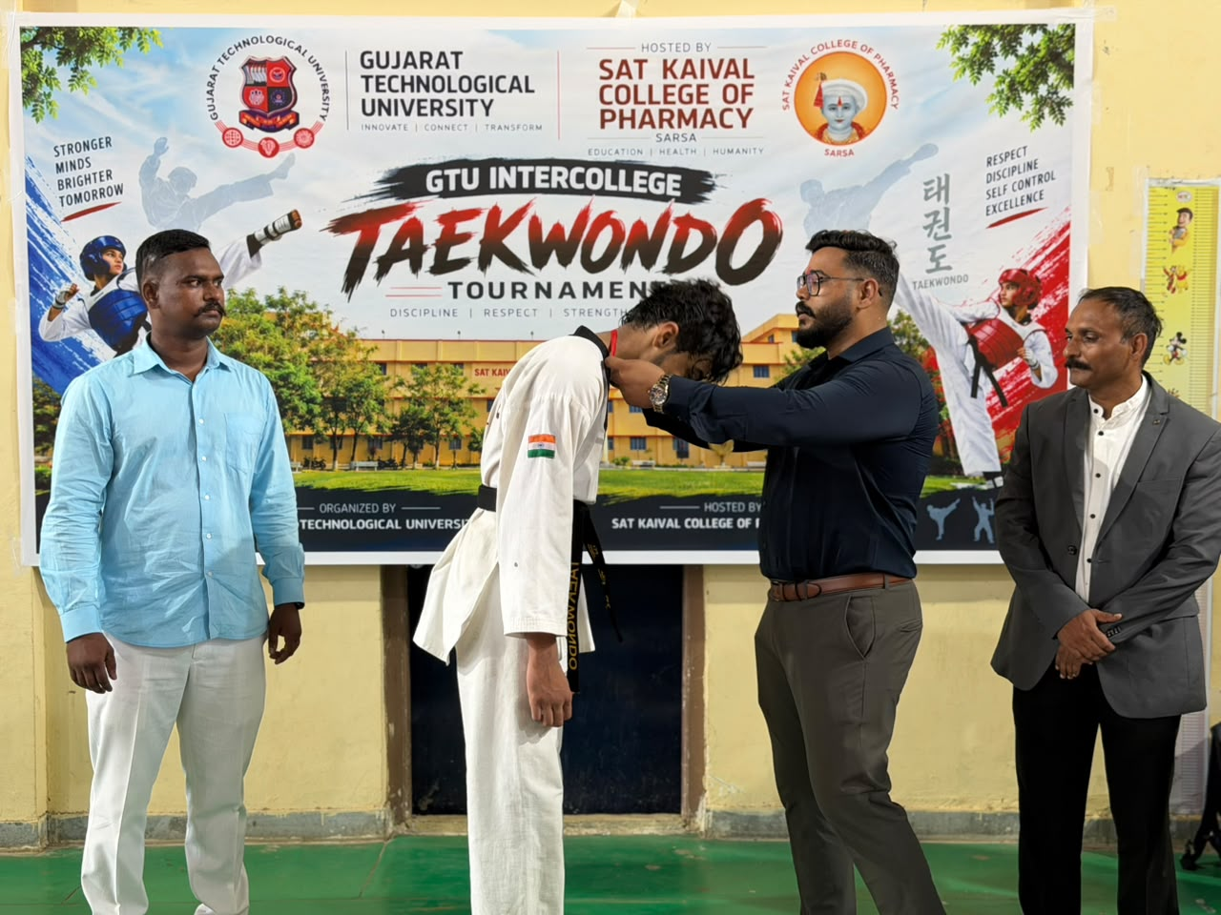
Submitted by Sejal bhoi( assistant professor),sat kaival college of pharmacy

