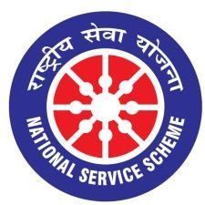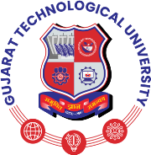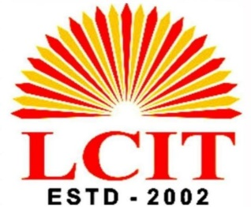

GUJARAT TECHNOLOGY UNIVERSITY
NATIONAL SERVICE SCHEME

Independence Day Celebration Date: 15th August 2026

Organized by: NSS Unit of L C Institute of technology Bhandu
Date: 15th August 2026
Venue: MLCT Campus
Participants: NSS Volunteers/Students (110), Faculty Members (09), Other Staff (05)
- Introduction
L C Institute of technology Bhandu, celebrated the 80th Independence Day of India on 15th August 2026 with great enthusiasm, patriotism, and national pride. The celebration was organized to commemorate India's independence from British rule and to develop a sense of national unity, responsibility, and patriotism among students and staff members.
2. Chief Guest
The program was graced by Dr. D. D. Patidar, who attended the celebration as the Chief Guest. The presence of the Chief Guest added significance to the occasion and inspired students and faculty members.
3. Program Details
- The celebration began with the arrival and welcome of the Chief Guest, followed by the flag-hoisting ceremony and the National Anthem. The national flag was hoisted with great respect and honor, creating an atmosphere of patriotism and unity.
- After the flag-hoisting ceremony, Dr. D. D. Patidar delivered an inspiring speech. In his address, he highlighted the importance of Independence Day, the sacrifices made by freedom fighters, and the responsibilities of citizens in building a strong and developed nation. He encouraged students to focus on education, discipline, hard work, innovation, and moral values to contribute positively to society and the country.
- The speech motivated students to become responsible citizens and to work sincerely towards their personal growth and the development of the nation.

4. Participation of Students and Staff
The program was attended by the principal, faculty members, non-teaching staff, and students of the
institute. Everyone participated with enthusiasm and respect. The celebration provided an opportunity to remember the sacrifices of our freedom fighters and to renew our commitment to the progress and prosperity of India.
5. Photographs
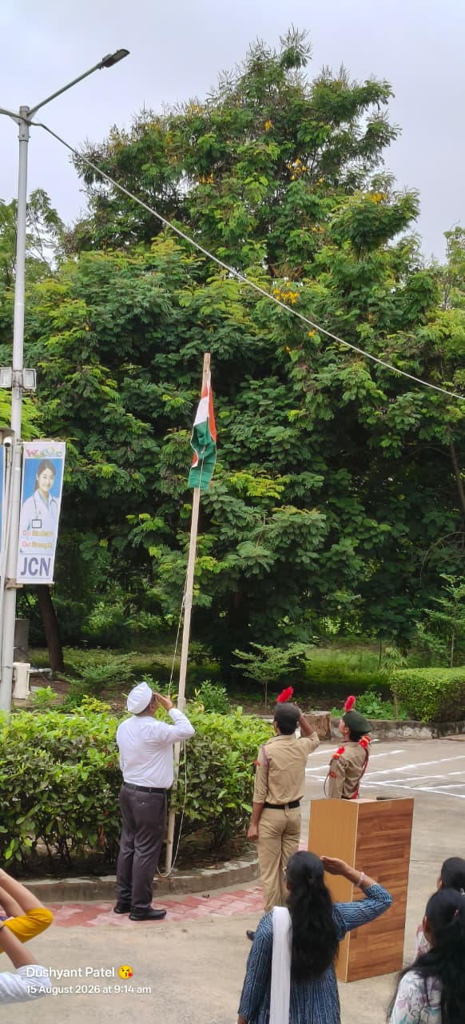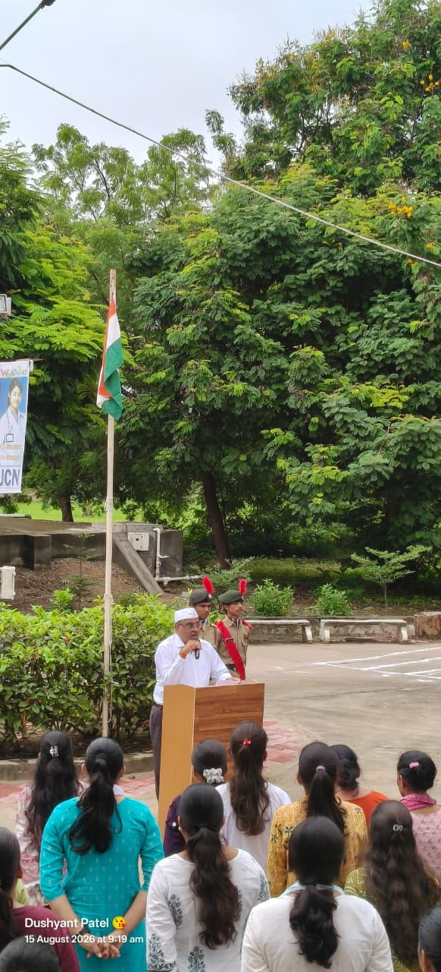
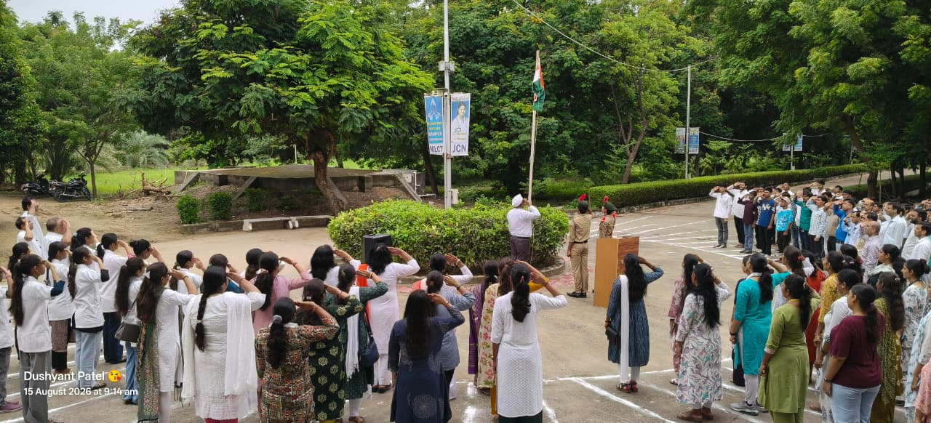

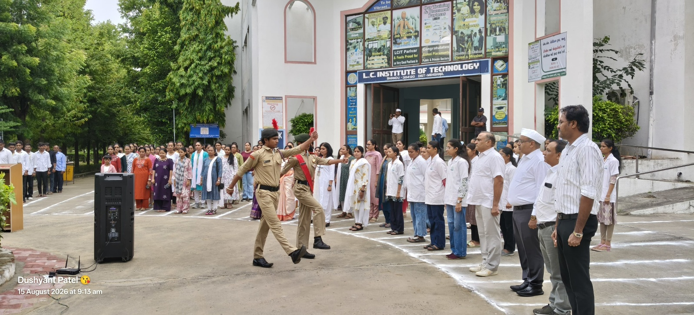

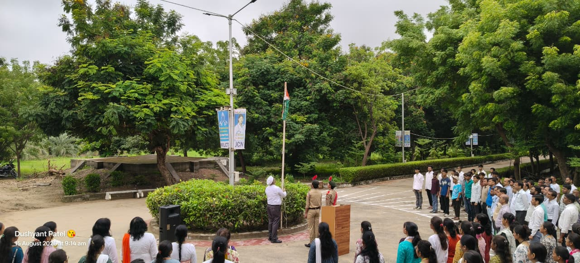

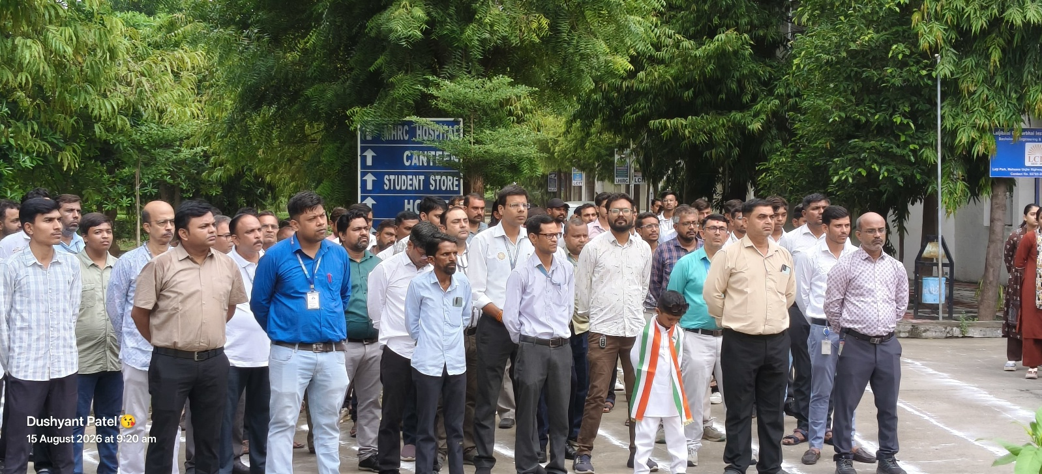

6. Conclusion
The Independence Day celebration concluded on a patriotic and inspiring note. The speech delivered by Dr. D. D. Patidar was an important highlight of the program and encouraged students to uphold the values of freedom, unity, discipline, and responsibility.
The celebration was a memorable occasion for the institute and successfully spread the message of patriotism and national pride among students and staff members.

******

