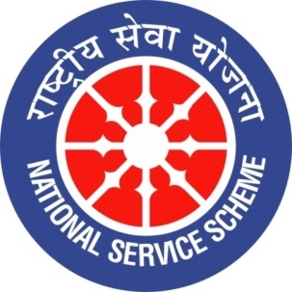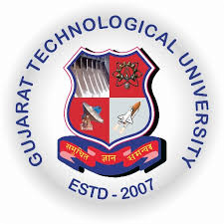
College Logo
GUJARAT TECHNOLOGY UNIVERSITY
NATIONAL SERVICE SCHEME
R N G PATEL INSTITUTE OF TECHNOLOGY
A Report on Art and Science of Manifestations on 14/07/2026 of 084/ R N G Patel Institute of Technology

NSS Unit Name/College Name: R N G Patel Institute of Technology
Event NAME: Mental Stress and Its Management
Event Date, Time and Location: RNGPIT, Tajpore College, Bardoli, 14 July 2026 at 1:00 PM
Brief Description of the Event
A session on “Mental Stress and Its Management” was organised on 14 July 2026 at the RNGPIT Auditorium, with Dr. Dhiren Desai as the speaker. The programme focused on creating awareness about the causes, symptoms, and effects of mental stress in students and young adults. Dr. Desai explained how academic pressure, personal challenges, lifestyle, and excessive expectations can contribute to stress. The session also highlighted the importance of recognising early signs of stress and maintaining a balanced approach towards academic and personal life. The interactive discussion provided participants with useful insights into managing stress effectively.
The event helped participants understand the importance of mental well-being and develop practical strategies for managing stress. Students learned about the value of proper time management, adequate rest, positive thinking, physical activity, relaxation, and maintaining healthy social relationships. The session encouraged participants to identify stressful situations and respond to them in a calm and constructive manner. It also emphasised the importance of seeking support when stress becomes difficult to manage. Overall, the programme enhanced awareness about mental health, encouraged healthier lifestyle choices, and motivated students to develop positive coping strategies for maintaining emotional balance and overall well-being.

