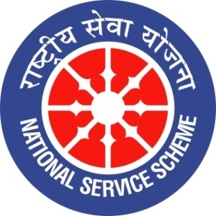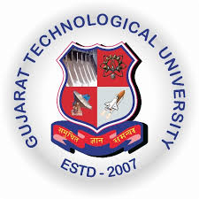
College Logo
GUJARAT TECHNOLOGY UNIVERSITY
NATIONAL SERVICE SCHEME
R N G PATEL INSTITUTE OF TECHNOLOGY
A Report on Art and Science of Manifestations on 04/08/2026 of 084/ R N G Patel Institute of Technology

NSS Unit Name/College Name: R N G Patel Institute of Technology
Event NAME: Nashamukti Pratigna Maha abhiyan
Event Date, Time and Location: RNGPIT, Tajpore College, Bardoli, 04 August 2026 at 10:00 AM
Brief Description of the Event
Nasha Mukt Bharat Abhiyan (Drug-Free India Campaign) was organised by the Brahma Kumaris at the RNGPIT Auditorium to create awareness about the harmful effects of drug and substance abuse. The programme highlighted the physical, mental, social, and financial consequences of addiction. Speakers encouraged students to adopt a healthy and disciplined lifestyle and stay away from intoxicating substances. The importance of self-control, positive thinking, family support, and community participation in overcoming addiction was also discussed. The programme was informative and inspiring, motivating participants to contribute towards building a healthier, safer, and drug-free society.
The event successfully created awareness among students about the harmful effects of drug and substance abuse. Participants gained a better understanding of the physical, psychological, and social consequences of addiction and the importance of maintaining a healthy lifestyle. The programme encouraged students to develop self-discipline, make responsible choices, and stay away from addictive substances. It also motivated them to spread awareness among their peers, families, and communities. Overall, the event strengthened the participants’ commitment to supporting the vision of a healthy and drug-free India.

