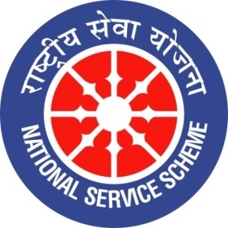
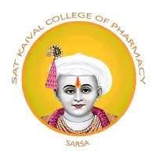

GUJARAT TECHNOLOGY UNIVERSITY
NATIONAL SERVICE SCHEME
SAT KAIVAL COLLEGE OF PHARMACY

A Report on rally(De-Addiction drive & pollution control) celebration at sat kaival college of pharma

NSS Unit Name/College Name:De addiction drive rally & Pollution control rally
Event NAME: “ De addiction drive and pollution control”
Event Date, Time and Location:24/09/2026 ,9.A.M SKCOP,SARSA
Brief Description of the Event:
Sat Kaival College of Pharmacy (SKCOP) organized a Pollution Control Rally in a village to create awareness among the local community about the harmful effects of environmental pollution. Students actively participated in the rally and performed an educational street play to highlight the importance of controlling air, water, and land pollution. They encouraged villagers to maintain cleanliness, avoid littering, dispose of waste properly, and adopt eco-friendly practices. The activity promoted environmental awareness, community participation, and social responsibility among students and villagers, contributing towards the goal of a cleaner and healthier environment.
.
Outcomes of this event:
1 Awareness About De-Addiction: Villagers were made aware of the harmful effects of tobacco, alcohol, and other addictive substances on physical and mental health.
2. Promotion of a Healthy Lifestyle: The awareness drama encouraged people to avoid addictive substances and adopt healthy habits for a better quality of life.
3. Environmental Awareness: The pollution control rally educated villagers about the harmful effects of air, water, and land pollution on human health and the environment.
4. Importance of Cleanliness: The programme motivated villagers to maintain cleanliness, avoid littering, and dispose of waste responsibly.
5. Effective Communication Through Drama: The street plays performed by SKCOP students made the messages easy to understand, engaging, and memorable for the local community.
6. Community Participation: The rally encouraged villagers to take an active role in preventing substance abuse and protecting the environment.
7. Development of Social Responsibility: Students developed communication skills, teamwork, leadership qualities, and a sense of responsibility towards society.
8. Promotion of Public Health: The event highlighted the role of pharmacy students in spreading health awareness and contributing to community welfare.
9. Encouragement of Positive Behaviour: The programme inspired the community to work towards a drug-free society and a cleaner, healthier environment.

Photograph of event:

