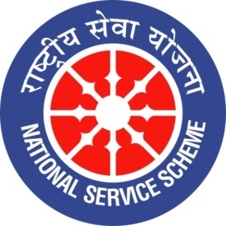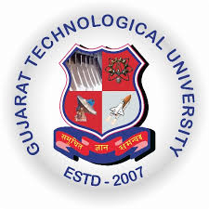
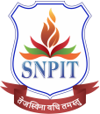
GUJARAT TECHNOLOGY UNIVERSITY
NATIONAL SERVICE SCHEME
S. N. Patel Institute of Technology and Research Centre,Umrakh
A Report on Tiranga Yatra on: 14/08/2026, of S. N. Patel Institute of Technology , Umrakh
NSS Unit Name/College Names. S. N. Patel Institute of Technology , Umrakh
Event Name : Tiranga Yatra
Faculty Name- Prof. Hitesh Tailor.
Event Date, Time and Location: 14/08/2026, vidya bharti campus
Brief Description of the Event:

A grand Tiranga Yatra was organized on 14thAugust,2026 by all the colleges under Vidya Vidhyabhati Trust. The Tiranga Yatra commenced from Bardoli Railway Station and concluded at Bardoli Town Hall.A large number of students from various colleges under the Trust, along with more than 50 faculty members and more than 50 NSS volunteers, participated enthusiastically in the yatra. During the yatra, patriotic songs, including “Vande Mataram,” and patriotic slogans were presented, creating an atmosphere of national pride and unity. The programme was organized with the objective of instilling patriotism, national unity and a sense of responsibility among the youth, and inspiring them to contribute towards building a strong and developed nation.The event was marked by enthusiastic participation and heartfelt patriotism, reflecting our commitment to honoring our nation's freedom and heritage.

