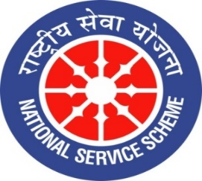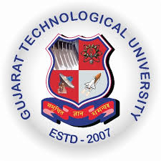
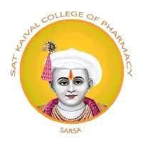

GUJARAT TECHNOLOGY UNIVERSITY
NATIONAL SERVICE SCHEME
SAT KAIVAL COLLEGE OF PHARMACY

A report on world entrepreneurship day celebration at sat kaival college of pharmacy

NSS Unit Name/College Name: World Entrepreneurship day Celebration
Event NAME: “ World Entrepreneurship day”
Event Date, Time and Location:21.08.2026 ,10 A.M SKCOP,SARSA
Brief Description of the Event: Sat Kaival College of Pharmacy celebrated World Entrepreneurship Day with the aim of creating awareness among students about entrepreneurship, innovation, and self-employment opportunities. The programme encouraged students to develop an entrepreneurial mindset, explore innovative business ideas, and understand the importance of startups in economic development. The event provided a platform for students to enhance their creativity, leadership, problem-solving, and decision-making skills. The celebration motivated students to become future entrepreneurs and contribute to society by creating employment opportunities and promoting sustainable development.
Outcomes of this event:
• Students gained awareness about the importance of entrepreneurship and self-employment opportunities.
• The programme encouraged students to develop innovative ideas and an entrepreneurial mindset.
• Students understood the role of startups and small businesses in economic growth and employment generation.
• The event enhanced students’ creativity, leadership, communication, and problem-solving skills.
• Students were motivated to explore business opportunities in the pharmaceutical and healthcare sectors.
• The celebration promoted confidence, teamwork, and decision-making abilities among students.
• Students developed a positive attitude towards innovation, risk-taking, and self-reliance.
• The programme inspired students to consider entrepreneurship as a potential career option and contribute to society through innovative business ventures.

Photograph of event:

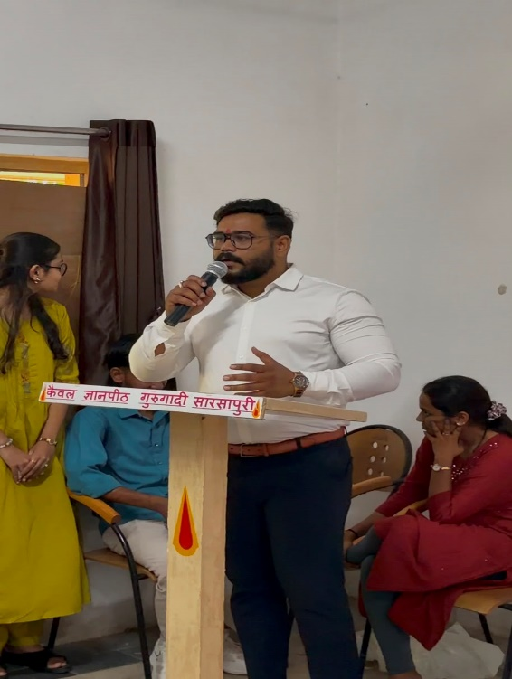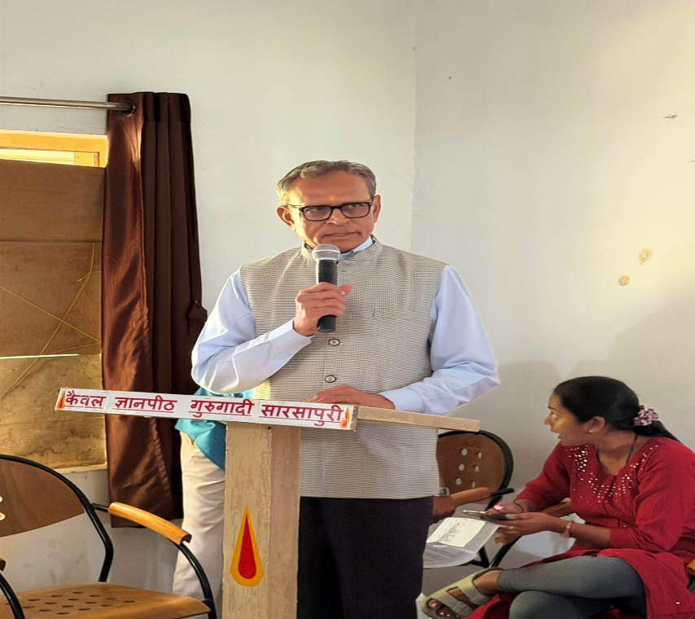
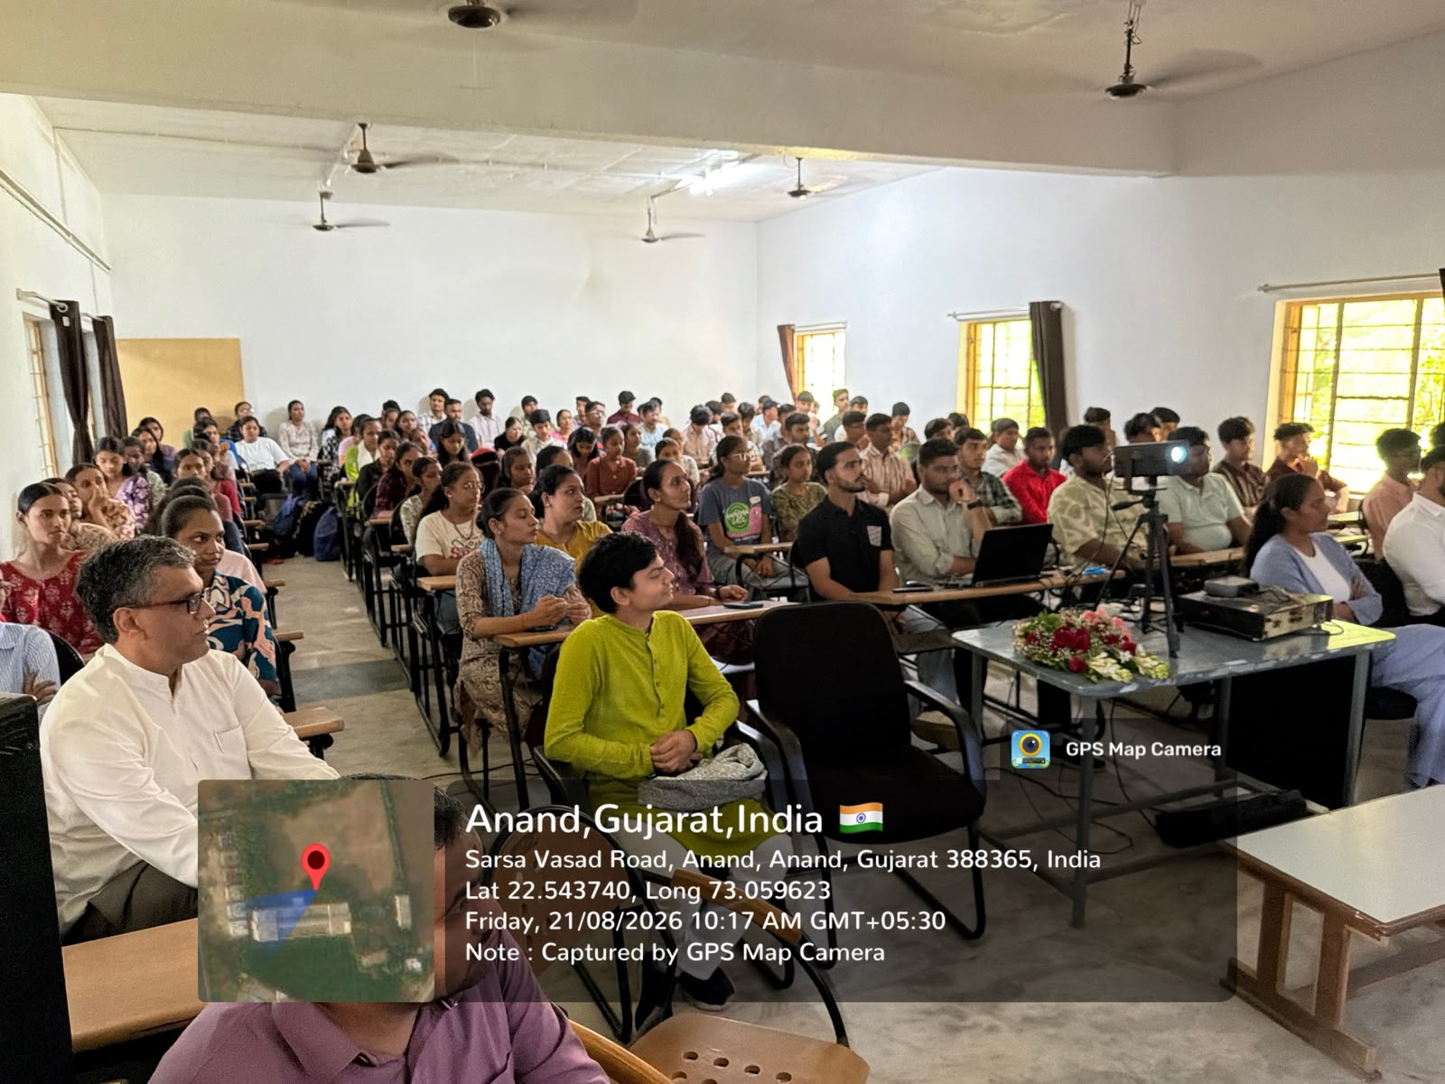
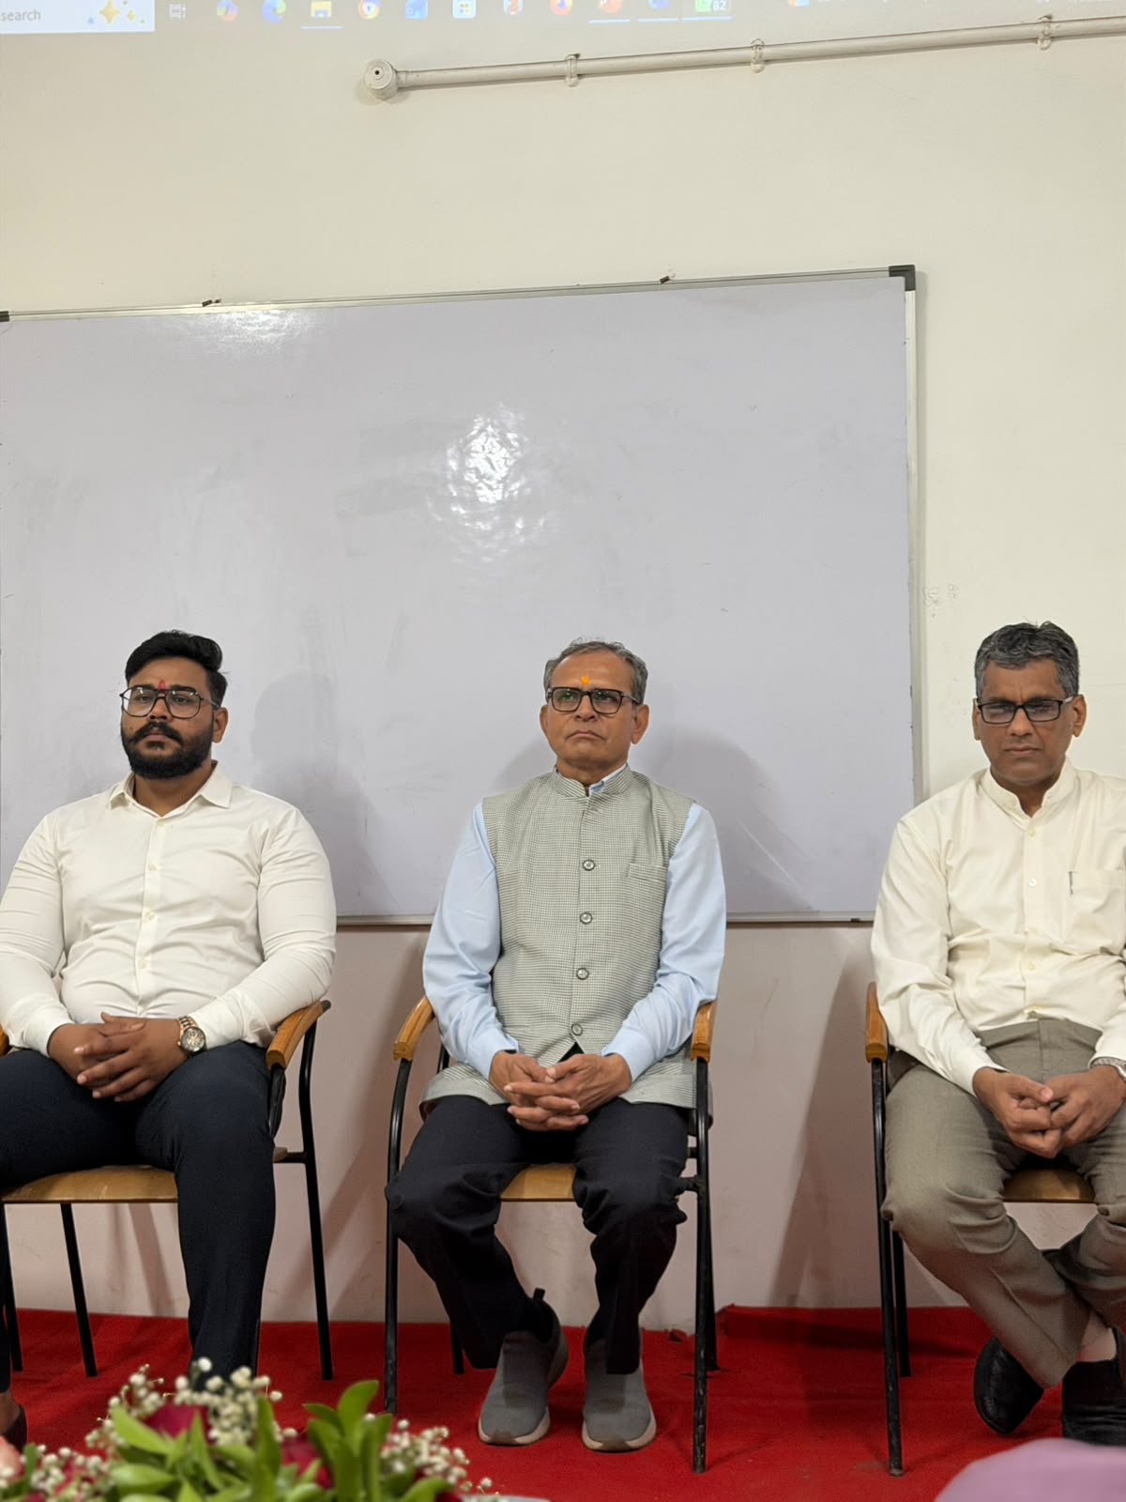

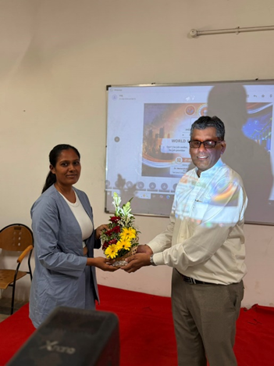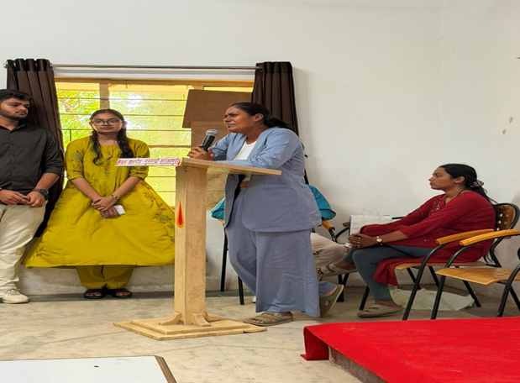
Submitted by
Sejal bhoi(Assistant Professor)

