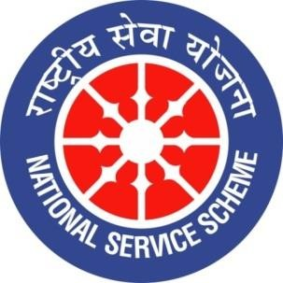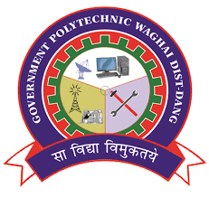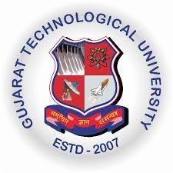
Government Polytechnic Waghai
Report on Har Ghar Tiranga Program

Date: 12/08/2026 to 15/08/2026
NSS Unit Name/College Name: GOVERNMENT POLYTECHNIC WAGHAI
Event NAME: - Har Ghar tiranga celebration
Event Date, Location: 02/08/2026 ,Government Polytechnic waghai
Programme HighlightsGovernment Polytechnic, Waghai organized a series of activities under the “Har Ghar Tiranga” campaign to celebrate the spirit of patriotism and commemorate India’s Independence Day.
On 12 August 2026, students and faculty members participated enthusiastically in the Har Ghar Tiranga awareness activities. Students were encouraged to display the National Flag with pride and to spread the message of national unity, patriotism and respect for the Tricolour.
On 14 August 2026, a special programme was organized at the institute. The students presented patriotic dramas depicting inspiring stories of freedom fighters and national unity. The girl students presented a beautiful patriotic dance, which created an atmosphere of pride and enthusiasm among the participants. The students also prepared a beautiful Rangoli based on the Tricolour and patriotic themes, adding colour and creativity to the celebration.
On 15 August 2026, Flag Hoisting (Dhwaj Vandan) was organized at Government Polytechnic, Waghai. The National Flag was hoisted with due respect, followed by patriotic activities and a celebration of the spirit of independence. Students and faculty members participated enthusiastically and expressed their respect for the nation.
As part of the “Selfie with Tiranga” activity, students enthusiastically took selfies with the National Flag and shared the message of patriotism and national pride. The activity encouraged students to connect with the Har Ghar Tiranga campaign and celebrate Independence Day with a strong sense of responsibility towards the nation.
The entire programme was conducted successfully with active participation from students and faculty members. The activities promoted patriotism, national unity, creativity, discipline and respect for the National Flag among the students.

Outcomes
• Enhanced patriotism and national pride among students and faculty members.
• Created awareness about the importance and honour of the National Flag.
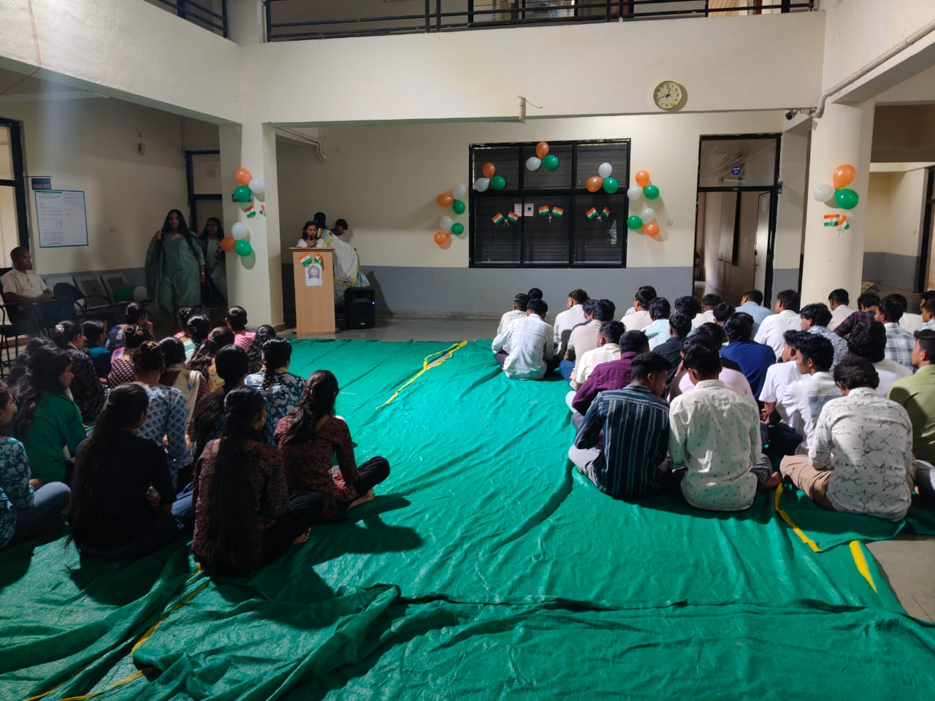 | 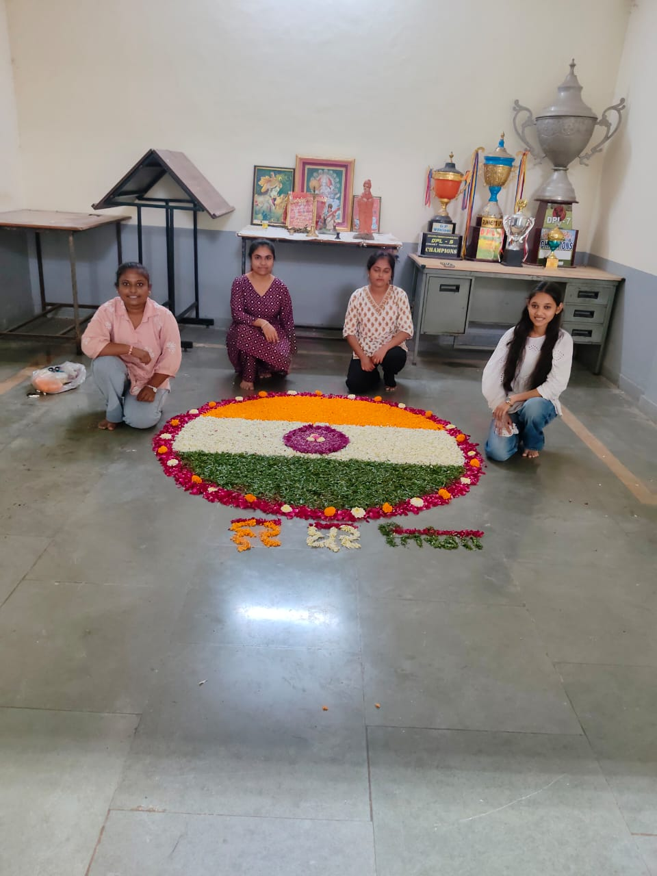
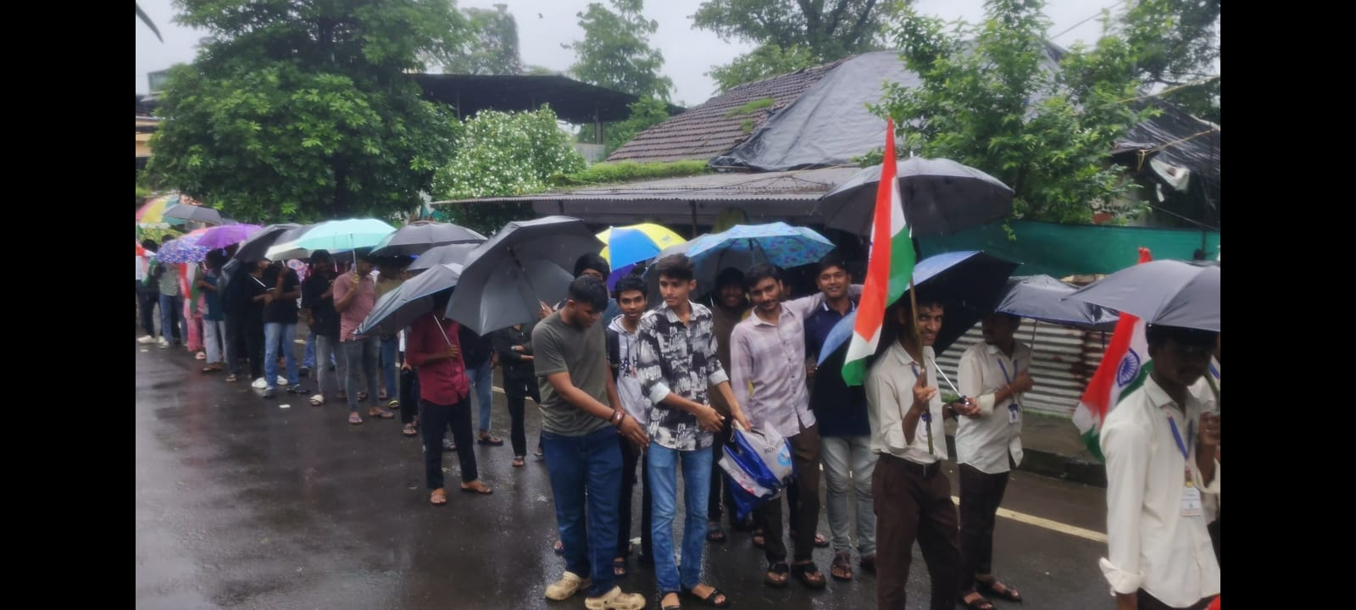 | 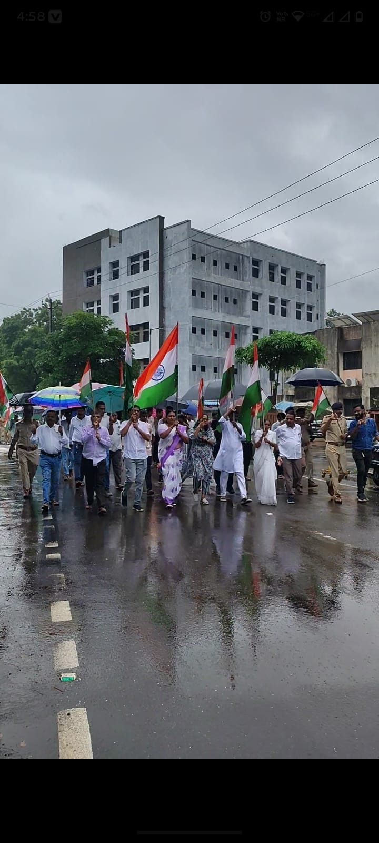
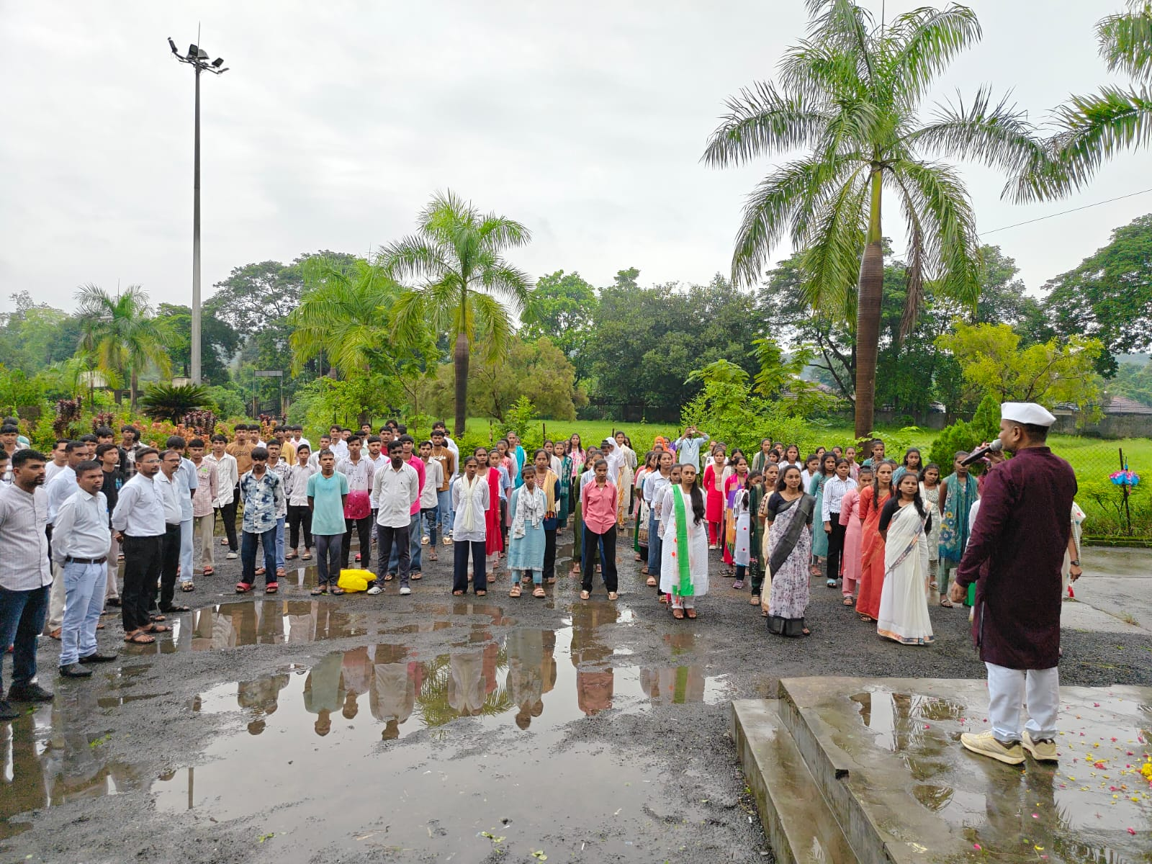 | 