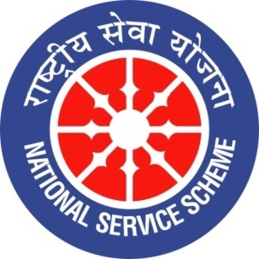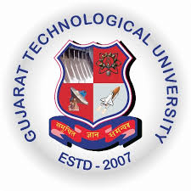
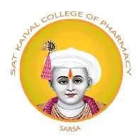

GUJARAT TECHNOLOGY UNIVERSITY
NATIONAL SERVICE SCHEME
SAT KAIVAL COLLEGE OF PHARMACY

- A Report on B.Pharm sem 1 orientation program
NSS unit Name: B.pharm sem 1 orientation program
Event name: Orientation programme
Event Date, Time and Location: 10/08/2026, Skcop Campus,Academic block 2
Brief Description of the Event:
Sat Kaival College of Pharmacy, Sarsa, celebrated orientation program for sem 1 students. the program was highly informative and beneficial for the new students. The programme commenced with Welcoming of new students and parents in traditional way. The informative and interactive sessions conducted by Principal Dr. Mayank Bapna sir and Dr. Pritesh Patel sir, Student leadership seamless peer led execution hosted entirely by sem 7 students. The Conclusion of event was done with structured networking and breakfast. Participants gained a better understanding about B. Pharm course and college. They got valuable information and guidance from our principal shri Mayank Bapna sir. Our GTU coordinator Dr. Pritesh Patel sir gave idea and valuable information on current NEW GTU syllabus of sem 1 B. pharm and also about college. Participants got knowledge, guidance and information that will be useful for their future.

Outcomes of this event:
- Participants gained a better understanding about Pharmacy course and college
- They got valuable information and guidance from our principal shri Mayank Bapna sir.
- Our GTU coordinator Dr. Pritesh Patel sir gave idea and valuable information on
current GTU syllabus of sem 1 B. pharm and also about college.
- Participants got knowledge, guidance and information that will be useful for their future.
- The event encouraged students and faculty members to work together in organizing and conducting the programme successfully.

Photograph of event:

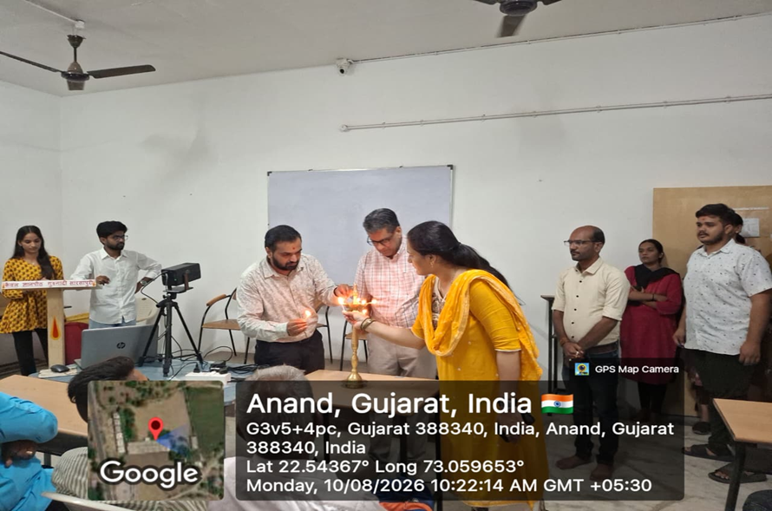

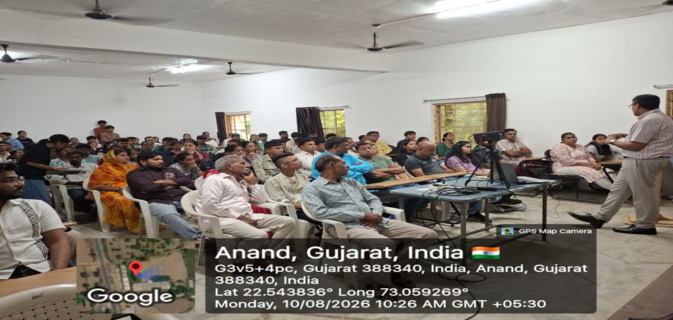

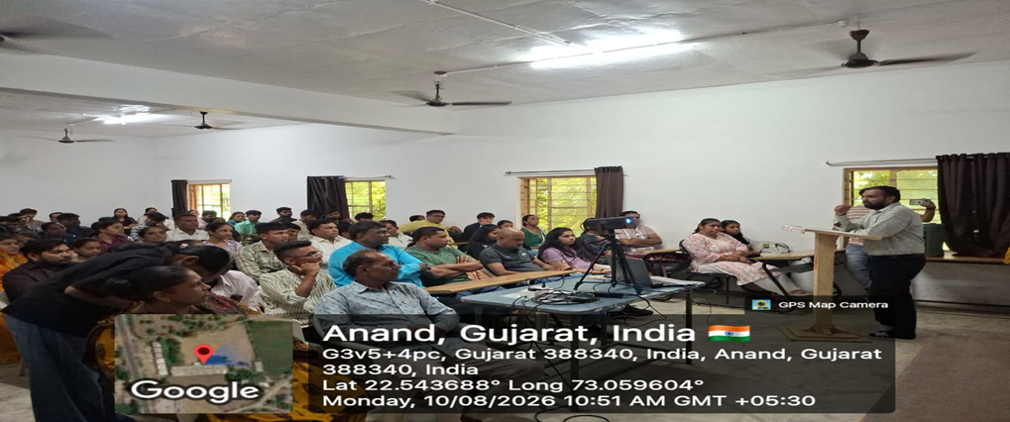

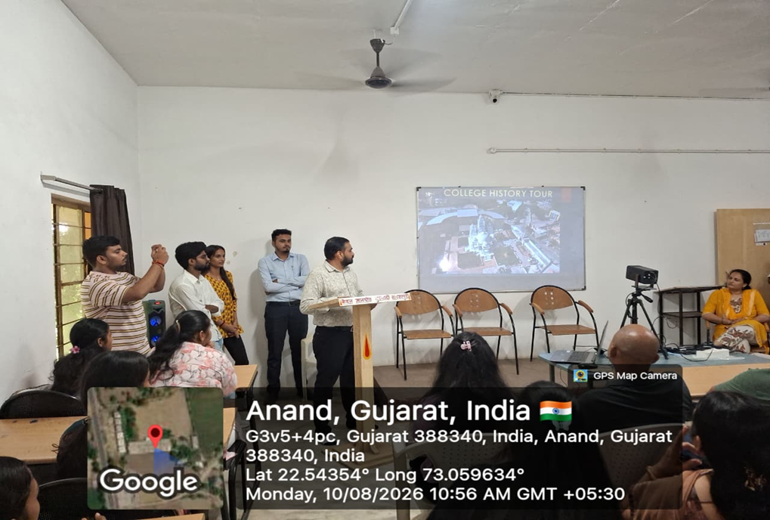

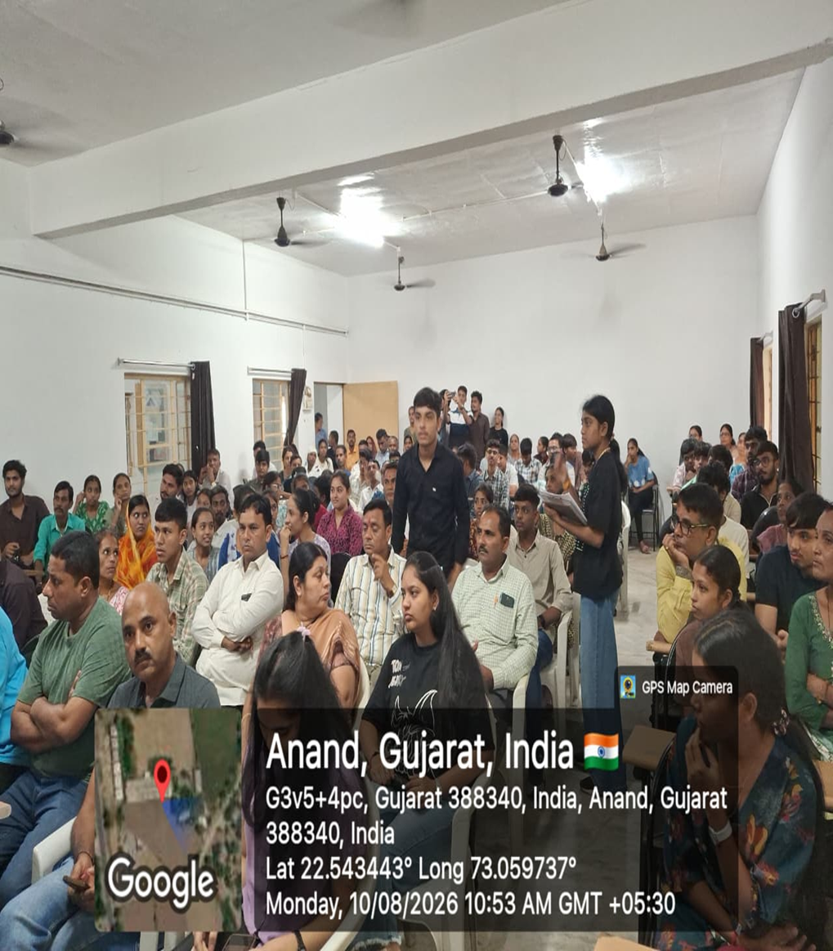

Submitted by
DHRUTI DIVETIA (assistant professor)

