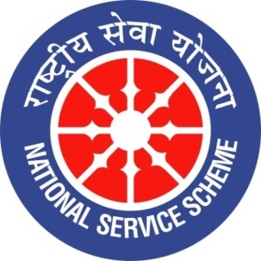
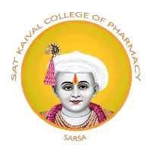

GUJARAT TECHNOLOGY UNIVERSITY
NATIONAL SERVICE SCHEME
SAT KAIVAL COLLEGE OF PHARMACY

A Report on World Pharmacist day celebration at sat kaival college of pharmacy

NSS Unit Name/College Name: World pharmacist day
Event NAME: “ Pharmacanva”
Event Date, Time and Location:25/09/2026 ,10A.M SKCOP,SARSA
Brief Description of the Event: Sat Kaival College of Pharmacy organized a Pharma Canva Competition as part of the celebration of World Pharmacist Day. The theme of the competition was “Introduction to Laboratory Instruments.” The activity aimed to enhance students’ knowledge of various laboratory instruments used in pharmaceutical education, research, quality control, and drug analysis. Through creative Canva designs, students presented the names, functions, applications, and importance of different laboratory instruments in an informative and visually attractive manner. The competition encouraged creativity, digital skills, scientific understanding, and active participation among students while highlighting the important role of laboratory instruments in pharmaceutical sciences.
Outcomes of this event
• Students gained knowledge about various laboratory instruments used in pharmaceutical sciences.
• Participants developed an understanding of the functions, applications, and importance of laboratory instruments in pharmaceutical analysis and research.
• The competition enhanced students’ creativity and presentation skills through the use of Canva.
• Students improved their digital literacy and ability to present scientific information visually.
• The activity encouraged active learning, innovation, and participation among pharmacy students.
• Students developed awareness of the role of laboratory instruments in drug development, quality control, and pharmaceutical research.
• The competition promoted teamwork, scientific communication, and knowledge sharing among participants.
• The event highlighted the importance of practical laboratory knowledge in developing competent and skilled pharmacy professionals.
Photograph of event:

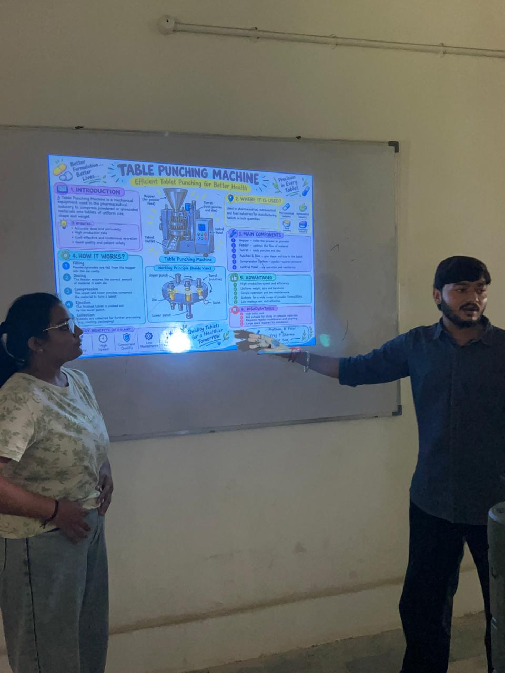
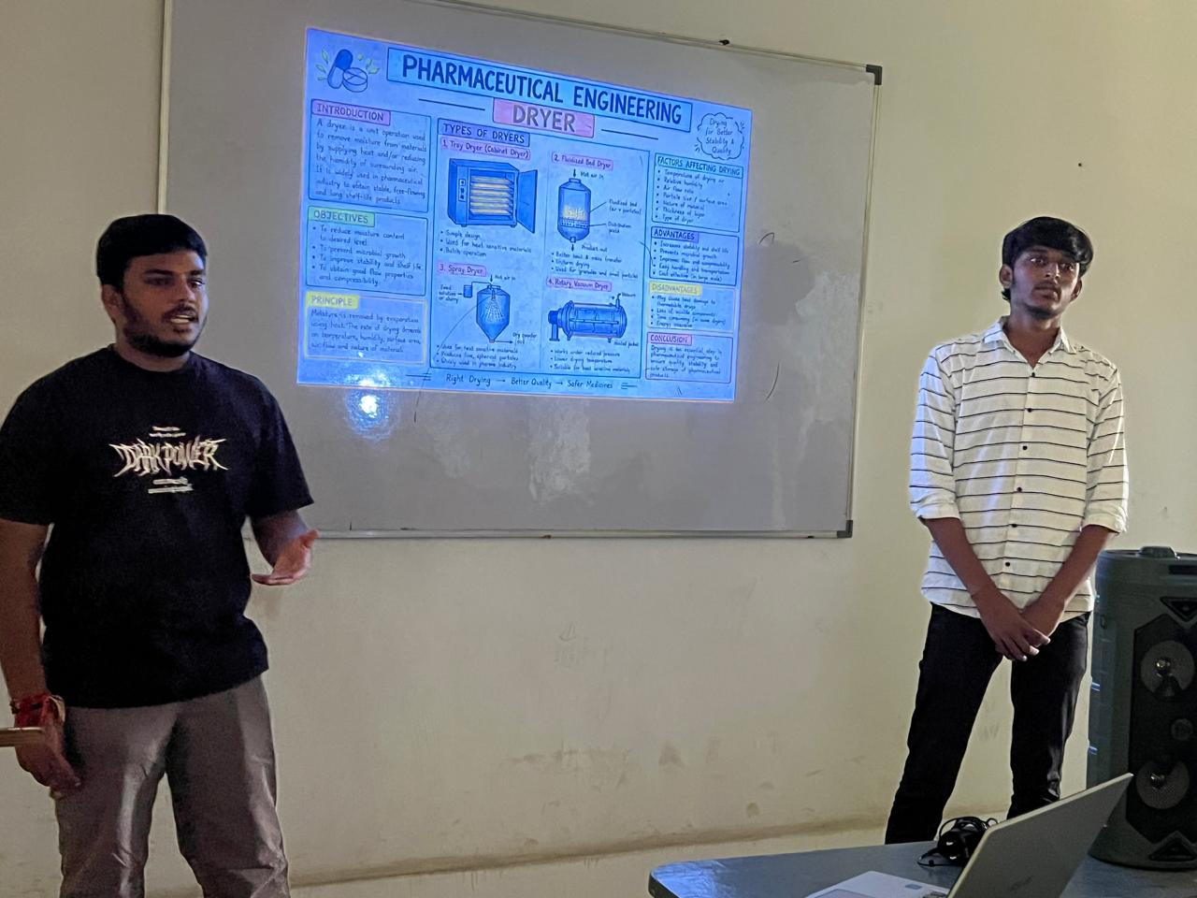
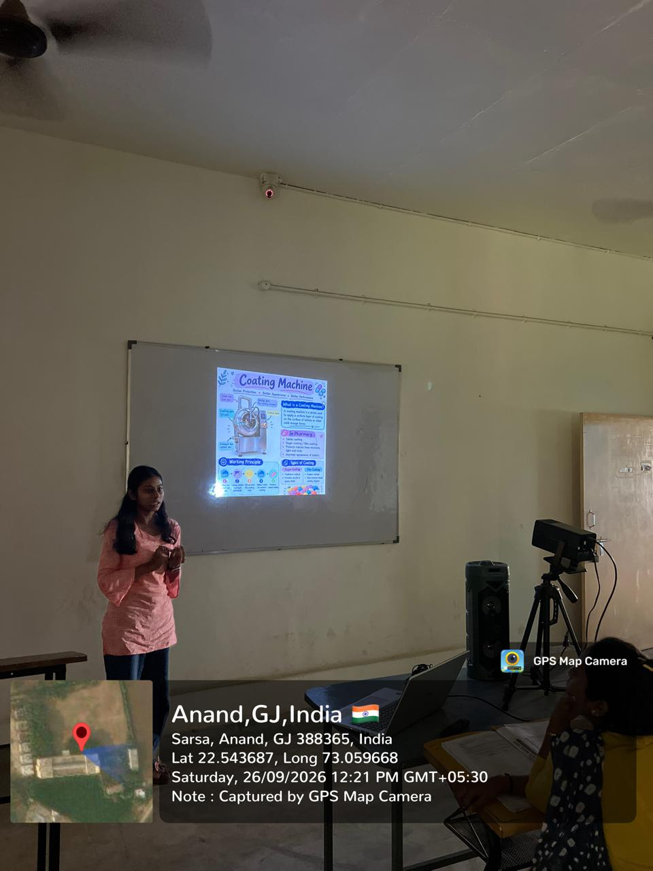

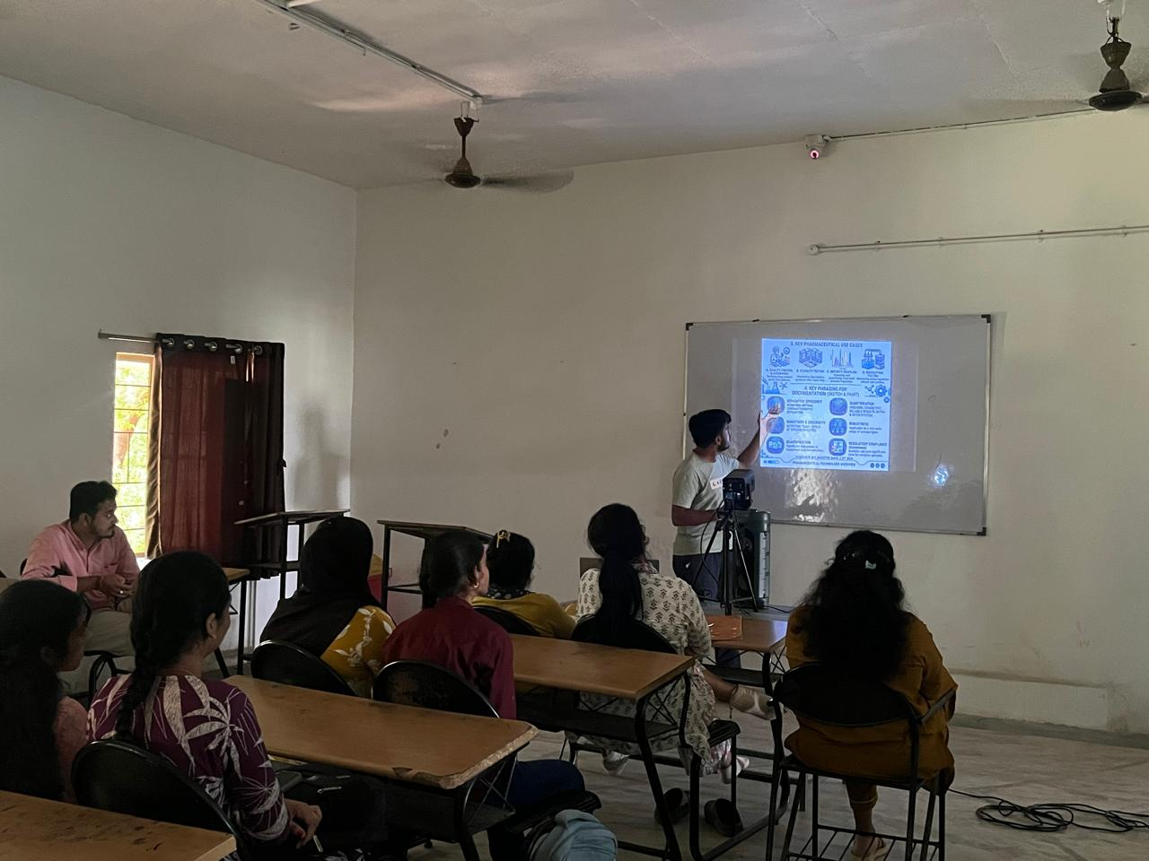
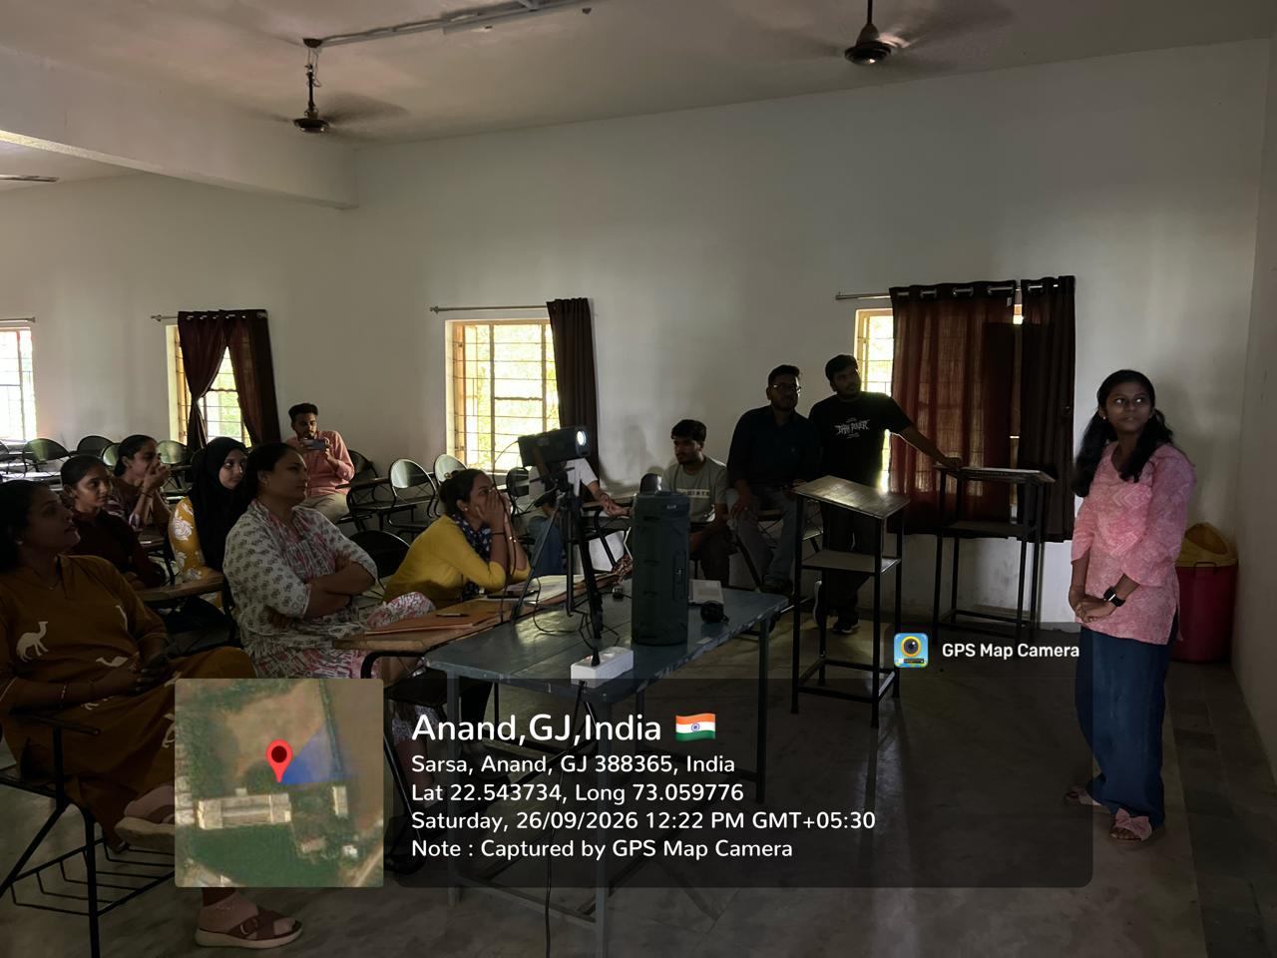
Submitted by( sejal bhoi)

